NAME: ECHEREBOR EFE CHRISTIAN.
MATRIC NO: 18/ENG05/014.
DEPARTMENT: MECHATRONICS ENGINEERING.
COURSE CODE: ENG 284. COURSE: ENGINEER IN SOCIETY .

SUBJECIVE
- A section is represented by Hatching Lines.
- Dimension and projection lines are narrow continuous lines 0.35mm thick, if possible, clearly placed outside the outline of the drawing.
ii.) Arrowhead should be approximately triangular, must be uniform size and shape and in every case touch the dimension lines to which they refer.
iii.) Arrowhead drawn manually should be filled in, arrowheads drawn by machine does not need to be filled in.
Iv.) Adequate space must be left between rows of dimensions and a spacing of about 12mm is recommended.
V.) Centre lines must never be used as dimension lines but must be left clear and distinct.
vi.) Dimensions are quoted in millimetres to the minimum number of significant figures.
Vii.) To enable dimension to be read clearly, figures are placed so that they can be read from the bottom of the drawing.
- Half section;
This is a view of an object showing one half of the view in section, the diagonal lines on the section drawing.
Full section;
If the imaginary cutting plane phases through the entire object, splitting the drawn object in two with the interior of the object revealed.
- A leader line can be terminated in three ways.
  - With a dot within the outline of the object (surface)
  - With an arrowhead on the outline of the object (edge)
  - Without a dot or an arrowhead on a dimension line.
- Scale 5:1
This means the drawing will mean that the drawing of the object is 5 times as large as the object itself.
Scale 1:10
This means the object is 10 times smaller than in real life.
- Diameter

Radius
R
Square

Spherical radius
SR
Centre line

Cutting plane line
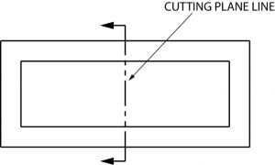

Long break

- An orthographic projection is a means of representing three dimensional objects in two dimensions..
- First angle projection is a method of creating a 2D drawing of a 3D object.
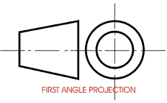
Third angle projection is a method of orthographic projection which is a technique in portraying a 3D design using a series of 2D views.
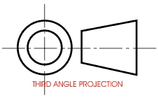
OBJECTIVES
- A
- B
- C
- B
- A
- B
- C
- B
- A
- A
- C
- A
- D
- C
- D

