WHAT IS GIS?
A geographic information system (GIS) is a framework for gathering, managing, and analyzing data. Rooted in the science of geography, GIS integrates many types of data. It analyzes spatial location and organizes layers of information into visualizations using maps and 3D scenes. ​With this unique capability, GIS reveals deeper insights into data, such as patterns, relationships, and situations—helping users make smarter decisions.

APPLICATIONS IN HYDROLOGY
Geographic information systems (GISs) have become a useful and important tool in the field of hydrology to study and manage Earth's water resources. Climate change and greater demands on water resources require a more knowledgeable disposition of arguably one of our most vital resources. Because water in its occurrence varies spatially and temporally throughout the hydrologic cycle, its study using GIS is especially practical. Whereas previous GIS systems were mostly static in their geospatial representation of hydrologic features, GIS platforms are becoming increasingly dynamic, narrowing the gap between historical data and current hydrologic reality.
The elementary water cycle has inputs equal to outputs plus or minus change in storage. Hydrologists make use of this hydrologic budget when they study a watershed. The inputs in a hydrologic budget include precipitation, surface flow, and groundwater flow. Outputs consist of evapotranspiration, infiltration, surface runoff, and surface/groundwater flows. All of these quantities can be measured or estimated based on environmental data and their characteristics can be graphically displayed and studies using GIS.

EXAMPLES OF GIS TOOLS
- THE BUFFER TOOL
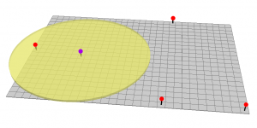
Buffers are proximity functions. When you use this geoprocessing tool, it creates a polygon at a set distance surrounding the features.
For example, a buffer is a polygon or collection of cells that are within a specified proximity of a set of features.
Buffers can have fixed and variable distances. In addition, they can be set to geodesic which accounts for the curvature of the Earth.
- THE CLIP TOOL
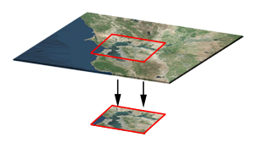
The clip tool is an overlay function that cuts out an input layer with the extent of a defined feature boundary. The result of this tool is a new clipped output layer.
If you can picture a cookie cutter, this is like using the clip tool. And carving out vectors and rasters is one of the most common operations in GIS.
In order to clip data, you need points, lines or polygons as input and a polygon as the clipping extent. The preserved data is the result of a clip.
- THE MERGE TOOL
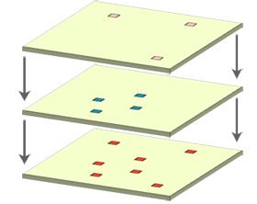
The merge geoprocessing tool combines data sets that are the same data type (points, lines or polygons). When you run the merge tool, the resulting data will be merged into one.
Similar to clip, we use the merge tool on a regular basis. For merging, data sets have to be the same type. For example, you can’t merge points and polygons into one data set.

- THE DISSOLVE TOOL
The Dissolve Tool unifies boundaries based on common attribute values. In other words, dissolve merges neighboring boundaries if the neighbors have the same attributes.
For example, if you want to remove the borders of countries to form a continent, the dissolve tool is the tool to use. But you would need an attribute for each country and the continent it belongs to.
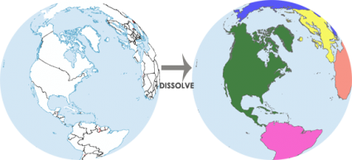

- THE INTERSECT TOOL
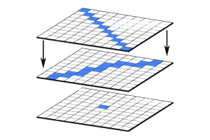
The Intersect Tool is very similar to the clip tool because the extents of input features defines the output. The only exception is that it preserves attributes from all the data sets that overlap each other in the output.
The Intersect Tool performs a geometric overlap. All features that overlap in all layers will be part of the output feature class – attributes preserved.
Add multiple inputs. The tool accepts different data types (points, lines and polygons). When features overlap each other, they will be in the output. The Intersect Tool preserves the attribute values in both input layers.
- THE UNION TOOL
Some say the Union tool should come with a bottle of antacid. The union tool gets a bad reputation because it creates a lot of features. The Union Tool maintains all input features boundaries and attributes in the output feature class.
After running this geoprocessing tool, it does get a bit messy especially when there are more overlaps. But it’s really not so bad. The Union tool spatially combines two data layers. It preserves features from both layers at the same extents.
- THE ERASE (DIFFERENCE) TOOL
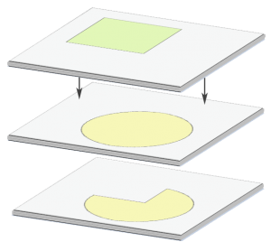
I like the erase tool. It’s always been helpful in erasing things! The input layer is what will be erased. The erase feature determines what to erase. Simple as that.
The Erase Tool removes features that overlap the erase features. This geoprocessing tool maintains portions of input features falling outside the erase features extent. The result is a new feature with the erase feature extent removed

