NAME: OMOROGBE JOHANNA
MATRIC NO.: 18/SMS09/076
COURSE TITLE: ELEMENTS OF COONTEMPORARY GLOBAL STUDIES
COURSE CODE: IRD 218
ASSIGNMENTS
The COVID 19 pandemic continues to ravage the world. Briefly assess the pandemic’s impacts on the global economic between December 2019 and April 2020. Basically explain both the intended and unintended consequences of the shutdown, looking at the statistics of global financial institution, for example, the IMF
ANSWER
INTRODUCTION
The COVID-19 pandemic has caused an unprecedented human and health crisis. The measures necessary to contain the virus have triggered an economic downturn. At this point, there is great uncertainty about its severity and length. The latest Global Financial Stability Report shows that the financial system has already felt a dramatic impact, and a further intensification of the crisis could affect global financial stability. Since the pandemic’s outbreak, prices of risk assets have fallen sharply. At the worst point of the recent selloff, risk assets suffered half or more of the declines they experienced in 2008 and 2009. For example, many equity markets—in economies large and small—have endured declines of 30% or more at the trough. Credit spreads have jumped, especially for lower-rated firms. Signs of stress have also emerged in major short-term funding markets, including the global market for U.S. dollars.
Market strain
Volatility has spiked, in some cases to levels last seen during the global financial crisis, amid the uncertainty about the economic impact of the pandemic. With the spike in volatility, market liquidity has deteriorated significantly, including in markets traditionally seen as deep, like the U.S. Treasury market, contributing to abrupt asset price moves.
To preserve the stability of the global financial system and support the global economy, central banks across the globe have been the first line of defence. First, they have significantly eased monetary policy by cutting policy rates—in the case of advanced economies to historic lows. And half of the central banks in emerging markets and lower income countries have also cut policy rates. The effects of rate cuts will be reinforced through central banks’ guidance about the future path of monetary policy and expanded asset purchase programs.
Second, central banks have provided additional liquidity to the financial system, including through open market operations.
Third, a number of central banks have agreed to enhance the provision of U.S. dollar liquidity through swap line arrangements.
And finally, central banks have reactivated programs used during the global financial crisis as well as launched a range of new broad-based programs, including to purchase riskier assets such as corporate bonds. By effectively stepping in as “buyers of last resort” in these markets and helping contain upward pressures on the cost of credit, central banks are ensuring that households and firms continue to have access to credit at an affordable price.
To date, central banks have announced plans to expand their provision of liquidity—including through loans and asset purchases—by at least $6 trillion and have indicated a readiness to do more if conditions warrant.
As a result of these actions aimed at containing the fallout from the pandemic, investor sentiment has stabilized in recent weeks. Strains in some markets have abated somewhat and risk asset prices have recovered a portion of their earlier declines. Sentiment continues to be fragile, however, and global financial conditions remain much tighter compared to the beginning of the year.
All in all, the sharp tightening of global financial conditions since the COVID-19 outbreak—together with the dramatic deterioration in the economic outlook has shifted the one-year-ahead distribution of global growth massively to the left. This point to a significant increase in downside risks to growth and financial stability. There is now a 5% likelihood (an event that happens once every 20 years) that global growth will fall below -7.4%. For comparison, this threshold was above 2.6 percent in October 2019.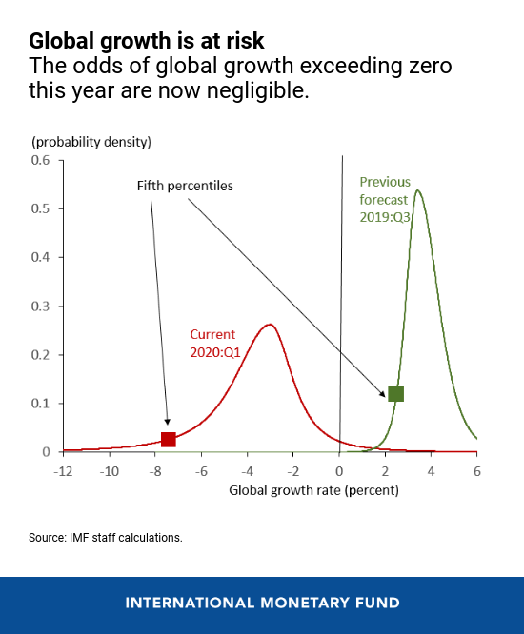
As so often happens at times of financial distress, emerging markets risk bearing the heaviest burden. In fact, emerging markets have experienced the sharpest portfolio flow reversal on record—about $100 billion or 0.4% of their GDP—posing stark challenges to more vulnerable countries.
The global spread of COVID-19 may require the imposition of tougher and longer-lasting containment measures—actions that may lead to a further tightening of global financial conditions should they result in a more severe and prolonged downturn. Such a tightening may, in turn, expose financial vulnerabilities that have built in recent years in the environment of extremely low interest rates. This would further exacerbate the COVID-19 shock. For example, asset managers facing large outflows may be forced to sell into falling markets—thus intensifying downward price moves. In addition, levered investors may face further margin calls and may be forced to unwind their portfolios; such financial deleveraging may aggravate selling pressures.
As firms become distressed and default rates climb higher, credit markets may come to a sudden stop, especially in risky segments like high yield, leveraged loan, and private debt markets. These markets have expanded rapidly since the global financial crisis, reaching $9 trillion globally, while borrowers’ credit quality, underwriting standards, and investor protections have weakened. Since early March, high-yield spreads have skyrocketed notwithstanding recent declines, particularly in the sectors most affected by the pandemic like air travel and energy. Similarly, leveraged loan prices have fallen sharply—about half the drop seen during the global financial crisis at one point. As a result, ratings agencies have revised upward their speculative-grade default forecasts to recessionary levels, and market-implied defaults have also risen sharply.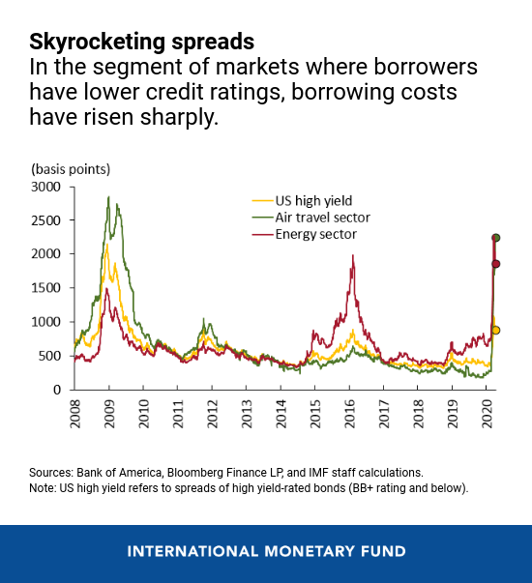
Banks have more capital and liquidity than in the past, and they have been subject to stress tests and greater supervisory scrutiny in recent years, putting them in a better position than at the onset of the global financial crisis. In addition, the substantial and coordinated action by central banks to provide liquidity to banks in many economies should also help alleviate potential liquidity strains.
Nonetheless, the resilience of banks may be tested in the face of a sharp slowdown in economic activity that may turn out to be more severe and lengthy than currently anticipated.
Indeed, the large declines in bank equity prices since mid-January suggest that investors are concerned about profitability and prospects for the banking sector. For example, measures of bank capitalization based on market prices are now worse than during the 2008 global financial crisis in many countries. The concern is that banks and other financial intermediaries may act as an amplifier should the crisis deepen further.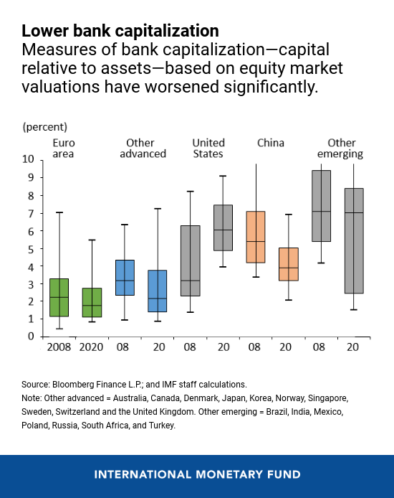
Looking ahead
Central banks will remain crucial to safeguarding the stability of global financial markets and maintaining the flow of credit to the economy. But this crisis is not simply about liquidity. It is primarily about solvency—at a time when large segments of the global economy have come to a complete stop. As a result, fiscal policy has a vital role to play.
Together, monetary, fiscal, and financial policies should aim to cushion the impact of the COVID-19 shock and to ensure a steady, sustainable recovery once the pandemic is under control. Close, continuous international coordination will be essential to support vulnerable countries, to restore market confidence, and to contain financial stability risks. The IMF is ready to assert the full weight of its resources—first, to help protect the world’s most vulnerable economies, and, for the long term, to strengthen the eventual recovery.

THE DREADFUL CONSEQUENCES OF THE RAVAGING PANDEMIC
The coronavirus pandemic and economic shutdowns could have multiple second-order impacts such as deflation in some economies, a loss of output, permanently-shifted supply chains and a re-evaluation of regulation, the director of the International Monetary Fund's monetary and capital markets department said. The comments came after the IMF, the world's largest multilateral lender, on Monday released its Global Financial Stability Report, warning the crisis presents a very serious threat to the stability of the global financial system. For some countries around the world, it is dangerous to keep expanding public sector debt, because it may be unsustainable, but in the major advanced economies like the United States and many European economies, the problem is more one of deflationary pressures, said Tobias Adrian in an interview.
UNITED STATES DRASTIC PRICE FALL
US consumer prices fell by the most in more than five years in March, and further decreases are likely as the outbreak suppresses demand for some goods and services. Economists are predicting the disinflationary trend will persist for a while, or there will even be a short period of outright deflation.
Adrian also said he was concerned about a persistent loss of output as the economy cannot be simply switched off and back on and there may be a permanent change in the structure of the economy and supply chains may shift permanently. The initial story was that we will shut down the economy and restart and [all is] back to normal, said Adrian. I worry the economic structure gets damaged in the meantime, [that] there is scarring, businesses get shut, people are unemployed, you can't go back to where you left off.
In Monday's report, the IMF said asset managers remain vulnerable if there is a prolonged period of dislocation in financial markets. Financial markets, which fell into a bear market on concerns about the spread of the virus, have been regaining on the back of massive fiscal and monetary stimulus. I do expect some shakeout in the asset management industry where some of the funds that have weaker balance sheets are hit harder by corporate distress, said Adrian. The Fed and the Treasury can't protect everyone to the same degree.
Adrian said an upshot could be strengthened prudential regulation for asset managers globally, for example, regarding leverage and liquidity transformation - using short-term liabilities to finance illiquid long-term assets. In terms of financial stability, I think that there will be an impetus to look at market-based finance and regulatory approaches so that if there is another shock, then the central bank doesn't have to come in and backstop everything, Adrian said.
United States crude oil futures plunged back into negative territory and Brent collapsed on Tuesday following a historic plunge in oil prices below zero for the first time ever.
The fall in prices was triggered by the expiry of May futures contracts for US West Texas Intermediate (WTI) crude, which would have left traders stuck with barrels of physical oil in a market with few willing buyers as the coronavirus pandemic continues to ravage energy demand. US WTI crude for May delivery traded at -$2.58 a barrel by 08:07 GMT, up $35.05 from Monday's close when the contract settled at -$37.63 a barrel.
Negative oil prices are a sign that producers are willing to pay people to take oil off their hands. Brent crude oil, which is the international standard for crude oil prices, slumped more than 26% or $6.76 to $18.81, its lowest since 2002. Global stocks were also dragged into the red on Tuesday with MSCI's index of emerging market stocks down 2% eyeing its worst day in nearly three weeks. The currencies index was down 0.4%.
In Asia, Japan's Nikkei fell 1.97% and China’s blue-chip CSI300 fell 1.18%, while the broader Shanghai Composite Index declined 0.9%.
The slump in the US futures contract for crude was exaggerated by the looming expiry late on Tuesday of the front-month contract for the delivery of oil in May when the lack of storage is set to be particularly acute. The more active June contract, which had earlier been well supported, slipped more than $1 to just above $18 a barrel. June trading volumes were roughly 80 times those of the expiring May contract.
The coming weeks are surely going to be interesting for the oil markets, Suvro Sarkar, of DBS Bank, told Al Jazeera. DBS sees the second quarter of 2020 as being the trough for oil prices and Sarkar expects that WTI futures may continue to trend towards zero in the coming month.
We do not think Brent will follow it all the way there. But, we would not be shocked if Brent breaches 20 or 10 dollars per barrel in coming days or weeks, he said.
Unlike the internationally shipped Brent crude, WTI front-month contracts involve physical deliveries of the oil to a specific location, namely the oil terminal in Cushing, Okhlahoma, which is rapidly filling up, Sarkar, explained. Although international storage is more readily available than US storage at this point, Sarkar said, one might wonder ... if traders cannot access US storage for physical crude deliveries in May, how will they find storage for June?
The coronavirus pandemic has pummelled global travel, transportation and economic activity, sending the demand for crude plummeting. As such, many traders holding oil futures were left with an oversupply of physical oil. Unfortunately, the options for the Saudi Arabia-led Organisation of Petroleum Exporting Countries and fellow major oil producers including Russia - a group known collectively as OPEC+ - options for further supply cuts are limited.
Cutting production further on a [government-to-government] level can hardly make too much of a dent in the near term, and is not feasible for smaller countries to agree to cut above 25%. So options for US and OPEC+ are limited in the face of this deep hole in demand that we see in 2Q20, Sarkar said. OPEC+ had previously agreed to reduce oil output by a record 10 million barrels per day, although most analysts saw this move as insufficient to support oil prices in a market where demand remains weak due to the pandemic.
The American Petroleum Institute is set to release its data at 4:30pm (20:30 GMT) on Tuesday, and the weekly report by the US Energy Information Administration is due at 10:30am (14:30 GMT) on Wednesday.
President Donald Trump said his administration would consider blocking oil imports from Saudi Arabia to protect the US shale oil industry. The oil price will stay low for some time as supply exceeds demand and the current situation on global oil markets is reminiscent of the 1980s oil glut, former BP boss John Browne said on Tuesday.
Browne, who ran BP from 1995 to 2007, said the negative prices were a US issue because of a lack of storage, though he said across the world demand was down while production was still high.
The prices will be very low, and I think they will remain low and very volatile for some considerable time, Browne told the BBC. There is still a lot of oil being produced that is going into storage and not being used. This is very reminiscent of a time in the mid-1980s when exactly the same situation happened - too much supply, too little demand and prices of oil stayed low for 17 years. The 1980s glut - when oil prices tumbled in the mid-1980s - ultimately led to geopolitical tremors across the world: The Soviet Union collapsed in 1991 while Algeria faced a political crisis that spawned a deadly civil war. Browne said the demand for hydrocarbons would likely fall, partly as a result of a greater awareness of climate change.
Demand for hydrocarbons will continue to be weak, he said. And that demand will be filled primarily by those who have no choice but to produce oil - so the state oil companies of the world. US President Donald Trump said his administration would look at a proposal to block Saudi Arabian oil shipments to the US to help buoy the US shale oil industry against an unprecedented rout that threatens its survival. Well, I'll look at it, Trump told reporters at a daily news conference after he was asked about requests by some Republican legislators to block the shipments under his executive authority.
CONCLUSION
Looking at the above analysis and statistics it can be concluded that sooner than later the world will plunge into universal want. The oil price collapse and other happenings round the world as a result of the ravaging pandemic have given a high level of uncertainty. The question asked in most companies is whether this is ultimately a long term downward structural adjustment in the price of oil or a short term temporary correction. Whether they are right or wrong, the continuing uncertainty means the 2020 certainly looks like being a huge challenge for both the oil sector and every other sector of the economy as this pandemic continues to eat deep into the economy of the 193 country round the world and causing serious problem for the third world countries’

