- With the use of section lines. When sketching an object or part that requires a sectional view, the lines are drawn by eye at an angle of approximately 45 degrees, and are spaced about 0.25m” apart. Since they are used to set off a section, they must be drawn with care.

- Rules of dimensioning
- Dimensions should not be duplicated, nor should the same info be given in two different ways
- Dimensions should be attached to the view that best shows the contour of the feature being dimensioned
- Wherever possible avoid dimensioning to hidden lines
- Avoid dimensions over or through the object Wherever possible locate dimensions in adjacent views
- In general a circle is measured by its diameter circle with line through it, and arc by its radius R
- Holes are located by their centerlines, which may be extended and used as an extension line
- Rule Holes should be located and sized in the view that shows that feature as a circle

- Half and full section
  - Full section: This Is when the cutting plane in the drawing had extended along the diameter of the cylinder, or object in question
  - Half section: this is when the cutting plane in this drawing extends the distance of the radius, or only half the distance of a full section.

- The British technical drawing standards give us four different types of terminators to use with our leader lines. They include;
  - Closed filled arrow terminator
  - Closed blank arrow terminator
  - Dot terminator
  - Tick terminator

- Scale 5:1; This simply means that an object or a figure is to be appear five times larger it’s original size. Example if 50mm line is to be drawn at a scale of 5:1 (ie 5 times more than its original size). The measurement 50mm is multiplied by 5 to give 250m
Scale 1:10; This simply means that an object or figure is to appear ten times smaller than its original size. Example if 150mm line is to be drawn at a scale of 1:10 (ie 10 times smaller than its original size). The measurement 150 is divided by 10 to give 15.

- Shape definition symbol
  - Diameter-⌀
  - Radius-R
  - Square-
  - Spherical radius-SR

- Elements to be considered when obtaining a projection include;
  - Dimensions lines and arrows
  - Type is projection (ie isometric, oblique, orthographic, auxiliary, etc)
  - Scale to be used (if any)
  - Direction of viewing
  - hidden details
  - Extension lines and Gap
Orthographic projection: this is common method of projection in which an object is depicted using parallel lines to project its outline on to a plane. It is a method of representing three-dimensional objects, usually by three two-dimensional drawings in each of which the object is viewed along parallel lines that are perpendicular to the plane of the drawing.

- The projection of an object is orthographic when the object (usually three-dimensional) is represented in two dimensions in which all the projection lines are orthogonal to the projection plane, resulting in every plane of the scene appearing in affine transformation on the viewing surface.

- First angle projection is a method of creating a 2D drawing of a 3D object. It is mainly used in Europe and Asia. To get the first angle projection, the object is placed in the first quadrant meaning it's placed between the plane of projection and the observer.
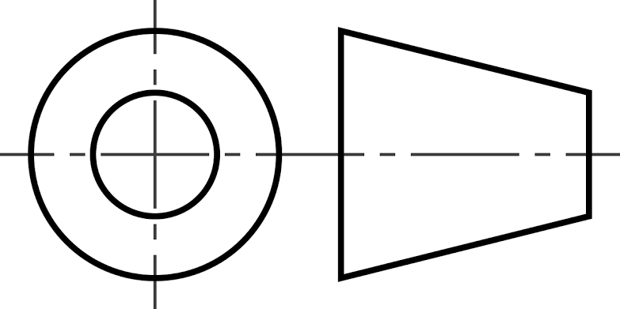

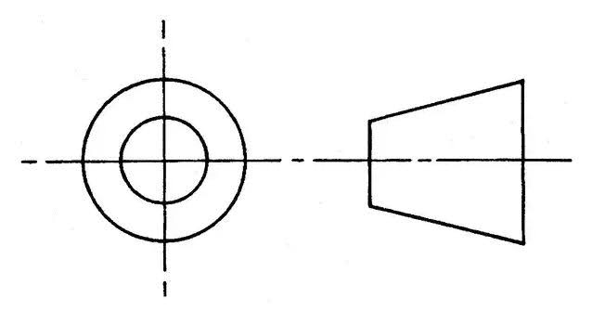
Third angle projection is a method of creating a 2D drawing of a 3D object. In Australia, third angle projection is the preferred method of orthographic projection. For the third angle projection, the object is placed below and behind the viewing planes meaning the plane of projection is between the observer and the object.
OBJECTIVES
- A
- TRUE
- C
- A
- A
- B
- C
- B
- B
- A
- C
- D
- C
- C. 15. D

