OMORODION OSAROGIE YOMA
COMPUTER ENGINEERING 19/ENG02/051
CHM 102 ASSIGNMENT
1.
ORGANIC COMPOUND | IUPAC NAME
CH₃OCH₃ | Methoxymethane
CH₃CH₂OCH₂CH₃ | Ethoxyethane/Diethyl ether
(CH₃CH₂CH₂CH₂)₂O | Dibutyl ether
CH₃CH₂OCH₃ | Methoxyethane
CH₃CH₂CH₂OCH₂CH₃ | 1-Propoxypropane

2. Properties of ethers
An ether molecule has a net dipole moment. We can attribute this to the polarity of C-O bonds.
The boiling point of ethers is comparable to the alkanes. However, it is much lower compared to that of alcohols of comparable molecular mass. This is despite the fact of the polarity of the C-O bond.
The miscibility of ethers with water resembles those of alcohols.
Aromatic ethers undergo halogenations, for example; bromination, when we add a halogen in the presence or absence of a catalyst.
3. Methods of preparing ethers
DEHYDRATION OF ALCOHOLS: In the presence of sulphuric acid, dehydration of ethanol yields Ethoxyethane at 413K. This is an ideal method of preparation through primary alcohols. Preparation of ethers by dehydration of an alcohol is a nucleophillic substitution reaction.
2C₂H₅OH H₂SO₄.413K C₂H₅OC₂H₅
WILLIAMSON’S SYNTHESIS: When an alkyl halide reacts with sodium alkoxide, an ether is formed. This reaction is known as Williamson’s synthesis. The reaction generally follows the SN₂ mechanism for primary alcohols. 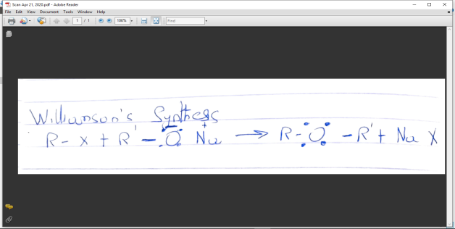
4. Uses of ethylene oxide
Production of ethylene glycol
Healthcare sterilant
Production of acrylonitrile

