NAME: KOSHOEDO-OLUSEGUN OLUWABUSOLA
DEPARTMENT: MECHATRONICS ENGINEERING
MATRIC NO: 18/ENG05/028
CORSE CODE: ENG232

MCQ ANSWERS
- A sectioned view is represented by the used of cross hatched line to indicate the surface being sectioned and the line are drawn using a 45 degree set square.
2a. Dimension lines should be narrow continuous lines and clearly placed outside the outline of the drawing.
b. The dimension lines should not touch the outline of the drawing and a small gap should be left depending on the size of the drawing.
c. The arrowhead of the dimension lines should be triangular and must be of uniform size and shape and touch the dimension line to which they refer.
d. Centre lines should not be used as dimension.
3. Half Section: the cutting plane line cuts halfway through the material and removes one quarter of the material.
Full Section: In full section, the cutting plane line passes fully through the material and a view is replaced with the full sectioned view.
4. Leader lines are terminated with an arrow touching the part or detail.
5a. scale =5:1 means a drawing with the size of 5 has an actual measurement of 1.
b. scale= 1:10 means a drawing with the size of 1 has an actual measurement of 10.

6 a. b. c.
Square

Diameter

Radius

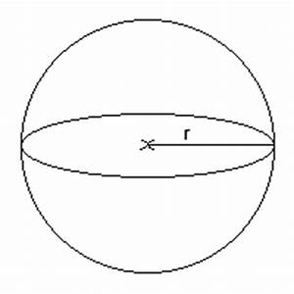
Spherical radius

e.

Center line

f.

Cutting plane line
g. 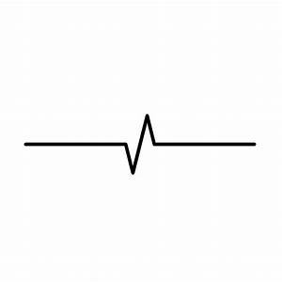long break
7. The elements of a projection are
a. planes
b. ray of site
c. object
d. projector

8. A projection is called orthographic when an object is projected on planes at right angles to each other
9. First angle projection Second angle projections

E F P
P E F

Objectives
- D
- A
- D
- A
- A
- B
- C
- B
- B
- A
- C
- A
- C
- C
- D

