Name: Iroegbu Ugochi Miriam
Matric. number: 17/mhs01/164
Department: Medicine and Surgery
Course:Neuro Histology
- Write an essay o the histological importance of eye in relations to their cellular functions
The eyes can be viewed broadly as a series of overlapping tissues. External structures of the eye include the eyelashe, lids, muscles, accessory glands and conjunctiva. The internal structures of the eye consist of three layers of tissues arranged concentrically:
- The sclera and cornea make up the exterior layers
- The uvea is the vascular layer in the middle,subdivided into the iris,ciiiary body, and choroid.
- The retina constitutes the innermost layer and is made up of nervous tissue
Structure of the eye:
- External structure-
Conjunctiva: the conjunctiva lines the inner part of the eyelids. The tarsal plate lies beneath the conjunctiva meibomian glands which secrete any oily substance to decrease the evaporation of tear film.
Tear film: the tear film consists of aqueous, mucus and oily secretions.
Accessory glands: Apocrine glands of moll, meibomian glands, lacrimal glands.
Muscles : orbitucularis oculi, levator palpebrea, superioris, superior tarsal muscle.
Eyelid : The eyelid is lown as the cover of the eye, a mobile layer made up of skin and also muscular tissue and covers the eye ball.
- Internal structures- the innermost layer of the eye are organized in three layers as follows:
Outermost layer : sclera and cornea
- The sclera(the white of eye): the sclera is a dense connective tissue made of mainly type 1 collagen fibres, oriented in different directions. The lack of parallel orientation of collagen fibres gives the sclera its white appearance, as opposed to the transparent nature of the cornea. However, the collagen of the sclera and cornea are continous. The four layers of the sclera from external to internal episclera, stroma, lamina fusca, endothelium
- The cornea (transparent front layer of the eye): consists of type 1 collagen fibres oriented in a uniform parallel direction to maintain transperancy. It consists of five layers : epithelium(non-keratinized, stratified squamous epithelium), bowman layer, stroma(also called substantia propria), Descemets membrane, corneal endothelium.
Middle layer: uvea(iris ,cilliary body , choroid)
- Iris: consists of stromal layer with pigmented, fibrovascular tissue and pigmented epithelial cells beneath the stroma. The sphincter papillae and dialator papillae muscles connect to the stroma. The pigmented layer of cells blocks rays of light and ensures that the light must move through the pupil to reach the retina. The angle formed by the iris and cornea contains connective tissue with endothelial channels called the trabecular meshwork, which drains aqueous humour in the anterior chamber into the venous canal of schlemm.
- Ciliary body: the tissue that divides the posterior chamber and vitreous body. It consists of the ciliary muscle which controls the structure of the lens and ciliary epithelium which produces aqueous humor which fills the anterior compartment of the eye.
- Choroid : it consists of a dense network of blood vessels supplying nourishment to structures of the eye, housed in loose connective tissue. The choriocapillary layer is located in the innermost part of the choroid and supplies the retina.
Innermost layer: Lens, Vitreous, Retina-
- Lens : seperates the aqueous and vitreous chambers. It consists of an outside capsule, a middle layer called the nucleus. The capsule is the basement membrane of the lens epithelium which lies below. New lens differentiate from the lens epithelium and incorporated peripherically, pushing older lens cells towards the middle.
- Vitreous: this is a jelly-like space made of type 2 collagen separating the retina and the lens.
- Retina : this is a nervous tissue of the eye where photons of light convert to neuro chemical energy via action potentials.
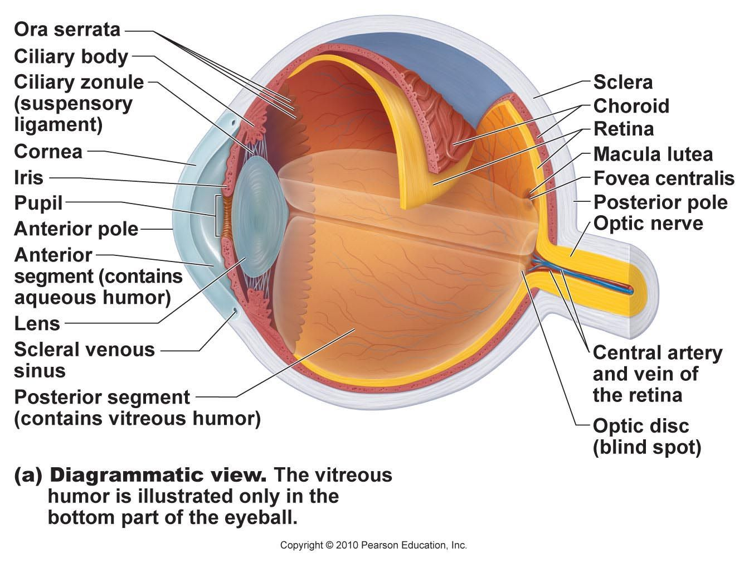
- Briefy discuss the layers of the retina for information penetration.
The vertebrae retina has ten distinct layers. From closest the farthest from the vitreous body:
- Inner limiting membrane : this consists of terminal expansions of other muller cell processes that cover the collagenous membrane of the vitreous body.
- Gangalion cell layer: this contains nuclei of ganglion cells, the axos of which become the optic nerve fibres, and some displaced amacrine cells.
- Inner plexiform layer: this contains the synapse between the bipolar cell axons and the dendrites of the gangalion and amacrine cells.
- Inner nuclear layer: it contains the nuclei and surrounding cell bodies(perikarya) of the amacrine cells, bipolar cells and horizontal cells.
- Outer plexiform layer: projections of rods and cones endig in the rod spherule and cone pedicle, repectively . These make synapses with dendrites of bipolar cells and horizontal cells. In the macular region, this is known as fibre layer of henle
- Outer nuclear layer: this contains cell bodies of photoreceptors(the rod and cone cells)
- External limiting membrane: this is the layer that separates the inner segment portions of the photoreceptors from their cell nuclei.
- Retinal pigment epithelium : this is a single layer of cuboidal epithelial cells. The layer is closest to choroid, and provides nourishment and supportive functions to the neural retina, the black pigment melanin in the pigment layer prevents light reflection throughout globe of the eyeball; this is important for clear vision.

