NAME: NWOSU SEAN-MICHAEL

MATRIC NO: 18/ENG02/064

DEPARTMENT: Computer Engineering.

COURSE CODE: ENG 232

TITLE: Engineering Drawing

- Using section lines that are inclined at angle 45⁰

- I) Dimensions shouldn't be duplicated or the same information will be given in two different ways
.
II) Unnecessary dimensions shouldn't be used - only the dimensions needed to create or inspect the part.

III)Make sure to avoid dimensioning to hidden lines wherever possible.

IV) Dimensions shouldn't be placed on the object unless that is the only option.

V) A circle is dimensioned by its diameter, an arc by its radius.

VI) Holes should be located by their center lines.

VII) Holes should be located in the view that shows the feature as a circle.

VIII) Dimensions should never be crossed.

IX) Never cross extension lines.
X) Overall dimensions should be placed the greatest distance away from the object so that intermediate dimension can nest closer to the object to avoid crossing extension lines.

3
a) Half-section: A half-section is a view of an object showing one-half of the view in section. Symmetrical parts can be shown in half sections.
b) Full-section: If the imaginary cutting plane passes through the entire object, splitting the drawn object in two with the interior of the object revealed, this is called a "full section."

4. A leader line also has a terminator and some text. It may have a reference line under the text. An arrow terminator is used to point to an edge of an item.The Architectural tick can be used for referring to multiple parallel edges.

5
a. 5:1 scale: Used for enlarging the object 5 times its original size(Enlargement Scale).
b. 1:10 scale: Used to reduce the object 10 times its original size (Reduction Scale).

6a. Φ
b. R
c.
d. SR

7a) Front View
b) Side View
c) The Plan
An orthographic drawing is a clear and detailed way to represent the image of an object.

8. It is called orthographic projection when the principal planes/axes of an object in an orthographic projection are not parallel with the projection plane

9
a) 1st Angle Projection: It is a method of creating a 2D drawing of a 3D object. It is mainly used in Europe and Asia and has not been officially used in Australia for many years.

b) 3rd Angle Projection: is a method of orthographic projection which is a technique in portraying a 3D design using a series of 2D views. For the third angle projection, the object is placed below and behind the viewing planes meaning the plane of projection is between the observer and the object.
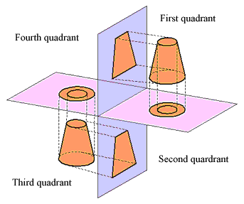

Objective Answers
- A

- A

- C

- B

- A

- B

- C

- B

- A

10 A

11 C

12 A

13 C

14 C

15 D

