NAME: Usman Mahmud Yahaya

MATRIC NO: 18/ENG04/076

DEPARTMENT: Elect/Elect

COURSE CODE: ENG 232

TITLE: Engineering Drawing

- By using section lines which are inclined at angle 45⁰

- I) Dimensions should NOT be duplicated, or the same information be given in two different ways
II) No unnecessary dimensions should be used - only those needed to produce or inspect the part.
III) Avoid dimensioning to hidden lines wherever possible
IV) Dimensions should not be placed on the object unless that is the only clear option.
V) In general, a circle is dimensioned by its diameter, an arc by its radius.
VI) Holes should be located by their center lines.
VII) Holes should be located in the view that shows the feature as a circle.
VIII) Never cross dimension lines.
IX) Never cross extension lines.
X) Overall dimensions should be placed the greatest distance away from the object so that intermediate dimension can nest closer to the object to avoid crossing extension lines.

3a) Half-section: A half-section is a view of an object showing one-half of the view in section. Symmetrical parts can be shown in half sections. Half sections are commonly used to show both the internal and outside view of symmetrical objects. The cutting plane is off-set to include features that are not in a straight line.
b) Full-section: If the imaginary cutting plane passes through the entire object, splitting the drawn object in two with the interior of the object revealed, this is called a "full section." A full section is the most widely-used sectional view.

4. A leader line also has a terminator and some text. A leader line may have a reference line under the text. An arrow terminator is used to point to an edge of an item. The dot is used to point to a face. The Architectural tick can be used for referring to multiple parallel edges.
5a. 5:1 scale: This is an enlargement scale used for enlarging the object 5 times its original size.
b. 1:10 scale: This is a reducing scale used to reduce the object 10 times its original size

6a. Φ
b. R
c.
d. SR

7a) Front View
b) Side View
c) The Plan
An orthographic drawing is a clear, detailed way to represent the image of an object.

8. It is called orthographic projection when the principal planes or axes of an object in an orthographic projection are not parallel with the projection plane

9a) 1st Angle Projection: It is a method of creating a 2D drawing of a 3D object. It is mainly used in Europe and Asia and has not been officially used in Australia for many years. In Australia, third angle projection is the preferred method of orthographic projection. Note the symbol for first angle orthographic projection.
b) 3rd Angle Projection: is a method of orthographic projection which is a technique in portraying a 3D design using a series of 2D views. For the third angle projection, the object is placed below and behind the viewing planes meaning the plane of projection is between the observer and the object.
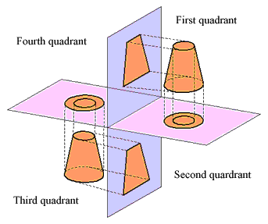

Objective Answers
- A
- A
- C
- B
- A
- B
- C
- B
- A
- A
- C
- A
- C
- C
- D

