NAME: EZEOBIDI CLEMENTINA ONYINYECHUKWU
COURSE: ELECTRICAL MACHINES II
COURSE CODE: EEE326
MATRIC NO: 17/ ENG04/027

QUESTION 1

- A single phase induction motor does not have a self-starting torque
- During light load conditions, the power factor of the load drops to a very low value
- The speed control of an induction motor is very hard to attain.
- Due to poor starting torque the motor cannot be used for applications which requires high starting torque.

According to double field revolving theory, we can resolve any alternating quantity into two components. Each component has a magnitude equal to the half of the maximum magnitude of the alternating quantity, and both these components rotate in the opposite direction to each other. For example – a flux, φ can be resolved into two components
each of these components rotates in the opposite direction i. e if one φ_{m}/2 is rotating in a clockwise direction then the other φ_{m} / 2 rotates in an anti-clockwise direction.
When we apply a single phase AC supply to the stator winding of single phase induction motor, it produces its flux of magnitude, φ_{m}. According to the double field revolving theory, this alternating flux, φ_{m} is divided into two components of magnitude φ_{m}/2. Each of these components will rotate in the opposite direction, with the synchronous speed, N_{s}.
Let us call these two components of flux as forwarding component of flux, φ_{m} and the backward component of flux, φ_{m} . The resultant of these two components of flux at any instant of time gives the value of instantaneous stator flux at that particular instant.
Now at starting condition, both the forward and backward components of flux are exactly opposite to each other. Also, both of these components of flux are equal in magnitude. So, they cancel each other and hence the net torque experienced by the rotor at the starting condition is zero. So, the single phase induction motors are not self-starting motors.

According to double field revolving theory, we can resolve any alternating quantity into two components. Each component has a magnitude equal to the half of the maximum magnitude of the alternating quantity, and both these components rotate in the opposite direction to each other. For example – a flux, φ can be resolved into two components

each of these components rotates in the opposite direction i. e if one φ_{m}/2 is rotating in a clockwise direction then the other φ_{m} / 2 rotates in an anti-clockwise direction.
When we apply a single phase AC supply to the stator winding of single phase induction motor, it produces its flux of magnitude, φ_{m}. According to the double field revolving theory, this alternating flux, φ_{m} is divided into two components of magnitude φ_{m}/2. Each of these components will rotate in the opposite direction, with the synchronous speed, Ns.
Let us call these two components of flux as forwarding component of flux, φ_{f} and the backward component of flux, φ_{b}. The resultant of these two components of flux at any instant of time gives the value of instantaneous stator flux at that particular instant.

Now at starting condition, both the forward and backward components of flux are exactly opposite to each other. Also, both of these components of flux are equal in magnitude. So, they cancel each other and hence the net torque experienced by the rotor at the starting condition is zero. So, the single phase induction motors are not self-starting motors.

C. Constructional feature
Single phase induction motor is very simple and robust in construction. The stator carries a distributed winding in the slots cut around the inner periphery. The stator conductors have low resistance and they are winding called Starting winding is also mounted on the stator. This winding has high resistance and its embedded deep inside the stator slots, so that they have considerable inductance. The rotor is invariably of the squirrel cage type. In practice, in order to convert temporarily the single phase motor into two-phase motor, auxiliary conductors are placed in the upper layers of stator slots. The auxiliary winding has a centrifugal switch in series with it. The function of the switch is to cut off the starting winding, when the rotor has accelerated to about 75% of its rated speed. In capacitor-start motors, an electrolytic capacitor of suitable capacitance value is also incorporated in the starting winding circuit.
The main stator winding and auxiliary (or starting) winding are joined in parallel, and there is an arrangement by which the polarity of only the starting winding can be reversed. This is necessary for changing the direction of rotation of the rotor.

Principle of operation

When power supply for the stator is switched on, an alternating current flows through the stator winding. This sets up an alternating flux. This flux crosses the air gap and links with the rotor conductors. By electromagnetic induction e.m.f.’s are induced in the rotor conductors. Since the rotor forms a closed circuit, currents are induced in the rotor bars. Due to interaction between the rotor induced currents and the stator flux, a torque is produced. It is readily seen that if all rotor conductors in the upper half come under a stator N pole, all rotor conductors in the lower half come under a stator S pole. Hence the upper half of the rotor is subjected to a torque which tends to rotate it in one direction and the lower half of the rotor is acted upon by an equal torque which tends to rotate it in the opposite direction. The two equal and opposite torques cancel out, with the result that the net driving torque is zero. Hence the rotor remains stationary. Thus the single phase motor fails to develop starting torque.

D.

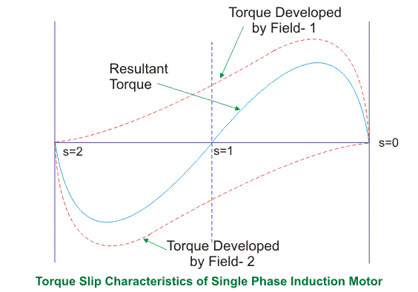
From the figure, we see that at a slip of unity, both forward and backward field develops equal torque but the direction of which are opposite to each other so the net torque produced is zero hence the motor fails to start. From here we can say that these motors are not self-starting unlike the case of three phase induction motor. There must be some means to provide the starting torque. If by some means, we can increase the forward speed of the machine due to which the forward slip decreases the forward torque will increase and the reverse torque will decrease as a result of which motor will start.
From here we can conclude that for starting of single phase induction motor, there should be a production of difference of torque between the forward and backward field. If the forward field torque is larger than the backward field than the motor rotates in forward or anti clockwise direction. If the torque due to backward field is larger compared to other, then the motor rotates in backward or clockwise direction. They are not self-starting because in induction machine a rotating magnetic field is required to produce torque. A rotating magnetic field can produced if we have balanced three phase supply and each phase is electrically spaced 120 to each other OR we have required minimum two phase but in single phase induction motor there is single phase supply to the stator of motor. A single phase supply cannot produce a rotating magnetic field but it produce a pulsating magnetic field which does not rotate. Due to this pulsating magnetic field torque cannot produce so motor is not self-start.

E.

- resistance-start motor or split phase motor
- capacitor start motor
-permanent capacitor or single-value capacitor Motor
-capacitor start capacitor run motor or two value capacitor motor
-shaded pole motor

- Shaded pole induction motor:

The shaded pole induction motor is simply a self-starting single-phase induction motor whose one of the pole is shaded by the copper ring. The copper ring is also called the shaded ring. This copper ring act as a secondary winding for the motor. The shaded pole motor rotates only in one particular direction, and the reverse movement of the motor is not possible.

- Why the Shaded Pole Induction Motor designs for low power rating?
The power losses are very high in the shaded pole induction motor. And the power factor of the motor is low. The starting torque induces in the induction motor are also very low. Because of the following reasons the motor has poor efficiency. Thus, their designs are kept small, and the motor has low power ratings.
- Construction of Shaded Pole Induction Motor
The shaded pole motor may have two or four poles. Here in this article, we use the two pole motor for the sake of simplicity. The speed of the motor is inversely proportional to the number of poles used in the motor.

Stator – The stator of the shaded pole motor has a salient pole. The salient pole means the poles of the magnet are projected towards the armature of the motor. Each pole of the motor is excited by its exciting coil. The copper rings shade the loops. The loops are known as the shading coil.

The poles of the motor are laminated. The lamination means multiple layers of material are used for making the poles. So, that the strength of the pole increases.

The slot is constructed at some distance apart from the edge of the poles. The short-circuited copper coil is placed in this slot. The part which is covered with the copper ring is called the shaded part and which are not covered by the rings are called unshaded part.

Rotor – The shaded pole motor uses the squirrel cage rotor. The bars of the rotor is skewed at an angle of 60º. The skew can be done for obtaining the better starting torque.

The construction of the motor is very simple because it does not contain any commutator, brushes, collector rings, etc. or any other part. The shaded pole induction motor does not have any centrifugal switch. Thus, the chances of failure of the motor are less.

The centrifugal switch is the type of electrical switch that starts operating by using the centrifugal force, generated by the rotating shaft. It is also used for controlling the speed of the shaft.

- Shaded Pole Induction Motor Working
When the supply is connected to the windings of the rotor, the alternating flux induces in the core of the rotor. The small portion of the flux link with the shaded coil of the motor as because it is short-circuited. The variation in the flux induces the voltage inside the ring because of which the circulating current induces in it.
The circulating current develops the flux in the ring which opposes the main flux of the motor. The flux induces in the shaded portion of the motor, i.e., a and the unshaded portion of the motor, i.e., b have a phase difference. The main motor flux and the shaded ring flux are also having a space displacement by an angle of 90°.

The connection diagram of the Shaded Pole Motor is shown below.

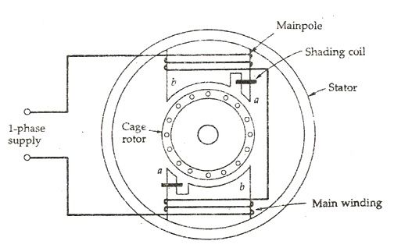
Shaded pole induction motor figAs there is time and space displacement between two fluxes, the rotating magnetic field induces in the coil. The rotating magnetic field develops the starting torque in the motor. The field rotates from the unshaded portion to the shaded portion of the motor.

- The advantages of shaded pole induction motor are

- Very economical and reliable.
- Construction is simple and robust because there is no centrifugal switch.

- The disadvantages of shaded pole induction motor are

- Low power factor.
- The starting torque is very poor.
- The efficiency is very low as, the copper losses are high due to presence of copper band.
- The speed reversal is also difficult and expensive as it requires another set of copper rings.

- Applications of the Shaded Pole Induction Motor
The various applications of the Shaded Poles Motor are as follows:-

- They are suitable for small devices like relays and fans because of its low cost and easy starting.
- Used in exhaust fans, hair dryers and also in table fans.
- Used in air conditioning and refrigeration equipment and cooling fans.
- Record players, tape recorders, projectors, photocopying machines.
- Used for starting electronic clocks and single-phase synchronous timing motors.

- Characteristics of shaded pole induction motor
- Shaded pole induction motor produces very small starting torque
about 50% of full load torque.
- Efficiency of shaded pole motor is low because of continuous power loss in shading coil.
- Used for small fans and small appliances.
- The direction of rotation of shaded pole motor depends upon the position of shading coil i.e. which half of pole is wrapped with shading coil. Therefore, the direction of rotation cannot be reversed unless the machine is constructed so that the shading coil can be shifted to another half of the pole

- Capacitor start induction motor
A Capacitor Start Motors are a single phase Induction Motor that employs a capacitor in the auxiliary winding circuit to produce a greater phase difference between the current in the main and the auxiliary windings. The name capacitor starts itself shows that the motor uses a capacitor for the purpose of the starting. The figure below shows the connection diagram of a Capacitor Start Motor
.
The figure below shows the connection diagram of a Capacitor Start Motor.
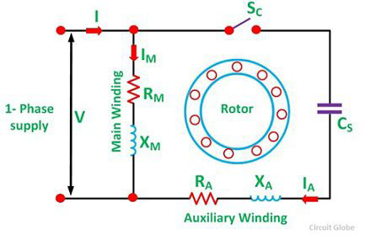

The capacitor start motor has a cage rotor and has two windings on the stator. They are known as the main winding and the auxiliary or the starting winding. The two windings are placed 90 degrees apart. A capacitor CS is connected in series with the starting winding. A centrifugal switch SC is also connected in the circuit.

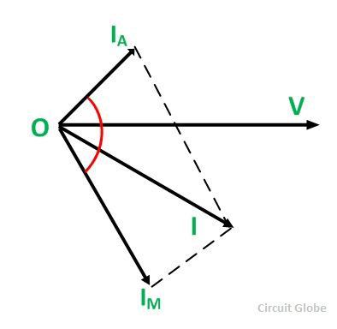
The Phasor Diagram of the Capacitor Start motor is shown above .

Im is the current in the main winding which is lagging the auxiliary current IA by 90 degrees as shown in the phasor diagram above. Thus, a single phase supply current is split into two phases. The two windings are displaced apart by 90 degrees electrical, and their MMF’s are equal in magnitude but 90 degrees apart in time phase.

The motor acts as a balanced two-phase motor. As the motor approaches its rated speed, the auxiliary winding and the starting capacitor is disconnected automatically by the centrifugal switch provided on the shaft of the motor.

- Characteristics of the Capacitor Start Motor
The capacitor starts motor develops a much higher starting torque of about 3 to 4.5 times of the full load torque. To obtain a high starting torque, the two conditions are essential. They are as follows:-

- The Starting capacitor value must be large.
- The valve of the starting winding resistance must be low.
The electrolytic capacitors of the order of the 250 µF are used because of the high Var rating of the capacitor requirement.

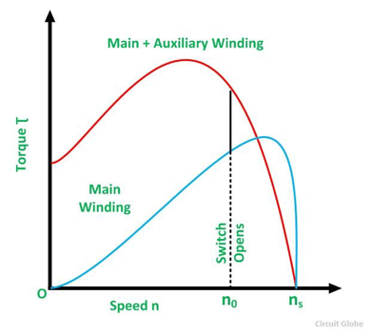
The Torque Speed Characteristic of the motor is shown below.

The characteristic shows that the starting torque is high. The cost of this motor is more as compared to the split phase motor because of the additional cost of the capacitor. The Capacitor start motor can be reversed by first bringing the motor to rest condition and then reversing the connections of one of the windings.

- Applications of the Capacitor Start Motor
The various applications of the motor are as follows:-
1.These motors are used for the loads of higher inertia where frequent starting is required.
2. Used in pumps and compressors
3. Used in the refrigerator and air conditioner compressors.
4. They are also used for conveyors and machine tools.

1F.

Under stationary rotor conditions (i.e, when speed N = 0 or slip s = 1), the two rotating fields slip pass the rotor at the same slip, s = 1 and inducing equal currents in the squirrel cage rotor. The two rotating fields are of the same strength and develop equal and opposite electro-magnetic torques resulting in net torque of zero value. Thus the starting torque is zero and the single phase induction motor is non- self-starting. Further, the two rotating fields induce a resultant EMF in the stator which balances the applied voltage assuming low leakage impedance of the stator winding.

QUESTION 2

A universal motor is a special type of motor which is designed to run on either DC or single phase AC supply. These motors are generally series wound (armature and field winding are in series), and hence produce high starting torque (See characteristics of DC motors here). That is why, universal motors generally comes built into the device they are meant to drive. Most of the universal motors are designed to operate at higher speeds, exceeding 3500 RPM. They run at lower speed on AC supply than they run on DC supply of same voltage, due to the reactance voltage drop which is present in AC and not in DC.

- 5 areas of Application of universal motors
- Washing machine
- Vaccine cleaner
- Weed trimmer
- Blenders
- Hair dryer

The construction of a universal motor is very similar to that of a DC machine. It consist of a stator on which field poles are mounted. Filed coils are wound on the field poles.
However, the whole magnetic path( stator field circuit and also armature) is laminated. Lamination is necessary to minimize eddy currents which induce while operating on AC .
The rotary armature is of wound type having a straight or skewed slots and commutator with brushes resting on it. The commutation on AC is poorer than that for DC. Because of the current induced in the armature coils. For that reason the brushes used are having high resistance.

2C
there is no difference. A universal motor has its rotor and stator windings connected in series, and it can run on both AC and DC that is why it’s called universal, or sometimes a DC series motor. It is mostly used in home appliances, electric tools and so on. Because it has a high speed.

QUESTION 3

A

- PRINCIPLE OF OPERATION OF A THREE PHASE INDUCTION MOTOR

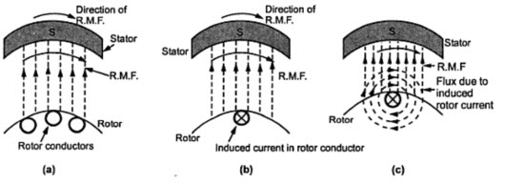

- When the motor is excited with three-phase supply, three-phase stator winding produce a rotating magnetic field with 120 displacements at constant magnitude which rotates at synchronous speed. This changing magnetic field cuts the rotor conductors and induces a current in them according to the principle of Faraday’s laws of electromagnetic induction. As these rotor conductors are shorted, the current starts to flow through these conductors.
- In the presence of magnetic field of stator, rotor conductors are placed, and therefore, according to the Lorenz force principle, a mechanical force acts on the rotor conductor. Thus, all the rotor conductors force, i.e., the sum of the mechanical forces produces torque in the rotor which tends to move it in the same direction of rotating magnetic field.
- This rotor conductor’s rotation can also be explained by Lenz’s law which tells that the induced currents in the rotor oppose the cause for its production, here this opposition is rotating magnetic field. This result the rotor starts rotating in the same direction of the stator rotating magnetic field. If the rotor speed more than stator speed, then no current will induce in the rotor because the reason for rotor rotation is the relative speed of the rotor and stator magnetic fields. This stator and the rotor fields difference is called as slip. This how 3-phase motor is called as asynchronous machine due to this relative speed difference between the stator and the rotors.
- As we discussed above, the relative speed between the stator field and the rotor conductors causes to rotate the rotor in a particular direction. Hence, for producing the rotation, the rotor speed Nr must always be less than the stator field speed Ns, and the difference between these two parameters depends on the load on the motor.

B

- Advantages

• They have very simple and rugged (almost unbreakable) construction
• they are very reliable and having low cost
• they have high efficiency and good power factor
• minimum maintenance required
• 3 phase induction motor is self starting hence extra starting motor or any special starting arrangement is not required
• 3 phase induction motors will have self starting torque unlike synchronous motors, hence no starting methods are employed unlike synchronous motor. However, single-phase induction motors does not have self starting torque, and are made to rotate using some auxiliaries.

Disadvantages
1. Unbalanced loading ( can cause voltage fluctuations )
2. Complex System (requires symmetrical components for analysis and operation )
3. Phase Sequence needed to be kept in mind while making connections

C
Equivalent motor resistance referred to stator: R₀₁=$R_{1}+\frac{R_{2}}{X_{2}} =0.06+0.06 =0.12Ω$
Equivalent motor reactance referred to stator: X₀₁= X₁+$\frac{X_{2}}{K^{2}}=0.2+0.22=0.42$Ω

Motor impedance: Z₀₁ =$\sqrt{(R_{01}^{2}+ X_{01}^{2})}$ =$\sqrt{{(0.12)}^{2}+{(0.42)}^{2}}$ =0.437Ω

S=$\frac{\frac{R_{2}}{K^{2}}}{\frac{R_{2}}{K^{2}}+Z_{01}} = \frac{0.06}{0.06+0.437} =0.12$

Maximum gross power output : $\frac{3V^{2}}{2(R_{01}+Z_{01})}$

$\frac{\begin{aligned}3*{\left(\frac{400}{\sqrt{3}}\right)}^{2} \\ \end{aligned}}{2(0.12+0.437)}$ = 143626.5709 W

D

at low values of slip, torque is approximately proportional to slip s and the torque slip characteristics of induction motor is a straight line as shown in the figure.

The region (from s = 0 to s = s_{m} ) is called the stable region of operation and operating point of the motor should be in this region.

In the stable region, the value of slip is small. Hence this region is also called as the low slip region.
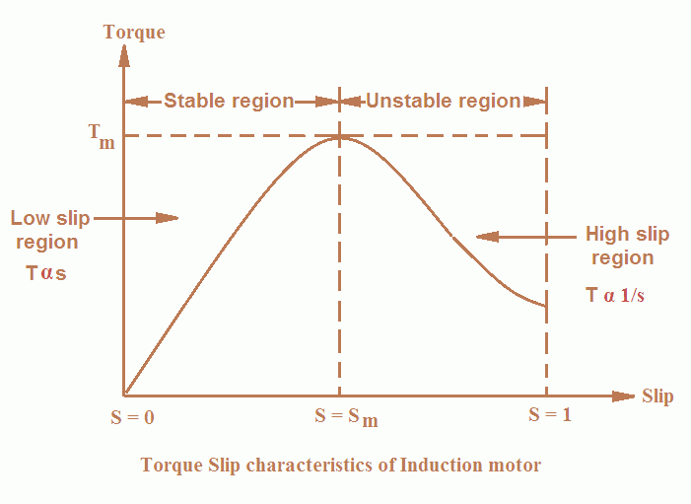
- As the slip increases torque increases and attains its maximum value when s = R2/X2. This maximum value of torque is also known as break down or pull out torque.
- When a further increase in slip occurs due to increase in load beyond the point maximum torque

i.e. when slip is high, the value of term (sX₂)² is very large in comparison to R₂².

Therefore, R22 is neglected as compare to (sX₂)² and torque is given by the expression:

T = ksE₂² R₂/ (sX₂)²

or T = kE22R₂ / (sX₂²)

In the above expression, all quantities are constant except s.
Therefore, T α 1/s

Thus at higher values of slip (i.e. the slip beyond that corresponding to maximum torque) torque is approximately inversely proportional to slip, s and the torque slip characteristics of induction motor is rectangular hyperbola as shown in the figure.

The region (extending from s = s_{m} to s = 1) is called unstable region. In this region with the increase in load, slip increases but torque decreases

E n_{s}((no load))=20 r p s , n_{s}(full load) =15 r p s F=60Hz

- Recall: n_{s}=$\frac{2F}{p}$ Ns= n_{s}*60
At no load N_{S}=20*60=1200 rpm
At full load N_{S}=15*60=900 rpm

At full load: N_{S}=$\frac{120F}{p}$ N_{s}*p = 120*F p= $\frac{120*F}{N_{S}}$

P= $\frac{120*60}{1200}$ =6 turns

At full load: p= $\frac{120*60}{1200}=8 turns$

- Slip=$\frac{N_{S}-N}{N_{S}}$
$\frac{1200-900}{1200}*100 =0.25$ or 25%

- F’= SF
0.25*60 =15 HZ

Iv N_{s}-N= rotor slip speed
1200-900=300 rpm

V at slip = 0.1
F’=SF
F’= 0.1*60 =6 HZ

QUESTION 4

A
-by changing the number of poles
-cascading the motors
-Changing frequency
-Changing Supply voltage
-Adding rotor resistance
-Injecting slip frequency emf on rotor side

B
According to double field revolving theory, we can resolve any alternating quantity into two components. Each component has a magnitude equal to the half of the maximum magnitude of the alternating quantity, and both these components rotate in the opposite direction to each other. For example – a flux, φ can be resolved into two components

each of these components rotates in the opposite direction i. e if one φm/2 is rotating in a clockwise direction then the other φm / 2 rotates in an anticlockwise direction.
When we apply a single phase AC supply to the stator winding of single phase induction motor, it produces its flux of magnitude, φm. According to the double field revolving theory, this alternating flux, φm is divided into two components of magnitude φm/2. Each of these components will rotate in the opposite direction, with the synchronous speed, Ns.
Let us call these two components of flux as forwarding component of flux, φf and the backward component of flux, φb. The resultant of these two components of flux at any instant of time gives the value of instantaneous stator flux at that particular instant.

Now at starting condition, both the forward and backward components of flux are exactly opposite to each other. Also, both of these components of flux are equal in magnitude. So, they cancel each other and hence the net torque experienced by the rotor at the starting condition is zero. So, the single phase induction motors are not self-starting motors.

- Direct-on-line (DOL) starters
-Star delta starter
-Auto Transformer Starter
- Rotor Impedance Starter
-Power Electronics Starter

C

- Star Delta Starter
The Star Delta Starter is a very common type of starter and is used extensively as compared to the other type of starting methods of the induction motor. A star delta is used for a cage motor designed to run normally on the delta connected stator winding. The connection of a three-phase induction motor with a star delta starter is shown in the figure below.

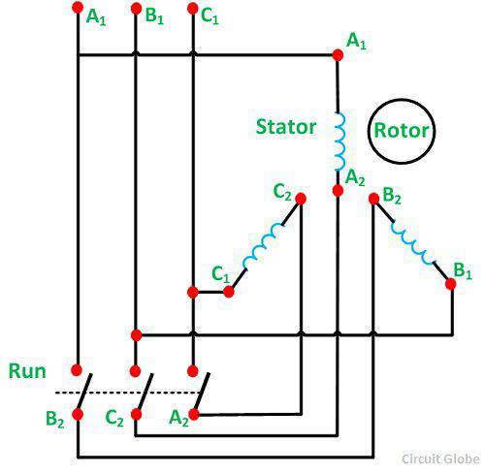

When the switch S is in the START position, the stator windings are connected in the star as shown below.
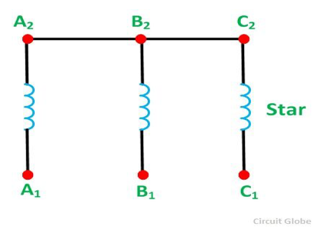
Star-Delta-Starter-Fig-2When the motor picks up the speed, about 80 percent of its rated speed, the switch S is immediately put into the RUN position. As a result, a stator winding which was in star connection is changed into DELTA connection now. The delta connection of the stator winding in shown in the figure below.

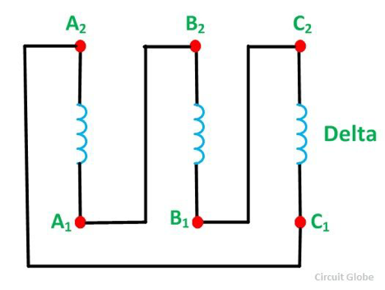

Star-Delta-Starter-Fig-3 Firstly, the stator winding is connected in star and then in Delta so that the starting line current of the motor is reduced to one-third as compared to the starting current with the windings connected in delta. At the starting of an induction motor when the windings of the stator are star connected, each stator phase gets a voltage VL/√3. Here VL is the line voltage.

Since the developed torque is proportional to the square of the voltage applied to an induction motor. Star delta starter reduces the starting torque to one-third that is obtained by direct delta starting.

Theory of Star Delta Starter Method of Starting of Induction Motor
At the starting of the induction motor, stator windings are connected in star and, therefore, the voltage across each phase winding is equal to 1/√3 times the line voltage

- Direct on like starter

Direct On Line Starter Method is a common method of starting of Cage Induction Motor. The motor is connected through a starter across the full supply voltage. The Direct On Line Starter Method figure is shown below. It consists a coil operated contactor C controlled by start and stop push button as shown in the connection diagram below.

The buttons which may be installed in a convenient place away from the starter. The start button is held open by a spring. On pressing the START pushbutton S1, the contactor C is energized from two line conductors L1 and L2.
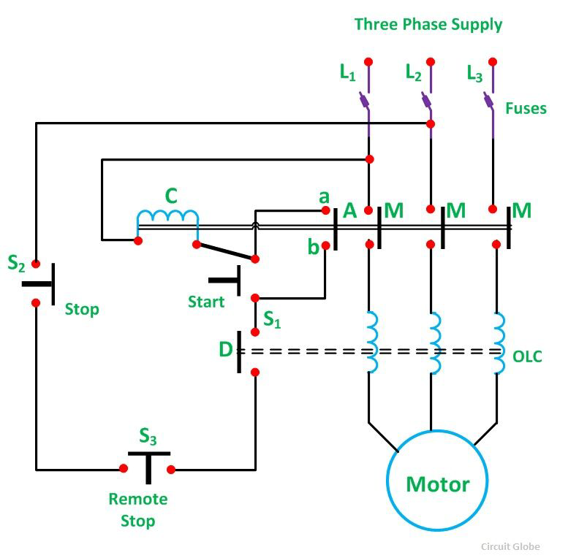
The three main contacts M and the auxiliary contact A are closed. The terminals a and b are short-circuited. The motor is then connected to the supply mains. The S1 button moves back under the spring action as soon as the pressure is released. The coil C remains energised through ab.

Thus, the main contact M remains closed, and the motor continues to get supplies. Therefore, contact A is known as Hold-On-Contact. The stop button S2 is normally held closed by the spring. If the S2 button is pressed to STOP the motor, the supply through the contactor coil C is disconnected. As the coil C is de-energized, the main contacts M and the auxiliary contact A are opened. The supply to the motor is disconnected, and the motor is stopped.

Undervoltage Protection
When the voltage falls below a certain value or when the supply fails or disrupted during the operation of the motor, the coil C is de-energized. Hence, the motor is disconnected from the supply Overload Protection

The motor is overloaded, one or all the overload coils (O.L.C) are energised. The normally closed contact D is opened, and the contactor coil C is de-energized to disconnect the supply from the motor. Fuses are provided in the circuit for short circuit protection.

In Direct on line starting the starting current may be as large as ten times the full load current, and the starting torque is equal to full load torque. Such a large starting current produces an excessive voltage drop in the line which supplies power to the motor.

Theory of Direct On Line Starting of Induction Motor
Let,

-I_{st} be the starting current drawn from the supply mains per phase.
- is the full load current drawn from the supply mains per phase.
-Test is the starting torque.
-S_{fl} is the slip at full load.

QUESTION 5

A

There could be many reasons to test an induction motor.

- The simplest would be to find out if it works.
- You could test it to see if it performs in accordance with its specifications.
- You could test it to determine the machine parameters necessary for modeling and vector controlling the machine.
- You could test it for reliability and lifetime.
- You could test it to failure to see how much performance margin it has.

B
SIMILARITIES

- the shaft of the motor is locked so that it cannot move and the rotor winding is short circuited.
- In the slip ring motor, the rotor winding is short circuited through the slip rings

DIFFERENCES

- in a blocked rotor test the rotor is blocked so that it cannot move, a voltage is applied to the motor, and the resulting voltage, current and power are measured while in a short circuit test the test is performed at a rated frequency and with balanced polyphase voltages applied to the stator terminal
- in a short circuit test as the motor is no load the power factor is very low whch is less than 0.5 while the block rotor test is conducted at low voltage because if the applied voltage was normal voltage then the current flowing through the stator windings were high enough to overheat the windings and damage them

5C )

SIMILARITIES

- Open circuit test or no load test on a transformer is performed to determine 'no load loss (core loss)' and 'no load current
- The open circuit and no load test are performed for determining the parameter of the transformer like their efficiency, voltage regulation, circuit constant

DIFFERENCES

- The purpose of the open circuit test is to determine the no-load current and losses of the transformer because of which their no-load parameter are determined. While the no load test determines the copper loss occur on the full load. The copper loss is used for finding the efficiency of the transformer.

- A open circuit test is conducted when the secondary of the transformer is kept in open condition without connecting any load with it. Thus there will not be any current in the secondary coil. While A no load test is conducted shorting the secondary terminals. Thus there will be huge current flow in the secondary coil when voltage is applied in the primary.

5D)
– power supply test

- Ac motor winding continuity test
- Ac motor winding resistance test
- Insulation resistance test

Power Supply Test

For three phase motors, the expected voltage for a 230/400V system is 230V phase to neutral and 400V between each of the three phase supply lines. Check that the correct voltage is applied to the motor using a multimeter. Ensure the terminal for power supply is in good condition. Check the connection bar for terminal (U, V, and W). three phase motors, connection type is either Star (Y) or Delta.

E)
GIVEN: applied voltage per phase, v =400v
No-load line current , I_{L}= 3A
No-load pase current ,I_{v}=$\frac{I_{L}}{\sqrt{3}}=\frac{3}{\sqrt{3}}\sqrt{3}A$ or 1.7320 A
Input on no-load, p_{o}=645watt
Stator copper loss, p_{cu}= $3I_{V}^{2}R_{L}=3\left({\sqrt{3}}^{2}*5\right)=45 watt$
Windage and frictional loss p_{w}=183watt
Total stator core loss p_{i}=p_{o}- p_{cu} -p_{w} =645-45-183=417 watt

No-load power factor, cos$∅$= $\frac{P_{i}}{3*v*i_{o}}=\frac{417}{3*400*\sqrt{3}}=0.2$
No-load line current on energy, I_{LE}=I_{L} cos$∅=3*0.2=0.6 A$

- Magnetizing component of no load line current, I_{lm}=$\sqrt{{\left(I_{l}\right)}^{3}-{\left(I_{LE}\right)}^{3}}=\sqrt{3^{2}-{0.6}^{2}}=2.939$38

Energy component of no-load phase current, I_{e}=1.732*0.2=0.3464 A

- No-load resistance,R_{O}=$\frac{V}{I_{e}}=\frac{400}{0.3464}=1154.700 Ω$

No load phase current, I_{m}=$\frac{2.93938}{\sqrt{3}}=1.697051 A$
No-load reactance, X₀=$\frac{v}{I_{m}}=\frac{400}{1.697051}=235.7028771$

- Short circuit voltage ,v_{s}=200v
Short circuit stator line current ,I_{LS}=12 A
Short circuit stator phase current I_{s}=$\frac{12.0}{\sqrt{3}}=6.928$ A
Input on short circuit, P_{S}=1660 watt
Power factor on short circuit, cos$∅$ =${\frac{p_{s}}{3*v*}}_{I_{S}}=\frac{1660}{3*200}$ = 0.39934
Z₀₁=$\frac{V_{S}}{I_{S}}=\frac{200}{6.928}=28.8683\frac{Ω}{phase}$
R₀₁=$\frac{P_{S}}{3I_{S}^{2}}=\frac{1660}{3{\left(6.928\right)}^{2}}=11.528454 Ω$/PHASE

X₀₁ =$\sqrt{{\left(Z_{01}\right)}^{2}-{\left(R_{01}\right)}^{2}}$
X₀₁ =$\sqrt{{\left(28.8683\right)}^{3}-{\left(11.528454\right)}^{2}}=26.46645$Ω

Short circuit current on the stator at 400v =$I_{S}*\frac{V}{V_{S}}=12*\frac{400}{200}=24 A$

QUESTION 6

A
synchronous generator converts mechanical energy to Electrical energy. The source of which creates the mechanical energy may be a steam engine, water falling through a waterwheel, a wind turbine, a hand crank or via compressed air.

A synchronous generator has 2 main parts:

1) Stator

2) Rotor

The Rotor is the rotating part whereas the Stator is the stationary part, hence where they get their names from.

• Rotor has north and south poles protruded on it, in the case of salient poles, on which Laminations are used to reduce Eddy losses. The north and south poles of the rotor are wrapped with windings, the number of poles will always be even and dependent on the speed of the generator.
• A separate DC supply is provided to the rotor with the help of slip rings and brushes and the current is passed to windings on the rotor. The rotor is attached to the shaft which makes the rotor rotate. As winding carrying current is under permanent magnet poles of rotor it will itself creates its own magnetic field
• Stator is the stationary part . it is the section made of steel plates combined together with windings on it at 120 degree intervals to balance it out.
• Now as the rotor rotates its magnetic field will cut the windings of the Stator and this in turn will cause an AC voltage to be induced in the Stator windings and an AC current is drawn.

A synchronous generator operates on the amount of poles wound within its stator. The more poles in the stator equates to a smaller rev/min. For example a 2 pole generator would run at maximum of 3000r/min whereas a 4 pole generator would only run at 1500r/min. This is done with the equation F=NsP to find the speed at which the motor runs at. The rotation of the shaft is synchronized with the frequency of the supply current, which means the rotation period is exactly equal to the number of AC cycles.

I would also use Faradays law to help explain the principle of operation with calculations. Faradays law means that the amount of voltage created is equal to the change in magnetic flux divided by the change in time. The bigger the change you have in the magnetic field, the greater amount of voltage.

Fleming's right hand rule (for generators) shows the direction of induced current when a conductor moves in a magnetic field. No current is induced if the motion of the conductor is in line with the field, going either direction, and the same can be said if it runs parallel to current.

The right hand is held with the thumb, first finger and second finger mutually perpendicular to each other (at right angles), as shown in the diagram .

• The Thumb represents the direction of Motion of the conductor.
• The First finger represents the direction of the Field. (north to south)
The Second finger represents the direction of the induced or generated Current (the direction of the induced current will be the direction of conventional current, from positive to negative.

B NOTE: it is a wye- connection
Number of pole=2, F=50HZ , V_{LINE}=11KV , S= 10MVA , X_{a}(full load)=150$Ω,$power factor=0.8
- Induced emf : E_{F} =$\sqrt{{\left(V_{phase}\right)}^{2}+{\left(I_{a}*X_{a}\right)}^{2}}$
but V_{phase}=$\frac{V_{LINE}}{\sqrt{3}}=\frac{11*{10}^{3}}{\sqrt{3}}=6350.852$
I_{a}=$\frac{S}{\sqrt{3}*V_{phase}}=\frac{10*{10}^{6}}{\sqrt{3}*6350.852}=909.0910467$
Therefore; E _{f =}$\sqrt{{\left(6350.852\right)}^{2}+{\left(909.0910467*150\right)}^{2}}=136511.4657$
Load angle , tan $δ=\frac{I_{a}*X_{a}}{V_{phase}}=\frac{909.0910467*150}{6350.852}$ = 21.47171
Tan⁻¹ (21.47171) = 87.33

- Maximum power, p_{max} : = $\frac{ (3*V\left(phase\right)* E_{f}}{Xa} = \frac{3*6350.852*136511.4657 }{150}$
P_{max} =17339282.3 watt

- Maximum torque= maximum torque /w but w=2$πf$
Maximum torque= $\frac{17339282.3}{2*π*50}= 55192.649 N/m$

C

Parallel operation of generators is by far the most common form of operation. Generators may be operated in parallel on a small scale, e.g. two or three generators operating in parallel to provide power to a remote community, or large scale, e.g. the north american power grid
Benefits of parallel operation include
1. Redundancy: failure of one unit does not affect the integrity of the power supply, generators may be taken out of service for preventative maintenance
2. Scaling: many units can combine to provide a power demand, rather than requiring fewer very large generators
3. Resource management: generators can be located and operated to best meet the generating conditions, instead of having to be located and operated to meet the requirements of a local load. An example of this may be a nuclear power plant, which may take many weeks to bring up to full operating conditions. Using a nuclear generating station at full power to meet a "base load" with smaller more rapid response generators is one way to supply fluctuating load requirements.
4. Efficiency: Generators operating at full load are more efficient than those operating at low loads. It is more efficient to meet a changing load by adding or removing smaller generators than having a single large generator operating inefficiently
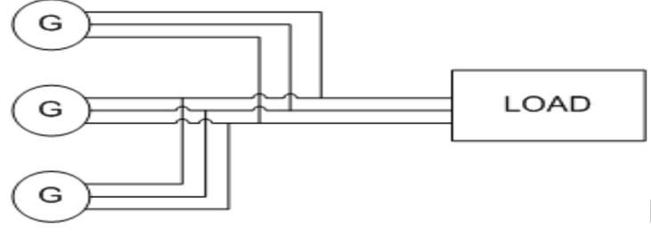
.
FIG. 1. EXAMPLE CIRCUIT OF THREE GENERATORS OPERATING IN PARALLEL TO SUPPLY A LOAD
Voltage and Frequency Variation
V-Q Relationship
When considering synchronous generators operating alone it becomes clear that the terminal voltage of the machine is dependent on the reactive power being supplied to the load. When supplying more reactive power, the termial voltage falls. In general, the effect of changes to terminal voltage with reactive load can be plotted as shown. Increasing the inductive load on the generator reduces the terminal voltage, adding capacitance increases the terminal voltage. Reductions to the terminal voltage can be compensated by increasing the no load voltage EE

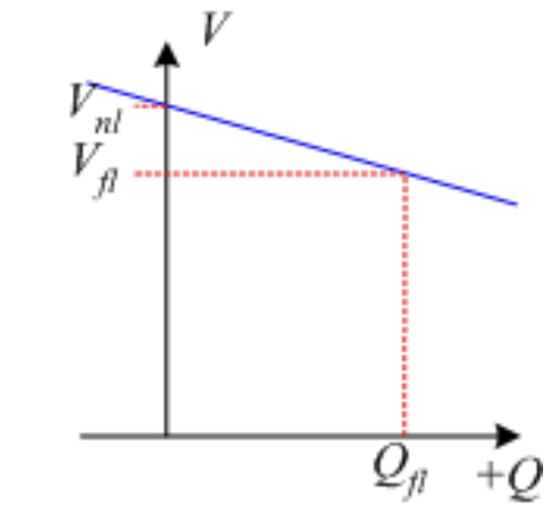
FIG. 2. GENERATOR VOLTAGE VARIATION WITH REACTIVE POWER
f-P Relationship
The output power of a generator is largely independent of the actual generator control. The ouput power closely matches in the input power from the prime mover. The speed of rotation of the generator is also set by the prime mover, with the frequency of the open circuit induced voltage directly determined by rotational speed:
f=p120nsf=p120ns
In order to understand the frequency-power relationship, it is important to try to understand the mechanical system that drives the generator. At no-load, the mechanical system is rotating at the no-load speed, nnlnnl and results in the generation of voltages at no load frequency nflnfl.
When the generator is loaded, power is drawn from the mechanical system and the generator applies a torque which opposes the direction of motion of the mechanical system. As a result, the generator tends to slow down the mechanical system. (In the same way that when you are driving on a flat road and then start to go up a hill, the car slows down).
In a synchronous generator, changing mechanical speed is undesirable, as it results in a change in the frequency of the induced voltages. For this reason, a "governor" is applied to the mechanical system to make the change in speed predictable with power changes. The mechanical governor sets the no-load speed and controls the reduction in speed so that the speed-power relationship is linear. This relationship is shown in Fig. 3. It is important to stress that this is not a function of the generator, but of how the mechanical system is controlled.
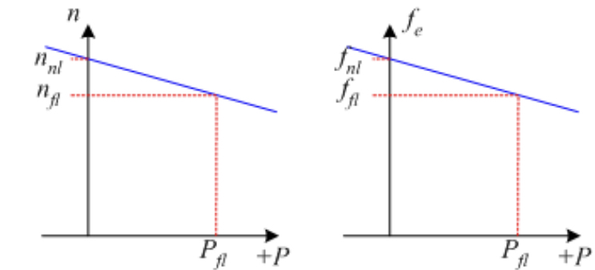

FIG. 3. GENERATOR FREQUENCY VARIATION WITH POWER OUTPUT
If the frequency of the generated voltages is too low, the frequency can be increased by increasing the no-load speed of the mechanical governor (equivalent to a cruise control in a car increasing the gas fed to the engine when the car goes up hill).
Mathematically, the changes in frequency with load are described using two quantities, the Speed Droop SDSD and the slope of the power-frequency plot, SpSp .
Speed Droop, SDSD is defined as
SD=nnl−nflnfl×100%=fnl−fflffl×100%SD=nnl−nflnfl×100%=fnl−fflffl×100%
Typical values for speed droop are in the range 2% - 4%
The power from the generator can be found using
P=Sp(fnl−fsys)P=Sp(fnl−fsys)
where
Sp=ΔPΔf=Pflfnl−fnlSp=ΔPΔf=Pflfnl−fnl
The slope SpSp is often quoted in kW/Hz or MW/Hz.
In the above equations, subscripts nl,flnl,fl refer to no-load and full-load operation respectively and syssys refers to the operating system frequency.
Infinite Bus
The infinite bus is a useful concept that summarizes how most people already view the power grid. It can be applied when the power grid is sufficiently large that the action of any one user or generator will not affect the operation of the power grid.
In an infinite bus:
1. System frequency is constant, independent of power flow
2. System voltage is constant, independent of reactive power consumed or supplied
An infinite bus assumed in many small electrical applications. As an example, we take for granted that the voltage supply to a residential outlet will be 120V and 60Hz: the voltage and frequency are not changed when you turn the TV on.
Frequency-power and voltage-reactive power plots for an infinite bus are shown in Fig. 4.
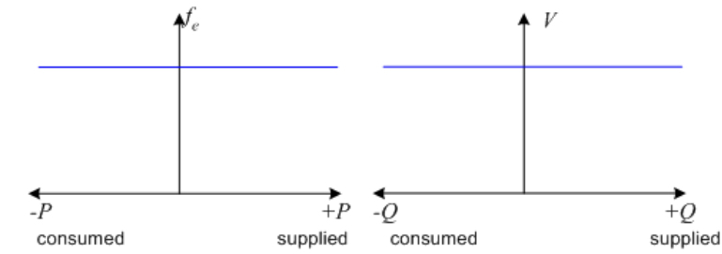
FIG. 4. F-P AND V-Q PLOTS FOR AN INFINITE BUS

