ENG 232 QUESTIONS
- How do you represent a sectioned surface on a drawing?
- List out the various principles to be followed while dimensioning a drawing.
- Explain the terms, (a) half section, (b) Full section
- How are leader lines terminated?
- What do you understand by, (a) scale = 5:1 and (b) scale = 1:10?
- Give the shape identification symbols for the following: (a) diameter, (b) radius, (c) square and (d) spherical radius.
(a) Centre line, (b) cutting plane line and (c) long break
- What are the elements to be considered while obtaining a projection and what is an orthographic projection?
- When is a projection of an object called an orthographic projection?
- Explain the following, indicating the symbol to be used in each case: (a) First angle projection, (b) Third angle projection
Objectives
1. To project the auxiliary view, an imaginary plane known as ……………….

a) Reference Plane
- Principle plane
- Normal plane
- Inclined plane
2. Reference plane is parallel to the direction of view
a) True

b) False
3. Dimension of one side of the inclined surface can be………………projected on the reference plane
- Indirectly
- Equally

Directly
d) Normally
4. In isometric projection the three edges of an object are inclined to each other at
(a) 60º (b) 120º (c) 100º (d) 90º
- The angle between the flanks of a metric thread is
(a) 60º (b) 90º (c) 75º (d) 55º
- Which one among the following represents a permanent fastener
a) Nut b) Rivet c) Screw d) Bolt
7. The convexity provided on the rim of the solid web cast iron pulley is called
a) Bending b) Curving c) Crowning d) Riveting
8. Section lines are generally inclined with the base, at an angle of
a) 30º b)45º c)60º d)90º
9. The isometric view of a sphere is always
a) a circle b) an ellipse c) a Parabola d) a Semicircle
10. In isometric projection, the four center method is used to construct
a) an ellipse b) a square c) a triangle d) a rectangle
11
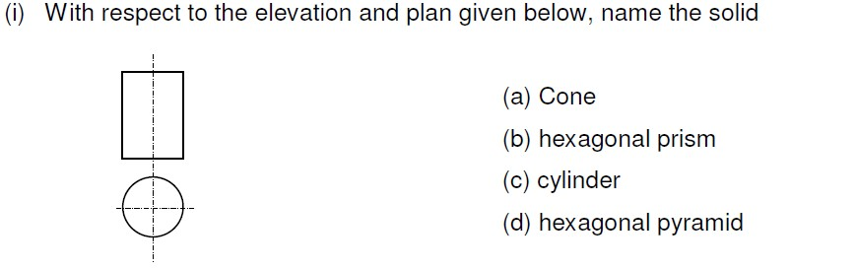
Ans : (C) cylinder
12
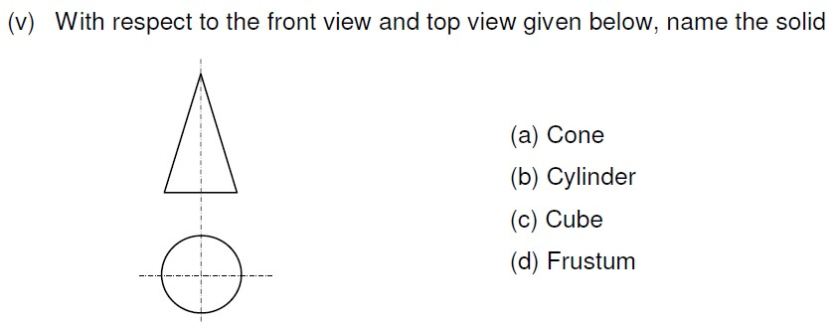
Ans : (A) cone

13. A footstep bearing is a
a) journal bearing b) thrust bearing c) pivot bearing d) pedestal bearing
14. The angle between the flanks of B.S.W. thread is
a) 60º b) 65º c) 55º d)75º
15. Top view is projected on the
a) Vertical Plane b) Corner Plane c) Side Plane d) Horizontal Plane
THEORY
- A sectional view is represented by hatching, along the cutting plane at an eye angle of 45 degrees
- Principles of dimensioning
  - All dimensional information necessary to define a part clearly and completely shall be shown directly on a drawing.
  - Each feature shall be dimensioned once only on a drawing.
  - Dimensions shall be placed on the view or section that shows clearly, the corresponding features
  - As far as possible, on a drawing, dimensions should be expressed in one unit only, preferably in millimeters, without showing the unit symbol (mm). Unit on the drawing, however, may be shown in a note
  - No more dimensions than are necessary to define a part shall be shown on the drawing.
  - No feature of a part shall be defined by more than one dimension in any one direction 7.Dimensions should be represented from the visible outlines, rather than from hidden lines
8.Dimensions should be given from a base line, a centre line of a hole, or a finished surface.
9.Dimensioning to a centre line should be avoided, except when it passes through the center of a hole
3.half section a scale drawing of a section through a symmetrical object that shows only half the object
. full section this is a scale drawing of a section through a symmetrical object that show the full object
5. 4. How are leader lines terminated?
they can be terminated by the use of arrow head
- scale = 5:1 this means a 50mm line is to be drawn at a scale of 5:1 that is 5 times more than the original size
Scale = 1:10 this means that the object is ten times smaller than in real life
- Ø = (diameter symbol)
R= ( radius)
- Orthographic projection is a method of producing a number of separate twodimensional inter-related views. These views are drawn mutually at right angles to each other. In engineering practice, orthographic projection is universally used to represent solid objects by two dimensional views, as many as are necessary to give all the information needed, clearly and accurately
When is a projection of an object called an orthographic projection
This is when a shape is seen from either a first angle projection, when the view is seen on either first or second angle projection showing the front elevation side elevation and plan
- First angle projection
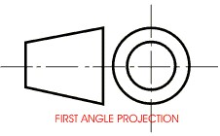
In the first angle projection system, the object placed in the first quadrant In 1st angle, the object is between the observer and the plane of projection,
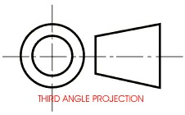 in third angle projection system the object placed in the
third quadrant. In 3rd angle, the plane is between the observer and the object.

