NAME: GOODHEAD IBIGOMIE ISSAC
MAT NO: 18/ENG06/024
DEPT: MECHANICAL ENGINEERING
COURSE CODE: ENG 232
- A cutting plane line is used to represent a sectioned surface on a drawing. A cutting plane is represented on a drawing by a cutting plane line. This is a heavy long-short, short-long kind of line terminated with arrows. The arrows therefore show the direction of the view
- Principles of dimensioning a drawing
- Centre lines must never be used as dimension lines but must be left clear and distinct. They can be extended, however, when used in the role of projection lines.
- Dimensions shown with dimension lines and arrowheads should be placed to be read from the bottom of the drawing.
- A dimension line should never coincide with an object line or a centre line, nor should it be an extension of these lines.
- Crossing of extension lines or dimension lines should be avoided if possible. Where such crossings are unavoidable, there should be no break in either of the lines. However, if extension lines cross dimension lines through the arrowheads, the extension line may be broken.
- Dimensions are preferably placed outside the outlines of the views.
- Half sectioning: A half-section is a view of an object showing one-half of the view in section, as in the drawing below. The diagonal lines on the section drawing are used to indicate the area that has been theoretically cut. These lines are called section lining or cross-hatching.
Full sectioning: If the imaginary cutting plane passes through the entire object, splitting the drawn object in two with the interior of the object revealed, this is called a "full section." A full section is the most widely-used sectional view.
- Leader Lines – A leader or a pointer is a thin continuous line connecting a note or a dimension figure with the feature to which it applies. One end of the leader terminates either in an arrowhead or a dot. The arrowhead touches the outline, while the dot is placed within the outline of the Outline object. The other end of the leader is terminated in a horizontal line at the bottom level of the first or the last letter of the note. The leader is never drawn vertical or horizontal or curved. It is drawn at a convenient angle of not less than 30° to the line to which it touches.
- (a) Scale 5:1- A scale of 5:1 means that everything is in reality five times as small. In other words: 1 cm in the drawing is 0.2 cm in reality
(b) Scale 1:10- A drawing at a scale of 1:10 means that the object is 10 times smaller than in real life scale 1:1. You could also say, 1 unit in the drawing is equal to 10 units in real life
6. DIAMETER- ⌀
RADIUS-r
SQUARE-
SPHERICAL RADIUS- SR
7. Orthographic projection (sometimes referred to as orthogonal projection, used to be called analemma) is a means of representing three-dimensional objects in two dimensions. It is a form of parallel projection, in which all the projection lines are orthogonal to the projection plane, resulting in every plane of the scene appearing in affine transformation on the viewing surface. The obverse of an orthographic projection is an oblique projection, which is a parallel projection in which the projection lines are not orthogonal to the projection plane
Orthographic projection: Orthographic projection is a means of representing three-dimensional objects in two dimensions. It is a form of parallel projection, in which all the projection lines are orthogonal to the projection plane, resulting in every plane of the scene appearing in affine transformation on the viewing surface.
8. An object is called an orthographic projection when projection of a single view of an object (such as a view of the front) onto a drawing surface in which the lines of projection are perpendicular to the drawing surface.
9. First angle projection: It’s a way of showing a 3D object on a 2D piece of paper, and it shows what a part looks like from each direction - top, bottom, left right. If some details of a view can be inferred from another, then you don’t bother to draw that view.
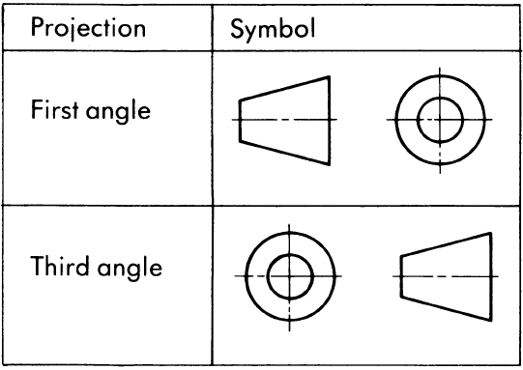
Third angle projection: Third Angle projection is a method of orthographic projection the object is placed below and behind the viewing planes meaning the plane of projection is between the observer and the object

OBJECTIVES
- A
- B(FALSE)
- C(DIRECTLY)
- B
- A
- B
- C(CROWNING)
- B(45)
- CIRCLE
- AN ELLIPSE
- CYLINDER
- CONE
- PIVOT BEARING
- C (55)
- HORIZATAL PLANE

