β-oxidation of fatty acid
β-oxidation of fatty acid is defined as a metabolic pathway that oxidizes fatty acids, and generates fatty acyl-CoA ( a thioester of fatty acid and CoA) and acetyl CoA which consists of a series of four repeated reactions, in which a molecule of acetyl CoA is generated, and an end product of the fatty acid by beta-oxidation is also acetyl CoA. Since, oxidation at the β-position of the fatty acyl-CoA was performed step wise, it was named β-oxidation. Fatty acids are oxidized by most of the tissues in the body. However, brain, erythrocytes and adrenal medulla cannot utilize fatty acids for energy requirement. The four steps are involved in β-oxidation spiral of fatty acid metabolism which is oxidation, hydration, a second oxidation, and finally thiolysis. These happens in repeating cycles through the sequential removal of 2 carbons and production of acetyl-CoA, which then enters the Krebs cycle for oxidation and ATP production. Another target of acetyl-CoA is the production of ketone bodies in the liver that are elated to tissues like the heart and brain for release of energy during starvation. Fatty acids with an odd number of carbons in the acyl chain are left at the end with propionyl-CoA, which is converted to succinyl-CoA that then also enters the Krebs cycle. Furthermore, unsaturated fatty acids with bonds in the cis configuration require three separate enzymatic steps to prepare themselves for the β-oxidation pathway.

Mitochondrial oxidation of fatty acids takes place in 3 stages:

First Stage: β- oxidation pathway
In this stage, the fatty acids undergo oxidative removal of successive two-carbon units in the form of acetyl-CoA, starting from the carboxyl end of the fatty acyl chain. For example, the C 16 fatty acid palmitic acid (palmitate at pH 7) undergoes 7 passes through this oxidative sequence, in each pass losing two carbons as acetyl- CoA. At the end of seven cycles, the last two carbons of palmitate (originally C-15 and C-16) are left as acetyl- CoA. The overall result is the conversion of 16-carbon chain of palmitate to 8 two-carbon acetyl-CoA molecules.

Second Stage: Citric acid cycle
In this stage of fatty acid oxidation, the acetyl residues of Acetyl- CoA are oxidized to CO2 via the citric acid cycle, which also takes place in the mitochondrial matrix. Acetyl-CoA derived from fatty acid oxidation, thus, enters a final common pathway of oxidation along with acetyl- CoA derived from glucose via glycolysis and pyruvate oxidation.

Third Stage: Mitochondrial respiratory Chain
The first two stages of fatty acid oxidation produce the electron carriers, NADH and FADH2, which in the third stage donate electrons to the mitochondrial respiratory chain, through which electrons are carried to oxygen. Coupled to this flow of electrons is the phosphorylation of ADP to ATP. Thus, energy released by fatty acid oxidation is conserved as ATP

Mitochondrial β-oxidation
The enzymes of β-oxidation either are associated with the inner mitochondrial membrane or are located in the mitochondrial matrix. Four acyl-CoA dehydrogenases with different but overlapping chain length specificities cooperate to assure the complete degradation of all fatty acids that can be metabolized by mitochondrial β-oxidation. The names of the four dehydrogenases, short-chain, medium-chain, long-chain, and very-long-chain acyl-CoA dehydrogenases, reflect their chain-length specificities. The first stage of fatty acid oxidation for the simple case of a saturated chain with an even number of carbons, and for the slightly more complicated cases of unsaturated and odd-number chains, will now be described in detail. Once the fatty acids are transported to the mitochondrial matrix via carnitine pathway, β-oxidation of fatty acyl-CoA (n carbons) occurs within the mitochondria in four steps. Each cycle of B-oxidation, liberating a two carbon unit-acetyl CoA, occurs is a sequence of four reactions:
1. Oxidation
Fatty acyl-CoA is acted upon by an enzyme acyl-CoA dehydrogenase which is FAD dependent enzyme. Fatty acyl-CoA undergoes dehydrogenation and forms a trans-double bond at the α and β carbons to form trans- Δ2-enoyl-CoA. Acyl-CoA dehydrogenase are present as three isoenzymes each specific for a particular carbon chain length (short, intermediate and long). The electrons which were removed from the fatty acyl-CoA chain are transferred to FAD which gets reduced to FADH2. This FADH2 immediately via the Electron Transport System gets converted to ATP molecules.
2. Hydration
Enoyl-CoA hydratase or cronotase catalyzes this reaction where one molecule of water is added trans-Δ2-enoyl-CoA. Hydration occurs at the double bond resulting in the formation of β-hydroxyacyl-CoA, also called as 3-hydroxyacyl-CoA.
3. Oxidation
β-hydroxyacyl-CoA undergoes dehydrogenation to form β-ketoacyl-CoA in the presence of β-hydroxyacyl-CoA dehydrogenase. The electrons available as a result of dehydrogenation are accepted by NAD+ to form NADH + H+ which immediately exchanges these electrons with oxygen in the Electron Transport System to form ATP molecules.
4. Thiolysis or Thioclastic scission
This reaction is called as thiolysis as acyl-CoA acetyltransferase (also known as thiolase or β- ketothiolase)
In the presence of CoA-SH which causes the cleavage of β-ketoacyl-CoA to form acetyl CoA and the thioester of the original fatty acid with two carbons less. This cleavage occurs as the β carbon ketone group is a good target for nucleophilic attack by the thiol (-SH) group of the coenzyme A. The shortened acyl-CoA then undergoes another cycle of oxidation, starting with the reaction catalyzed by acyl-CoA dehydrogenase. Beta-ketothiolase, hydroxyacyl dehydrogenase and enoyl- CoA hydratase all have broad specificity with respect to the length of the acyl group. Thus, by repeated turns of the cycle, a fatty acid is degraded to acetyl-CoA molecules with one being produced every turn until the last cycle, wherein two are produced. Acetyl CoA formed from the above steps now enters the Kreb‘s cycle to get oxidized to CO2 and H2O. The β-oxidation of fatty acids completes in a cyclical manner.

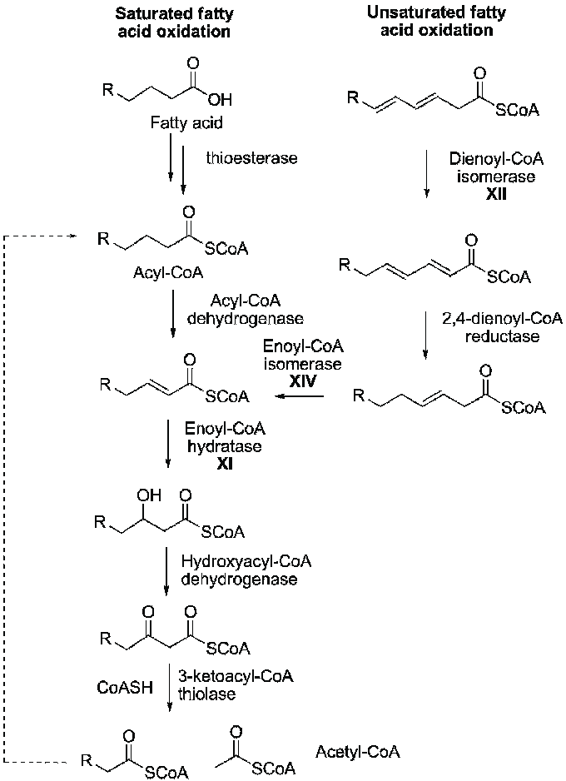

+2

Beta (β)-Oxidation of Fatty Acid and its associated

