NAME: AHMED FAWWAZ ABIOLA

MATRIC NUMBER: 18/ENGO6/004

COLLEGE: ENGINEERING

DEPARTMENT: MECHANICAL

COURSE CODE: ENG 232

COURSE TITLE: ENGINEERING DRAWING

TITLE: ASSESSMENT
- A section surface on a drawing is represented using thin lines at an angle of 45 degrees.
B.PRINCIPLES OF DIMENSIONING RULE 1: Dimensions should not be duplicated, nor should be given in two different ways.
RULE 2: Dimension should be attached to the view that best shows the contour of the feature being dimensioned.
RULE 3: Wherever possible avoid dimensioning to hidden lines.
RULE 4: Avoid dimensions over or through the object.
RULE 5: Wherever possible locate dimensions in adjacent views.
RULE 6: In general a circle is measured by its diameter cir cle with line through it, and arc by its radius.
RULE 7: Holes are located by their centerlines, which may be extended and used as an extension line.
- HALF SECTION This is a view of an object showing one-half of the view in section. The diagonal lines on the section drawing are used to indicate the area that has been theoretically cut.
FULL SECTION When a cutting plane line passes entirely through an object, the resulting section is called the full section.

- One end of the leader terminates either in an arrowhead or a dot. The arrowhead touches the outline, while the dot is placed within the outline of the Outline object. The other end of the leader is terminated in a horizontal line at the bottom level of the first or last letter.
- SCALE = 5:1 This scale is used only when the Student or Architect wants to enlarge the size of a drawing.
SCALE = 1:10 This scale is used only when the Student or Architect wants to reduce the size of a drawing.
- R= radius, ϕ= diameter, SR= spherical radius, = long break line, = center line, = cutting plate line.
- ORTHOGRAPHIC PROJECTION This is a means of representing three-dimensional objects in two dimensions. It is a form of parallel projection, in which all the projection lines are orthogonal to the projection plane. ELEMENTS OF PROJECTION 1. Height axis. 2. Length axis. 3. Width axis. 4. Top view. 5. Side view. 6. Front view.

- A drawing is orthographic when is shows different views of three dimensional objects.
- FIRST ANGLE PROJECTION In first angle projection, the object is placed in the first quadrant meaning it’s placed between the plane of projection and the observer.
- THIRD ANGLE PROJECTION In third angle projection, the object is placed below and behind the viewing planes meaning the plane of projection is between the observer and the object. 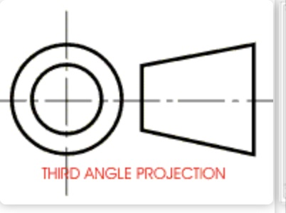 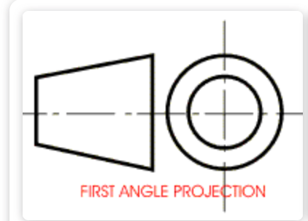

OBJECTIVES
- Inclined plane.
- True.
- Indirectly.
- 60 Degrees.
- 60 Degrees.
- Rivets.
- Crowning.
- 45 Degrees.
- A circle.
- Ellipse.
- Cylinder.
- Cone.
- Pivot bearing.
- 55 Degrees.
- Horizontal plane.

