NNACHETTA Kenechukwu 18/ENG03/040 Civil Engineering

ENG 232 QUESTIONS

1. How do you represent a sectioned surface on a drawing?

Sectioned surfaces in drawings are represented by using sectioning lines inclined at 45 degrees.

1. List out the various principles to be followed while dimensioning a drawing.

The following principles are;

* The dimensions should be given on such view which illustrates the true shape and size of an object.
* As far as possible the dimensions should be given outside a view but can be given inside as well if unavoidable.
* All the dimensions are given in group form. Scattering of these is not correct.
* The dimensions should be intelligibly written.
* All the dimensions should be written parallel to the object line and the numbers should be written such that they could be read easily.

1. Explain the terms, (*a*) half section, (*b*) Full section
2. Half section: A half section is a view of an object showing one-half of the view in section, as in the drawing below. The diagonal lines on the section drawing are used to indicate the area that has been theoretically cut.
3. Full section: A full section is a view of an object when a cutting plane line passes entirely through an object.
4. How are leader lines terminated?

Leader lines are terminated at the circumference.

1. What do you understand by, (a) scale = 5:1 and (b) scale = 1:10?
2. This means that the drawing will be five times in size of the original drawing.
3. This means that the drawing will be one-tenth in size of the original drawing.
4. Give the shape identification symbols for the following: (*a*) diameter, (*b*) radius, (*c*) square and (*d*) spherical radius
5. Centre line, (*b*) cutting plane line and (*c*) long break

 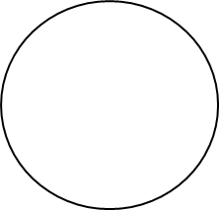

**Diameter** **Radius** **Square**

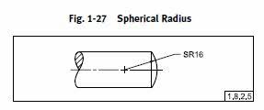

**Spherical Radius**

1. What are the elements to be considered while obtaining a projection and what is an orthographic projection?

The elements to be considered in an orthographic projection are;

* Front Elevation
* Plan
* Side Elevation

Orthographic Projection is a way of drawing a 3D object from different directions. Usually a front, side and plan view are drawn so that a person looking at the drawing can see all the important sides.

1. When is a projection of an object called an orthographic projection?

A projection is called an orthographic projection when multiple views of the object being projected are displayed.

1. Explain the following, indicating the symbol to be used in each case: (*a*) First angle projection, (*b*) Third angle projection

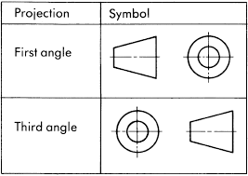

1. **First angle projection:**

**End view Front view**

**Plan**

1. **Third angle projection**

Plan view

Side view Front view

Objectives

1. To project the auxiliary view, an imaginary plane known as ……………….
2. **Reference Plane**
3. Principle plane
4. Normal plane
5. Inclined plane
6. Reference plane is parallel to the direction of view
7. True
8. **False**
9. Dimension of one side of the inclined surface can be………………projected on the reference plane
10. Indirectly
11. Equally
12. **Directly**
13. Normally
14. In isometric projection the three edges of an object are inclined to each other at

(a) 60o (b) **120o** (c) 100o (d) 90o

5. The angle between the flanks of a metric thread is

1. **60o** (b) 90o (c) 75o (d) 55o

6. Which one among the following represents a permanent fastener

a) Nut b) **Rivet** c) Screw d) Bolt

7. The convexity provided on the rim of the solid web cast iron pulley is called

a) Bending b) Curving c) **Crowning** d) Riveting

8. Section lines are generally inclined with the base, at an angle of

a) 30o b)**45o** c)60o d)90o

9. The isometric view of a sphere is always

a) **a circle** b) an ellipse c) a Parabola d) a Semicircle

10. In isometric projection, the four center method is used to construct

a) **An ellipse** b) a square c) a triangle d) a rectangle

11 The Answer is **(c) Cylinder**



12 The answer is **(a) Cone**



13. A footstep bearing is a

a) Journal bearing b) thrust bearing c) **pivot bearing** d) pedestal bearing

14. The angle between the flanks of B.S.W. thread is

a) 60o b) 65o c) **55o** d)75o

15. Top view is projected on the

a) Vertical Plane b) Corner Plane c) Side Plane d) **Horizontal Plane**