- Write an essay on the histological importance of eye in relation to their cellular functions.
ANSWER
The human eye is a specialized sense organ capable of receiving visual images, which are then carried to the brain. It is an organ that reacts with light and allows light perception, color vision and depth perception.

Parts of the eye
- Tear Layer: The Tear Layer (The Lacrimal System) is the first layer of the eye that light strikes. It is clear, moist, and salty. Its purpose is to keep the eye smooth and moist.
- Cornea: The Cornea is the second structure that light strikes. The function of the cornea is to let light rays enter the eye and converge the light rays.
- Anterior Chamber: The Anterior Chamber is filled with Aqueous Humor. Aqueous Humour is a clear, watery fluid that fills the space between the back surface of the cornea and the front surface of the vitreous, bathing the lens (The anterior and posterior chambers. Its function is to nourish the cornea, iris, and lens by carrying nutrients, it removes waste products excreted from the lens, and maintain intraocular pressure and thus maintains the shape of the eye.
- Iris: The iris is the pigmented tissue lying behind the cornea that gives color to the eye and controls the amount of light entering the eye by varying the size of the papillary opening. It is responsible for near point reading (to see close, pupils must constrict).
- Lens: The lens is the natural lens of the eye (chrystaline lens). Transparent, biconvex intraocular tissue that helps bring rays of light to focus on the retina (It bends light, but not as much as the cornea).
- Vitreous Humour (Chamber): Vitreous Humour (Chamber) is the transparent, colorless gelatinous mass that fills rear two-thirds of the eyeball, between the lens and the retina. It has to be clear so light can pass through it and it has to be there or eye would collapse.
- Retina: The retina is the light sensitive nerve tissue in the eye that converts images from the eye’s optical system into electrical impulses that are sent along the optic nerve to the brain, to interpret as vision. Forms a thin membranous lining of the rear two-thirds of the globe; consists of layers that include two types of cells: rods and cones.
- Choroid: The vascular (major blood vessel), central layer of the eye lying between the retina and sclera. Its function is to provide nourishment to the outer layers of the retina through blood vessels. It is part of the uveal tract.
- Sclera: The sclera is the opaque, fibrous, tough, protective outer layer of the eye (“white of the eye”) that is directly continuous with the cornea in front and with the sheath covering the optic nerve behind. The sclera provides protection and form.
- Optic Nerve: The Optic Nerve is the largest sensory nerve of the eye. It carries impulses for sight from the retina to the brain. Composed of retinal nerve fivers that exit the eyeball through the optic disc, traverse the orbit, pass through the optic foramen into the cranial cavity, where they meet fibers from the other optic nerve at the optic chiasm.
- Extraocular Muscles
There are six extraocular muscles in each eye:
- Rectus Muscles. There are four Rectus muscles that are responsible for straight movements: Superior (upward), Inferior (lower), Lateral (toward the outside, or away from the nose), and Medial (toward the inside, or toward the nose).
- Oblique Muscles. There are two Oblique muscles that are responsible for angled movements. The superioroblique muscles control angled movements upward toward the right or left. Inferior oblique muscles control angled movements downward toward the right or left.
The human eye contains about 130 million rods and about 7 million cones. These cells are known as photoreceptor cells and are the main cells of the eye.

A photoreceptor cell is a specialized type of neuroepithelial cell found in the retina that is capable of visual phototransduction. The great biological importance of photoreceptors is that they convert light (visible electromagnetic radiation) into signals that can stimulate biological processes. To be more specific, photoreceptor proteins in the cell absorb photons, triggering a change in the cell's membrane potential.
There are currently three known types of photoreceptor cells in mammalian eyes: rods, cones, and intrinsically photosensitive retinal ganglion cells. The two classic photoreceptor cells are rods and cones, each contributing information used by the visual system to form a representation of the visual world, i.e sight.
Rod and cone photoreceptors are found on the outermost layer of the retina; they both have the same basic structure. The membranous photoreceptor protein opsin contains a pigment molecule called retinal. In rod cells, these together are called rhodopsin. In cone cells, there are different types of opsins that combine with retinal to form pigments called photopsins. Three different classes of photopsins in the cones react to different ranges of light frequency. The function of the photoreceptor cell is to convert the light energy of the photon into a form of energy communicable to the nervous system and readily usable to the organism: This conversion is called signal transduction. There are over a million retinal ganglion cells in the human retina, and they allow you to see as they send the image to your brain.
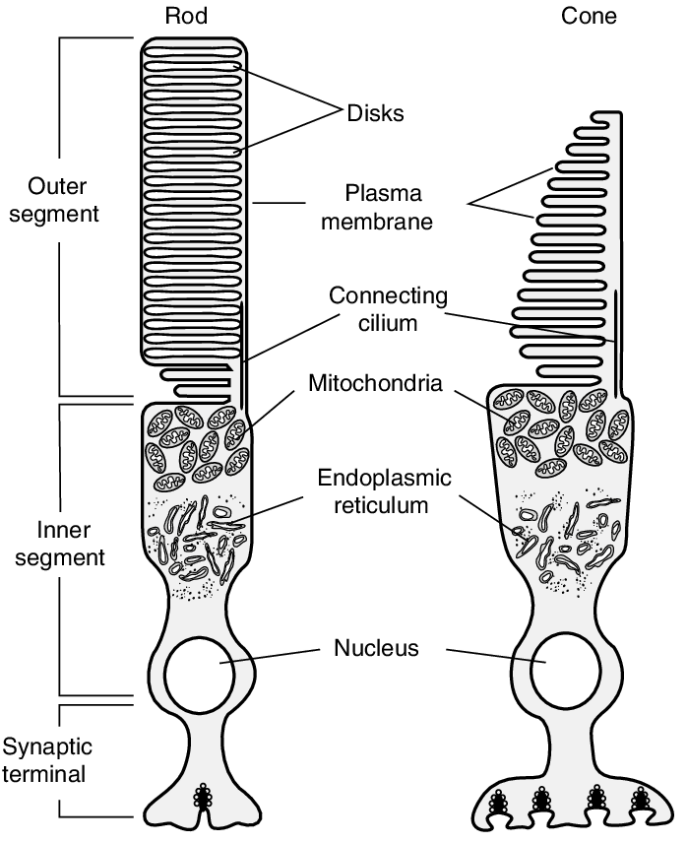
DIAGRAM OF A ROD AND CONE CELL

However, there are 3 types of cones which we will refer to as the short-wavelength sensitive cones, the middle-wavelength sensitive cones and the long-wavelength sensitive cones or S-cone, M-cones, and L-cones for short.
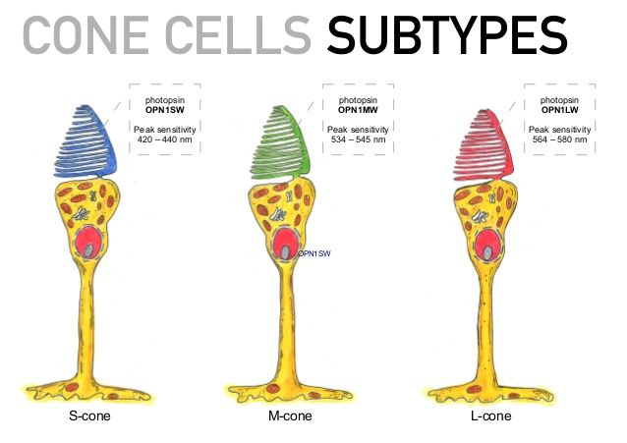
The following are the functions of the above mentioned photoreceptor cells:
- Rod cells produce low-light, low-resolution vision, and are very sensitive to motion (as in drawing one’s attention to something moving in the peripheral vision). Rod vision is largely nonfunctional at the intensities of daylight and even most indoor artificial light. Rod vision also is monochromatic.
- Cone cells produce high-resolution, trichromatic vision but require higher light intensity. . Cones are more concentrated in the macula (the central part of the retina). However, they are not limited to daylight. The threshold for activation of cone vision is about midway between the intensity of starlight and moonlight reflected from a sheet of white paper.
- Retinal ganglion cells process visual information that begins as light entering the eye and transmit it to the brain via their axons, which are long fibers that make up the optic nerve.

2. Corona virus can penetrate the body through eye and implicate the immune system, briefly discuss the layers of retina for information penetration.
ANSWER
- Outer limiting membrane
Radial glial cells of the retina, also known as Muller cells, are in the outer limiting membrane (OLM) of the retina and form adherens junctions between Muller cells and rods and cones in the inner segments which serves to separate the photosensitive regions of the retina from the areas that transmit the electrical signals.
- Inner limiting membrane
The ILM is the retina's inner surface bordering the vitreous humor and thereby forming a diffusion barrier between the neural retina and vitreous humor. The ILM contains laterally contacting Muller cell synaptic boutons and other basement membrane parts. It is a thin layer of Muller glial cells and basement membrane which demarcates the vitreous anteriorly from the retina posteriorly.
- Nerve fiber layer (NFL)
The nerve fiber layer is the second innermost layer of the retina from the vitreous. This layer contains axons of retinal ganglion cells and the astroglia which support them. Collectively, these axons constitute the optic nerve.
- Ganglion cell layer
This layer contains the retinal ganglion cells (RGCs) and displaced amacrine cells. As a rule of thumb, smaller RGCs dendrites arborize in the inner plexiform layer while larger RGCs dendrites arborize in other layers.
- Inner plexiform layer
The inner plexiform layer is an area comprised of a dense reticulum of fibrils formed by interlaced dendrites of RGCs and cells of the inner nuclear layer. This layer relays information from cells of the inner nuclear layer.
- Inner nuclear layer
This layer of the retina contains the cell bodies of glial, bipolar cells, horizontal cells, and amacrine cells.
- Outer plexiform layer
This layer of the retina contains a neuronal synapse of between rods and cones with the footplate of horizontal cells. Capillaries are also found to be primarily running through the outer plexiform layer.
- Outer nuclear layer
This layer contains the rod and cone granules that sense photon, extensions from the rod, and cone cell bodies.
- External limiting membrane
This layer contains the bases of the rod and cone photoreceptors cell bodies. The ELM forms a barrier between the subretinal space, into which the inner and outer segments of rods and cones project to be in close association with the pigment epithelial layer behind the retina, and the neural retina proper.

- Retinal pigment epithelium
The retina is supported by the retinal pigment epithelium (RPE), which has many functions including vitamin A metabolism, maintenance of the blood-retina barrier, phagocytosis of photoreceptor outer segments, production of mucopolysaccharide matrix surrounding the outer segments of the retina, and active transport of materials into and out of the RPE.
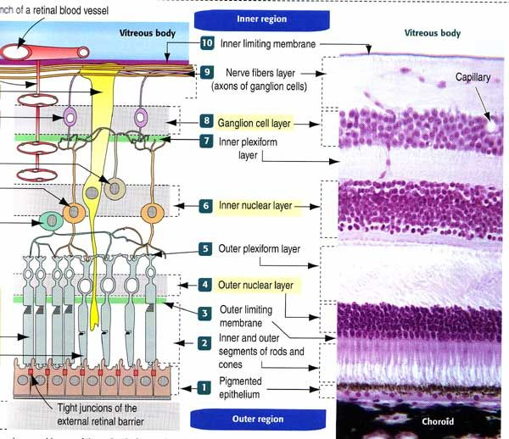
DIAGRAM SHOWING THE LAYERS OF THE RETINA

The following are the cells in the above mentioned layers of the retina:
- Horizontal cells: These cells are connect to the photoreceptors that surround the bipolar connected photoreceptor cells and help the help integrate and regulate the input from multiple photoreceptor cells, increasing your visual acuity.

- Bipolar cells: The dependence of each layer of the retina on each other is exemplified here. These cells take the electrical information from the photoreceptor cells and pass it along to other retinal cells.

- Ganglion cells: These cells extend to form an optic nerve that conveys information to the brain and take the electrical information from the bipolar cells and process it to determine shapes, contrast and color.
- Amacrine Cells: Amacrine cells are intermediate neurons that release the inhibitory neurotransmitter GABA or glycine. However, given their unique gap junction physiology, they can be both inhibitory or excitatory. There is great diversity among amacrine cells, and they fulfill a variety of jobs and functions within the retina; serving as the ultimate utility cell of the retina.

