NAME; ABIMBOLA OLAMIDE REBECCA
MATRIC NUMBER; 18/MHS02/004
COURSE TITLE; SYSTEMIC EMBRYOLOGY (ORGANOGENESIS)
COURSE CODE; ANAL206
DEPARTMENT; HUMAN ANATOMY
ASSIGNMENT TITLE; DEVELOPMENT OF THE LUNGS AND STOMACH
QUESTION
Write short notes on the following
- Development of the lungs
- Rotation of the stomach and the formation of theo mental bursa
- Development of the esophagus
Development of the lungs
Fetal and postnatal lung development depend on several key developmental processes; branching morphogenesis to promote branching of the lungs bud into the surrounding mesenchyme, static and cyclic stretching of the lung that assist in promoting sacculation, alveolarization to enhance the expansion of the gas exchange surface area, and vasculogenesis and angiogenesis to ensure that the development epithelial surface area is invested with both a gas- exchange and nourishing vascular supply
Branching morphogenesis
This is a fundamental mechanism of lungs development .Branching is mediated by the accelerated growth of epithelial cells along the stalk of a branching airway with concomitant growth arrest at the branch tip. This process requires extensive communication between epithelial cells and with adjacent mesenchyme as well as integration of microenviomental cues from the extracellular matrix. Classic tissue recombination experiments in which mesenchyme from proximal airways was transplanted to distal airways and vice versa indicate that the mesenchyme has an important inductive role in dictating the branching pattern and cell fate of the expanding epithelium
Composition of human fetal lung fluid compared with other body fluids
component | Lung fluid | Interstitial fluid | plasma | Amniotic fluid
Sodium(mEq/L) | 150 | 147 | 150 | 113
Potassium(mEq/L) | 6.3 | 4.8 | 4.8 | 7.6
Chloride(mEq/L) | 157 | 107 | 107 | 87
Bicarbonate (mEq/L) | 3 | 25 | 24 | 19
pH | 6,27 | 7.31 | 7.34 | 7.02

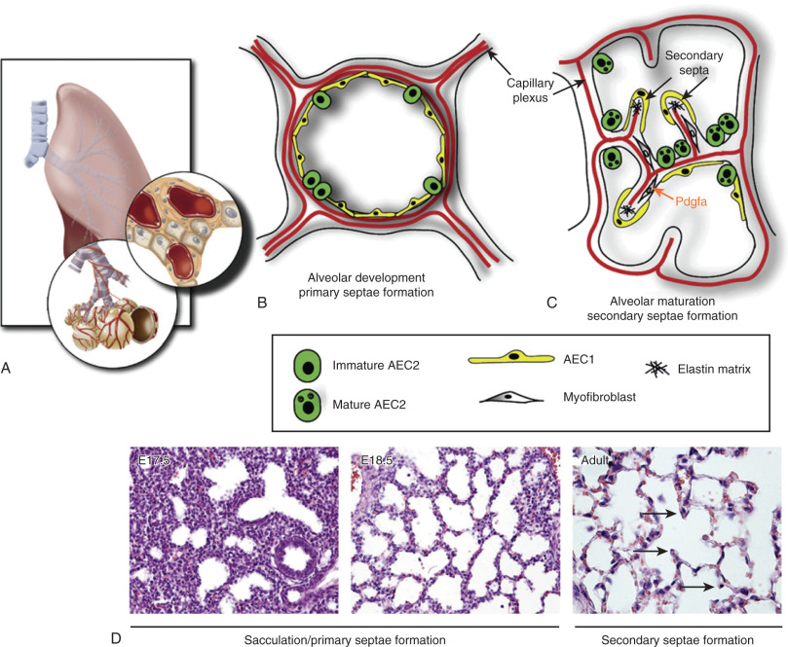
Rotation of the stomach and the formation of the omental bursa
The stomach is located between the esophagus and small intestine .the longitudinal rotation of the stomach involves a 90 degree clockwise rotation resulting in the right side of the stomach becoming posterior oriented and left side of the stomach facing interiorly
The stomach subsequently rocks on its longitudinal axis causing the pylorus to shift to right and the cardiac orifice to shift to the left
During rotation
- The cranial end moves to the left and slightly the left and slightly downward
- The caudal end moves to the right and upward
After rotation
Stomach assumes its final position with its long axis running from above left to below right
During the rotation one side of the stomach grows faster than the other forming the greater and lesser curvatures of the stomach
Formation of the omental bursa
Begins as small isolated clefts in the dorsal mesogastrium that soon join to form single cavity. Rotation of the stomach pulls the dorsal mesogastrium to the left thus enlarging the cavity
The bursa expands transversely cranially and lies between the stomach and posterior abdominal wall
The superior part of the bursa is cut off as the diaphragm develops inferiorly it persists as the superior recess of the omental bursa
The inferior part grows within the 4-layered greater omentum forming the inferior recess of the omental bursa
The inferior recess later on closes down because of fusion of the layers of the greater omentum
Development of the esophagus
In early embryogenesis, the esophagus develops from the endodermal primitive gut tube. The ventral part of the embryo abuts the yolk sac. During the second week of embryological development, as the embryo grows, it begins to surround parts of the sac. The enveloped portions forms the basis for the adult gastrointestinal tract. The sac is surrounded by a network of viteline artery ,over time these arteries consolidate into the three main arteries that supply the developing gastrointestinal tract; the celiac artery, superior mesenteric artery and inferior mesenteric artey.The areas supplied by these artery are used to define the midgut,hindgut and foregut
The surrounded sac becomes the primitive gut. Section of this gut begin to differentiate into the organ of the gastrointestinal tract such as the esophagus, stomach and intestine. Thes esophagus develops as part of the foregut tube. The innervations of the esophagus develops from the pharyngeal arches

