Name: ALEGBELEYE OLUWAFEMI OLADIPUPO
Matric No: 17/ENG04/011
Department: ELECTRICAL/ELECTRONICS ENGINEERING
EEE 326 ASSIGNMENT

QUESTION ONE
(a) What is the limitation of single Phase Induction Motor?
(b) Explain why a single phase induction motor does no self-start. Discuss this based on the double revolving theory
(c) Explain the constructional features and principle of operation of a Single Phase induction motor
(d) Using the double revolving field theory explain the torque –slip characteristics of a single phase induction. Hence explain why a Single-phase induction motor are not self-starting
(e) List five (5) types of Single Phase Induction Motor and explain explicitly any two with relevant circuit/connection diagrams
(f) Describe the operation of Single Phase Induction Motor using the Double-Field Revolving Theory

Solution
- A single phase induction motor does not have a self-starting torque
- During light load conditions, the power factor of the load drops to a very low value
- The speed control of an induction motor is very hard to attain.
- Due to poor starting torque the motor cannot be used for applications which requires high starting torque.
- According to double field revolving theory, we can resolve any alternating quantity into two components. Each component has a magnitude equal to the half of the maximum magnitude of the alternating quantity, and both these components rotate in the opposite direction to each other.
Now at starting condition, both the forward and backward components of flux are exactly opposite to each other. Also, both of these components of flux are equal in magnitude. So, they cancel each other and hence the net torque experienced by the rotor at the starting condition is zero. So, the single phase induction motors are not self-starting motors.
- Constructional features of a single phase IM
The single phase motor stator has a laminated iron core with two windings arranged perpendicularly.
- One is the main and the other is the auxiliary winding or starting winding
- Two perpendicular coils that has current 90 degrees out of phase can generate the necessary rotating magnetic fields
- Requires a starting torque
All the single phase induction motor have one construction feature in common, viz, the auxiliary starting winding. The starting winding is provided so that, together with the main or working winding, the motor can stimulate a two phase motor to develop torque at start. In the case of the permanent capacitor the auxiliary winding remains in the circuit after starting and thus closely approximates a two-phase motor also when it is operating under load. Hence the term ‘split phase’ may rightly be applied to all the single phase induction motors
Principle of operation single phase induction motor
Under stationary rotor conditions (i.e, when speed N = 0 or slip s = 1), the two rotating fields slip pass the rotor at the same slip, s = 1 and inducing equal currents in the squirrel cage rotor. The two rotating fields are of the same strength and develop equal and opposite electro-magnetic torques resulting in net torque of zero value. Thus the starting torque is zero and the single phase induction motor is non- self-starting. Further, the two rotating fields induce a resultant EMF in the stator which balances the applied voltage assuming low leakage impedance of the stator winding.

- Torque Slip Characteristics of Single Phase Induction Motor
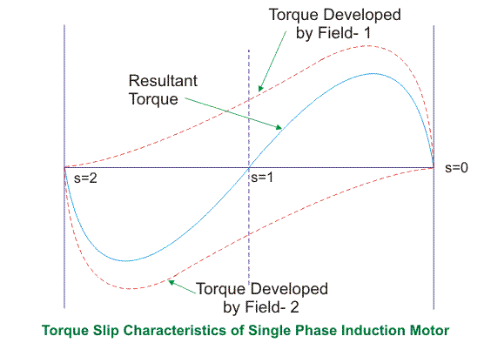
From the figure, we see that at a slip of unity, both forward and backward field develops equal torque but the direction of which are opposite to each other so the net torque produced is zero hence the motor fails to start. From here we can say that these motors are not self-starting unlike the case of three phase induction motor. There must be some means to provide the starting torque. If by some means, we can increase the forward speed of the machine due to which the forward slip decreases the forward torque will increase and the reverse torque will decrease as a result of which motor will start.
From here we can conclude that for starting of single phase induction motor, there should be a production of difference of torque between the forward and backward field. If the forward field torque is larger than the backward field than the motor rotates in forward or anti clockwise direction. If the torque due to backward field is larger compared to other, then the motor rotates in backward or clockwise direction. They are not self-starting because in induction machine a rotating magnetic field is required to produce torque. A rotating magnetic field can produced if we have balanced three phase supply and each phase is electrically spaced 120 to each other OR we have required minimum two phase but in single phase induction motor there is single phase supply to the stator of motor. A single phase supply cannot produce a rotating magnetic field but it produce a pulsating magnetic field which does not rotate. Due to this pulsating magnetic field torque cannot produce so motor is not self-start.

- Split phase induction motor.
- Capacitor start induction motor
- Capacitor start capacitor run induction motor
- Permanent split capacitor motor
- Shaded pole induction motor

Shaded Pole Single Phase Induction Motors
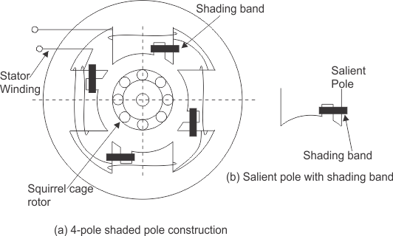
The stator of the shaded pole single phase induction motor has salient or projected poles. These poles are shaded by copper band or ring which is inductive in nature. The poles are divided into two unequal halves. The smaller portion carries the copper band and is called as shaded portion of the pole.
We know that the stator winding current is alternating in nature and so is the flux produced by the stator current. In order to clearly understand the working of shaded pole induction motor consider three regions;

    - When the flux changes its value from zero to nearly maximum positive value.
    - When the flux remains almost constant at its maximum value.
    - When the flux decreases from maximum positive value to zero
1stREGION
When the flux changes its value from zero to nearly maximum positive value –
In this region, the rate of rise of flux and hence current is very high. According to Faraday’s law whenever there is change in flux emf gets induced. Since the copper band is short circuited the current starts flowing in the copper band due to this induced emf. This current in copper band produces its own flux. Now according to Lenz’s law the direction of this current in copper band is such that it opposes its own cause i.e rise in current. So the shaded ring flux opposes the main flux, which leads to the crowding of flux in the unshaded part of stator and the flux weaken in shaded part. This non uniform distribution of flux causes magnetic axis to shift in the middle of the unshaded part.

2ndREGION
when the flux remains almost constant at its maximum value-
In this region, the rate of rise of current and hence flux remains almost constant. Hence there is very little induced emf in the shaded portion. The flux produced by this induced emf has no effect on the main flux and hence distribution of flux remains uniform and the magnetic axis lies at the center of the pole.

3rdREGION
when the flux decreases from maximum positive value to zero –
In this region, the rate of decrease in the flux and hence current is very high. According to Faraday’s law whenever there is change in flux emf gets induced. Since the copper band is short circuit the current starts flowing in the copper band due to this induced emf. This current in copper band produces its own flux. Now according to Lenz’s law the direction of the current in copper band is such that it opposes its own cause i.e decrease in current. So the shaded ring flux aids the main flux, which leads to the crowding of flux in shaded part of stator and the flux weaken in unshaded part. This non uniform distribution of flux causes magnetic axis to shift in the middle of the shaded part of the pole.This shifting of magnetic axis continues for negative cycle also and leads to the production of rotating magnetic field. The direction of this field is from unshaded part of the pole to the shaded part of the pole

Split Phase Induction Motor
In addition to the main winding or running winding, the stator of single phase induction motor carries another winding called auxiliary winding or starting winding. A centrifugal switch is connected in series with auxiliary winding. The purpose of this switch is to disconnect the auxiliary winding from the main circuit when the motor attains a speed up to 75 to 80% of the synchronous speed. We know that the running winding is inductive in nature. Our aim is to create the phase difference between the two winding and this is possible if the starting winding carries high resistance.
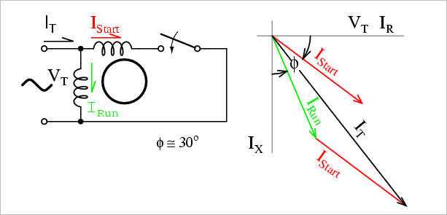
We know that for highly resistive winding the current is almost in phase with the voltage and for highly inductive winding the current lag behind the voltage by large angle. The starting winding is highly resistive so, the current flowing in the starting winding lags behind the applied voltage by very small angle and the running winding is highly inductive in nature so, the current flowing in running winding lags behind applied voltage by large angle. The resultant of these two current is I_{T}. The resultant of these two current produce rotating magnetic field which rotates in one direction. In split phase induction motor the starting and main current get split from each other by some angle so this motor got its name as split phase induction motor.

- The double revolving field theory of a single phase induction motor states that a pulsating magnetic field is resolved into two rotating magnetic fields. They are equal in magnitude but opposite in directions. The induction motor responds to each of the magnetic fields separately. The net torque in the motor is equal to the sum of the torque due to each of the two magnetic fields.
The direction in which the single phase motor is started initially is known as the positive direction. Both the revolving field rotates at the synchronous speed. ω_{s}= 2πf in the opposite direction. Thus, the pulsating magnetic field is resolved into two rotating magnetic fields. Both are equal in magnitude and opposite in direction but at the same frequency.
At the standstill condition, the induced voltages are equal and opposite as a result; the two torques are also equal and opposite. Thus, the net torque is zero and, therefore, a single phase induction motor has no starting torque.

QUESTION TWO
- What is a Universal Motor? List five (5) areas of application of this type of motor.
- Describe the Construction of a Universal Motor.
- Distinguish Universal motor from the DC series motor with respect to the additional
Constructional features. Describe these additional constructional features.

Solution
- Universal motor are small series motors designed in order to increase saturation of the magnetic circuit at the peak of the sine wave of current may materially reduce the flux below the dc value, and this tends to increase the speed in ac operation. A universal motor is a special type of motor which is designed to run on either DC or single phase AC supply. It can be applied in the following areas;
- Vacuum cleaners
- Food mixers
- Sewing Machine
- Blenders
- Fans
- Hair dryers
- Construction of the Universal Motor
- Commutator
- Brushes
- Rotors
- Stator
Construction of a universal motor is very similar to the construction of a DC machine. It consists of a stator on which field poles are mounted. Field coils are wound on the field poles.

Non-Compensated Universal Motor:
The Non-compensated motor has two salient poles and it is laminated as shown in figure below.
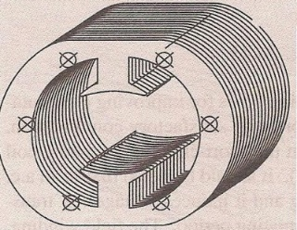
The armature is of wound type and the laminated core is either straight or skewed slots. The leads of the armature winding are connected to the commutator. High resistance brushes are used along with this type of motor to help better commutation. An equivalent Non-compensated type Universal Motor is shown in figure below.
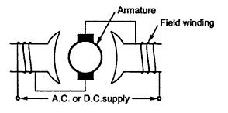

Compensated Type with Distributed Field:
The compensated type Universal Motor consists of distributed field winding and the stator core is similar to that of split-phase motor. The compensating winding helps in reducing the reactance voltage which is caused due to alternating flux, when the motor runs with the AC supply.
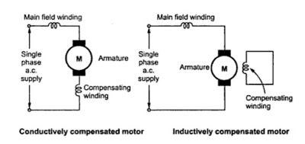
An equivalent compensated type universal motor is shown above
- There is actually no difference between the two in reference to their additional features. A universal motor has its rotor and stator windings connected in series, and it can run on both AC and DC that is why it’s called universal, or sometimes a DC series motor. It is usually used in home appliances, electric tools and so on. Because it has a high speed.

QUESTION THREE
- Describe the principle of operation of a three phase Induction Motor.
- State the advantages and disadvantages of Three Phase Induction Motor.
- A 400V, three phase, star connected induction motor has a stator impedance of (0.06+j0.2) ohm and an equivalent rotor impedance of (0.06+j0.22) ohm. Determine the maximum gross power output and the slip at which it occurs.
Hint: take k as unity, Solve using the approximate equivalent circuit referred to the Stator (Version 2)
- Draw and explain the Torque Vs Slip relationship of three-phase Induction Motor.
- A 3-phase induction motor runs at 20rps on no-load, and 15 rps at full load when supplied with power from a 60Hz, 3-phase source. Calculate the following;
- The number of poles of the motor
- The percentage slip at full load
- The frequency of the rotor’s voltage
- The rotor’s slip speed
- The rotor’s frequency at a slip of 10 percent

Solution
- Principle of Operation of 3-Phase Induction Motor
The stator of the motor consists of overlapping winding offset by an electrical angle of 120. When we connect the primary winding, or the stator to a 3 phase AC source, it establishes rotating magnetic ﬁeld which rotates at the synchronous speed. Secrets behind the Rotation: According to Faraday’s law an emf induced in any circuit is due to the rate of change of magnetic ﬂux linkage through the circuit. As the rotor winding in an induction motor are either closed through an external resistance or directly shorted by end ring, and cut the stator rotating magnetic ﬁeld, an emf is induced in the rotor copper bar and due to this emf a current ﬂows through the rotor conductor.
Here the relative speed between the rotating ﬂux and static rotor conductor is the cause of current generation; hence as per Lenz’s law, the rotor will rotate in the same direction to reduce the cause, i.e., the relative velocity.
Thus from the working principle of three phase induction motor, it may be observed that the rotor speed should not reach the synchronous speed produced by the stator. If the speeds become equal, there would be no such relative speed, so no emf induced in the rotor, and no current would be ﬂowing, and therefore no torque would be generated. Consequently, the rotor cannot reach the synchronous speed. The difference between the stator (synchronous speed) and rotor speeds is called the slip. The rotation of the magnetic ﬁeld in an induction motor has the advantage that no electrical connections need to be made to the rotor.

- Advantages of the three phase induction motor
- It has low cost and minimum maintenance
- It is simple and rugged
- Has a good power factor (about 0.89)
- It has a high efficiency (90%)
- It has a good speed regulation
- They are self-starting
- It has reduced lossess

Disadvantages of the three phase induction motor
- The speed decreases with increases with increase in load
- Efficiency is reduced with increased speed
- Its starting torque is less than a DC shunt motor

- The equivalent motor resistance referred to stator =
R₀₁= $R_{1}+\frac{R_{2}}{X_{2}}$ = 0.06+0.06 = 0.12Ω.
The equivalent motor reactance referred to stator,
X₀₁ = $X_{1}+\frac{X_{2}}{k^{2}}$ = 0.2+0.22 = 0.42Ω
Motor impedance
Z₀₁ = $\sqrt{\left(R_{01}^{2}\right)+\left(X_{01}^{2}\right)}$ = $\sqrt{{(0.12)}^{2}+{(0.42)}^{2}}$ = 0.437Ω.
=$\frac{\frac{R_{2}}{K^{2}}}{\frac{R_{2}}{K^{2}}+Z_{01}}$
= $\frac{0.06}{0.06+0.437}$ = 0.12
Maximum gross power output
=
$$\frac{3V^{2}}{2(R_{01}+Z_{01}}$$=
$$\frac{3×{\left(\frac{400}{\sqrt{3}}\right)}^{2}}{2(0.12+0.437)}$$
= 143,626W or 143.63kW

Thus, at low values of slip, torque is approximately proportional to slip s and the torque slip characteristics of induction motor is a straight line as shown in the figure. The region (from s = 0 to s = sm) is called the stable region of operation and operating point of the motor should be in this region. In the stable region, the value of slip is small. Hence this region is also called as the low slip region.
As the slip increases torque increases and attains its maximum value when s = R2/X2. This maximum value of torque is also known as break down or pull out torque. When a further increase in slip occurs due to increase in load beyond the point maximum torque
Thus at higher values of slip (i.e. the slip beyond that corresponding to maximum torque) torque is approximately inversely proportional to slip, s and the torque slip characteristics of induction motor is rectangular hyperbola as shown in the figure. The region (extending from s = sm to s = 1) is called unstable region. In this region with the increase in load, slip increases but torque decreases. The result is that the motor could not pick up the load and slows down and eventually stops. In the unstable region, the value of slip is large so this region is also called as the high-slip region.
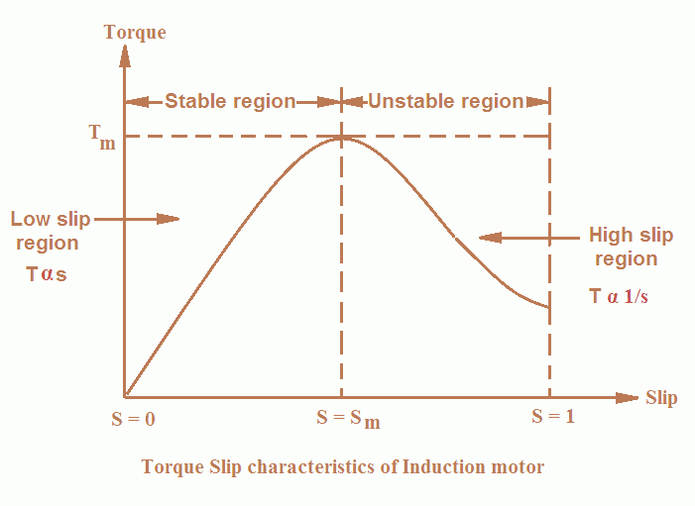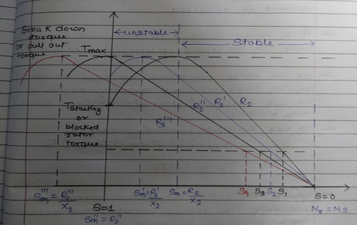
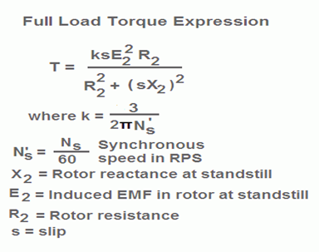

- 20 rps = rpm = 20 x 60 = 1200rpm
15rps = rpm = 15 x 60 = 900 rpm
$$N_{s}=\frac{120f}{p}$$
$$\frac{120 ×60}{1200}=6poles$$
$$\% slip= \left\lfloor \frac{Ns-Nr}{Ns}\right\rfloor ×100$$
$$\left\lfloor \frac{1200-900}{1200}\right\rfloor ×100=25\%$$
F’= 0.25 x 60 = 15Hz
Ns-Nr = 1200 -900 = 300
F’= SF
  - X 60 = 6Hz
QUESTION FOUR
- Highlight five methods of controlling the speed of Induction Motors
- List four methods of Starting the three phase Induction Motors
- Explain any two methods in Q4(b) using appropriate circuit diagram

Solution

- Control From Stator Side
- Control From Rotor Side
- Speed Control by Pole Changing
- Speed Control by injected EMF
- Speed Control by varying Rotor resistance

- Direct On-Line Starter (DOL)
- Star-Delta Starter
- Auto Transformer Starter
- Rotor Impedance Starter

Star-Delta Starter: The star delta starting is a very common type of starter and extensively used, compared to the other types of the starters. This method used reduced supply voltage in starting. Figure 2 shows the connection of a 3phase induction motor with a star – delta starter. The method achieved low starting current by first connecting the stator winding in star configuration, and then after the motor reaches a certain speed, throw switch changes the winding arrangements from star to delta configuration. By connecting the stator windings, first in star and then in delta, the line current drawn by the motor at starting is reduced to one-third as compared to starting current with the windings connected in delta. At the time of starting when the stator windings are start connected, each stator phase gets voltage VL/√3 , where VL is the line voltage. Since the torque developed by an induction motor is proportional to the square of the applied voltage, star- delta starting reduced the starting torque to one – third that obtainable by direct delta starting.
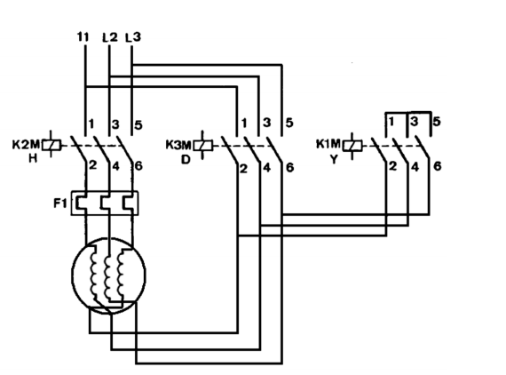
Figure: Star Delta Starter
Direct On-Line Starter (DOL): The Direct On-Line (DOL) starter is the simplest and the most inexpensive of all starting methods and is usually used for squirrel cage induction motors. It directly connects the contacts of the motor to the full supply voltage. The starting current is very large, normally 6 to 8 times the rated current. The starting torque is likely to be 0.75 to 2 times the full load torque. In order to avoid excessive voltage drops in the supply line due to high starting currents, the DOL starter is used only for motors with a rating of less than 5KW. There are safety mechanisms inside the DOL starter which provides protection to the motor as well as the operator of the motor. The power and control circuits of induction motor with DOL starter are shown in figure below
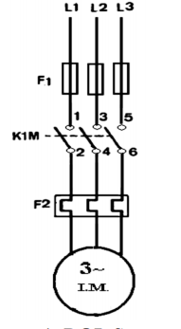
Figure: Direct On Line Starter

QUESTION SIX
- What is the importance of testing on three –phase Induction Motors
- State two similarity and differences between the short-circuit test of transformers and the Blocked –Rotor test in Induction Motor.
- State two similarity and differences between the Open circuit test in transformer and the No-load test in Induction Motor
- List four types of testing carried out on three-phase Induction Motors and explain any one (1)
- A 400-volts, three phase STAR connected Induction Motor gave the following results on no-load and short-circuit test
No Load Test | 400V | 3.0A | 645 Watts
Blocked Rotor Test | 200V | 12.0A | 1660 Watts
Given that the wind age losses amount to 183 Watts, and the stator resistance as 5Ω; Determine the following;
- The Energy component of the No-load current
- The magnetizing component of the No-load current
- The power factor on No-load
- No-load resistance, R₀
- No-load reactance, X0
- Equivalent resistance per phase as referred to the primary
- Equivalent reactance per phase as referred to the primary
- Power factor on Short Circuit
- Short Circuit current with normal voltage applied of 400V across the stator
Solution
- Importance of Testing Induction Motors
- The simplest would be to find out if it works.
- You could test it to see if it performs in accordance with its specifications.
- You could test it to determine the machine parameters necessary for modeling and vector controlling the machine.
- You could test it for reliability and lifetime.
- You could test it to failure to see how much performance margin it has.
- Similarities and Differences between the short-circuit test of transformers and the Blocked –Rotor test in Induction Motor
Similarities
- The shaft of the motor is locked so that it cannot move and the rotor winding is short circuited.
- In the slip ring motor, the rotor winding is short circuited through the slip rings

Differences
- In a blocked rotor test the rotor is blocked so that it cannot move, a voltage is applied to the motor, and the resulting voltage, current and power are measured while in a short circuit test the test is performed at a rated frequency and with balanced poly-phase voltages applied to the stator terminal
- In a short circuit test as the motor is no load the power factor is very low which is less than 0.5 while the block rotor test is conducted at low voltage because if the applied voltage was normal voltage then the current flowing through the stator windings were high enough to overheat the windings and damage them
- Similarities and Differences between the open-circuit test of transformers and No-load test in Induction Motor
Similarities
- Open circuit test or no load test on a transformer is performed to determine 'no load loss (core loss)' and 'no load current
- The open circuit and no load test are performed for determining the parameter of the transformer like their efficiency, voltage regulation, circuit constant
Differences
- The purpose of the open circuit test is to determine the no-load current and losses of the transformer because of which their no-load parameter are determined. While the no load test determines the copper loss occur on the full load. The copper loss is used for finding the efficiency of the transformer.

- An open circuit test is conducted when the secondary of the transformer is kept in open condition without connecting any load with it. Thus there will not be any current in the secondary coil. While a no load test is conducted shorting the secondary terminals. Thus there will be huge current flow in the secondary coil when voltage is applied in the primary.

- Types of testing carried out on three-phase Induction Motors
- Blocker rotor Test
- Insulation Resistance Test
- Power supply Test
- No load Test

Blocker Rotor Test
In this test, the rotor of the induction motor is blocked. A reduced voltage is applied to the stator terminal so that the rated current flows through the stator winding. The input power, voltage and current flows through the stator winding. The input power, voltage and current are measured. The experimental setup of blocked rotor test is shown in below fig. fig.2. Circuit shown below is for Blocked Rotor Test to obtain more reliable values ranges of both wattmeter should be 10A, 250V for Blocked Rotor Test. Similarly the range of Ammeter and voltmeter during blocked rotor test, 10A, 250V.
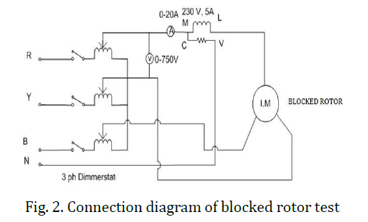

Applied Voltage, V= 400V
No-Load line current, $I_{lo}=3A$
No load phase current $I_{o}=\frac{I_{lo}}{\sqrt{3}}$ = $\sqrt{3}A$
Input on no-load, $P_{o}=645 watts$
Stator copper loss, $P_{cl}=3{I_{o}}^{2}R_{1}={3(\sqrt{3})}^{2}$ x 5 = 45watts
Windage and friction loss, $P_{wf}=183watts$
Total stator core loss, $P_{i}=P_{o}-P_{cl}- P_{wf}=645-45-183=417watts$
No-load power factor, cosθ = $\frac{P_{i}}{3VI_{o}}=\frac{417}{3 x 400 x \sqrt{3}}=0.2$
Energy component of no load phase current, $I_{e}= I_{o}$cosθ = 3 x 0.2 = 0.6A
Magnetising component of no load phase current, $I_{m}= \frac{2.94}{\sqrt{3}}=1.7A$
No-load leakage reactance, $X_{o}=\frac{V}{I_{e}}$ = 1.7A
On Block rotor test applied per phase, $V_{s}=200V$
On Block rotor test phase current, $I_{psc}=$ $\frac{I_{s}v}{V_{s}}$ = $\frac{12}{√3}$= 6.928A
Equivalent impedance, $Z_{01}=$ $\frac{{V_{s}}/{\sqrt{3 }}}{I_{S}}$= 28.87
Equivalent Stator, $X_{0}= \frac{P_{s}}{3{I_{s}}^{2}}$ = $\frac{1660}{3 x 6,928 x 6.928}=11.53ohms$
Power factor on block rotor circuit, cosθ = $\frac{P_{s}}{\sqrt{3}V_{s}I_{psc}}$= $\frac{1660}{3 x 200 x 6.6928}=0.4$
Equivalent Stator, $X_{01}= \sqrt{{Z_{01}}^{2}-{R_{01}}^{2}}$ =$\sqrt{{\left(28.87\right)}^{2}-{\left(11.53\right)}^{2}}=26.5ohms$
Block rotor circuit current with normal voltage of 400V applied to the stator,
$I_{sc}= \frac{I_{lsc} x V}{V_{sc}}=\frac{12 X 400}{200}=24A$

QUESTION SEVEN
- Explain the operation of synchronous generator
- A Y connected, two pole, 50 Hz, 11kV, 10MVA synchronous generator with Xs=150Ω is operating at full load and 0.8 power factor lagging. Calculate the following
- The induced emf and load angle, Ef <
- The maximum power ,Pmax
- The maximum Torque
- Explain the concept of parallel connection of generators and give four (4) advantages of connecting generators in parallel.
Solution

A Synchronous generator converts mechanical energy to Electrical energy. The source of which creates the mechanical energy may be a steam engine, water falling through a waterwheel, a wind turbine, a hand crank or via compressed air.
A synchronous generator has two parts;
- Stator
- Rotor
The Rotor is the rotating part whereas the Stator is the stationary part, hence where they get their names from.
Fleming's right hand rule (for generators) shows the direction of induced current when a conductor moves in a magnetic field. No current is induced if the motion of the conductor is in line with the field, going either direction, and the same can be said if it runs parallel to current.

The right hand is held with the thumb, first finger and second finger mutually perpendicular to each other (at right angles)
- The Thumb represents the direction of Motion of the conductor.
- The First finger represents the direction of the Field. (north to south)
The Second finger represents the direction of the induced or generated Current (the direction of the induced current will be the direction of conventional current, from positive to negative.
The principle of operation of synchronous generator is electromagnetic induction, if there exists a relative motion between the flux and conductors, then an emf is induced in the conductors.

S/MVA rating=10MVA,$V_{line}=11KV$, p.f=0.8, $X_{s}=15Ω$, f=50Hz, number of poles=2
Induced emf is given as;
$$I_{a(line)}=\frac{V_{t(lines)}}{√3}$$
So;
$$\left|E_{f(phase)}\right|=\sqrt{\left(V_{t\left(phase\right)}Cosφ^{2}\right)+(I_{a}X_{a}+Sinφ^{2})}=12,741KW$$

$$\left(Cosφ+δ\right)=\frac{V_{t\left(phase\right)}Cosφ}{E_{f(phase)}}=\frac{(6351)(0.8)}{12,741}=0.399$$
$$φ+δ=\cos^{-1}\left(0.399\right)={66.5}^{0}$$
Recall;
$$Cosφ=0.8$$
$$φ=\cos^{-1}{(0.8)}$$
$$φ=36.90$$
Hence,
$$δ=66.5-36.9={29.6}^{0}$$

ii.) Maximum power,
$$P_{max}=\frac{3\left|V_{t}\right|\left|E_{f}\right|}{X_{s}}=\frac{3(12,741)(6351)}{15}=16,138,618.22W$$
iii.) Maximum torque,
$$T_{max}=\frac{P_{max}}{2πf}=\frac{16,138,618.22}{2×3.142×50}=51,507.4Nm$$

Parallel operation of generators is by far the most common form of operation. Generators may be operated in parallel on a small scale, e.g. two or three generators operating in parallel to provide power to a remote community, or large scale, e.g. the North American power grid.
This is the process in which voltage and frequency of the generators are matched to provide a standard AC output waveform.
Connecting generators in parallel increases the power capacity, control in load management, ease of maintenance, and redundancy. The process involves the physical connection of two or more electric generators, and the synchronization of their outputs.
The synchronization matches the waveform of the output voltage of one generator with the voltage waveform of the other generator (s).
Advantages of parallel operation include
- Redundancy: failure of one unit does not affect the integrity of the power supply, generators may be taken out of service for preventative maintenance
- Scaling: many units can combine to provide a power demand, rather than requiring fewer very large generators
- Resource management: generators can be located and operated to best meet the generating conditions, instead of having to be located and operated to meet the requirements of a local load. An example of this may be a nuclear power plant, which may take many weeks to bring up to full operating conditions. Using a nuclear generating station at full power to meet a "base load" with smaller more rapid response generators is one way to supply fluctuating load requirements.
- Efficiency: Generators operating at full load are more efficient than those operating at low loads. It is more efficient to meet a changing load by adding or removing smaller generators than having a single large generator operating inefficiently.

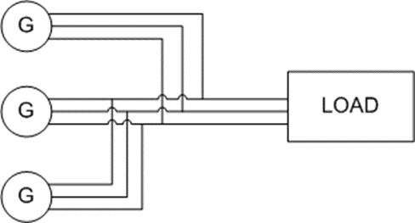
Fig: Example Circuit Of Three Generators Operating In Parallel To Supply A Load

