NAME: VALERIE NENGI AMINIA-JUMBO
MATRIC NO: 17/MHS01/059
COURSE TITILE: HISTOLOGY OF SPECIAL SENSES & NEURO HISTOLOGY
COURSE CODE: ANA 305

1. Histological importance of the eye in relation to their cellular functions
Eyes are highly developed photosensitive organs for analyzing the form, intensity and colour of light reflected from objects and providing a sense of sight. Protected within the orbits of the skull which also contains adipose cushions, each eyeball consists externally of a tough fibrous globe that maintains its overall shape. Internally, the eys contains transparent tissues that refract light to focus the image, a layer of photosensitive cells, and a system of neurons that collect, process and transmit visual information to the brain.
Each eye is composed of 3 concentric tunics or layers
- A tough external fibrous layer consisting of the sclera and the transparent cornea
- A middle vascular layer that includes the choroid, ciliary body and iris
- An inner sensory layer, the retina, which communicates with the cerebrum through the posterior optic nerve
External Structures of the Eye
1. Conjunctiva
- The conjunctiva lines the inner part of the eyelids.
- The tarsal plate lies beneath the conjunctiva and contains meibomian glands, which secrete an oily substance to decrease the evaporation of the tear film.
2. Tear film: The tear film consists of aqueous, mucus, and oily secretions.
3. Accessory glands: Apocrine glands of Moll, meibomian glands, lacrimal glands.
4. Muscles: Orbicularis oculi, levator palpebrae superioris, superior tarsal muscle.
5. Eyelid: The eyelid, likewise known as the cover of the eye, a mobile layer made up of skin and also muscular tissue and also covers the eyeball.
Internal Structures of the Eye
The innermost structures of the eye are organized in the three layers as follows
A. Outermost Layer: Sclera and Cornea
1. The sclera (white of the eye)
- The sclera is dense connective tissue made of mainly type 1 collagen fibers, oriented in different directions. The lack of parallel orientation of collagen fibers gives the sclera its white appearance, as opposed to the transparent nature of the cornea. However, the collagen of the sclera and cornea are continuous.
- The four layers of the sclera from external to internal are episclera, stroma, lamina fusca, and endothelium.
- The episclera is the external surface of the sclera. It is connected to the Tenon capsule by thin collagen fibers. At the corneoscleral junction, also known as the limbus, the Tenon capsule contacts stroma of the conjunctiva.
2. Cornea (transparent front layer of the eye):
- Consists of type I collagen fibers oriented in a uniform parallel direction to maintain transparency
- Consists of five layers: epithelium (non-keratinized, stratified squamous epithelium), Bowman layer, stroma (also called substantia propria), Descemet’s membrane, corneal endothelium.
- Corneal epithelium: fast growing, regenerating multicellular layer which interacts directly with the tear film.
- Bowman layer: This is a layer of subepithelial basement membrane protecting the underlying stroma. It is composed of type 1 collagen, laminin, and several other heparan sulfate proteoglycans.
- Stroma: The largest layer of the cornea, the stroma has collagen fibers arranged in a regular pattern. Keratocytes maintain the integrity of this layer. The function of this layer is to maintain transparency, which occurs by the regular arrangement, and lattice structure of the fibrils, whereby scatter from individual fibrils gets canceled by destructive interference, and the spacing of less than 200 nm allows for transparency.
- Descemet’s membrane: An a cellular layer made of type IV collagen that serves as a modified basement membrane of the corneal endothelium
- Corneal endothelium: a one cell thick layer made of either simple squamous or cuboidal cells. Cells in this region do not regenerate and have pumps that maintain fluid balance and prevent swelling of the stroma. When corneal endothelial cells are lost, neighboring cells stretch to attempt to compensate these losses.
(B) Middle Layer: Uvea (Iris, Ciliary Body, Choroid)
1. IRIS
- Consists of (1) stromal layer with pigmented, fibrovascular tissue and (2) pigmented epithelial cells beneath the stroma
- The sphincter pupillae and dilator pupillae muscles connect to the stroma
- The pigmented layer of cells blocks rays of light and ensures that light must move through the pupil to reach the retina
- The angle formed by the iris and cornea contains connective tissue with endothelial channels called the trabecular meshwork, which drains aqueous humor in the anterior chamber into the venous canal of Schlemm[8]. From here, fluid drains into episcleral veins.
2. CILIARY BODY
The tissue that divides the posterior chamber and vitreous body
- Consists of the ciliary muscle and the ciliary epithelium
- The ciliary muscle, via the lens zonules, controls the structure of the lens, which is vital for accommodation. Zonules are connective tissue fibers that connect the ciliary muscle and lens.
- The ciliary epithelium produces aqueous humor which fills the anterior compartment of the eye.
3. CHOROID
- Consists of a dense network of blood vessels supplying nourishment to structures of the eye, housed in loose connective tissue.
- The choriocapillary layer is located in the innermost part of the choroid and supplies the retina
- The Bruch membrane is an extracellular matrix layer situated between the retina and choroid and has significance in age-related macular degeneration, where an accumulation of lipid deposits prevent diffusion of nutrients to the retina.
(C) Innermost layer: Lens, Vitreous, Retina
1. Lens: separates the aqueous and vitreous chamber
- Consists of an outer capsule, a middle layer called cortex, and an inner layer called the nucleus.
- The capsule is the basement membrane of the lens epithelium which lies below
- New lens cells differentiate from the lens epithelium and are incorporated peripherally, pushing older lens cells towards the middle.
2. Vitreous: a jelly-like space made of type II collagen separating the retina and the lens
3. Retina: nervous tissue of the eye where photons of light convert to neurochemical energy via action potentials
Moreover, the retina itself is divided into various layers as follows
Retinal pigment epithelium: made of cuboidal cells containing melanin which absorbs light. These cells also establish a blood-retina barrier through tight junctions.
"Rod and cone cells": the layer of cells with photoreceptors and glial cells. Rods are located peripherally and are more sensitive to light and motion than cones. Cones have higher visual acuity and specificity for color vision.

2. Layers of retina for information penetration
Choroid – This is made up of a layer of blood vessels that supply oxygen and nutrients to the retina. Defect in the CHM gene can cause choroideremia, leaky blood vessels can expand in the retina causing wet age-related macular degeneration (AMD) and diabetic retinopathy.
Retinal pigment epithelium – This is a single layer of cells that provide essential nutrition and waste removal for the photoreceptor cells. Accumulation of waste can lead to AMD and Stargardt disease.
Photorecptors – This is where the rods and cones are located that convert light into electrical signals. Rods help you with night and peripheral vision. Cones are more concentrated in the macula (the central part of the retina) and proved central and color vision. Death of the rods can cause vision loss called retinitis pigmentosa, while AMD is the loss of central vision.
Horizontal cells – These cells are connect to the photoreceptors that surround the bipolar connected photoreceptor cells and help the help integrate and regulate the input from multiple photoreceptor cells, increasing your visual acuity.
Bipolar cells – The dependence of each layer of the retina on each other is exemplified here. These cells take the electrical information from the photoreceptor cells and pass it along to other retinal cells.
Ganglion cells – These cells extend to form an optic nerve that conveys information to the brain and take the electrical information from the bipolar cells and process it to determine shapes, contrast and color. Glaucoma vision loss results from high intraocular pressure that affects the optic nerve, interrupting the signals to the brain.
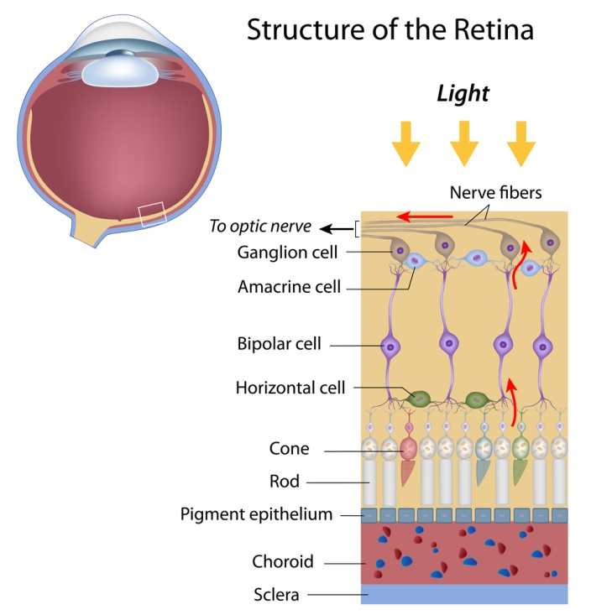
The corona virus is able to enter the body through the eye because the eye contains a mucous membrane, via which the virus has a passage to the rest of the body.

