NAME: AFABOR AARON
DEPTMENT: PETROLEUM ENGINEERING
MATRIC NO: 18/ENG07/001
COURSE: ENG 284

ASSIGNMENT: Answers to engineering drawing MCQ questions

- A sectioned surface is represented on a drawing when a view of the drawing structure as though it had been sliced in half or cult along another imaginary plane

- The principles to be followed while dimensioned a drawing are
- All dimension, extension, and leader lines should be thin, sharp, dark lines (.5mm/2H).
- Extension lines indicate the points between which the dimension figures apply. They are drawn perpendicular to the dimension lines, start with a visible gap (~1/32") between them and the object, and terminate 1/8" (3.2 mm) beyond the last arrowhead.
- Each dimension should be terminated by arrowheads touching the extension lines and pointing in opposite directions. Arrowheads are drawn freehand with .7mm/HB lead. The line should be broken only at the approximate center for the dimension figures.
- Dimensions shown with dimension lines and arrowheads should be placed to be read from the bottom of the drawing (unidirectional system).
- All dimensions should be given in decimal format. When dimensions are given in inches, leading zeros are omitted from dimension values less than 1.00
- When all dimensions on a drawing are given in inches, the inch marks (") are omitted, the same applies to millimeters. If metric units are used, the word METRIC will appear boxed in a spot toward the lower portion of the drawing sheet.
- A dimension line should never coincide with an object line or a center line, nor should it be an extension of these lines. Both, however, may be used as extension lines.
- Crossing of extension lines or dimension lines should be avoided if possible. Where such crossings are unavoidable, there should be no break in either of the lines. However, if extension lines cross dimension lines through the arrowheads, the extension line may be broken.
- Dimensions should be at least 3/8" (10 mm) from the object outline, then equally spaced at least 1/4" (6 mm) apart. A continuous series of dimensions should be aligned rather than staggered. Standard practice is to place the shortest dimensions nearest to the object and space adjacent parallel dimension lines further away from the object in order of their length.
- Dimensions are preferably placed outside the outlines of the views. (See rule #11)
- When placement outside the views will result in (a) dimensions too far from the distance they indicate, (b) long and confusing extension lines or leader lines that cross other lines of the drawing, or (c) any confusion in understanding where the dimension applies, they may be placed inside the view and close to the distance they indicate.
- As the distance dimensioned becomes less than about 1/2" (12.7 mm), the space between extension lines becomes too small for both arrowheads and figures. For these small dimensions the methods shown may be used. Each dimension should have two arrowheads associated with it, pointing in opposite directions. Dimensions can 'share' arrowheads. The following depicts appropriate forms for linear dimensions.

DIMENSIONING ROUND HOLES
Rules:
Holes are specified by a local note and placed in the view where the hole appears as a true circle. The leader line should extend radially from the circle, touching its circumference. See section on Leader Forms.
- Dimensions locating holes should be given to both of the two center lines that intersect at right angles at the hole centers, and should be placed in the view where the hole appears as a true circle. Do not give location dimensions to the edge of holes.
- When specifying a hole, the numerical value of the hole size (diameters) should be preceded by Ø. Symbols should be used to indicate the specific details related to the hole. See example below. A summary of the symbols follows:

Notes should be written in the same sequence by which the hole would be produced.
- If two or more identical holes exist, one note can be used as shown.
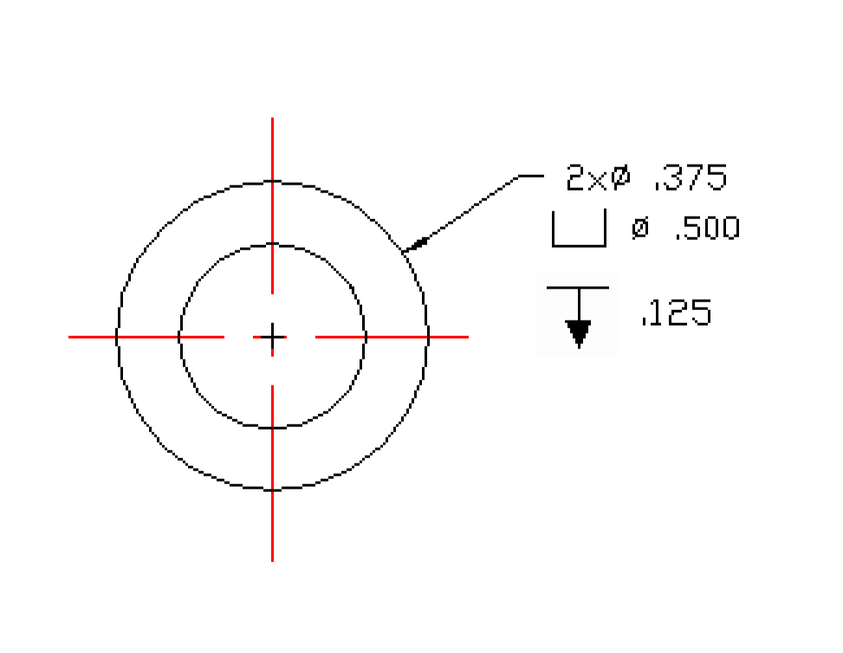

RADIAL DIMENSION FORMS
The standard radial form is a dimension line extending from the center of the arc to the arc line and having one arrowhead placed at its outer end. As the radius size becomes smaller than 1/2" (12.7 mm), the modified leader form shown may be used.
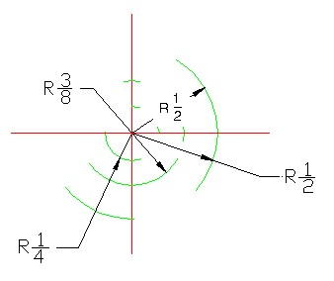
Rules:
- Radial dimensions are given for circular arcs that are less than 180°.
- Radial dimension lines should always be placed in the circular view of the arc, and should be drawn at an angle, never horizontal or vertical.
- The dimension figures should be horizontal on the page, and are preceded by "R".
- The forms shown above should be used regardless of radius size when (a) the normal position is too crowded with object lines, and (b) the normal dimension would fall within a cross-hatched area.

LEADER FORMS
A leader form is used to direct information in local note form, to its intended place on the view. It should be an inclined straight line with a short horizontal portion extending to the mid-height of the lettering, and terminating at the other and by an arrowhead touching the feature it dimensions. The note end of the leader should extend from either the beginning of the first line, or the end of the last line of the note.

Rules:
- Leaders should make a large angle (30° to 60°) with the line they touch. Leaders should never be horizontal or vertical.
- Leader lines should never cross one another, nor should they be parallel or nearly parallel to nearby dimensions, extension, or cross-hatching lines.
- The note portion of the leader should be outside the limits of the view, but as close as possible to the feature it dimensions.

ANGULAR DIMENSION FORMS
Rules:
- Dimension lines for angles are drawn as arcs with their centers at the vertex of the angle dimensioned.
- The angular dimension should be expressed in degrees (and minutes/seconds if required), and the figures should be placed horizontally.

FINISH MARKS
Surfaces of castings and forgings where extra material is to be provided for the purpose of machine finishing must be indicated by finish marks. Shown below are the various types of finish marks that are in use, together with their approximate proportions on the drawing.
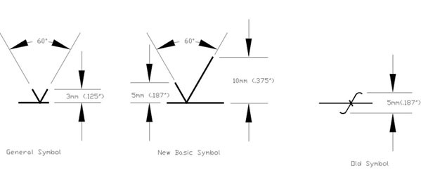
Rules for placement are as follows:
- Finish marks should be placed on the surface to be finished in every view where it shows as a line, even if it is hidden. The point of the V should touch the surface and point toward the solid material of the part. Where the surface is too small or too crowded to contain the mark, it may be placed on an extension line from that surface.
- On a cylindrical surface, the mark should be placed on the rectangular projection of the surface.
- Finish marks may be omitted (a) on holes where finishing operations are specified by notes, (b) where the part is to be finished all over, and a general note to this effect is included. The basic finish mark symbol may be modified to define surface texture, roughness and lay as shown below.
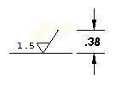

GENERAL PLACEMENT RULES
The following rules may be described as the basic rules for dimension placement, since they may well affect the location of all dimension forms used on a drawing. They often define not only the view on which a dimension should be placed, but also its particular location in that view. They should be kept clearly in mind at all times during the dimensioning process.
- Always dimension each feature of the object on the view where it appears in profile. The best view to use is that one in which the feature shows in its true shape and in visible lines.
- Do not repeat dimensions on the same view or in other views.
- Dimensioning to hidden lines should be avoided if possible (preference rule).
- Notes on the drawing are classified as general or local. General notes refer to the part as a whole (for example, "Finish All Over" or "One Req'd-Steel"); they should be placed in the right hand corner just above the title block, in a position below the views of the object, or in a central position between the views of the object. Local notes apply to a specific local feature only, such as a machined hole. They should therefore be placed as close to the point of application as possible, preferably outside the outline of the view.
- A dimension or note is useless if it cannot be read easily, or if its point of application on the object cannot be determined quickly and correctly. Therefore, dimensions should be placed in clear spaces as close as possible to their point of application. Dimension and extension lines should plainly indicate the limits of application and the lettering should be distinct and clearly related to the proper dimension.
- When dimensioning through crosshatching, the crosshatching should be broken around the dimension figures but not around the dimension line.
- When a dimension figure has been changed so that it no longer agrees with the actual scaled distance on the drawing, it is customary to underline it with a wavy line or mark it NTS (not to scale).
DIMENSION NOT TO SCALE.
- When a dimension value is displayed parenthetically, for example (2.00), the dimension is value is for reference only. This means it will not be used for quality control inspection of the component
3,
- In a half section view, the cutting plane is assumed to bend at the right angle and cuts through only half of the represented object, when the quarter of the object that was cut is removed, the remainder is called a “half section”. A half section view is effective only on symmetrical objects, and its main purpose is to show an object’s internal and external construction in the same drawing .An illustration is provided below.
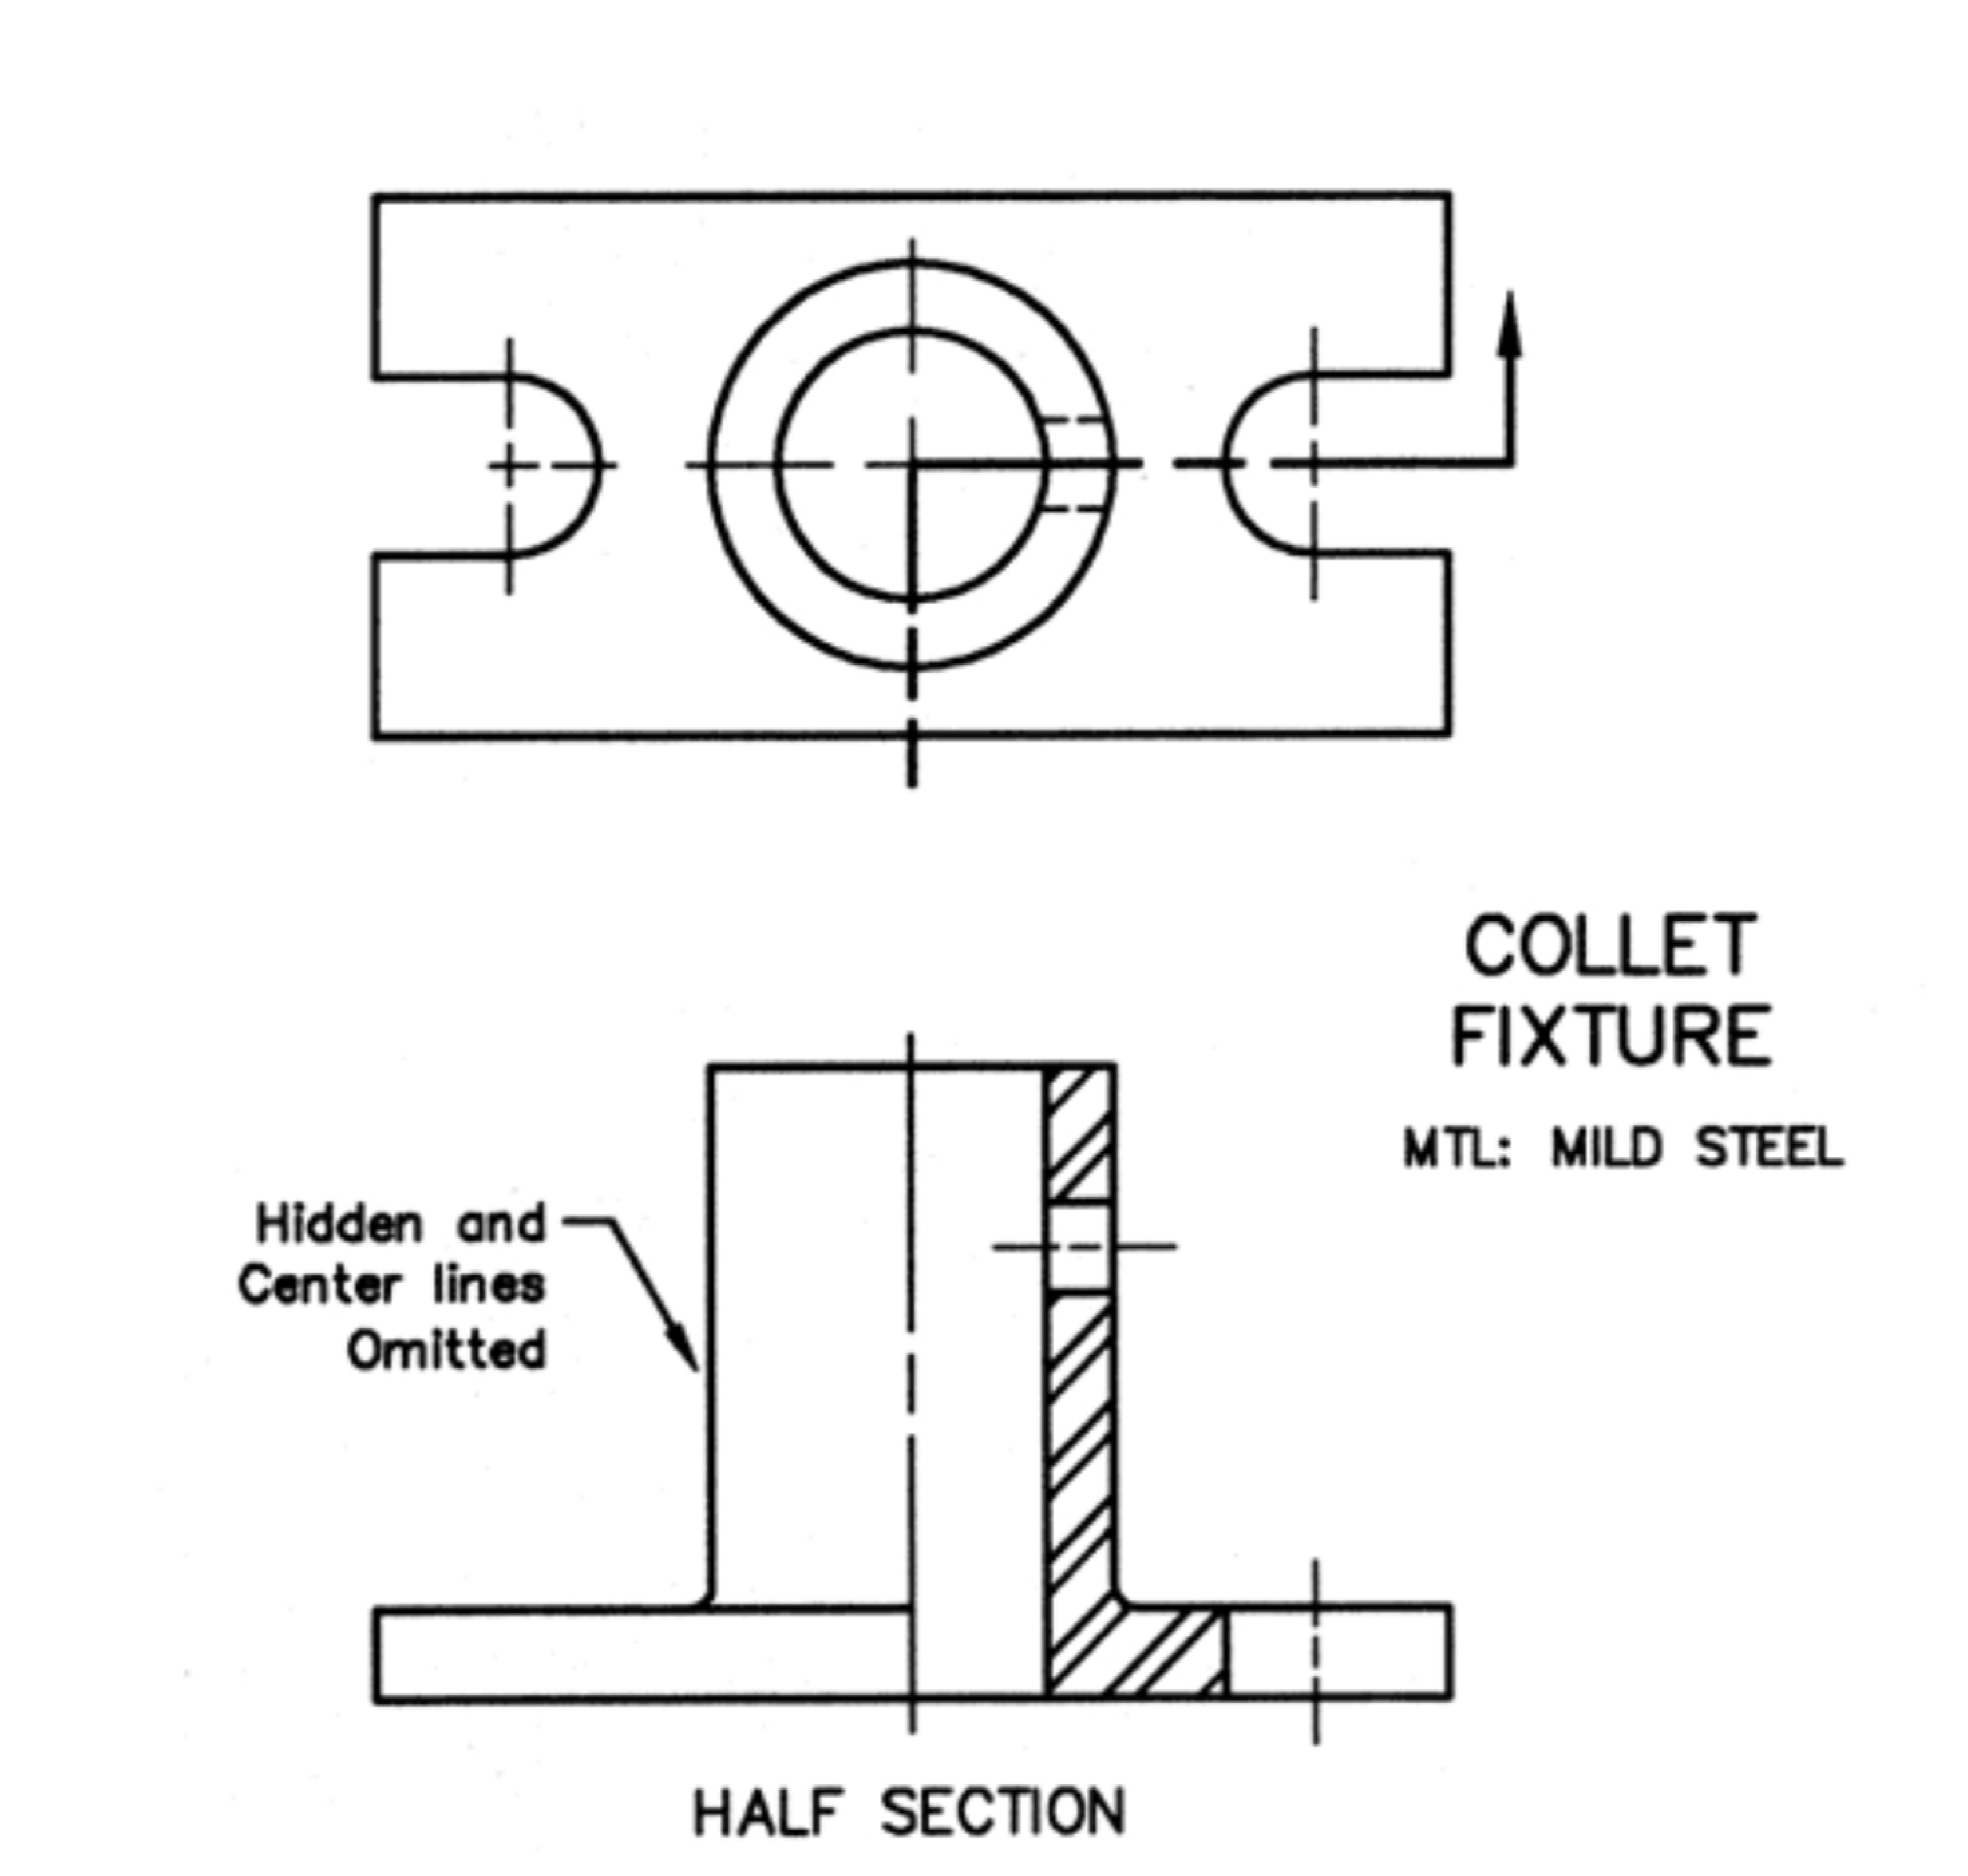
- In a full section view, if the imaginary cutting plane passes through the entire object, splitting the drawn object in two with the interior of the object revealed, this is called a “full section”. A full section is the most widely-used sectional view
- They are terminated by the use of termination and sine text such as
- Closed filled or closed blank
- Dot
- Tick

5 a) scale = 5:1
It means that the original measurement should be multiplied by 5
b) Scale = 1:10
It means that the original measurement should be divided by 10

- a) diameter
b) Radius
c) Square
d) Spherical radius
e) Centre line
f) Cutting plane line
g) Long break

- a) Element are; front view, side view and plain/top view
b) Orthographic projection: it is method used for representing 3-dimensional objects in two dimensions.

- It is when all the plane of the object is arranged in first angle or third angle or afire transformation (projection)
- a) First angle projection: It is a method of creating 2d drawing of a 3D object.
b) Third angle projection: it is a method of orthographic projection which is a technique in portraying a 3D design using a series of 2D views.

OBJECTIVE
- A
- B
- C
- B
- A
- B
- C
- B
- B
- A
- C
- A
- B
- C
- A

