NAME; BABATUNDE ANUOLUWAPO ORIYOMI
MATRIC NO; 19/MHS02/030
DEPT; NURSING SCIENCE
COURSE; CHEM102
LEVEL; 100 LEVEL
ASSIGNMENT ON CARBOXYLIC ACID
- Give the IUPAC names of the following compounds
a HCOOH --------Methanoic acid
b HOOCCH2CH2COOH---------Pentan-1,5-dioic acid
c CH3CH2CH2COOH-----------Butanoic acid
d HO2C-CO2H---------- Ethanedioic acid
e CH3(CH2)4COOH------------Haxanoic acid
f CH3CH=CHCH2CH2COOH--------Hex-4-eneoic acid.

2. Discuss briefly the physical properties of carboxylic acids under the following heading. Physical appearance, solubility, boiling point
Physical appearance; All simple aliphatic carboxylic acid up to C10 are liquids at room temperature. Most other carboxylic acid (acetic acid) also known as glacial ethanoic acid freezes to an ice-like splid below the room temperature.
Boiling point; Boiling point increases with increasing relative molecular mass. Aromatic carboxylic acids are crystalline solids and have higher melting points than aliphatic counterparts of comparable relative molecular mass.
Solubility; Lower molecular mass of carboxylic acids with up to four carbon atoms in their molecules are soluble in water; this largely due to their ability to form hydrogen bonds with water molecules. The water solubility of acids decreases as the relative molecular mass increases because the structure becomes relatively more hydrocarbon in nature and covalent. All carboxylic are soluble in orgsnic solvents.

3. WRITE TWO INDUSTRIAL PREPARATION OF CARBOXYLIC ACID

4. WITH EQUATIONS AND BRIEF EXPLANATION DISCUSS THE SYSTEMATIC PREPARATION OF CARBOXYLIC ACID.

5. WITH CHEMICAL EQUATION ONLY, OUTLINE THE REDUCTION, DECARBOXYLATION AND ESTERIFICATION OF CARBOXYLIC ACID.
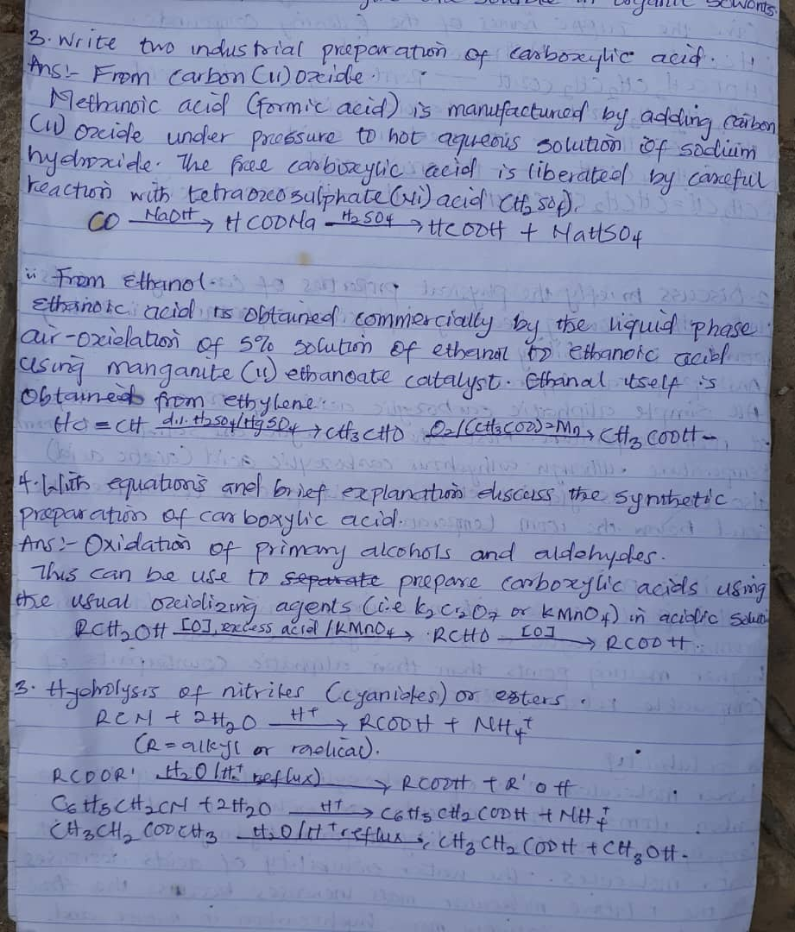
5.