SUBERU ANDA EMMANUEL
COMPUTER ENGINEERING
18/ENG02/088

- We can represent it by drawing thin line on the sectioned surface which is positioned at 45⁰.

- Principles for dimensioning line:
- locate dimension in the adjacent view where possible
- avoid duplicating dimension line
- avoid dimensions over or through the object
- avoid dimension to hidden line
- your dimension line must not touch the drawing
- your leader lines should be thin
- the label on the leader line should not touch the line and the label must be centralized

- Half section: This is a section where the cutting plane is assumed to bend at right angle and cut through only half of the represented object
Full section: This is a section where the cutting plane passes through the entire object splitting the drawing object into two with the interior of the object revealed
- Leader lines are terminated with a sharp slim thick arrow head known as a crossed fill. But they can also be terminated with closed, blank, and thick etc.
- Scale 5:1 is an example of an enlarging scale
Scale 1:10 is an example of a reducing scale
- Diameter:
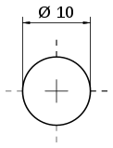
Radius:

Square:
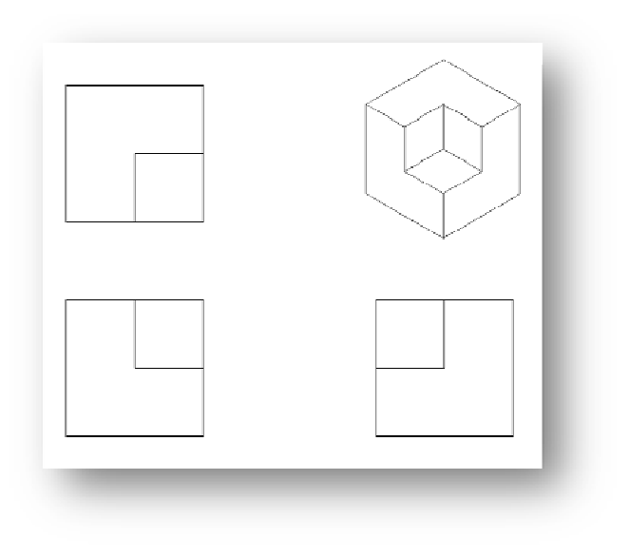
- The plan
- The front elevation

- The end elevation
An orthographic projection (also called artigonal) is the smallest type of projection. It is the representation of a three dimensional object in 2D, in which the method of projection in which an object is depicted using parallel lines to project its outline to the plane.

- Projection of an object is said to be orthographic when the object is divided into plan, end and front elevation, and these are shown using parallel lines to project its outline to the plane.

- First Angle Projection: in this projection method, the object is placed in the first quadrant and is positioned in front of the vertical plane and above the horizontal plane.

- Third angle projection: in this projection the object to be projected is placed in the third quadrant and is positioned behind the vertical plane and below the horizontal plane.
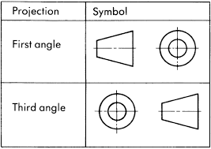
OBJECTIVES

- A 6. B 11. C
- B 7. C 12. A
- C 8. B 13. C
- B 9. B 14. C
- A 10. A 1. D

