Differences between compilers and interpreters
INTERPRETER | COMPILER
Translates program one statement at a time | Scans the entire program and translates it as a whole
It takes less time to analyze the source code but overall execution time is slower | It takes large amount of time to analyze the source code but the overall execution time is comparatively faster
No intermediate code is generated. Hence, memory efficient. | Generates intermediate object code which further requires linking. Hence, requires memory
Continues translating the program until the first error is met, in which case it stops. Hence, debugging is easy. | It generates the error message only after scanning the whole program. Hence, debugging is comparatively hard.
Programming languages like python, ruby use interpreters | Programming languages like C, C++, java use compliers.

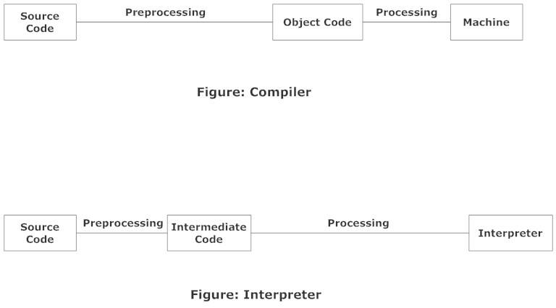
Fig: working of compiler and interpreter

