NAME: NWOYE CHINONYELUM O.
MATRTIC NUMBER: 17/MHS01/212 LEVEL: 300
HISTOLOGY ASSIGNMENT
- Write an essay on the histological importance of eye in relation to their cellular functions.
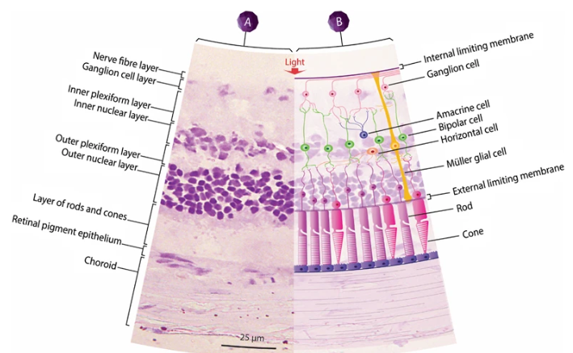
A histological understanding of the layers of the eye is essential for appreciating disease pathophysiology and also understanding certain therapeutic approaches. The eye can be viewed as series of overlapping tissues.
External structures of the eye include eyelashes, eyelids, muscles, accessory glands and conjunctiva.
Internal structures of the eyes consist of three layers of tissues arranged concentrically:
- The Sclera and cornea make up the external layers
- The uvea is the vascular layer in the middle, subdivided into the iris, ciliary body and choroid.
- The retina consists of the innermost layer and it is made up of the nervous tissue.
All these layers can further substitute and undergo histological classification;
Starting from the outermost layer; sclera and cornea
- (a) Sclera (white of the eye): which is a dense connective tissue mainly type 1 collagen fibers, oriented in different directions. The lack of parallel orientation of collagen fibers gives sclera its white appearance as opposed to its transparent nature of the cornea. However, collagen of the sclera and cornea are continuous.
The four layers of sclera from external to internal are episcleral, lamina fusca, endothelium.
- The episcleral is the external surface of the sclera. It is connected to the tenon capsule by thin collagen fibers. At the corneoscleral junction, also known as the limbus, the tenon capsule contacts stroma of the conjunctiva.
(b) Cornea (transparent front layer of the eye):
Consists of type 1 collagen fibers oriented in a uniform parallel direction to maintain transparency.
Consists of five layers epithelium: - epithelium(non-keratinized), stratified squamous epithelium, Bowman’s layer, stroma (also called substant la propria), Descemet’s membrane, corneal epithelium.
- Corneal epithelium: fast growing, regenerating multicellular layer which interacts directly with the tear film.
- Bowman layer: this is a layer of subepithelial basement membrane protecting the underlying stroma. It is composed of type 1 collagen fibers, laminin and several heparan sulfate proteoglycans.
- Stroma: the largest of the cornea the stroma has collagen fibers arranged in a regular pattern, keratocytes maintain the integrity maintain the integrity of this layer. The function of this layer is to maintain transparency, which occurs by the regular arrangement, and lattice structure of the fibrils, whereby scatter from individual fibrils gets canceled by destructive interface, and the spacing of less than 200nm allows for transparency.
- Descemet’s membrane: an acellular layer made of type iv collagen that serve as a modified basement membrane of the corneal endothelium.
- Corneal epithelium: a one thick layer made up of either simple and have pumps that maintain
- fluids balance and prevent swelling of the stroma. When cornea endothelial cells are lost, neighboring cells stretch to attempt to compensate these losses.

MIDDLE LAYER: UVEA (IRIS, CILIARY BODY, CHOROID)
- (a) IRIS;
- (I) Consists of stromal layer with pigmented, fibrovascular tissue (II) pigmented epithelial cells beneath the stroma.
- The sphincter pupillae and the dilator pupillae muscles connect to their stroma.
- The pigmented layer of cells blocks rays of light and ensures that light must move through the pupil to reach the retina.
- The angle formed by the iris and cornea contains connective tissue with endothelial channels called trabecular meshwork, which drains aqueous humor in the anterior chamber into the venous canal of schlemn. From here, fluid drains into episcleral veins.
(b) CILIARY BODY: The tissue that divides the posterior chamber and vitreous body.
- Consists of ciliary muscle and the ciliary epithelium
- The ciliary muscle, via the lens zonules, controls the structure of the lens which is vital for accommodation. Zonules are connective tissue fibers that connects the ciliary muscles and lenses.
- The ciliary epithelium produces aqueous humor which fills the anterior compartment of the eye.
(c) CHOROID:
- Consists of a dense network of blood vessels that supplying nourishment to structures of the eye, housed in a loose connective tissue.
- The choro capillary layer is located in the innermost part of the choroid and supplies the retina.
- The Bruch membrane is an extracellular matrix layer situated between the retina and choroid and has significance in age related macular degeneration, where an accumulation of lipid deposit prevents diffusion of nutrients to the retina.
INNERMOST LAYER: LENS, VITREOUS, RETINA.
- (a) LENS: separates the aqueous and vitreous chambers
- Consists of an outer capsule, a middle layer called cortex, and an inner called the nucleus.
- The capsule is the basement membrane of the lens epithelium which lies below.
- New lens cells differentiate from the lens epithelium and are incorporated peripherally, pushing older lens cells towards the middle.
(b) Vitreous: A jelly like space made up of type II collagen separating then retina and the lens.
(c) Retina: Nervous tissue of the eye where photons of light convert to neurochemical energy of an action potential.
Moreover, the retina itself is divided into various layers as follows: -
- Retinal pigment epithelium: made of cuboidal cells containing melanin which absorbs light. These cells also establish a blood retina barrier through tight junctions.
“Rods and Cones cells”: the layers of cells which photoreceptors and glial cells. Rods are located peripherally and are more sensitive tom light and motion than cones. Cones are higher visual activity and specificity for color vision.
- “outer limiting membrane”: a layer of muller cells and wide cone junctions which serve to separate the photosensitive region of the retina from the areas that transmit the electrical signals.
- Outer nuclei layer: this layer consists of nuclei of rod and cone cells.
- Outer plexiform layer: this layer contains synaptic processes of rod and cone cells.
- Inner nuclei layer: this layer contains the cell body of glial cells, amacrine, bipolar, and glial cells and dendrites of retinal ganglion cells.
- Ganglion cell layer: this layer contains nuclei of retina ganglion cells.
- Nerve fiber layer: this layer contains axons of retina ganglion cells and the astroglia which support them collectively, this axon constitutes of optic nerve.
- Internal limiting membrane: a thin layer of muller glial cells and basement membrane which demarcates the vitreous anteriorly from the retina posteriorly.

TISSUE PREPARATION
The tissue of the eye and orbit can undergo preparation in several different ways for analysis. For light microscopy, Davidson solution and Bouin’s solution are used as fixatives for the eye while glutaraldehyde is the standard choice for electron microscopy. The widely used hematoxylin and eosin stain can be used as well staining the nucleus dark purple. The periodic acid-schiff stain detects carbohydrates in tissue and can be used to visualize basement membrane.
MICROSCOPY LIGHT
In ophthalmology, a specialized form of microscopy called slit lamp bio microscopy is used to visualize anterior and posterior studies of the eye by using an adjustable slit beam of light, an observer can examine layers of the eye and appreciate depth. For example, an ophthalmologist makes evaluate a corneal abrasion in a patent and characterize the severity and extension of the lesion within the layers of the cornea. Several types of illumination techniques exist including diffuse illumination, direct to Cal, retro illumination, specular reflection, indirect proximal illumination and sclerotic scatter.
CLINICAL SIGNIFICANCE
- CHALAZION: A sterile lump often in the upper eyelid caused by obstruction of the meibomian oil glands
- CONJUCTIVITIS: inflammation of the transparent conjunctiva that maybe caused by bacteria or viral infections, allergies or exposure to certain chemicals.
- CATARACTS: A sclerotic nuclear cataract is the most common addictive to opacification in the central nucleus of the lens. Cortical cataract is due to opacification in the cortex and have a distinct wedge- shaped appearance. Posterior subcapsular cataracts arise from behind the sac-like structure of the lens.
- GLAUCOMA: Refers to optic nerve damage related to increased intraocular pressure. Damage of aqueous humor through the trabecular meshwork is often implicated.
- FLOATERS: the sensation of floater is due to changes that occur in the jelly like vitreous layer of the eye.

- Corona virus can penetrate the body through eye and implicate the immune system, briefly discuss the layers of retina for information penetration.
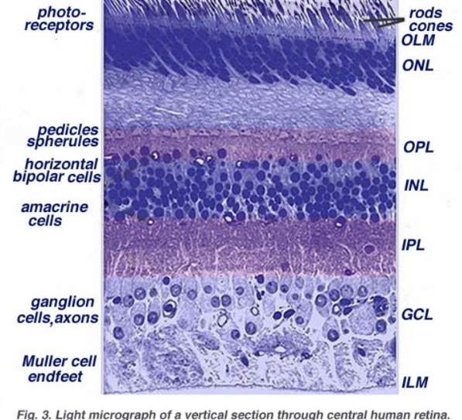
Corona virus can penetrate the eye through the conjunctiva and then spread throughout the body through blood vessels within the conjunctiva.

RETINAL STRUCTURES: LAYERS AND CELLS FOR INFORMATION PENETRATION;
Vertebrate retina is organized in super imposed layers formed by the different cells. The retina contains five major types of cells; photoreceptors (rods and cones), bipolar cells, horizontal cells, amacrine cells and ganglion cells. In general, cell somas are grouped in three distinct nuclear layers separated by two connecting layers plexiform layers, where synapses between cells are formed. The innermost later is the ganglion cell layer which contains the cell bodies of the ganglion cells and displaced amacrine cells. The next cell layer the inner nuclear layer which contains the cell bodies of the amacrine cells, the bipolar cells and the horizontal cells; it may also contain some displaced ganglion cells. The next cell layer is the outer nuclear by, which contains the cell bodies of the photoreceptive, outside of these layers, the layer of photoreceptive outer segment contains the light sensitive elements of the retina. Light must pass through the vitreous humor and the different layers of the retina before receding the outer segment of the photoreceptive.
Interspersed between the ganglia cells layers and the inner nuclear layers is the inner plexiform layer, which contains the axons of bipolar cells, dendrites of ganglion cells and cell processes of amacrine cells (axons and/or dendrites) between the outer and inner nuclear areas is the outer plexiform layer which contains the axon terminals of photoreceptors, the dendrites of bipolar and cell processes of horizontal cells(axons and/or dendrites).
The basic system of retinal information processing consists on a direct pathway of visual information that flows from photoreceptors to bipolar cells to ganglion cells. The ganglion cells form action potential in response to light and implies propagate down the optic nerve to the projection nuclei in the brain. The direct pathway is influenced by two transverse fluxes of modulatory signals coming from horizontal in outer plexiform layer and amacrine cells in inner plexiform layer. Horizontal cells receive input from the photoreceptors and project their processes laterally to influence surrounding bipolar cells. Amacrine cells receive input from bipolar cells and project their processes laterally to influence surrounding bipolar and ganglion cells. Both, horizontal and amacrine cells usually electrical and chemical synapses with neighbor cells of the same type.

