Name: Agada Emmanuella Nkem
Matric No: 18/mhs06/007.
Department: Medical Laboratory Science
Course title: Histology of special senses and neurohistology
Course code: ANA 204
Second Assignment
Answers
Microanatomy of Small Intestine
The Small Intestine is a long tube, longest part of the alimentary canal (about 6m) extending from the Pyloric Sphincter in Stomach and joins large Intestine at ileocecal Sphincter. Small intestine is five times longer than the large intestine but is called small due its relatively smaller diameter of only about 2.54 cm. it has a surface area of approximately 200 m², more than 100 times the surface area of your skin. This large surface area is necessary for complex processes of digestion and absorption.
The coiled tube of the small intestine is subdivided into three regions or segments: the duodenum, jejunum, and ileum.
- Duodenum: is the shortest region of the small intestine which begins at the pyloric sphincter(from the stomach), Just past the pyloric sphincter, it bends posteriorly behind the peritoneum, becoming retroperitoneal, and then makes a C-shaped curve around the head of the pancreas before ascending anteriorly again to return to the peritoneal cavity and join the jejunum. The duodenum can therefore be subdivided into four segments: the superior, descending, horizontal, and ascending duodenum.
- Jejunum: also called the body of the small intestine and runs from the duodenum to the ileum. Jejunum means “empty” in Latin and supposedly was so named by the ancient Greeks who noticed it was always empty at death. No clear demarcation exists between the jejunum and ileum.
- Ileum: The ileum is the longest part of the small intestine. It is thicker, more vascular, and has more developed mucosal folds than the jejunum. The ileum joins the cecum, the first portion of the large intestine, at the ileocecal sphincter (or valve). The jejunum and ileum are tethered to the posterior abdominal wall by the mesentery. The large intestine frames these three parts of the small intestine.
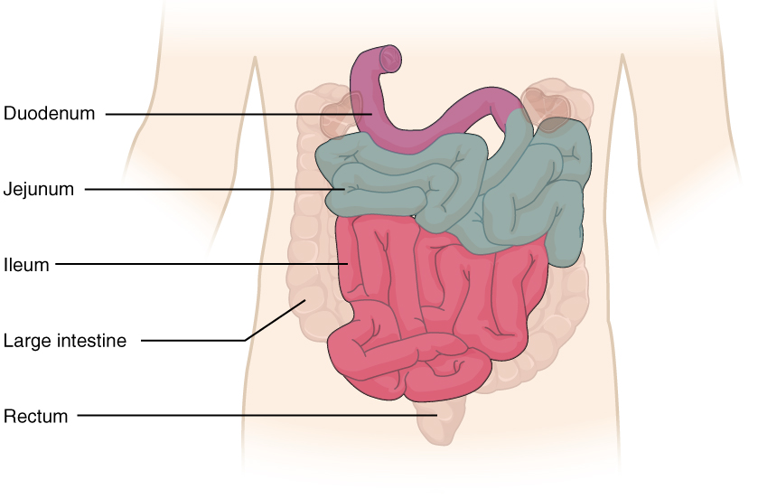
Diagram showing the Small Intestine

Histology of the small intestine
The wall of the small intestine, lined by Simple Columnar Epithelium is composed of the same four layers typically present in the alimentary system;
- Mucosa: consists of epithelium (consists of simple columnar cells), lamina propria, muscularis mucosae.
- Sub-mucosa: contains Lymphatic vessel, Venule, Arteriole.
- Muscle/cartilage layer: consists of two layers of smooth muscle (inner circular and outer longitudinal)
- Adventitia
However, three features of the mucosa and sub-mucosa are unique. These features, which increase the absorptive surface area of the small intestine more than 600-fold, include circular folds, villi, and microvilli. These adaptations are most abundant in the proximal two-thirds of the small intestine, where the majority of absorption occurs.
In addition to the three specialized absorptive features, the mucosa between the villi is dotted with deep crevices that each lead into a tubular intestinal gland (crypt of Lieberkühn), which is formed by cells that line the crevices.

Cells of the Small Intestinal Mucosa
Cells found in the mucosa of the small intestine include;
- Absorptive Cells: Digestion and absorption of nutrients in chime
- Goblet Cells: Secretion of mucus.
- Paneth Cells: Secretion of the bactericidal enzyme lysozyme; phagocytosis
- G cells: Secretion of the hormone intestinal gastrin.
- I cells: Secretion of the hormone cholecystokinin, which stimulates release of pancreatic juices and bile.
- K cells: Secretion of the hormone glucose-dependent insulinotropic peptide, which stimulates the release of insulin.
- M cells: Secretion of the hormone motilin, which accelerates gastric emptying, stimulates intestinal peristalsis, and stimulates the production of pepsin.
- S cells: Secretion of the hormone secretin.

General features of Small intestine.
- The sub-mucosa (the only site of the complex mucus-secreting duodenal glands (Brunner’s glands)), produces a bicarbonate-rich alkaline mucus that buffers the acidic chyme as it enters from the stomach.
- Surface area is increased by intestinal mucosal folding, villi and Microvilli.
- Parasympathetic nerve fibers from the vagus nerve and sympathetic nerve fibers from the thoracic splanchnic nerve provide extrinsic innervation to the small intestine. The superior mesenteric artery is its main arterial supply. Veins run parallel to the arteries and drain into the superior mesenteric vein. Nutrient-rich blood from the small intestine is then carried to the liver via the hepatic portal vein.
- Intestinal glands produce intestinal juice, a slightly alkaline (pH 7.4 to 7.8) mixture of water and mucus. Each day, about 0.95 to 1.9 liters (1 to 2 quarts) are secreted in response to the distention of the small intestine or the irritating effects of chyme on the intestinal mucosa.
- Lamina Propria of small intestine is studded with MALT. It also consists of loose connective tissue that fills the spaces between the intestinal glands and forms the cores of the intestinal villi. Within the core of each villus is a central lacteal, capillaries, and delicate wisps of smooth muscle that extend from the muscularis mucosae.

Functions of Small Intestine
- Small intestine is the site where digestion and absorption occurs. Aids in digestion of Carbohydrates, protein and dietary fats.
- Aids in Absorption.
- Aids in secretion.
- Aids in motility of digested particles by segmentation and a form of peristalsis called migrating motility complexes.
- Aggregations of intestinal MALT, which are typically referred to as Peyer’s patches, are concentrated in the distal ileum, and serve to keep bacteria from entering the bloodstream. Peyer’s patches are most prominent in young people and become less distinct as you age, which coincides with the general activity of our immune system.

Microanatomy of Large Intestine
The Large Intestine is the terminal part of the alimentary canal which runs from the appendix to the anus. It frames the small intestine on three sides. It is about one-half as long as the small intestine but is called large because it is more than twice the diameter of the small intestine, about 3 inches (7.62 cm).
The large intestine is subdivided into four main regions or segments: the cecum, the colon, the rectum, and the anal canal. The ileocecal valve, located at the opening between the ileum and the large intestine, controls the flow of chyme from the small intestine to the large intestine.
- Cecum: is the first part of the large intestine, a sac-like structure that is suspended inferior to the ileocecal valve (about 6 cm long). It receives the contents of the ileum, and continues the absorption of water and salts. Attached to it, is the appendix, a winding tube (7.6-cm long ) which contains lymphoid tissue, suggesting an immunologic function, this organ is generally considered vestigial. In diarrheal illness, the appendix may serve as a bacterial reservoir to repopulate the enteric bacteria for those surviving the initial phases of the illness. Moreover, its twisted anatomy provides a haven for the accumulation and multiplication of enteric bacteria. The mesoappendix, the mesentery of the appendix, tethers it to the mesentery of the ileum.

- Colon: is the second part of the Large intestine. It can be divided into four parts and two flexures. The cecum blends seamlessly with the colon. Upon entering the colon, the food residue first travels up the 1) Ascending Colon on the right side of the abdomen. At the inferior surface of the liver, the colon bends to form the Right Colic Flexure (Hepatic Flexure) and becomes the 2) Transverse Colon.
The region defined as hindgut begins with the last third of the transverse colon and continues on. Food residue passing through the transverse colon travels across to the left side of the abdomen, where the colon angles sharply immediately inferior to the spleen, at the Left Colic Flexure (Splenic Flexure). From there, food residue passes through the 3) Descending Colon, which runs down the left side of the posterior abdominal wall. After entering the pelvis inferiorly, it becomes the s-shaped 4) Sigmoid Colon, which extends medially to the midline.
- Rectum: is the third part of the Large Intestine, final 20.3 cm of the alimentary canal. Food residue leaving the sigmoid colon enters the rectum in the pelvis, near the third sacral vertebra. The rectum extends anterior to the sacrum and coccyx following the curved contour of the sacrum and has three lateral bends that create a trio of internal transverse folds called the rectal valves. These valves help separate the faeces from gas to prevent the simultaneous passage of faeces and gas.
- Anal Canal: is the last part of the Large Intestine which is located in the perineum, completely outside of the abdominopelvic cavity (about 3.8–5 cm) opens to the exterior of the body at the anus. The anal canal includes two sphincters. The internal anal sphincter is made of smooth muscle, and its contractions are involuntary and the external anal sphincter, made of skeletal muscle which is under voluntary control. Except when defecating, both usually remain closed.
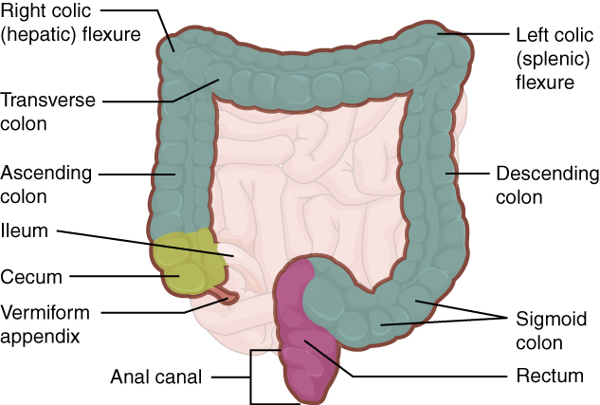
Diagram showing the Large Intestine

Histology of Large Intestine
The wall of the Large Intestine is similar to that of Small Intestine with few notable differences. For example, few enzyme-secreting cells are found in the wall of the large intestine, and there are no circular folds or villi. Other than in the anal canal, which has Stratified Squamous Epithelial in the Mucosa, mucosa of the colon is Simple Columnar Epithelium made mostly of enterocytes (absorptive cells) and goblet cells.
In addition, the wall of the large intestine has far more intestinal glands, which contain a vast population of enterocytes and goblet cells.
Cells found in the Large Intestine
- Goblet cells: secrete mucus that eases the movement of feces and protects the intestine from the effects of the acids and gases produced by enteric bacteria.
- Enterocytes: absorb water and salts as well as vitamins produced by your intestinal bacteria.

Features of Large Intestine
Three features are unique to the large intestine: Teniae Coli, Haustra, and Epiploic Appendages. The teniae coli are three bands of smooth muscle that make up the longitudinal muscle layer of the muscularis of the large intestine, except at its terminal end. Tonic contractions of the teniae coli bunch up the colon into a succession of pouches called haustra (singular = hostrum), which are responsible for the wrinkled appearance of the colon.
Attached to the teniae coli are small, fat-filled sacs of visceral peritoneum called epiploic appendages. The purpose of these is unknown. Although the rectum and anal canal have neither teniae coli nor haustra, they do have well-developed layers of muscularis that create the strong contractions needed for defecation.
The stratified squamous epithelial mucosa of the anal canal connects to the skin on the outside of the anus. This mucosa varies considerably from that of the rest of the colon to accommodate the high level of abrasion as faeces pass through. The anal canal’s mucous membrane is organized into longitudinal folds, each called an anal column, which house a grid of arteries and veins. Two superficial venous plexuses are found in the anal canal: one within the anal columns and one at the anus.
The pectinate line (or dentate line) is a horizontal, jagged band that runs circumferentially just below the level of the anal sinuses (depressions between the anal columns, each called an anal sinus) and represents the junction between the hindgut and external skin. The mucosa above this line is fairly insensitive, whereas the area below is very sensitive. The resulting difference in pain threshold is due to the fact that the upper region is innervated by visceral sensory fibers, and the lower region is innervated by somatic sensory fibers.

Functions of Large Intestine
- The large intestine absorbs water and forms faeces, and is responsible for defecation.
- Bacterial Flora (trillions of bacteria live within the large intestine) breaks down additional carbohydrate residue, and synthesizes certain vitamins.
- The mucosa of the large intestinal wall is generously endowed with goblet cells, which secrete mucus that eases the passage of faeces.
- The entry of faeces into the rectum activates the defecation reflex.
- Depressions between the anal columns, each called an anal sinus, secrete mucus that facilitates defecation.

