NAME: UMIOM FAVOUR VICTOR
MATRIC NUMBER: 18/MHS06/053
DEPARTMENT: MEDICAL LABORATORY SCIENCE
LEVEL: 200
COURSE: BCH 204

Beta oxidation is the catabolic process by which fatty acid molecules are broken down in the cytosol in prokaryotes and in the mitochondria in eukaryotes to generate Acetyl-CoA which enters the citric acid cycle and NADH and FADH₂; which are coenzymes used in the electron transport chain. It is referred to as beta oxidation because the beta carbon of the fatty acid undergoes oxidation to a carbonyl group. 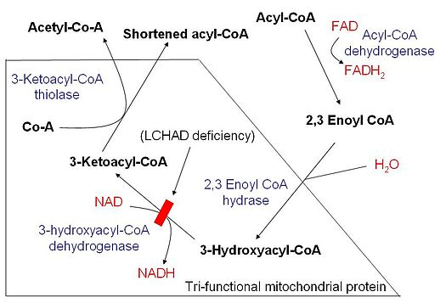

Depending on the length, the Acyl-CoA chain will enter the mitochondria in one of two ways;
- If the Acyl-CoA chain is short, it can freely diffuse through the mitochondrial membrane.
- If the Acyl-CoA chain is long, it needs to be transported across the membrane by the carnitine shuttle. For this, the enzyme carnitine palmitoyltransferase 1(CPT1)-bound to the outer mitochondrial membrane-converts the acyl-CoA chain to acylcarnitine chain, which can be transported across the mitochondrial membrane by carnitine translocase(CAT). Once inside the mitochondria,CPT2-bound to the inner mitochondrial membrane-converts the acylcarnitine back to acyl-CoA. At this point, acyl-CoA is inside the mitochondria and can now undergo beta oxidation. If the acyl-CoA chain is too long to be processed in the mitochondria, it will be broken down by beta oxidation in the perixosomes. Beta oxidation in the peroxisomes yields H₂O₂ instead of FADH2 and NADH, producing heat as a result.
Beta oxidation occurs in four stages. Each stage is catalyzed by a distinct enzyme. Briefly, each cycle of this process begins with an acyl-CoA chain and ends with one acetyl-CoA, one FADH2, one NADH and water, and the acyl-CoA chain becomes two carbons shorter. The total energy yield per cycle is 17 ATP molecules. This cycle is repeated until two acetyl-CoA molecules are formed as opposed to one acyl-CoA and one acetyl-CoA. Thus, the four stages of beta oxidation are described below;
- DEHYDROGENATION: In this stage, acyl-CoA is oxidized by the enzyme acyl CoA dehydrogenase. A double bond is formed between the second and third carbons of the acyl-CoA chain entering the beta oxidation cycle. This stage uses FAD and produces FADH2, which will enter the citric acid cycle and form ATP to be used as energy. 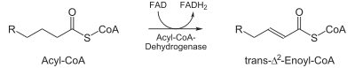
- Hydration: in this stage, the double bond between the second and third carbon of trans-enoyl –CoA is hydrated, forming the end product L-beta-hydroxyacyl CoA, which has a hydroxyl group in cabon two, in place of the double bond. This reaction is catalyzed by another enzyme called enoyl CoA hydratase. This stage requires water. 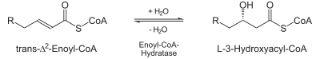
- OXIDATION: in this stage, the hydroxyl group in carbon two of L-beta-hydroxyacyl CoA is oxidized by NAD+ in a reaction that is catalyzed by 3-hydroxyacyl-CoA dehydrogenase. The end products are beta-ketoacyl CoA and NADH+H. NADH will the citric acid cycle and produce ATP that will be used as energy. 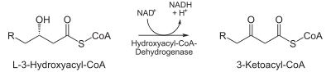

Thus, the general reaction of one cycle of beta oxidation is:
C_{n}-acyl-CoA+FAD+NAD⁺+H₂O+CoAC_{n2}-acyl-CoA+FADH₂+NADH+H⁺+acetyl-CoA

