OKANDEJI JASMINE OGHENEMARO
16/MHS01/175
PHARMACOLOGICAL BIOCHEMISTRY
ASSIGNMENT 2

QUESTION: With the aid of relevant examples, describe drug transport by membrane proteins

ANSWER
Drug transporters are membrane proteins present in various tissues such as the lymphocytes, intestine, liver, kidney, testis, placenta, and central nervous system. These transporters play a significant role in drug absorption and distribution to organic systems, particularly if the organs are protected by blood-organ barriers, such as the blood-brain barrier or the maternal-fetal barrier. In contrast to neurotransmitters and receptor-coupled transporters or other modes of interneuronal transmission, drug transporters are not directly involved in specific neuronal functions, but provide global protection to the central nervous system. The lack of capillary fenestration, the low pinocytic activity and the tight junctions between brain capillary and choroid plexus endothelial cells represent further gatekeepers limiting the entrance of endogenous and exogenous compounds into the central nervous system. Drug transport is a result of the concerted action of efflux and influx pumps (transporters) located both in the basolateral and apical membranes of brain capillary and choroid plexus endothelial cells. By regulating efflux and influx of endogenous or exogenous substances, the blood-brain barrier and, to a lesser extent the blood-cerebrospinal barrier in the ventricles, represents the main interface between the central nervous system and the blood, i.e., the rest of the body.

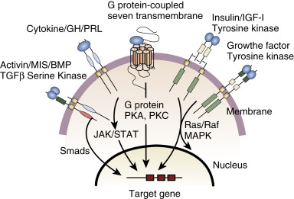

Figure 1: Membrane proteins
DRUG TRANSPORT OF PARACETAMOL
Paracetamol (acetaminophen) is one of the most popular and widely used drugs for the treatment of pain and fever. It occupies a unique position among analgesic drugs. Unlike NSAIDs it is almost unanimously considered to have no anti-inflammatory activity and does not produce gastrointestinal damage or untoward cardiorenal effects. Unlike opiates it is almost ineffective in intense pain and has no depressant effect on respiration. Although paracetamol has been used clinically for more than a century, its mode of action has been a mystery until about one year ago, when two independent groups (Zygmunt and colleagues and Bertolini and colleagues) produced experimental data unequivocally demonstrating that the analgesic effect of paracetamol is due to the indirect activation of cannabinoid CB(1) receptors. In brain and spinal cord, paracetamol, following deacetylation to its primary amine (p-aminophenol), is conjugated with arachidonic acid to form N-arachidonoylphenolamine, a compound already known (AM404) as an endogenous cannabinoid. The involved enzyme is fatty acid amide hydrolase. N-arachidonoylphenolamine is an agonist at TRPV1 receptors and an inhibitor of cellular anandamide uptake, which leads to increased levels of endogenous cannabinoids; moreover, it inhibits cyclooxygenases in the brain, albeit at concentrations that are probably not attainable with analgesic doses of paracetamol. CB(1) receptor antagonist, at a dose level that completely prevents the analgesic activity of a selective CB(1) receptor agonist, completely prevents the analgesic activity of paracetamol. Thus, paracetamol acts as a pro-drug, the active one being a cannabinoid. These findings finally explain the mechanism of action of paracetamol and the peculiarity of its effects, including the behavioral ones. Curiously, just when the first CB(1) agonists are being introduced for pain treatment, it comes out that an indirect cannabino-mimetic had been extensively used (and sometimes overused) for more than a century.
DRUG TRANSPORT OF INSULIN
The insulin receptor (IR) is a large, multi-domain, integral membrane protein with both extracellular and intracellular domains. Domains positioned outside the cell bind insulin and activate the tyrosine kinase (Tyr-K) catalytic domain located within the cell. The Tyr-K, in turn, activates various other proteins in a signaling cascade leading to insulin’s various functions. Key steps in insulin signaling, include:
- The ligand (insulin) binds to IR, a receptor tyrosine kinase.
- Conformational changes resulting from insulin:IR binding activates the tyrosine kinase catalytic domain, which phosphorylates specific tyrosine residue found within the juxtamembrane and Tyr-K domains of the IR.
- The activated IR Tyr-K in turn phosphorylates other proteins, such as insulin receptor substrate (IRS), which activate proteins downstream in the signaling cascade - phosphoinositide 3-kinase (PI3K), phosphoinositide-dependent kinase-1 (PDK-1), and protein kinase B (PKB or AKT), etc.
- The signaling processes enable translocation of glucose transporters (e.g., GLUT4) to the cell surface, where they contribute to glucose uptake. This insulin-responsive glucose uptake is critical for energy, particularly in muscle and fat cells.
Following entry into cells (e.g., facilitated by GLUT4) the glucose is either metabolized for energy, converted to glycogen for storage, stored as triglycerides, and/or used for cell growth processes.
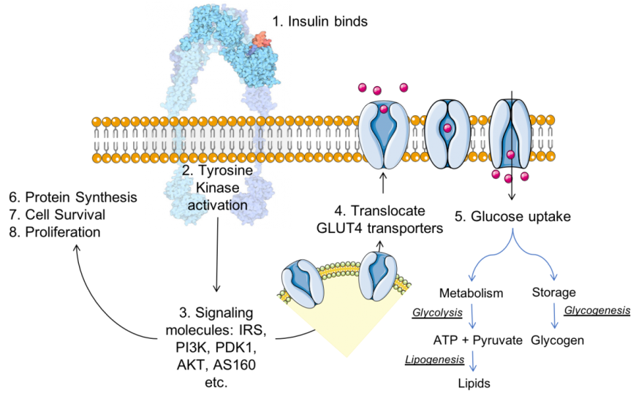
Figure 2: Insulin (colored red) – insulin receptor (colored blue) complex formation results in a signaling cascade, for insulin function.

