THEORY
1.Sectioned surfaces on drawings are represented using dash lines.
(2)
- Dimensions should not be duplicated.
- No unnecessary dimensions should be used.
- Dimensions should be placed at finished surfaces or important center lines.
- Holes should be located by their centre lines.
- Never cross dimension lines.
- Avoid crossing extension likes when possible.
- In general, a circle is dimensioned by its diameter, an arc by its radius.
- Avoid dimensioning to hidden lines when ever possible.
- A dimension should be attached to only one view.
- Leaders should slope at a 30,45 or 60 degrees
Angle.
3. Half section: A half section is a view of an object showing one half of the view in a section, in a drawing diagonal lines on section drawing are used to indicate areas that have been theoretically cut. The lines are called section lining or cross hatching.
ii. Full section: If the imaginary cutting plane passes through the entire object, splitting the drawn object in two with the interior of the object revealed, this is called a "full section." A full section is the most widely-used sectional view.
4. Leader lines can be terminated in four different ways ;
(ii)closed filled or closed blank (ii) Dot (iii) Tick (iv) Dimension leader.
5. Scale 5:1 means a 50mm line is to be drawn at the scale ( 5 times more than it’s original size. While scale=1:10 means the object is 10 times smaller than than in real life scale 1:1.
6. Diameter (ii) radius R (iii) square SQ (iv) spherical radius SR
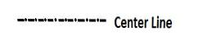
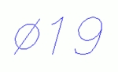
( a)
- 7. Orthographic projection is the means of representing three dimensional objects in two dimensions. a method of projection in which an object is depicted using parallel lines to project its outline on to a plane. The following are elements to be considered while obtaining projection; Dimensions which are parallel to the direction of viewing will not be seen. Edges which are parallel to
- the direction of viewing are seen as points. Surfaces
- which are parallel to it are seen as lines.
- The visible edges and the intersection if the surfaces
- are shown by object lines. But the hidden edges are
- shown by dotted lines.
- The centre linens of the symmetrical parts like whole
- cylinder etc. should be clearly shown.
8. The projection of an object is called orthographic when the whole object is represented in 2 dimensions.
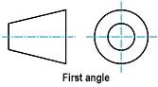
9. First angle projection: this is a method of creating a 2dDdrawing of a 3Dobject .
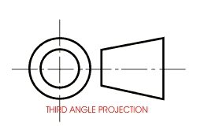
10. Third angle projection: this is a method of orthographic projection which is technique in portraying a 3D design using a series of 2D view.
OBJECTIVES
1.Reference plane
2.False
3. Directly
4. 120°
5. 60°
6. Rivet
7. Crowning
8. 45°
9. A circle
10. An eclipse
11. Cylinder
12. Frustrum
13. Pivot bearing
14. 55°
15. Horizontal plane

