NAME: EGBURHE OGHENEOCHUKO JEFFREY

DEPARTMENT: COMPUTER ENGINEERING

MARTIC NO: 18/ENG02/035

1. How do you represent a sectioned surface on a drawing?

A section drawing shows a view of a structure as though it had been sliced in half or cut along imaginary plane’.

The direction of the plane through which the section is cut is often represented on plan drawings and elevations by a line of long and short dashes, called a section plane.If there are a number of sections a line may have letters at each and indicating the name of the name of the section drawing

1. List out the various principles to be followed while dimensioning a drawing.
2. Dimension lines are narrow continuous lines 0.35mm thick
3. When several dimensions are placed on the same side of the drawing, position he shortest dimension nearest components and this will avoid lines crossing
4. Overall dimensions which are given for surfaces that can be seen in two projected views are generally best positioned between these two views
5. Dimensions should not be duplicated and should not be drawn in two different ways.
6. Holes are located by their centerlines which may be extended and used as an extension line
7. The numbers should be clear and legible’
8. The extension and dimensions lines should not intersect
9. Explain the terms, (*a*) half section, (*b*) Full section

Half Section

A half section is a view of an object showing one-half of the view in section. The diagonal lines on the section drawing are used to indicate the area that has been theoretically cut. Symmetical parts can be shown in half sections and half sections without hidden lines.

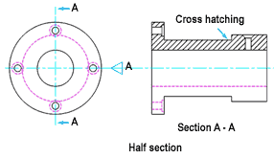

Full Section

Full section is the imaginary cutting plane passes though the entire object, splitting the drawn object in two with the interior of the object revealed this is a full section. When the cutting plane is right across the object it results in a full sectional view (commonly referred to as a full section).

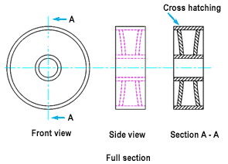

1. How are leader lines terminated?

Leaders lines are terminated with arrow heads

1. What do you understand by, (a) scale = 5:1 and (b) scale = 1:10?

Scale 5:1

A scale of 5:1 means that everything is in reality five times as small. In other words: 1 cm in the drawing is 0.2 cm in reality.

Scale 1:10

A drawing at a scale of 1:10 means that the object is 10 times smaller than in real life scale 1:1

1. Give the shape identification symbols for the following: (*a*) diameter, (*b*) radius, (*c*) square and (*d*) spherical radius.

Diameter: ⌀

Radius: R

Square:

Spherical Radius: SR

Center line:

Cutting plane line:

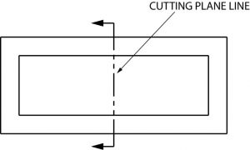

1. Centre line, (*b*) cutting plane line and (*c*) long break

Long break:

1. What are the elements to be considered while obtaining a projection and what is an orthographic projection?

An orthographic projection means representing the three dimensional object with two dimensional drawings. The elements are front view, side view and plan view

1. When is a projection of an object called an orthographic projection?

When the figure is drawn in the first or third angle elevation

1. Explain the following, indicating the symbol to be used in each case: (*a*) First angle projection, (*b*) Third angle projection

First Angle Projection

First angle projection is a types of Orthographic projection used to draw 3D objects in 2D plane. In 1st angle projection system, object is placed in the first quadrant and lies in between observer and plane of projection.

Third angle Projection

Third Angle projection is a method of orthographic projection which is a technique in portraying a 3D design using a series of 2D views.

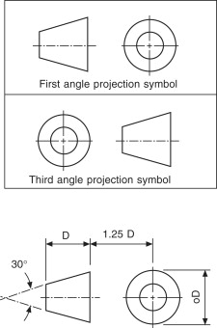

Objectives

1. To project the auxiliary view, an imaginary plane known as ……A……….
2. Reference Plane
3. Principle plane
4. Normal plane
5. Inclined plane
6. Reference plane is parallel to the direction of view
7. True Answer False
8. False
9. Dimension of one side of the inclined surface can be……C…………projected on the reference plane
10. Indirectly
11. Equally
12. Directly
13. Normally
14. In isometric projection the three edges of an object are inclined to each other at

(a) 60o (b) 120o (c) 100o (d) 90o ANSWER B

5. The angle between the flanks of a metric thread is

1. 60o (b) 90o (c) 75o (d) 55o ANSWER A

6. Which one among the following represents a permanent fastener

a) Nut b) Rivet c) Screw d) Bolt ANSWER B

7. The convexity provided on the rim of the solid web cast iron pulley is called

a) Bending b) Curving c) Crowning d) Riveting ANSWER C

8. Section lines are generally inclined with the base, at an angle of

a) 30o b)45o c)60o d)90o ANSWER B

9. The isometric view of a sphere is always

a) a circle b) an ellipse c) a Parabola d) a Semicircle ANSWER

10. In isometric projection, the four center method is used to construct

a) an ellipse b) a square c) a triangle d) a rectangle ANSWER A

11



The answer is C

12



The answer is A

13. A footstep bearing is a

a) journal bearing b) thrust bearing c) pivot bearing d) pedestal bearing ANSWER C

14. The angle between the flanks of B.S.W. thread is

a) 60o b) 65o c) 55o d)75o ANSWR C

15. Top view is projected on the

a) Vertical Plane b) Corner Plane c) Side Plane d) Horizontal Plane

ANSWER D