OKPODU JESSICA ONAJITE
18/ENG07/010
PETROLEUM ENGINEERING
ENG 232

- Section views are a very important aspect of design and documentation and are used to improve clarity and reveal interior features of parts. Sectional drawings are multiview technical drawings that contain special views of a part or parts, a view that reveal interior features. In the figure a regular multiview drawing and a sectioned multiview drawing of the same part in the front view, the hidden features can be seen after sectioning. When an object becomes more complex, as in the case of an automobile engine block, a clearer presentation of the interior can be made by sketching the object as it would look if it were cut apart. In that way, the many hidden lines on the sketch are eliminated, THIS PROCESS IS CALLED SECTIONING.

- Dimensions should not be duplicated, nor should the same info be given in two different ways.

- Dimensions should be attached to the view that best shows the contour of the feature being dimensioned.
- Wherever possible avoid dimensioning to hidden lines.
- Avoid dimensions over or through the object.
- Wherever possible locate dimensions in adjacent views.
- In general a circle is measured by its diameter circle with line through it, and arc by its radius R0.50.
- Holes are located by their centerlines, which may be extended and used as an extension line.
- Holes should be located and sized in the view that shows that feature as a circle.

- Full section: When a cutting plane line passes entirely through an object, the resulting section is called a full section.
Half section: If the cutting plane is passed halfway through an object, and one-quarter of the object is removed, the resulting section is a half section.
- A leader line creates a connection between a drawing of an item and some text. A dimension line, terminating at either end in a long, pointed arrowhead, is inserted between each pair of extension lines. It is a thin line, and, except in architectural and structural drafting, it is usually broken to provide a space for the dimension numerals.
- (a) 5:1 : A 50mm line is to be drawn at a scale of 5:1 (I.e 5 times more than its original size). The measurement 50mm is multiplied by 5 to give 250mm. A 250mm line is drawn.
(b) 1:10 : A drawing at a scale of 1:10 means that the object is 10 times smaller than in real life scale 1:1. You could also say, 1 unit in the drawing is equal to 10 units in real life.

- (i) diameter : (⌀)
(ii) radius: the “R” is being used to represent radius.
(iii) square: basics, structure, and balance.

(iv) spherical radius:
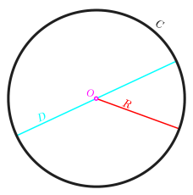

- an orthographic projection drawing consists of three different views: a front view, a top view, and a side view. An orthographic drawing represents a three-dimensional object using several two-dimensional views of the object.

- when the principal planes or axes of an object in an orthographic projection are not parallel with the projection plane, but are rather tilted to reveal multiple sides of the object, the projection is called an axonometric projection.

- First angle projection is a method of creating a 2D drawing of a 3D object.

The 3rd Angle projection symbol shows the orientation of a cone in the 3rd Angle projection.

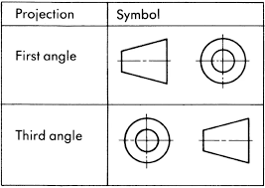
Objectives

1) A –reference plane
2) A - true
- C - directly
- B -120°
- A -60°
- D – bolt
- C – crowning
- D - 90°
- B – an ellipse
- A- an ellipse
- C – cylinder
- A – cone
- C – pivot bearing
- C -55°
- D –horizontal plane

