APPLICATION OF IMAGING TECHNIQUES TOWARDS FOETAL ALCOHOL SYNDROME
GROUP 4 MEMBERS
S/N | NAME | MATRIC NUMBER
1. | CHIMA-BOMS CHIMGOZIRIM | 17/MHS03/012
2. | NWACHUKWU CHINAZA | 17/MHS03/033
3. | AJUWA EPHRAIM UGONNA | 17/MHS03/004
4. | OLADIMEJI OLUWASEUN OREOLUWA | 17/MHS01/253
5. | AYENI IFEOLUWA | 17/MHS01/074

OVERVIEW
Fetal alcohol syndrome (FAS) is a condition in a child that results from alcohol exposure during the mother's pregnancy. Fetal alcohol syndrome causes brain damage and growth problems.
Until recently, it was impossible to evaluate the effects of ethanol on human brain structure and function in vivo. However, novel neuroimaging techniques have been employed on individuals with FAS to provide insights into the structural and functional alterations caused by prenatal ethanol exposure. They include:
-Magnetic resonance imaging (MRI)
-Diffusion tensor imaging (DTI)
-Single photon emission computed tomography (SPECT)
-functional MRI (fMRI)
-Magnetic Resonance Spectoscopy (MRS)
MAGNETIC RESONANCE IMAGING IN FETAL ALCOHOL SPECTRUM DISORDER (FASD)
It is now widely accepted that heavy alcohol consumption during pregnancy can have life-long adverse consequences on the developing embryo and fetus. Fetal Alcohol Spectrum Disorders (FASD) is the non-diagnostic umbrella term used to refer to the entire continuum of outcome severity. (Eileen M. Moore, Robyn Migliorini and Edward P. Riley an article on FASD: Neuroimaging Findings)
Magnetic Resonance Imaging has far- reaching real and possible clinical applications. Its usefulness has been best explored and realized in the Central Nervous System, especially the posterior fossa and brain stem, where most abnormalities are better identified than with computed tomography. Its lack of ionizing radiation and extreme sensitivity to normal and abnormal patterns of myelination make magnetic resonance imaging advantageous for diagnosing many neonatal and pediatric abnormalities. Magnetic resonance imaging is a sensitive technique for detecting deficient or delayed myelination of the brain in children. Inversion recovery seems to be the most sensitive technique because it optimizes the contrast between grey and white matter.
Magnetic Resonance Imaging findings among children with fetal alcohol syndrome, partial fetal alcohol syndrome and alcohol related neurodevelopmental disorders. Since the identification of Fetal Alcohol Syndrome over 40 years ago; much has been learned about the detrimental effects of prenatal alcohol exposure on the developing brain. Structural magnetic resonance imaging has described morphological differences in the brain and their relationships to cognitive deficits and measures of facial dysmorphology. Functional magnetic resonance imaging has revealed differences in neural activation patterns underlying sensory processing, cognition and behavioral deficits.
MRI studies have shown and reported overall volume reductions in cranial, cerebral and cerebellar vaults in Fetal Alcohol Syndrome (Mattson et al, 1992,1994,1996; Swayze il et al; 1997; Archibald et al., 2001; Sowell et al 2001a, 2002a; Autti-Ramo et al.,2002) furthermore other studies have suggested that this decrease is not uniform but rather that the parietal lobes(Archibald et al 2001; Sowell et al 1996; Autti- Ramo et al 2002; O’Hare et al., 2005) appear to be especially sensitive to alcohol insult.
Among the most serious consequences of in utero alcohol exposure are the effects on the brain and the resulting alterations in behavior and cognition, it is important to note that these effects can occur even among individuals without all the features of FAS. Many studies have confirmed the abiity of MR imaging to detect and show abnormalities in the entire central nervous system, including the brain, the brain stem and the spinal cord. This ability has caused some imaging physicians to identify MR imaging as the preferred imaging modality for many central nervous system diseases .Magnetic resonance imaging has revealed an overall reduction in brain size and also has revealed 4 major brain structures that are affected (either having an abnormal shape or a size reduction) by prenatal alcohol exposure and these structures are as follows: The corpus callosum, The caudate Nucleus, The hippocampus, The cerebellum.
There are reports of variations in the shape of bilateral caudate and hippocampal nuclei, corpus callosum malformation and also shape changes in the cerebral cortex( cortical folding abnormalities which range from lissencenphaly which is the absence of cortical folding to polymicrogyria which is the presence of many or small folds. Cortical complexity which is the average ratio of sulcal to gyral surface area is reduced in children with prenatal alcohol exposure (De Guio)
Diffusion Tensor Imaging (DTI)
Over the past 5 years, Diffusion Tensor Imaging (DTI) has begun to provide new evidence about the effects of prenatal alcohol exposure on white matter development. DTI, which examines microstructural tissue integrity, is sensitive to more subtle white matter abnormalities than traditional volumetric MRI methods.
It is sensitive to degree and direction of water permeability in biological tissues, providing in vivo indices of white matter microstructure.
It makes use of the random properties of water diffusion to generate images that can be used to evaluate tissue microstructure. Two important variables of interest in DTI are the apparent diffusion coefficient (ADC) and fractional anisotropy (FA).
ADC is a measure of the ability of water to diffuse within a given tissue compartment. FA is an index measure of anisotropy, where values range from 0 to 1, with higher values indicating more restricted diffusion, and thus more coherent microstructure.
So far, DTI data suggests that white matter microstructural abnormalities depend on the severity of fetal alcohol syndrome. Abnormalities are prominent in the corpus callosum, but also evident in major anterior-posterior fiber bundles. These subtle abnormalities are correlated with neurocognitive deficits, especially in processing speed, non-verbal ability, and executive functioning.
Subjects with Fetal alcohol syndrome have decreased FA and increased ADC in the genu and splenium of the corpus callosum as compared to controls, suggesting microstructural abnormalities in this region.
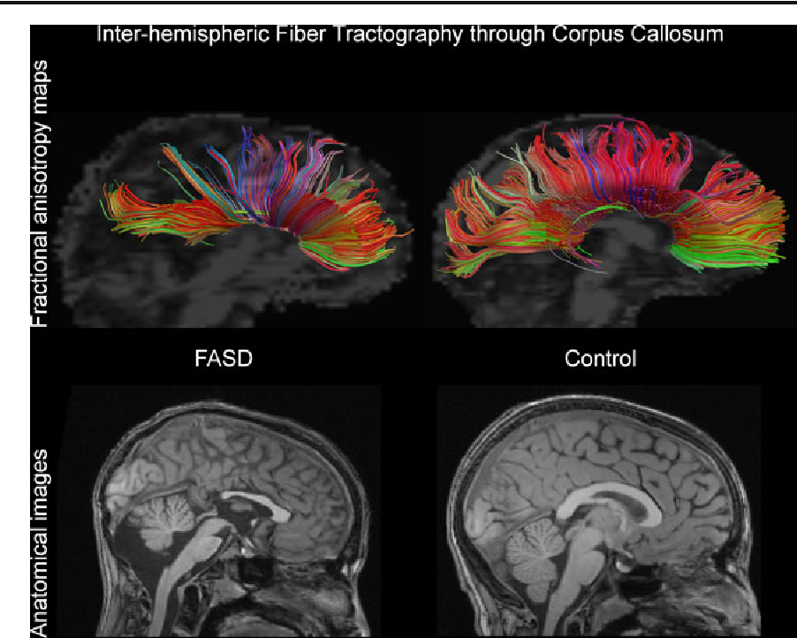
Inter-hemispheric fiber tracking through the corpus callosum in a 12 year-old boy with partial FAS and gross structural abnormalities including partial agenesis of the corpus callosum (left panel) compared with a non-exposed 12 year-old male control subject (right panel). The top panels are DTI tractography images overlaid on fractional anisotropy maps. The bottom panels are T1-weighted anatomical images.
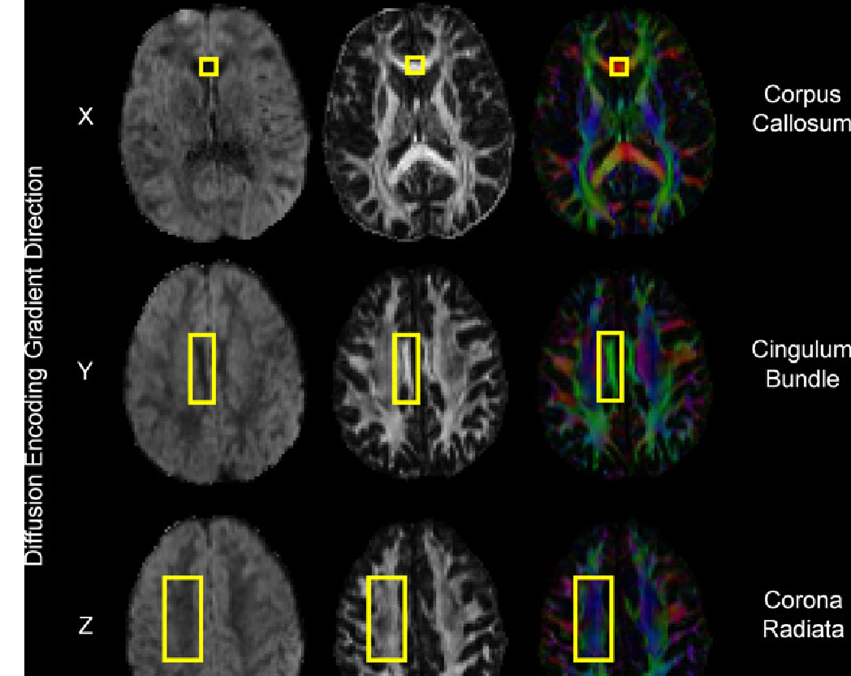
The first column illustrates raw diffusion-weighted images with diffusion weighting applied in “X” (left-right), “Y” (anterior-posterior), and “Z” (superior-inferior) planes. Signal attenuation (dark regions) is the result of water diffusion in the plane of the diffusion encoding gradient. The second column shows fractional anisotropy (FA) maps at the same slices. The third column shows diffusion encoded color maps, where red indicates diffusion in “X”, green indicates diffusion in “Y”, blue indicates diffusion in “Z”, and combinations of the colors indicates diffusion in combinations of “X”, “Y”, and/or “Z”. Yellow boxes highlight structures within each image to illustrate signal attenuation in the diffusion images and the corresponding color encoding in the diffusion encoded color maps.
Single-Photon Emission Computed Tomography (SPECT).
SPECT (single-photon emission computed tomography) has proven to be a great asset in studying the effect of fetal alcohol syndrome.
- Differences in cerebral blood flow (CBF), are measured using SPECT and have been reported in the temporal (Bhatara et al., 2002), frontal, parietal-occipital regions of the brain (Riikonen et al.,1999).
- SPECT also suggest lower levels of serotonin transporter in the medial frontal cortex and higher levels of dopamine transporter binding in basal ganglia (Riikonen et al.,2005).Abnormal neurotransmitter levels may mediate behavioral problems seen in individuals with FASD, as serotonin has been linked with inhibition and impulsive aggression(witte et al.,2009).
Functional Magnetic Resonance Imaging
Physicians use fMRI to assess how risky brain surgery or similar invasive treatment is for a patient and to learn how a normal, diseased or injured brain is functioning. They map the brain with fMRI to identify regions linked to critical functions such as speaking, moving, sensing, or planning. This is useful to plan for surgery and radiation therapy of the brain. Clinicians also use fMRI to anatomically map the brain and detect the effects of tumors, stroke, head and brain injury, or diseases such as Alzheimer's, and developmental disabilities such as Autism etc.
Functional magnetic resonance imaging has revealed differences in neural activation patterns underlying sensory processing, cognition and behavioral deficits
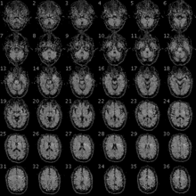
fMRI image of the brain of a participant in the Personal Genome Project.
fMRI has been used clinically to map functional areas, check left-right hemispherical asymmetry in language and memory regions, check the neural correlates of a seizure, study how the brain recovers partially from a stroke, test how well a drug or behavioral therapy works, detect the onset of Alzheimer's, and note the presence of disorders like depression. Mapping of functional areas and understanding lateralization of language and memory help surgeons avoid removing critical brain regions when they have to operate and remove brain tissue. This is of particular importance in removing tumors and in patients who have intractable temporal lobe epilepsy. Lesioning tumors requires pre-surgical planning to ensure no functionally useful tissue is removed needlessly. Recovered depressed patients have shown altered fMRI activity in the cerebellum, and this may indicate a tendency to relapse.
fMRI is a potentially powerful tool that can assess regional brain activation in response to performance on specific cognitive, perceptual, or motor tasks. Many studies, spanning a broad array of disease states and disorders, have used this tool to document activation that is different in intensity and/or spatial extent in subjects with brain damage and/or impairment on the specific tasks being assessed. Only three FASD fMRI studies have been published to date. Significant differences in brain activation patterns were observed between FASD and Control groups during verbal learning, response inhibition, and spacial working memory tasks. All of these tasks require higher-order cognitive abilities that are often deficient in individuals with FASD. All three studies clearly demonstrated the value of fMRI in this clinical population. The present study extends this line of inquiry to nonspatial working memory, using an fMRI N-back paradigm. Working memory is the ability to hold and manipulate information online in the brain. The constituent processes involved in working memory are encoding, rehearsal, storage, and executive processes on the contents of stored memory. Working memory is subserved by a neurocognitive network comprising regions involved in attention (anterior cingulate), executive function (dorsolateral prefrontal cortex), and short-term mnemonic strategies (parietal cortex and precuneous).

Recent functional neuroimaging (fMRI, MEG, EEG) studies of individuals with prenatal alcohol exposure
Brain region | Modality | Findings | References
Whole Brain | fMRI | • ↓ Baseline functional connectivity  ↓ Deactivation of default mode network during in dysmorphic group only | • Santhanam et al. [59]
 |  | • ↓ Interhemispheric connectivity during resting state | • Wozniak et al. [60]
 |  | • Abnormal functional connectivity during resting state:  ↑ characteristic path length  ↓ network global efficiency | • Wozniak et al. [61]

MRI² was used to assess neuroactivation in seven brain regions (anterior cingulate; anterior and posterior parietal lobe; and the dorsolateral prefrontal, inferior frontal, middle frontal, and precentral regions of the frontal lobe) during performance of N-back working memory tasks.

Functional magnetic resonance imaging
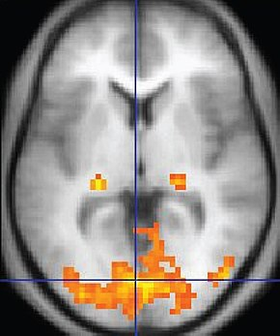
An fMRI image with yellow areas showing increased activity compared with a control condition.
Purpose | Measures brain activity detecting changes due to blood flow.

MAGNETIC RESONANCE SPECTROSCOPY
Objective of the study is to analyze the metabolic constitution of brain areas through proton magnetic resonance spectroscopy in children affected with fetal alcohol spectrum disorder compared with normal children.
METHOD
The sample of this case-control study included eight boys with epidemiologic history of in utero exposure to alcohol (median age 13.6+/-3.8 years) who were diagnosed with fetal alcohol spectrum disorder, and eight controls (median age 12.1+/-3,4 years). An 8 cm(3) single voxel approach was used, with echo time 30 ms, repetition time 1500 ms, and 128 acquisitions in a 1.5T scanner, and four brain areas were analyzed: anterior cingulate, left frontal lobe, left striatum, and left cerebellar hemisphere. Peaks and ratios of metabolites N-acetylaspartate, choline, creatine, and myo-inositol were measured.
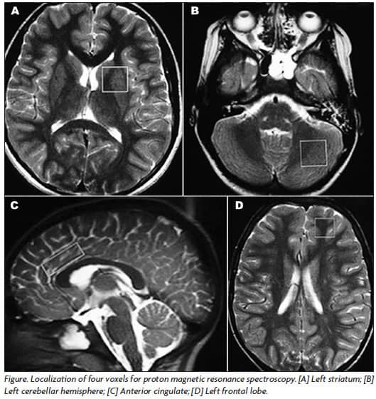
RESULTS
Children with fetal alcohol spectrum disorder showed a decrease in choline/creatine ratio (p=0.020) in left striatum and an increase in myo-inositol/creatine ratio (p=0.048) in left cerebellum compared with controls. There was no statistically significant difference in all peaks and ratios from the anterior cingulate and frontal lobe between the two groups.
CONCLUSION
This study found evidence that the left striatum and left cerebellum are affected by intrauterine exposure to alcohol. Additional studies with larger samples are necessary to expand our knowledge of the effects of fetal exposure to alcohol. Currently, this is the most frequently used 1H-MRS technique, as it is easier to obtain and it offers a more effective water and fat suppression31.
As the central nervous system is the primary focus of permanent damage in FAS, with long-standing loss in quality of life of affected individuals, it is hoped that 1H-MRS may become an important tool to clarify alcohol noxious effects, even in the absence of structural lesions. 1H-MRS may also be able to assess integrity of neuronal and glial markers29. Nevertheless, the increased 1H-MRS sensitivity is counteracted by its decreased specificity, as similar changes in cerebral metabolites may be found in various central nervous system disorders. For example, MI elevation was also described in the frontal lobe white matter of diabetic patients with and without major depression32.
A few comments on this study limitations are in order. IQ tests were unavailable at the time of research, and this obstacle reduced characterization of cases and controls and may have added significant cognitive differences among the subjects. The small sample size (n=16) decreases statistical power of the research data. Finally, one of the cases was receiving pharmacologic therapy at the time of brain neuroimaging, which theoretically may have interfered with his 1H-MRS results.
In summary, compared with age-, gender-, and socioeconomic class-matched controls, children and adolescents with FASD showed at 1H-MRS a statistically significant decrease in Cho/Cr ratio (p=0.020) in left striatum, as well as an increase in MI/Cr ratio (p=0.048) in left cerebellar hemisphere. These findings suggest that significant intrauterine exposure to alcohol may impair left striatum and left cerebellum functioning. Additional studies, including larger samples, are likely to increase our knowledge of the neuroradiologic findings in children that sustained intrauterine exposure to alcohol.
REFERENCES
- Ghazi Sherbaf, F., Aarabi, M. H., Hosein Yazdi, M., & Haghshomar, M. (2019). White matter microstructure in fetal alcohol spectrum disorders: A systematic review of diffusion tensor imaging studies. Human brain mapping, 40(3), 1017-1036.
- Donald, K. A., Roos, A., Fouche, J. P., Koen, N., Howells, F. M., Woods, R. P., ... & Stein, D. J. (2015). A study of the effects of prenatal alcohol exposure on white matter microstructural integrity at birth. Acta neuropsychiatrica, 27(4), 197-205.
- Wozniak, J. R., & Muetzel, R. L. (2011). What does diffusion tensor imaging reveal about the brain and cognition in fetal alcohol spectrum disorders?. Neuropsychology review, 21(2), 133-147.
- Almeida L.G., Ricardo-Garcell J., Prado H., Barajas L., Fernandez Bouzas A., & Avila D., Martinez R.B. (2010): Reduced cortical thickness in children, adolescents and adults with ADHD and its correlation to clinical variables: A cross-sectional study. J Psychiatry Res 44:1214-1223
- Astley S. (2004): Diagnostic Guide for Fetal Alcohol Spectrum Disorders: The 4-Digit Diagnostic Code. Seattle, USA: Fetal Alcohol Syndrome Diagnostic and Prevention Network, University of Washington
- Chudley A.E., Conry J., Cook L.L., Loock C., Rosales T., LeBlanc N. (2005): Fetal Alcohol Spectrum disorder. Can Med Association J 172: S1-S21
- Lebel C., Mattson S.N., Riley E.P., Jones K.L., Kan E., Abaryan Z., Sowell E.R. (2012): A study on the long-term consequences of drinking during pregnancy. Heavy in utero alcohol exposure disrupts the normal process of brain development J Neuroscience 32:15243-15251
- Lebel C., Rousette F., Sowell E.R. (2011): Imaging the impact of prenatal alcohol exposure on the structure of the developing human brain. Neuropsychology Rev 21:102-118
- Coles C.D., Goldstein F.C., Lynch M.E., Chen X.C., Kable J.A., & Johnson K.C., Hu X.P. (2011): Memory and brain volumes in adults prenatally exposed to alcohol. Brain Cognit 75:67-77
- Astley S.J., Aylward E.H., Olson H.C., Kerns K., Brooks A., Coggins T.E., Davies J., Dorn S., Gendler B., Jirikowic T., Kraegel P., Maravilla K., & Richards T. (2009): Magnetic resonance imaging outcomes from a comprehensive magnetic resonance study of children with fetal alcohol spectrum disorders. Alcohol: Clin Exp Res 33:1671-1689
- Norman, A. L., Crocker, N., Mattson, S. N., & Riley, E. P. (2009). Neuroimaging and fetal alcohol spectrum disorders. Developmental disabilities research reviews, 15(3), 209-
- Spadoni, A. D., McGee, C. L., Fryer, S. L., & Riley, E. P. (2007). Neuroimaging and fetal alcohol spectrum disorders. Neuroscience & Biobehavioral Reviews, 31(2), 239-245.
- Moore, E. M., Migliorini, R., Infante, M. A., & Riley, E. P. (2014). Fetal alcohol spectrum disorders: recent neuroimaging findings. Current developmental disorders reports, 1(3), 161-172.
- Astley, S. J., Aylward, E. H., Olson, H. C., Kerns, K., Brooks, A., Coggins, T. E., ... & Kraegel, P. (2009). Functional magnetic resonance imaging outcomes from a comprehensive magnetic resonance study of children with fetal alcohol spectrum disorders. Journal of neurodevelopmental disorders, 1(1), 61.
- Lemoine P, Harousseau H, Borteyru JP, Menuet JC. Les enfants de parents alcooliques. Anomalies observées: a propos de 127 cas. Ouest Med 1968;25:476-482.
Jones KL, Smith DW, Ulleland CN, Streissguth P. Pattern of malformation in offspring of chronic alcoholic mothers. Lancet 1973;1:1267-1271.
Manning MA, Hoyme HE. Fetal alcohol spectrum disorders: a practical clinical approach to diagnosis. Neurosci Biobehav Rev 2007;31:230-238.
Volpe JJ. Teratogenic effects of drugs and passive addiction. In: Volpe JJ. Neurology of the newborn. 4th edition. Philadelphia: W. B. Saunders, 2001:859-898.
- Hoyme E, May PA, Kalberg WO, et al. A practical clinical approach to diagnosis of fetal alcohol spectrum disorders: clarification of the 1996 institute of medicine criteria. Pediatrics 2005;115:39-47.
- Elgen I, Bruaroy S, Laegreid LM. Lack of recognition and complexity of fetal alcohol neuroimpairments. Acta Paediatr 2007;96:237-241.
Gahagan S, Sharpe TT, Brimacombe M, et al. Pediatricians’ knowledge, training, and experience in the care of children with fetal alcohol syndrome. Pediatrics 2006;118:657-668.
Jones KL, Robinson LK, Bakhireva LN, et al. Accuracy of the diagnosis of physical features of fetal alcohol syndrome by pediatricians after specialized training. Pediatrics 2006; 118:1734-1738.

