Tobi Olaniyi-Sholanke
15/ENG06/053
Mechanical Engineering
MEE 586 Assignment

- Q1. What is an integrated CAD/ CAM?
An integrated CAD/CAM system provides one model supporting both design and manufacturing functions instead of having various file formats, numerous data translations/conversions, and different CAD and CAM models. To the CAM system, the CAD model becomes the sole geometry in play.

- Draw a product cycle to describe the scope of CAD/CAM in the operation of manufacturing firm
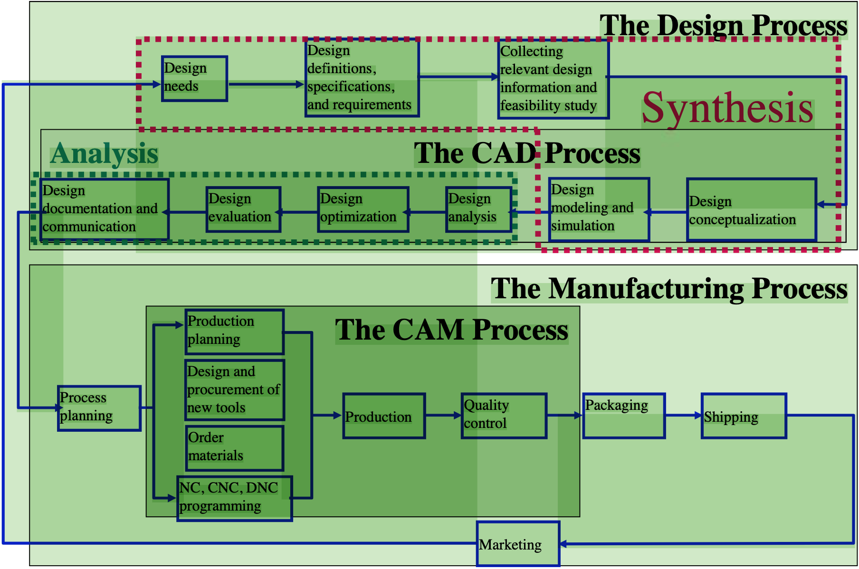

3. Explain seven (7) characteristics of a good CAD software
A) Efficiency:- An Efficient software is that which can use less resources such as CPU in terms of time and usage to give a better output.

B) Simplicity:- A software must be simple to use and easy to understand and must be user friendly.

C) Flexibility: - The software must be able to incorporate the design modification with out much of difficulty.

D) Readability:- This provides the capability within the software to help the user as and when required.

E) Portability: - The software must have the capacity to get transferred from one system to other.

F) Reliability: - To avoid causality the software must be able to avoid unwanted operation.

G) Recover ability: - A Good software must be able to give warnings before getting crashed and must be able to recover.

- Explain three (3) divisions of software components
- Application software
This is a software that uses the computer system to perform special functions or provide entertainment functions beyond the basic operation of the computer itself. There are many different types of application software, because the range of tasks that can be performed with a modern computer is so large.

- System Software
This is a software for managing computer hardware behaviour, as to provide basic functionalities that are required by users, or for other software to run properly, if at all. System software is also designed for providing a platform for running application software, and it includes the following.

- Operating System
These are essential collections of software that manage resources and provide common services for other software that runs "on top" of them. Supervisory programs, boot loaders, shells and window systems are core parts of operating systems. In practice, an operating system comes bundled with additional software (including application software) so that a user can potentially do some work with a computer that only has one operating system.

