NAME: OSUBOR STEPHANIE
MATRIC NO: 17/mhs01/275
LEVEL: 200
COURSE: ANA305
QUESTION 1
Histological Importance of the eye In relation to their cellular function
From an anatomical perspective, the eye can be viewed as a series of overlapping layers of tissue.
These layers can further subdivide and undergo histological classification.
Structure
External Structures of the Eye:
1. Conjunctiva
- The conjunctiva lines the inner part of the eyelids.
- The tarsal plate lies beneath the conjunctiva and contains meibomian glands, which secrete an oily substance to decrease the evaporation of the tear film.
2. Tear film: The tear film consists of aqueous, mucus, and oily secretions.
3. Accessory glands: Apocrine glands of Moll, meibomian glands, lacrimal glands.
4. Muscles: Orbicularis oculi, levator palpebrae superioris, superior tarsal muscle.
5. Eyelid: The eyelid, also known as the cover of the eye, a mobile layer made up of skin and also muscular tissue and also covers the eyeball.
Internal Structures of the Eye: are organized in the three layers as follows
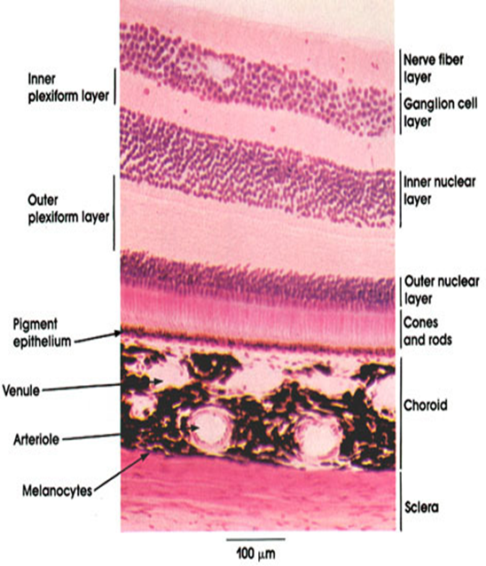
(A)- Outermost Layer: Sclera and Cornea (make up the exterior of the eye):
1. The sclera (white of the eye):
The sclera is dense connective tissue made of mainly type 1 collagen fibers, oriented in different directions. The lack of parallel orientation of collagen fibers gives the sclera its white appearance, as opposed to the transparent nature of the cornea. However, the collagen of the sclera and cornea are continuous.
The four layers of the sclera from external to internal are episclera, stroma, lamina fusca, endothelium.
The episclera is the external surface of the sclera. It is connected to the Tenon capsule by thin collagen fibers. At the corneoscleral junction, also known as the limbus, the Tenon capsule contacts stroma of the conjunctiva.
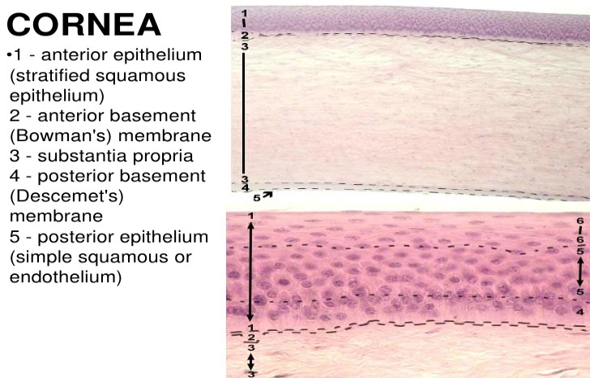
2. Cornea (transparent front layer of the eye):
Consists of type I collagen fibers oriented in a uniform parallel direction to maintain transparency
Consists of five layers: epithelium (non-keratinized, stratified squamous epithelium), Bowman layer, stroma (also called substantia propria), Descemet’s membrane, corneal endothelium.
Corneal epithelium: fast growing, regenerating multicellular layer which interacts directly with the tear film.
Bowman layer: This is a layer of subepithelial basement membrane protecting the underlying stroma. It is composed of type 1 collagen, laminin, and several other heparan sulfate proteoglycans.
Stroma: The largest layer of the cornea, the stroma has collagen fibers arranged in a regular pattern. Keratocytes maintain the integrity of this layer. The function of this layer is to maintain transparency, which occurs by the regular arrangement, and lattice structure of the fibrils, whereby scatter from individual fibrils gets canceled by destructive interference, and the spacing of less than 200 nm allows for transparency.
Descemet’s membrane: an acellular layer made of type IV collagen that serves as a modified basement membrane of the corneal endothelium
Corneal endothelium: a one cell thick layer made of either simple squamous or cuboidal cells. Cells in this region do not regenerate and have pumps that maintain fluid balance and prevent swelling of the stroma. When corneal endothelial cells are lost, neighboring cells stretch to attempt to compensate these losses.
(B)- Middle Layer: Uvea (vascular layer subdivided into the Iris, Ciliary Body, Choroid):
1. "Iris":
Consists of (1) stromal layer with pigmented, fibrovascular tissue and (2) pigmented epithelial cells beneath the stroma
The sphincter pupillae and dilator pupillae muscles connect to the stroma
The pigmented layer of cells blocks rays of light and ensures that light must move through the pupil to reach the retina
The angle formed by the iris and cornea contains connective tissue with endothelial channels called the trabecular meshwork, which drains aqueous humor in the anterior chamber into the venous canal of Schlemm. From here, fluid drains into episcleral veins.
2. "Ciliary Body": The tissue that divides the posterior chamber and vitreous body
Consists of the ciliary muscle and the ciliary epithelium
The ciliary muscle, via the lens zonules, controls the structure of the lens, which is vital for accommodation. Zonules are connective tissue fibers that connect the ciliary muscle and lens.
The ciliary epithelium produces aqueous humor which fills the anterior compartment of the eye.
3. "Choroid":
Consists of a dense network of blood vessels supplying nourishment to structures of the eye, housed in loose connective tissue.
The choriocapillary layer is located in the innermost part of the choroid and supplies the retina
The Bruch membrane is an extracellular matrix layer situated between the retina and choroid and has significance in age-related macular degeneration, where an accumulation of lipid deposits prevent diffusion of nutrients to the retina.
(C)- "Innermost layer: Lens, Vitreous, Retina (contains nervous tissue)":
1. Lens: separates the aqueous and vitreous chambers
Consists of an outer capsule, a middle layer called cortex, and an inner layer called the nucleus. The capsule is the basement membrane of the lens epithelium which lies below. New lens cells differentiate from the lens epithelium and are incorporated peripherally, pushing older lens cells towards the middle.
2. Vitreous: a jelly-like space made of type II collagen separating the retina and the lens
3. Retina: nervous tissue of the eye where photons of light convert to neurochemical energy via action potentials
Moreover, the retina itself is divided into various layers as follows
Retinal pigment epithelium: made of cuboidal cells containing melanin which absorbs light. These cells also establish a blood-retina barrier through tight junctions.
"Rod and cone cells": the layer of cells with photoreceptors and glial cells. Rods are located peripherally and are more sensitive to light and motion than cones. Cones have higher visual acuity and specificity for color vision.
- "Outer limiting membrane": a layer of Muller cells and rod/cone junctions which serves to separate the photosensitive regions of the retina from the areas that transmit the electrical signals.
- "Outer nuclear layer": This layer consists of nuclei of rod and cone cells.
- "Outer plexiform layer": This layer contains synaptic processes of rod and cone cells.
- "Inner nuclear layer': This layer contains the cell body of glial, amacrine, bipolar, and horizontal cells
- "Inner plexiform layer": This layer relays information from cells of the inner nuclear layer. Thus, this layer has axons of amacrine, bipolar, and glial cells and dendrites of retinal ganglion cells.
- "Ganglion cell layer": This layer contains nuclei of retinal ganglion cells.
- "Nerve fiber layer": This layer contains axons of retinal ganglion cells and the astroglia which support them. Collectively, these axons constitute the optic nerve.
- "Internal limiting membrane": A thin layer of Muller glial cells and basement membrane which demarcates the vitreous anteriorly from the retina posteriorly.
Function
The layers of the eye perform distinct functions which coalesce to create a unified, perceptual experience. The essential role of the external eye structures is to protect the delicate tissue of the internal eye. The eyelid prevents foreign bodies from entering the inner eye and helps refresh and distribute the tear film by blinking. Eyelashes are finely sensitive to touch and warn the eye of possible debris and particles that may cause injury.
Internal parts of the eye have primarily structural and visual functions. The cornea serves a protective role and is responsible for two-thirds of the refractive properties of the eye. The remaining one-third of refraction is performed by the lens, which is functionally adjustable through the action of the zonular fibers and ciliary muscles. At the end of the visual process, as rays of light bend through the cornea and lens, photon energy is converted to neurochemical action potentials by cells of the retina, which then send these impulses to the brain, via the optic nerve.
The uvea of the eye is a crucial mediator of nutrition and gas exchange, as blood vessels course through the ciliary body and iris, while the choriocapillaris in the posterior eye help support the retina. This abundant blood supply is implicated in uveitis, as inflammatory mediators enter the eye through this vascular network.
Clinical Significance
Several of the most common diseases of the eye are manifestations of pathology within specific histological layers. Below are examples of common eye conditions, and the layers of the eye implicated.
- Chalazion: A sterile lump often in the upper eyelid caused by obstruction of the meibomian oil glands.
- Conjunctivitis: Inflammation of the transparent conjunctiva that may be caused by bacterial or viral infections, allergies, or exposure to certain chemicals.
- Cataracts: A sclerotic nuclear cataract is the most common and is due to opacification in the central nucleus of the lens. Cortical cataracts are due to opacifications in the cortex and have a distinct wedge-shaped appearance. Posterior subcapsular cataracts arise from behind the sac-like structure of the lens.
- Glaucoma: Refers to optic nerve damage related to increased intraocular pressure. Drainage of aqueous humor through the trabecular meshwork is often implicated.
- Age-related macular degeneration: A progressive eye disease causing damage to the macula or central portion of the retina. Accumulation of drusen, or lipid-laden deposits in Bruch’s membrane of the retina, is associated with disease severity.
- Fuchs Dystrophy: A disease of the corneal endothelium, that causes accumulation of excess edema in the corneal stroma. Progression of the disease often causes blisters in the eye, also referred to as bullous keratopathy.
- Floaters: The sensation of floaters is due to changes that occur in the jelly-like vitreous layer of the eye.
- Retinal detachment: It occurs when the outer pigment epithelial layer separates from the inner neurosensory layer consisting of rods and cones; this is a vision-threatening condition as the neurosensory layer is unable to receive nutrients from the underlying choriocapillaris and retinal pigment epithelium.

QUESTION 2
Layers of the retina in information penetration
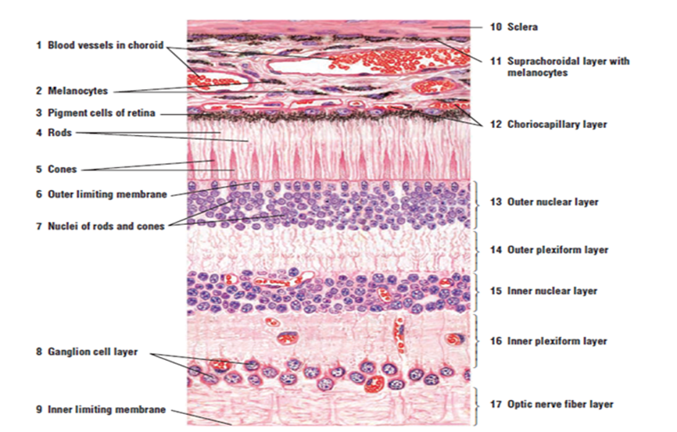
The retina is the innermost layer in the eye that is responsible for the visual processing that turns light energy from photons into three-dimensional images. The retina transmits light signals into chemical signals that are sent to the brain. This process requires the ability to sense the stimulus of light and transmit that signal from cell to cell. Retinal tissue develops to become the most metabolically expensive tissue in the human body, consuming oxygen more rapidly than any other tissue. The retina is fed oxygen from a unique dual blood supply that divides the retina into outer and inner layers for more efficient oxygenation. The retina itself consists of six different cell lines divided into ten different layers, each playing a specific role in creating and transmitting vision. The different cell types perform a particular role and form functional circuits that specialize in detecting specific variations and movements of light.
Structure and Functions
Six major cell types form the various layers within the human retina:
- Photoreceptors (rods and cones) - form the outer nuclear layer
  - Synapse with bipolar cells at the outer plexiform layer
  - Rods deal predominantly with peripheral and night vision
  - Cones deal mainly with central vision
Function: The detection of light begins at the deepest cell layer in the retina, the photoreceptors, located in the outer nuclear layer. Rods are very light sensitive and are responsible for dim-light vision. Cones, on the other hand, are not very light sensitive but are specific for a particular wavelength of light. Thus, cones are responsible for high acuity color vision.
- Bipolar cells - make up the inner nuclear layer
  - Synapse with amacrine cells and ganglion cells at the inner plexiform layer
Function: Photoreceptors use the neurotransmitter, glutamate, to communicate at the synapse with bipolar cells within the outer plexiform layer. Bipolar cell bodies are just shallow to this layer at the inner nuclear layer. At the inner plexiform layer, bipolar cells are responsible for transmitting an impulse to retinal ganglion cells.
- Amacrine cells
  - Inhibitory cells which interact with bipolar cells and retinal ganglion cells
Function: Amacrine cells modulate the excitation of the retinal ganglion cells through contact with ganglion cell dendrites or bipolar cell axon terminal bulbs, using the neurotransmitters GABA and glycine.
- Retinal ganglion cells - form the ganglion cell layer (innermost layer, furthest from the photoreceptors)
  - Axons tract towards the back of the eye and form the optic nerve
Function: These are the final receivers and transmitters of the initial stimulus. They send the information they receive down their axons, which eventually form the optic nerve and project to higher brain centers.
- Horizontal cells
  - Assist in operations such as contrast enhancement and preservation of spatial information.
Function: These cells function to modulate the communication between photoreceptors and bipolar cells. Bipolar cells contact ganglion and amacrine cells at the inner plexiform layer.
- Muller cells
  - glial cells which support metabolism and homeostasis of the retina.
Function: These are cells are of glial origin and are essential for proper retinal function. They contact almost every cell type in the retina, spanning the entire width from the photoreceptors to the inner retina. They serve to recycle neurotransmitters, prevent glutamate toxicity, and regulate nutrient homeostasis in the retina.
The 10 Layers of the Retina
The retina is a layered structure with ten distinct layers of neurons interconnected by synapses. The cells subdivide into three basic cell types: photoreceptor cells, neuronal cells, and glial cells. The layers from the closest to the front anterior of the head towards the posterior of the head are as follows:
- Inner limiting membrane: The ILM is the retina's inner surface bordering the vitreous humor and thereby forming a diffusion barrier between the neural retina and vitreous humor. The ILM contains laterally contacting Muller cell synaptic boutons and other basement membrane parts.
- Nerve fiber layer (NFL): The nerve fiber layer is the second innermost layer of the retina from the vitreous. Patients with retinitis pigmentosa may have a measurable degree of RNFL thinning as determined by OCT.[14]
- Ganglion cell layer: This layer contains the retinal ganglion cells (RGCs) and displaced amacrine cells. As a rule of thumb, smaller RGCs dendrites arborize in the inner plexiform layer while larger RGCs dendrites arborize in other layers.
- Inner plexiform layer The inner plexiform layer is an area comprised of a dense reticulum of fibrils formed by interlaced dendrites of RGCs and cells of the inner nuclear layer.
- Inner nuclear layer: This layer of the retina contains the cell bodies of bipolar cells, horizontal cells, and amacrine cells.
- Middle limiting membrane
- Outer plexiform layer: This layer of the retina contains a neuronal synapse of between rods and cones with the footplate of horizontal cells. Capillaries are also found to be primarily running through the outer plexiform layer.
- Outer nuclear layer: This layer contains the rod and cone granules that sense photon, extensions from the rod, and cone cell bodies.
- External limiting membrane: This layer contains the bases of the rod and cone photoreceptors cell bodies. The ELM forms a barrier between the subretinal space, into which the inner and outer segments of rods and cones project to be in close association with the pigment epithelial layer behind the retina, and the neural retina proper.
- The Layer of rods and cones
Retinal pigment epithelium
The retina is supported by the retinal pigment epithelium (RPE), which has many functions including vitamin A metabolism, maintenance of the blood-retina barrier, phagocytosis of photoreceptor outer segments, production of mucopolysaccharide matrix surrounding the outer segments of the retina, and active transport of materials into and out of the RPE.
NOTE: Efficient delivery of drugs to the retina is critical but difficult to achieve with current methods. There have been a number of attempts to use intravitreal injection of liposomes, artificial vesicles composed of a phospholipid bilayer, to overcome the limitations of conventional intravitreal injection (short retention time, toxicity, poor penetration, etc.). Here, we report an optimal liposomal formulation that can diffuse through the vitreous humor, deliver the incorporated agents to all retinal layers effectively, and maintain them for a relatively long time. We first delivered lipophilic compounds and phospholipid-conjugated hydrophilic agents to the inner limiting membrane using engineered liposomes. Subsequently, the agents penetrated the retina deeply, presumably via extracellular vesicles, nanoscale vesicles secreted from retinal-associated cells. These results suggest that this engineered liposomal formulation can leverage the biological transport system for effective retinal penetration of lipophilic and lipid-conjugated agents.

