NAME: OLAITAN OLANREWAJU

DEPARTMENT: PHARMACOLOGY

MATRIC NUMBER: 18/MHS07/042

COURSE CODE: BCH 204

COURSE TITLE: Medical Biochemistry II

QUESTION: Describe the three stages of beta oxidation. (Show path ways where necessary)

Beta oxidation is the catabolic process by which fatty acids molecules are broken down in the mitochondria in eukaryotes to generate acetyl-coA. The acetyl-CoA produced is then fed directly into the krebs cycle. Beta oxidation involves three stages:
- Activation of fatty acids in the cytosol.
- Transport of activated fatty acid into the mitochondria (carnitine shuttle)
- Beta oxidation proper in the mitochondrial matrix.

- Activation of fatty acid:
This proceeds by fatty acid thiokinase (acetyl coA synthetase) present in cytosol. Thiokinase requires ATP, CoA SH, Mg⁺⁺. The product of this reaction is fatty acid acyl CoA and water.
Fatty acid + CoA + ATP fatty acid acyl CoA + AMP +2Pi

- Transport of fatty acyl CoA from the cytosol into the mitochondria:
- Long chain acyl CoA transverses the inner mitochondria membrane with a special transport mechanism called carnitine shuttle.
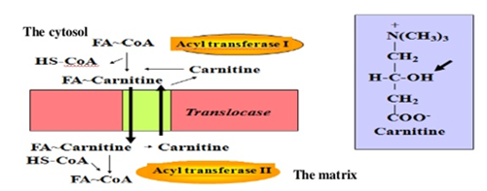
Rate limiting steps of stage 2:
- Acyl groups from acyl CoA is transferred to carnitine to form acyl carnitine catalyzed by carnitine acyltransferases I, in the outer mitochondrial membrane.
- Acylcarnitine is then shuttled across the inner mitochondrial membrane by a translocase enzyme.
- The acyl group is transferred back to CoA in matrix by carnitine acyl transferase II.
- Finally, carnitine is returned to the cytosolic side by translocase, in exchange for an incoming acyl carnitine.

- Proper of beta oxidation in the mitochondrial matrix
There are 4 steps in beta oxidation:
Step I: Oxidation by FAD linked dehydrogenase.
Step II: Hydration by hydratase.
Step III: Oxidation by NAD linked dehydrogenase.
Step IV: Thiolytic cleavage Thiolase.
The first step is the oxidation of acyl CoA by an acyl CoA dehydrogenase to give α-β unsaturated acyl CoA (enoyl CoA). FAD is the hydrogen acceptor.
The second step is the hydration of the double bond to β-hydroxyl CoA (p-hydroxyl CoA).
The third step is the oxidation of β-hydroxyacyl CoA to produce β-ketoacyl CoA a NAD-dependent reaction.
The fourth step is cleavage of the two carbon fragments by splitting the bond between α and β carbons by thiolase enzyme.
In summary
