Name: Katey Godwin Katey-Obaa
Mat. No.: 18/ENG06/035
Department: Mechanical

- Thin lines at an angle of 45° is used to represent is used to represent a section surface on a drawing
- Principles of dimensioning
1. All dimension, extension, and leader lines should be thin, sharp, dark lines (.5mm/2H).
2. Extension lines indicate the points between which the dimension figures apply. They are drawn perpendicular to the dimension lines, start with a visible gap (~1/32") between them and the object, and terminate 1/8" (3.2 mm) beyond the last arrowhead.
3. Each dimension should be terminated by arrowheads touching the extension lines and pointing in opposite directions. Arrowheads are drawn freehand with .7mm/HB lead. The lines should be broken only at the approximate centre for the dimension figures.
4. Dimensions shown with dimension lines and arrowheads should be placed to be read from the bottom of the drawing (unidirectional system).
5. All dimensions should be given in decimal format. When dimensions are given in inches, leading zeros are omitted from dimension values less than 1.00
6. When all dimensions on a drawing are given in inches, the inch marks (") are omitted, the same applies to millimetres. If metric units are used, the word METRIC will appear boxed in a spot toward the lower portion of the drawing sheet.
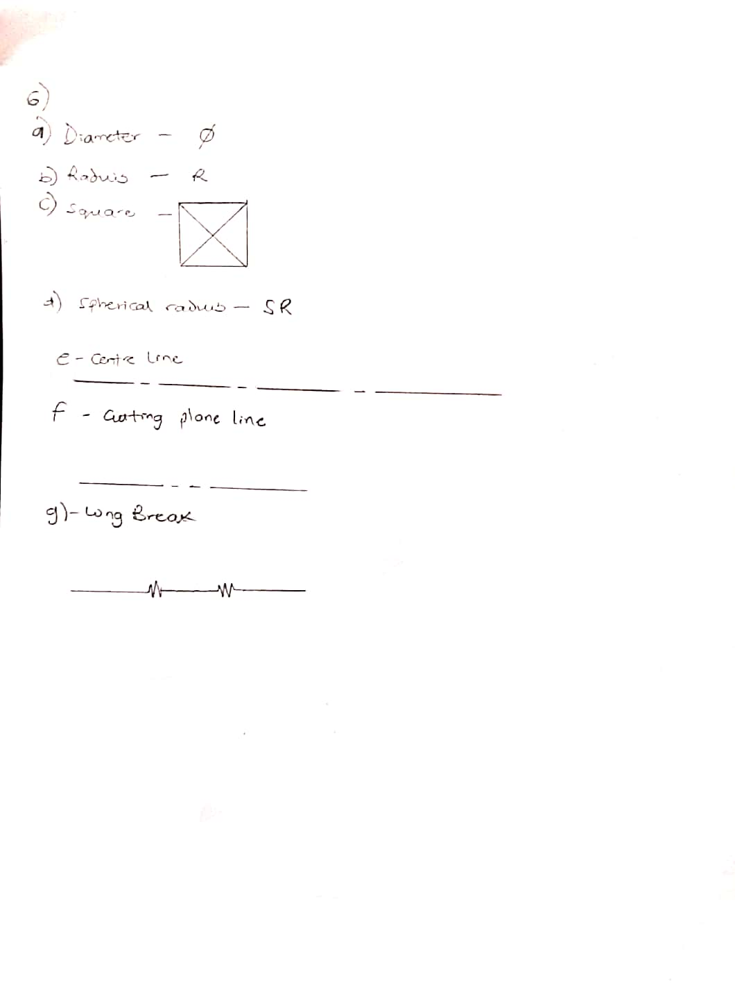
7. A dimension line should never coincide with an object line or a centre line, nor should it be an extension of these lines. Both, however, may be used as extension lines.
8. Crossing of extension lines or dimension lines should be avoided if possible. Where such crossings are unavoidable, there should be no break in either of the lines. However, if extension lines cross dimension lines through the arrowheads, the extension line may be broken.
- a.) Half Section
A half section exposes the interior of one half of an object while retaining the exterior of the other half. Half sections are used mainly for symmetric objects or assembly drawings. A centreline is used to separate the two halves. Hidden lines should not be shown on either half.

b.) Full Section
If the imaginary cutting plane passes through the entire object, splitting the drawn object in two with the interior of the object revealed, this is called a "full section." A full section is the most widely-used sectional view.
- Leader lines are thin, solid lines that terminate in an arrowhead or dot. The arrowhead touches the outline, while the dot is placed within the outline of the Outline object. The other end of the leader is terminated in a horizontal line at the bottom level of the first or last letter.
- Scale 5:1
This denotes that 5 units of a particular metric system represents 1 unit of another metric system
Scale 1:10
This denotes that 1 unit of a particular metric system represents 10 units of another.
- They are shown below
- The elements to be considered are:
  - Width
  - Height
  - Length
  - Side
  - Top
  - Scale
Orthographic Projection
It is a 2-D representation of 3-D objects in Engineering, used to show all details
- It Consists of Top view, Side view and plan, But drawn in 2-D
- FIRST ANGLE PROJECTION
In first angle projection, the object is placed in the first quadrant meaning it’s placed between the plane of projection and the observer.
THIRD ANGLE PROJECTION
In third angle projection, the object is placed below and behind the viewing planes meaning the plane of projection is between the observer and the object.
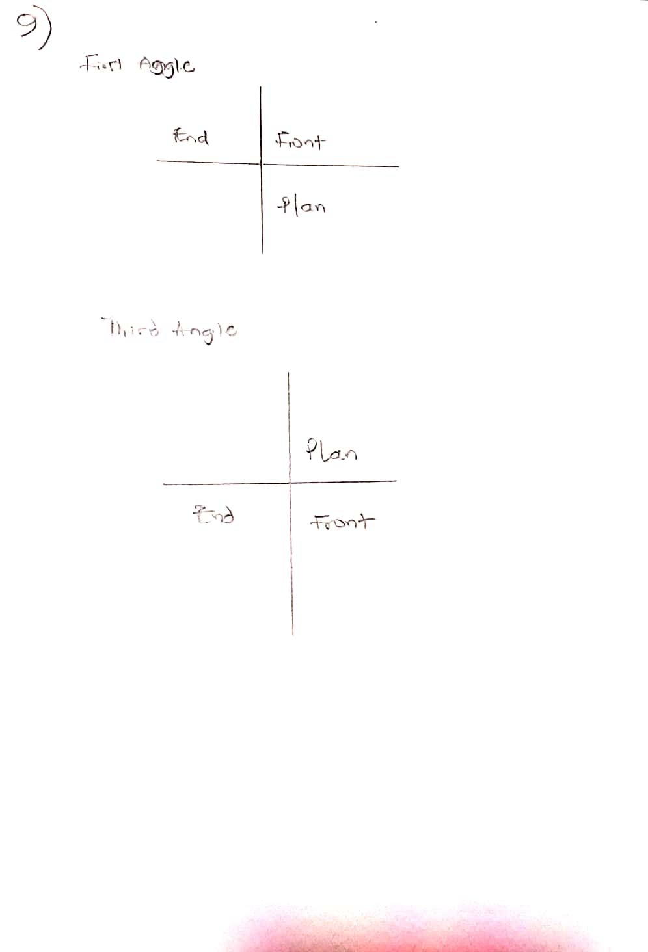
Multiple Choice Questions.
1. a.) Reference plane
2. a.) True
3. d.) Normally
4. a.) 60⁰
5. a.) 60⁰
6. b.) Rivet
7. c.) Crowning
8. b.) 45⁰
9. b.) Ellipse
10.a.) an ellipse
11.c.) Cylinder
12.a.) a cone
13.c.) pivot bearing
14.c.) 55⁰
15.d.) Horizontal plane

