NAME: JAJA ABINYE FRED
DEPARTMENT: COMPUTER ENGINEERING
MATRIC NUMBER:18/ENG02/051
1.We have learnt that when making a Multiview sketch, hidden edges and surfaces are usually shown with hidden (dash) lines.
When an object becomes more complex, as in the case of an automobile engine block, a clearer presentation of the interior can be made by sketching the object as it would look if it were cut apart. In that way, the many hidden lines on the sketch are eliminated.
The process of sketching the internal configuration of an object by showing it cut apart is known as sectioning. Sectioning is used frequently on a wide variety of Industrial drawings.
2.Dimensions and Projection lines are narrow continuous lines that are 0.35 thick
2i. Center lines must never be used as dimension lines but must be left clear and distinct.
2iiDimensions are quoted in millimeters to the minimum number of significant figures for example 19 not 19.0
2iii. To enable dimensions to be read clearly.
3. Half-Sectioning exposes the interior of one half of an object while retaining the exterior of the other half
WHILE
Full-Sectioning exposes the interior of the two halves of an object
4. 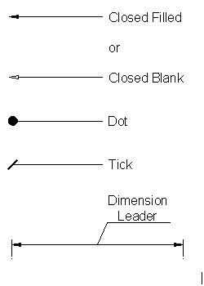

5. A scale 5:1 means that we are enlarging the drawing in size so that all the required details are clearly visible.
A Scale of 1:10 means that we are to reduce the drawing in size so that it will fit on to the page.
6.
Diameter- Ø
Radius- R
Square-□
Spherical Radius- SR
6a. Center Lines=
Cutting planes=
Long Break=
7. Orthographic Projection is a way of drawing an 3D object from different directions. Usually a front, side and plan view are drawn so that a person looking at the drawing can see all the important sides. Orthographic drawings are useful especially when a design has been developed to a stage whereby it is almost ready to manufacture.
8.There are two ways of drawing in orthographic - First Angle and Third Angle. They differ only in the position of the plan, front and side views.
9.

Objective
- Reference Point(A)
- False(B)
- Directly(C)
- 120º(B)
- 60º(A)
- Rivet(B)
- Crowning(C)
- 45º(B)
- A Circle(A)
- An Ellipse(A)
- Cylinder(C)
- Frustrum(D)
- Pivot Bearing(C)
- 53º(C)
- Horizontal Plane(D)

