NAME : OLASINDE OLAITAN OGHENERAIMA.
MATRIC NUMBER : 18/ENG05/047.
DEPARTMENT : MECHATRONICS
COURSE: ENG 232 ASSESMENT TEST.

QUESTION 1
The view obtained by cutting an object with an imaginary cutting plane is called Sectional View .The surface produced by cutting the object by the section plane is called Section. It is indicated by thin section lines uniformly spaced, generally at an angle of 45'.

QUESTION 2

* PRINCIPLES OF DIMENSIONING
1. All dimension, extension, and leader lines should be thin, sharp, dark lines (.5mm/2H).
2. Extension lines indicate the points between which the dimension figures apply. They are drawn perpendicular to the dimension lines, start with a visible gap (~1/32") between them and the object, and terminate 1/8" (3.2 mm) beyond the last arrowhead.
3. Each dimension should be terminated by arrowheads touching the extension lines and pointing in opposite directions. Arrowheads are drawn freehand with .7mm/HB lead. The line should be broken only at the approximate center for the dimension figures.
4. Dimensions shown with dimension lines and arrowheads should be placed to be read from the bottom of the drawing (unidirectional system).
5. All dimensions should be given in decimal format. When dimensions are given in inches, leading zeros are omitted from dimension values less than 1.00
6. When all dimensions on a drawing are given in inches, the inch marks (") are omitted, the same applies to millimeters. If metric units are used, the word METRIC will appear boxed in a spot toward the lower portion of the drawing sheet.
7. A dimension line should never coincide with an object line or a center line, nor should it be an extension of these lines. Both, however, may be used as extension lines

QUESTION 3
HALF SECTION
• A half-section is a view of an object showing one-half of the view in section.

- Symmetrical parts can be shown in half sections.
- Half section without hidden lines
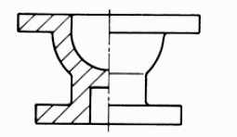

• Half sections are commonly used to show both the internal and outside view of symmetrical objects.
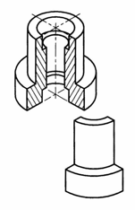

FULL SECTION

In this view, the section plane is across the object when the cutting plane is right.
The full-sectional view is shown below

QUESTION 4

Leader Lines are ended with an arrowhead

QUESTION 5
- A 50mm line is to be drawn at a scale of 5:1 (ie 5 times more than its original size).
- A drawing that shows a real object with accurate sizes reduced or enlarged by a certain amount (called the scale). ... Example: this drawing has a scale of "1:10", so anything drawn with the size of "1" would have a size of "10" in the real world, so a measurement of 150mm on the drawing would be 1500mm.

QUESTION 6
DIAMETER : The symbol or variable for diameter, ⌀, is sometimes used in technical drawings or specifications as a prefix or suffix for a number (e.g. "⌀ 55 mm", indicating that it represents diameter.

RADIUS : R
SQUARE :

SPHERICAL RADIUS: SR

QUESTION 7

Orthographic Projection is a method of projection in which an object is depicted using parallel lines to project its outline on to a plane.

QUESTION 8

Orthographic projection, a common method of representing three-dimensional objects, usually by three two-dimensional drawings in each of which the object is viewed along parallel lines that are perpendicular to the plane of the drawing. For example, an orthographic projection of a house typically consists of a top view, or plan, and a front view and one side view (front and side elevations).

QUESTION 9

FIRST ANGLE PROJECTION & FIRST ANGLE PROJECTION SYMBOL
In this, the object is imagined to be in the first quadrant. Because the observer normally looks from the right side of the quadrant to obtain the front view.
The objects will come in between the observer and the plane of projection.
Therefore, in this case, the object is to be transparent, and the projectors are imagined ta be extended from various points of the object to meet the projection plane. First, these meeting points when joined in the order form an image

Principle first angle projection view
This is the principle of the first angle projection. Thus in the first angle projection, any view is so placed that it represents the side of the object away from it.
First angle projection is mesurly used throughout all parts of Europe so that called European projection.
Most important of First angle projection symbol

2. Third angle projection & Third angle projection symbol
In this, the object is imagined to be placed in the third quadrant.
Again, as the observer is normally supposed to look from the right side of the quadrant to obtain the front view, in this method, the projection plane comes in between the observer and the object.
Therefore, the plane of projection has to be assumed to be transparent. The intersection of this plan with the projectors from all the points of the object would form an image on the transparent plane.
This is the principle of the third angle projection

Principle third angle projection view
Thus it is seen that in the third angle projection any view is so placed that it represents the side from the object nearest to it
Most important of Third angle Projection symbol The third angle is the system in used North America and alternatively described as American projection.

Objectives
1. To project the auxiliary view, an imaginary plane known as ……………….

a) Reference Plane
- Principle plane
- Normal plane
- Inclined plane
2. Reference plane is parallel to the direction of view
a) True

b) False
3. Dimension of one side of the inclined surface can be………………projected on the reference plane
- Indirectly
- Equally

Directly
d) Normally

4. In isometric projection the three edges of an object are inclined to each other at
(a) 60º (b) 120º (c) 100º (d) 90º
- The angle between the flanks of a metric thread is
(a) 60º (b) 90º (c) 75º (d) 55º
- Which one among the following represents a permanent fastener
a) Nut b) Rivet c) Screw d) Bolt
7. The convexity provided on the rim of the solid web cast iron pulley is called
a) Bending b) Curving c) Crowning d) Riveting
8. Section lines are generally inclined with the base, at an angle of
a) 30º b)45º c)60º d)90º
9. The isometric view of a sphere is always
a) a circle b) an ellipse c) a Parabola d) a Semicircle
10. In isometric projection, the four center method is used to construct
a) an ellipse b) a square c) a triangle d) a rectangle
11
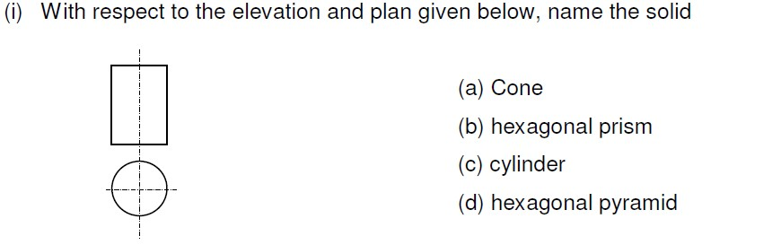
Ans : (C) cylinder
12
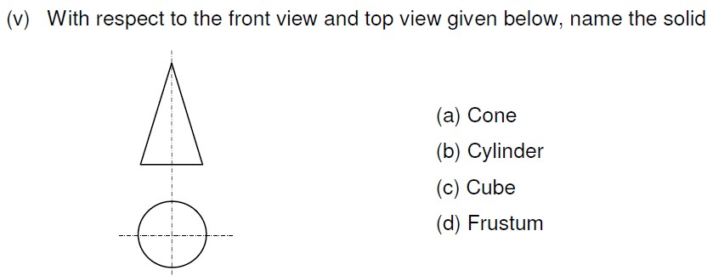
Ans : (A) cone

13. A footstep bearing is a
a) journal bearing b) thrust bearing c) pivot bearing d) pedestal bearing
14. The angle between the flanks of B.S.W. thread is
a) 60º b) 65º c) 55º d)75º
15. Top view is projected on the
a) Vertical Plane b) Corner Plane c) Side Plane d) Horizontal Plane

