NAME: SOJI-OYE IREOLUWA FAITH

MATRIC NO: 17/ MHS05/019

DEPARTMENT: MEDICINE AND SURGERY

COURSE TITLE: NEUROHISTOLOGY

ASSIGNMENT
- A histological importance of the cells of the eye is essential for appreciating disease pathology and also understanding certain therapeutics approaches.
There are various cells in various parts of the eye which have their various and similar functions.

- SCLERA: is the tough, white fibrous outer wall of the eye. It contains connective tissue cells (mostly scleral fibroblasts which are involved in sclera remodelling, which occurs during axial elongation in myopia) and some pigment cells; for absorption of excess light so photoreceptors can give clearer signal ,they also move nutrients to and waste from the choroid.

- CORNEA: is the transparent avascular tissue that acts as a structural barrier and protects inside the eye. It consists of :

- corneal epithelium (non-keratinized squamous epithelium) at the outermost layer and these cells’ glycocalyx interact with the mucin layer of the tear film to allow hydrophilic spread of the tear film with each eyelid blink. The cells in the deepest layer are low columnar or cuboidal, they are basal cells. The basal cells have abundant organelles and are active mitotically.
- Corneal keratocytes (fibroblasts or stromal cells) which are found in the stroma layer of the cornea become activated after injury to the cornea. In addition, it is involved in the extracellular matrix (ECM) production and inflammation regulation.
- Endothelial cells are located in the endothelial layer. The cells are hexagonal and metabolically active. They do not regenerate in adults. They allow leakage of solutes and nutrients from the aqueous humor to the more superficial layers of the cornea while at the same time pumping water in the opposite direction, from the stroma to the aqueous.
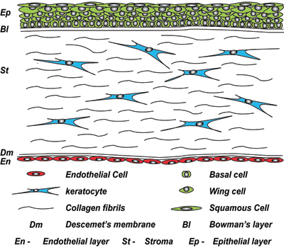
- CHOROID: the choroid is the vascular layer of the eye that lies between the retina and the sclera. It forms the uvea (the vascular coat) along with the ciliary body and the iris. Cells are located in the vascular system which consist of the outer Haller’s layer of large blood vessels and the inner Sattler’s layer of medium sized blood vessels. The stroma (extravascular tissue) contains fibroblasts for synthesis of ECM in connective tissue and plays a major role in wound healing, non vascular smooth muscles (NVSMC) ; are most numerous in the posterior pole of the eye leading to the suggestion that they support vision rather than vascular regulation. Mast cells are present and they fight against parasites, regulate blood flow and act in tissue repairing and remodelling after injury, e.g macrophages and lymphocytes. Melanocytes which produce melanin.

- CILIARY BODY: is a circular structure just behind the iris composed of the ciliary muscles and processes which attach to the lens. It comprises of two types of cells;

- the non pigmented epithelial cell, which has high degree of infolding on the part of the surface of each cell. This provides the ciliary body with an enormous surface area available for fluid secretion.
- the pigmented epithelial cell is continuous with the retinal pigment

- IRIS: this is the coloured part of the eye which helps to regulate the amount of light entering the eye. It is a flat ring-shaped membrane behind the cornea of the eye. It consists of cells few layers;
- Melanocytes and fibroblasts are located in the anterior border layer of the iris.
- Pigmented cells and non pigmented cells are found in the stroma layer. The pigment cells include the melanocytes and clump cells (altered macrophages and are scavengers of free pigment within the iris). The non pigmented cells include fibroblasts and mast cells.
- Myoepithelial cells are located in the anterior iris epithelium. They are stimulated by the sympathetic nervous system, when this is done the cells contract widening the pupil and allowing more light to enter the eye.
- The posterior surface of the iris is lined by simple cuboibdal pigmented epithelium.
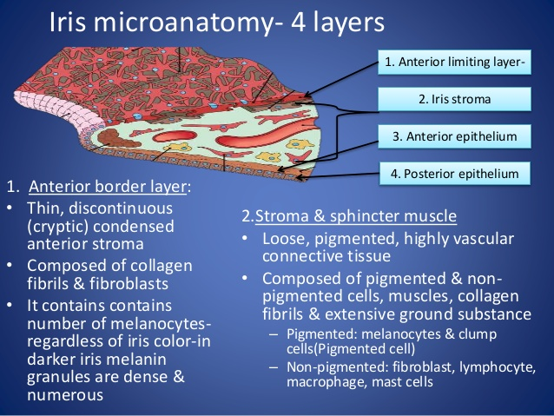
- RETINA: the retina is a thin layer of tissue that lines the back of the eye on the inside. It is located near the optic nerve. The cells in the retina are found in its layers as follows;
- The pigments cells located in the pigment cell layer have basal nucleus. Their pigment in the cytoplasm is melanin. With the EM it can be seen that the surface of the cell shows large microvilli that contain pigment. The functions include;
- The absorption of excessive light and avoidance of back reflection.
- They may play a role in regular spacing of rods and cones and may provide
mechanical support to them.
- They have a phagocytic role. They ‘eat up’ the ends of rods and cones.
- The rod and cone cells found in the layer of rods and cones. There are about seven million cone cells in each retina and more than a hundred million rod cells. The cones respond best to bright light (photopic vision). They are responsible for sharp vision and for the discrimination of colour. Rods can respond to poor light (scotopic vision) and specially to movement across the field of vision.
- The internal nuclear layer has the bipolar neurons, horizontal neurons, cells of muller (retinal gliocytes) and amacrine cells.
- The bipolar neurons exist between photoreceptors (rod cells and cone cells) and ganglion cells. They act, directly or indirectly, to transmit signals from the photoreceptors to the ganglion cells.
- The horizontal cells are the laterally interconnecting neurons having cell bodies in the inner nuclear layer of the retina. They help integrate and regulate the input from multiple photoreceptor cells. Among their functions, horizontal cells are responsible for allowing eyes to adjust to see well under both bright and dim light conditions. Horizontal cells provide inhibitory feedback to rod and cone photoreceptors.
- Amacrine cells also lie horizontally in the retina. They are interneurons in the retina. They are inhibitory neurons and they project their dendritic arbors unto the inner plexiform layer.
- Retinal gliocytes also called cells of muller give off numerous protoplasmic processes that extend through almost the whole thickness of the retina. The retinal gliocytes are neuroglial in nature. they support the neurons of the retina and may ensheath them. They probably have a nutritive function as well. Some astrocytes are also present in relation to retinal neurons. They are located in the outer limiting membrane.
- Retinal ganglion cells are found within the layer of ganglions and are the final output neurons of the vertebrate retina. They collect information about the visual world from the bipolar cells and amacrine cells. This information is in the form of chemical messages sensed by receptors on the ganglion cell membrane. RGCs receive both excitatory and inhibitory inputs from two types of intermediate neurons, amacrine cells, and bipolar cells. RGCs and amacrine cells form a functional subunit of on-off centers that allow for the brain to interpret a small dot moving at a distance.
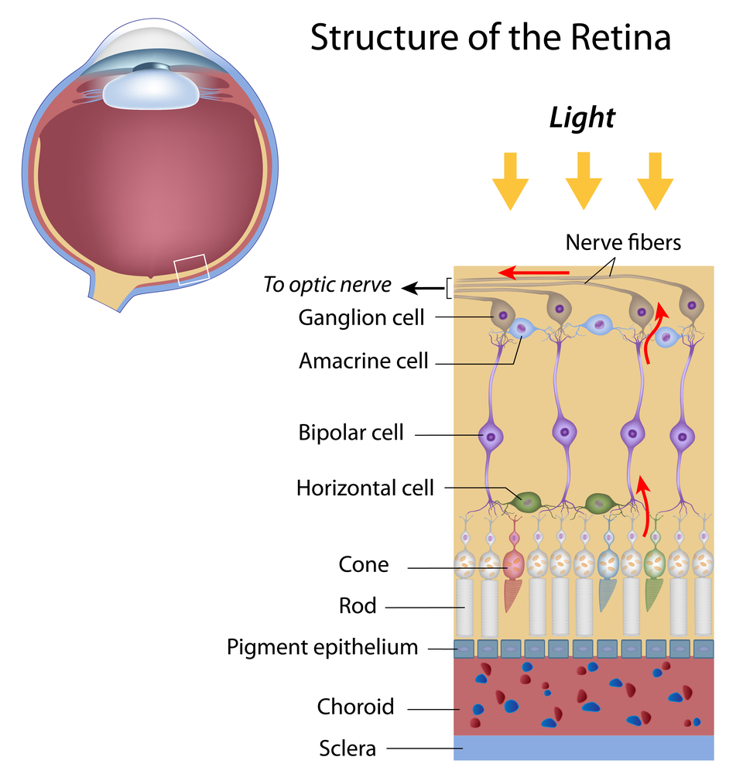
- LENS: the lens is a transparent biconvex structure in the eye that, along with the cornea, helps to refract light to be focused on the retina. The cells of the lens include the epithelial cells and the fiber cells (cortical and nuclear).
- Mitotic division in the lens occurs in the germinative zone of the anterior epithelium located just anterior to the equator.
- Fiber cells make up the lens nucleus. Layers of nucleated cortical fiber cells form highly ordered concentric shells around the nonnucleated central fiber cells which make up the fetal nucleus, with the ends of the peripheral fiber cells abutting in sutures anteriorly and posteriorly. Both the ordered arrangement of the fiber cells and their sutures as well as their intracellular structure are important for light transmission and lens transparency.

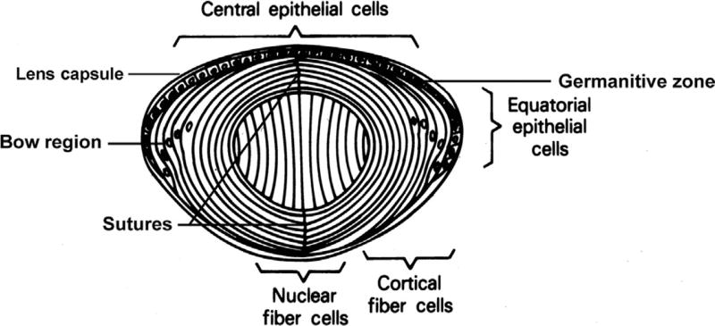
- The retina has 10 layers;
- Inner limiting membrane
- Nerve fiber layer (NFL)
- Ganglion cell layer
- Inner plexiform layer
- Inner nuclear layer
- Outer plexiform layer
- Outer nuclear layer
- External limiting membrane
- The layer of rods and cones
- Pigment epithelium
But the layers for information penetration include as follows (not in specific order);
- Nerve fiber layer (NFL): The layer of optic nerve fibres is made up of axons of ganglion cells. The fibres converge on the optic disc where they pass through foramina of the lamina cribrosa to enter the optic nerve. The nerve fiber layer is the second innermost layer of the retina from the vitreous.
- Ganglion cell layer: The layer of ganglion cells contains the cell bodies of ganglion cells. We have seen that dendrites of these cells enter the internal plexiform layer to synapse with processes of bipolar cells and of amacrine cells. Each ganglion cell gives off an axon that forms a fibre of the optic nerve. Retinal ganglion cells (RGC) are the retina's main output neuron, but also a third class of photoreceptors that are also photosensitive and help transmit both image-forming and non-image forming information that functions in the physiological processes of the circadian rhythm, modulation of melatonin release, and regulation of pupil size.
- Inner plexiform layer: the internal plexiform layer (or inner synaptic zone) consists of synapsing nerve fibres. The axons of bipolar cells synapse with dendrites of ganglion cells; and both these processes synapse with processes of amacrine cells. The internal plexiform layer also contains some horizontally placed internal plexiform cells; and also a few ganglion cells (As a rule of thumb, smaller RGCs dendrites arborize in the inner plexiform layer while larger RGCs dendrites arborize in other layers).
- Inner nuclear layer: The internal nuclear layer contains the cell bodies and nuclei of three types of neurons;
- The bipolar neurons give off dendrites that enter the external plexiform layer to synapse with the axons of rod and cone cells; and axons that enter the internal plexiform layer where they synapse with dendrites of ganglion cells.
- The horizontal neurons give off processes that run parallel to the retinal surface. These processes enter the outer plexiform layer and synapse with rods, cones, and dendrites of bipolar cells. Horizontal cells are involved in modulating information transfer between bipolar cells and photoreceptors and are involved with helping eyes adjust to both bright light and low light conditions.
- The amacrine cells also lie horizontal in the retina. Their processes enter the inner plexiform layer where they synapse with axons of bipolar cells, and with dendrite of ganglion cells. Amacrine cells are intermediate neurons that release the inhibitory neurotransmitter GABA or glycine. However, given their unique gap junction physiology, they can be both inhibitory or excitatory.
- External limiting membrane: radial glial cells of the retina, also known as Muller cells, are in the outer limiting membrane (OLM) of the retina and form adherens junctions between Muller cells and rods and cones in the inner segments. The retina's inner limiting membrane (ILM) is composed of laterally contacting Muller cell synaptic boutons and other basement membrane parts.
- Inner limiting membrane: the ILM is the retina's inner surface bordering the vitreous humor and thereby forming a diffusion barrier between the neural retina and vitreous humor.
- Outer plexiform layer: This layer of the retina contains a neuronal synapse of between rods and cones with the footplate of horizontal cells. Capillaries are also found to be primarily running through the outer plexiform layer.
- Outer nuclear layer: This layer contains the rod and cone granules that sense photon, extensions from the rod, and cone cell bodies.
- The layer of rods and cones: The rods are processes of rod cells, and cones are processes of cone cells. These cells are described below. The tips of the rods and cones are surrounded by processes of pigment cells.
- Pigment epithelium: This consists of a single layer of cells containing pigment. Processes from pigment cells extend into the next layer.

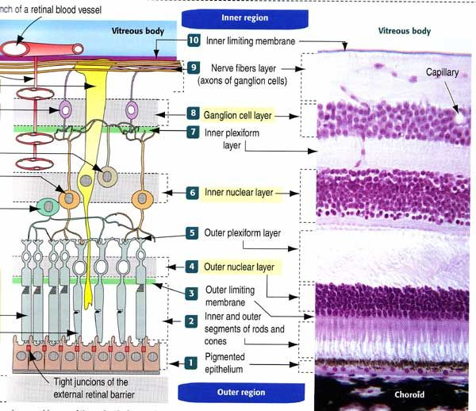
the diagram illustrates the correct order the layers of the retina are meant to be in.

References
http://www.sciencedirect.com
http://www.ncbi.nlm.nih.gov
textbook of human histology by Inderbir Singh

