NAME: ALAO BOLAJI WILLIAMS
MATRIC NO: 17/MHS01/049
CLASS: 300 LEVEL
COURSE: NEUROHISTOLOGY
1. Write an essay on the histological importance of eye in relation to their cellular functions.
Eyes: the photoreceptor system
The human eyes are the most complicated, complex sense organs and highly developed photosensitive organ that analyses the form, intensity, and colour of light reflected from objects, providing the sense of sight. The eyes are located in protective areas of the skull, the orbits, which also contain cushions of adipose tissue. Each eyeball includes a tough, fibrous globe to maintain its shape, a system of transparent tissues that refract light to focus the image, a layer of photosensitive cells, and a system of neurons whose function it is to collect, process, and transmit visual information to the brain. Eyes are the chief organs of vision in human body and hence termed as photoreceptors. Human eyes receive and form images from outside, also automatically changes in light and seeing things close up and at a distance.
Therefore, we can see most of things from outside world. But without light, we can't see anything. Light travels through space and the sun gives off light rays that enter the eyes they are bent or refracted and these light rays create images or picture of all the objects around you, that's why we can see things very clearly. How light enter the eye, first light enters the eye though pupil which control different amounts of light into our eye. Then crystalline lens helps us see clearly, when we look at near objects crystalline lens will grows thicker and when we look at far objects then it becomes thinner. An eye is almost a spherical ball, guarded by two eye lids: upper eye lid and lower eye lid which can move frequently.
These eye lids are bordered by hairs forming eye-lashes. In man the third eye lid is vestigial and lies at the corner of the eye and is known as plica semilunaris. On the margins of eye lids are small meibomian glands which secrete an oily substance for lubricating the eye lids and for holding a thin film of tears underneath. Below the outer corner of the upper eye lid are lacrimal or tear glands to produce tears that keep the eye ball (conjunctivae) moist. The tear flows across the front of the eye and excess of tears at the time of emotion are drained into the small lacrimal sac at the inner margin from where they are then discharged by means of nasolacrimal duct into the nasal passage ways. The tears: lubricate the surface of the eye ball, wash away dust particles fallen on the surface of the eye ball, help in killing germs thus prevent infection and communicate emotions.
The eye ball is formed of three coats, an outer fibrous(sclera and cornea), middle vascular(iris, choroid and ciliary body) and inner retina. Sclerotic:
It is the outermost layer of the eye ball and is formed of a tough layer of modified fibrous connective tissue. The sclerotic layer gives shape to the eye ball, protects the eye and provides surface for attachment of six extrinsic muscles.
Cornea:
It is optically transparent and the anterior most 1/6th external tunic, which is comprised of three cellular layers and two noncellular layers the outermost layer is the corneal epithelium: which is a stratified, non-keratinized epithelium that is continuous with the conjunctival epithelium overlying the adjacent sclera. Bowman's membrane: it is the basement membrane of the corneal epithelium. This is a layer of subepithelial basement membrane protecting the underlying stroma. It is composed of type 1 collagen, laminin, and several other heparan sulfate proteoglycans. The corneal stroma: the largest layer of the cornea, the stroma has collagen fibers and keratocytes maintaining the integrity of the layer. The function of this layer is to maintain transparency, which occurs by the regular arrangement, and lattice structure of the fibrils. Descemet's membrane: it is an acellular layer made of type iv collagen that serves as a modified basement membrane of the corneal endothelium. The corneal endothelium: it is a simple squamous epithelium facing the anterior chamber of the eye. Transparency of the cornea requires precise control of the hydration of the stroma and it is cells of the corneal endothelium that perform this function. Unlike the corneal epithelium, corneal endothelial cells have very limited proliferative potential, so severe damage to this epithelium can only be repaired by transplantation.

Iris:
The iris controls the amount of light that enters through the pupil and ensures that light must move through the pupil to reach the retina by dividing the cavity of the eye ball into a small, anterior aqueous chamber and a large, posterior vitreous chamber. The aqueous chamber is filled with a watery aqueous humour; while the vitreous chamber is filled with a gelatinous vitreous humour. The aqueous humour contains about 98% water, protein and sodium chloride. It maintains intraocular pressure, acts as a refractive medium, supplies nutrition to lens and drains away metabolic wastes.
Ciliary body:
The ciliary body functions primarily to control the shape of the lens and produce aqueous humor. Just behind the iris, the surface of the ciliary body is thrown into folds known as ciliary processes. The innermost cells facing the "lumen" of the eyeball are non-pigmented and are ultimately continuous with the ganglion cell layer of the neural retina, however these cells are obviously not neural. Instead, you should note that they are cuboidal and, particularly along the ciliary processes, quite eosinophilic which is due to their high content of mitochondria and ion channels essential for their primary role in the production of aqueous humor.

Choroid:

It is the middle layer lying below the sclerotic. The choroid is made of loose but highly vascular connective tissue having dark brown pigment. In nocturnal mammals this layer contains a silvery connective tissue (tapetum) for reflecting light causing the eye to shine at night. In front the choroid thickens as a circular ciliary body. It contains blood vessels, glands and ciliary muscles. In front of the ciliary body, the choroid separates from the sclerotic and passes inwards as iris which possesses a circular aperture in the centre called pupil.
Vitreous humour:
Vitreous humour is a jelly like material and almost has same composition as aqueous humour. However, it contains less glucose but higher concentration of pyruvic acid and lactic acid. A lymphatic vessel is found in the vitreous chamber passing from the lens to the blind spot and is known as hyaloid canal.
Retina:
It is the nervous tissue of the eye where photons of light convert to neurochemical energy via action potentials.Retina tunic includes; an outer pigmented epithelium and an inner neural retina proper. The photosensitive inner layer of the retina communicates with the cerebrum through the optic nerve on the eye's posterior side; its anterior edge is called the ora serrata. Moreover, the retina itself is divided into various layers as follows Retinal pigment epithelium: made of cuboidal cells containing melanin which absorbs light. These cells also establish a blood-retina barrier through tight junctions.

It is the innermost layer of the eye ball and consists of two sub-layers:
(a) an outer layer of pigment cells lying immediately after the choroid; and
(b) an inner retina proper consisting of two types of visual cells—rods and cones
The rods contain rhodopsin pigment or visual purple which can distinguish various degrees of light and darkness. The retina of the nocturnal animals is mainly formed of this pigment and enables them to see in dim light. Cones contain primarily iodopsin pigment and some cyanopsin which are concerned with colour vision. Recently three other pigments have been found in human eye, they are erythrolabe, chlorolabe, and cyanolabe which are sensitive to red, green and blue light respectively. These pigments appear to be located in cones and may be responsible for colour vision.
However, the histological parts of the eye have primarily structural and visual Importance. The cornea serves a protective role and is responsible for two-thirds of the refractive properties of the eye. The remaining one-third of refraction is performed by the lens, which is functionally adjustable through the action of the zonular fibers and ciliary muscles. At the end of the visual process, as rays of light bend through the cornea and lens, photon energy is converted to neurochemical action potentials by cells of the retina, which then send these impulses to the brain, via the optic nerve.The uvea of the eye is a crucial mediator of nutrition and gas exchange, as blood vessels course through the ciliary body and iris, while the choriocapillaris in the posterior eye help support the retina. This abundant blood supply is implicated in uveitis, as inflammatory mediators enter the eye through this vascular network.

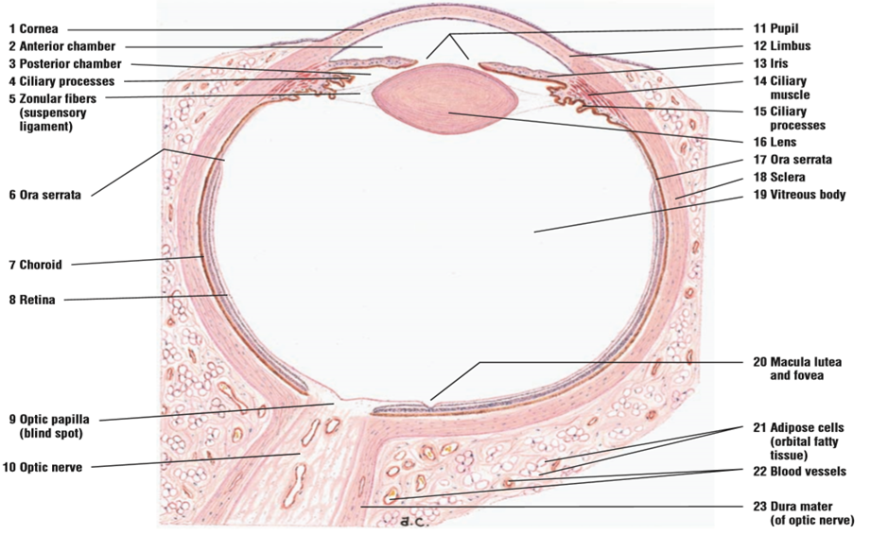

Clinical significance
Several of the most common diseases of the eye are manifestations of pathology within specific histological layers. Below are examples of common eye conditions, and the layers of the eye implicated.
- Myopia or short-sightedness: people having this eye defect can see near objects clearly but not distant objects. In this case the lens of the eye is too convex and the rays of light are focused at a point in front of the retina instead of upon it. This defect is corrected by the use of concave lenses.
- Hypermetropia or long-sightedness: a farsighted person can see distant objects clearly but not near objects. In this case the eye ball is too short, so that the retina is too close to lens and the focusing point lies behind retina. It is corrected by the use of convex lens.
- Astigmatism: this abnormality of vision is due to the irregularities in the shape of the lens and cornea. The lens shows different curvatures in different regions of the eye. So the light rays are not brought into sharp focus on the retina. This defect is corrected by the cylindrical lens.
- Presbyopia or old-age sight: it is due to the loss of flexibility of the lens in the old age. The person feels difficulty in focussing on near objects. This defect occurs at any time after the age of 35. It is corrected by the use of convex lens.
- Chalazion: a sterile lump often in the upper eyelid caused by obstruction of the meibomian oil glands.
- Conjunctivitis: inflammation of the transparent conjunctiva that may be caused by bacterial or viral infections, allergies, or exposure to certain chemicals.
- Cataracts: a sclerotic nuclear cataract is the most common and is due to opacification in the central nucleus of the lens. Cortical cataracts are due to opacifications in the cortex and have a distinct wedge-shaped appearance. Posterior subcapsular cataracts arise from behind the sac-like structure of the lens.
- Glaucoma: refers to optic nerve damage related to increased intraocular pressure. Drainage of aqueous humor through the trabecular meshwork is often implicated..

2. Corona virus can penetrate the body through eye and implicate the immune system , briefly discuss the layers of retina for information penetration.
Retina:
The retina, the inner layer of the eye, is derived from the embryonic optic cup. Like the optic cup, the retina consists of two major layers. The inner one, the neural retina, contains the neurons and photoreceptors. This layer's visual region extends anterior only as far as the ora serrata but it continues as a cuboidal epithelium lining the surface of the ciliary body and posterior iris. The outer pigmented layer is an epithelium resting on Bruch's membrane just inside the choroid. This pigmented, cuboidal epithelium also lines the ciliary body and posterior iris, contributing to the double epithelium described with those structures.
Retina is a nervous tissue of the eye where photons of light convert to neurochemical energy via action potentials.Retina tunic includes; an outer pigmented epithelium and an inner neural retina proper. The photosensitive inner layer of the retina communicates with the cerebrum through the optic nerve on the eye's posterior side; its anterior edge is called the ora serrata. Moreover, the retina itself is divided into various layers as follows Retinal pigment epithelium: made of cuboidal cells containing melanin which absorbs light. These cells also establish a blood-retina barrier through tight junctions.
The retina, with the exception of the blood vessels coursing through it, is transparent to up to its outer layer, the retinal pigment epithelium. The transparent portion of the retina is known as the neurosensory retina. The neurosensory retina is against the background orange colour of the melanin containing retinal pigment epithelium and blood-filled choroidal layer of the eye. The neuroretina is tightly attached to the underlying retinal pigment only at the margins of the optic nerve and at the ora serrata. There is a potential space between the neurosensory retina and the retinal pigment epithelium.
Anatomic layers of the retina
Each of the microscopic layers of the retina has a name and contains various structures. Beginning with the innermost layer (closest to the vitreous) and proceeding outwards towards the choroid and sclera, these layers are as follows:
- "Internal limiting membrane": A thin layer of Muller glial cells and basement membrane which demarcates the vitreous anteriorly from the retina posteriorly.
- "Nerve fiber layer": The nerve fiber layer is the layer of optic nerve fibers consisting of ganglion cell axon fibers, which course towards the optic nerve head. This layer contains axons of retinal ganglion cells and the astroglia which support them.
- "Ganglion cell layer": The ganglion cells layer contains the nuclei of retinal ganglion cells, the axons of which become the optic nerve fibers for messages. There are also some displaced amacrine cells within this layer. Additionally, this layer also contains the non-rod and non-cone photoreceptors, the photosensitive ganglion cells, which are important for reflexive responses to bright daylight.
- "Inner plexiform layer": This layer relays information from cells of the inner nuclear layer. Thus, this layer has axons of amacrine, bipolar, and glial cells and dendrites of retinal ganglion cells.
- "Inner nuclear layer': The inner nuclear layer contains the nuclei of horizontal, bipolar and amacrine cells. The inner nuclear layer is thicker in the central area of the retina compared with peripheral retina because of a greater density of cone-connecting second-order neurons (cone bipolar cells) and smaller and more closely spaced horizontal cells and amacrine cells concerned with the cone pathways. There are also nuclei of the supporting Muller cells.
- "Outer plexiform layer": the outer plexiform layer contains the rod and cone axons (projections of rods and cones ending in the rod spherule and cone pedicle), horizontal cell dendrites, and bipolar cells dendrites. Synapses among these structures occur within this layer. In the macular region, this layer is termed the fiber layer of Henle. The outer plexiform layer is also known as the outer synaptic layer.
- "Outer nuclear layer the outer nuclear layer consists of the cell bodies of the retinal rods and cones. In the peripheral retina, the rod cell bodies outnumber the cone cell bodies, whereas the reverse is true for the central retina.
- "Outer limiting membrane": A layer of Muller cells and rod/cone junctions which serves to separate the photosensitive regions of the retina from the areas that transmit the electrical signals.
- Rod and cone cell layer: the rod and cone cell layer (RCL), which contains the outer segments of these cells where the photoreceptors are located.
- Pigmented layer: the pigmented layer (PL) which is not sensory, but has several supportive functions important for maintenance of the neural retina.
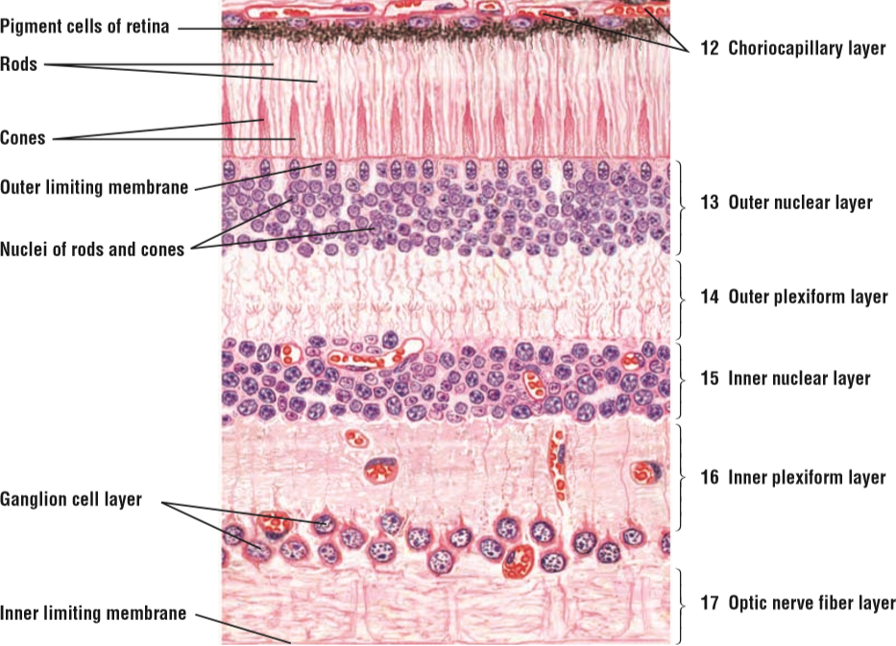
Functional Anatomy of the Retina
The conversion of light into neural signals involves four basic processes: photoreception, transmission to bipolar cells through synapses, transmission to ganglion cells, and transmission along the optic nerve.
Photoreception
Focused (or unfocused) light passes through the inner layers of the retina to reach the photoreceptors (rods and cones). Because the photoreceptive cells lie outermost within the retina, light must first pass through and around the ganglion cells and through the thickness of the retina before reaching the rods and cones. The light does not pass through the pigment epithelium or the choroid, which are opaque. The outer segments of the rods and cones contain photo pigment, which captures individual photons of light and initiates neural signaling.
Transmission to bipolar cells through synapses
The outer segments of the rods and cones transduce the light and send the signal through the cell bodies of the outer nuclear layer and out to their axons. In the outer plexiform layer, photoreceptor axons contact the dendrites of both bipolar cells and horizontal cells. Horizontal cells are horizontally oriented (parallel to the retinal surface) interneurons, which aid in signal processing. Bipolar cells are vertically oriented (perpendicular to the retinal surface).Cones synapse with eight different types of bipolar cells. Five of these are called diffuse bipolar cells and make synaptic contact with up to 20 cones.
Transmission to ganglion cells
The bipolar cells in the inner nuclear layer process input from photoreceptors and horizontal cells. They transmit the signal to their axons. In the inner plexiform layer, bipolar axons contact ganglion cell dendrites and amacrine cells, another class of interneurons, through synapses. Ganglion cells are vertically oriented while amacrine cells are horizontally oriented.
Transmission along the optic nerve
The ganglion cells of the ganglion cell layer send their axons through the nerve fiber layer and converge at a point nasal to the center of the retina, forming the optic nerve. The ganglion cell axons all leave the eye at the optic disk. Theses axons travel all the travel all the way to the lateral geniculate nucleus in the brain stem. At the optic disc, no retinal photoreceptors, bipolar cells, ganglion cells, or accessory cells are present.

