NAME : AGAMMEGWA DANIEL CHIDUBEM

MATRIC NUMBER : 19/ENG05/067

COURSE CODE : ENG 232

COURSE TITLE : ENGINEERING DRAWING

- A sectioned surface on a drawing can be represented when sketching an object or part that requires a sectional view , they are drawn by eye at an angle of 45 degrees and are spaced about 1/8 apart. It is best to use the symbol of a material being shown as a section on the sketch

- a. Dimensions are quoted in millimeters

b. Center line are never to be used as dimension lines

c. Arrowheads must be approximately triangular to avoid errors

d. The projection lines should always continue past the dimension lines

e.To enable dimensions to be properly read , measurements in figures are written .

- a. Half section- is a view of an object showing one half of the view in section.

b. Full section – this occurs when the imaginary cutting plane passes through the entire object , thereby splitting the object into two with the interior of the object revealed .

4 Leander lines are terminated with an arrow touching the part on the end opposite the arrow , the leader line would have a horizontal shoulder

5 a A scale 5:1 means that an object or line to be drawn is 5 times the original size
B A scale 1:10 means that an object or line to be drawn is 10 times smaller

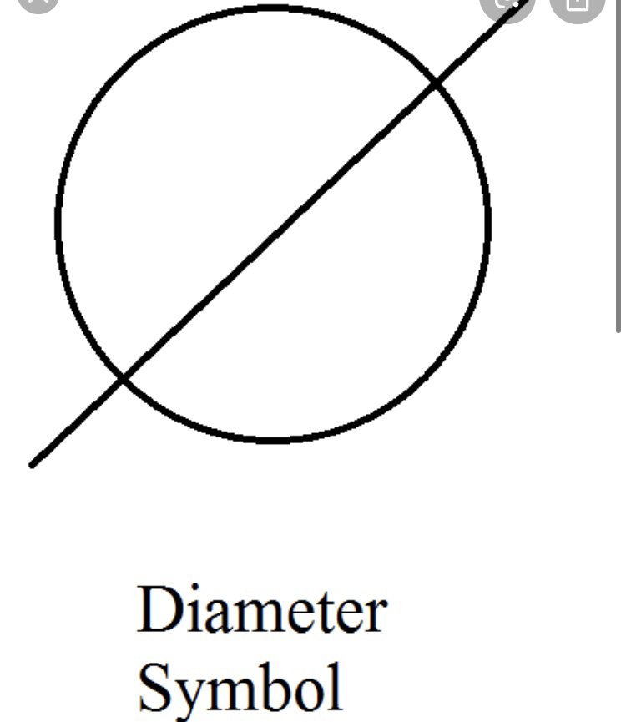
6. a diameter.
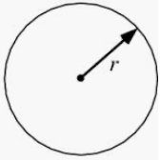
b radius
c square
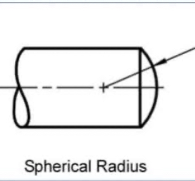
d spherical radius

e center line –

f. cutting plane line

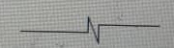
g. Long break lines

7.The dimension of the work to be projected
b Orthographic projection is a method of projection where an object is depicted using parallel lines to project its outline unto a plane .

8 It is said to be orthographic when the lines of sight are parallel to the projection plane .

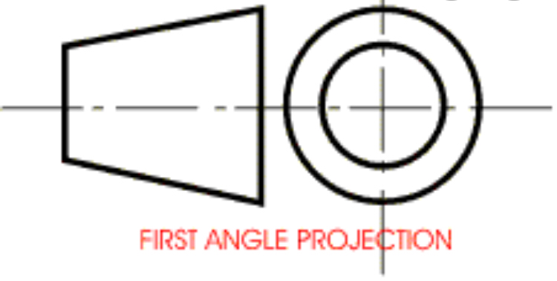
9.a First angle projection is a method of projection where a 2D drawing of 3D object is created .

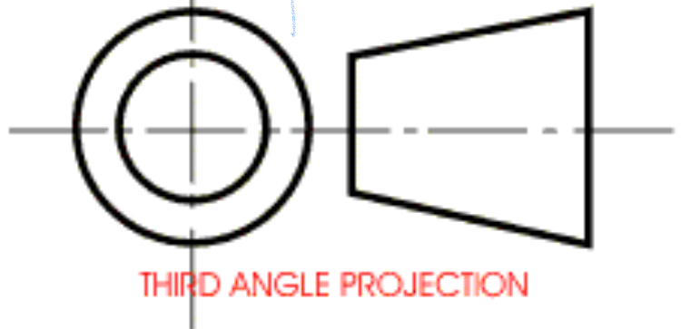
b Third angle projection is a method of orthographic projection where a 3D design is portrayed using a series of 2D views .

Objectives
1 A reference plane

2 B false

3 C directly

4 B 120 degrees

5 A 60 degrees

6 B rivet

7 C crowning

8 B 45 degrees

9 A a circle
10 A an ellipse

11 C cylinder

12 D frustum

13 C pivot bearing

14 C 55 degrees

15 D horizontal plane

