NAME: AYOOLA ENIOLUWADUROTI OGUNSEMOWO.
COURSE: BCH 204- MEDICAL BIOCHEMISTRY.
COLLEGE: MEDICINE AND HEALTH SCIENCES.
DEPERTMENT: ANATOMY.
MATRIC NUMBER: 18/MHS01/254.
ASSIGNMENT.
Describe the three stages of beta oxidation, showing pathways where necessary.
ANSWER.
Beta oxidation of fatty acid is involved in three stages;
1.Activation of fatty acid; Fatty acids are activated to their coenzyme A and this activation takes place in the cytoplasm. The enzyme needed for this activation is thiokinase and thiokinase requires ATP for the reaction. ATP is hydrolysed to AMP and PPi and the energy from the hydrolyses of PPi drives the reaction forward. The product of the reaction is fatty acid acyl-CoA.
Fatty acid + CoA+ATP Fatty acid CoA+AMP+2P_{i}
2.Transport of fatty acyl CoA from cytosol into mitochondria; Long chain of fatty acyl CoA cannot pass through the inner mitochondria membrane so it needs a transporter carnitine. The enzyme carnitine acyl transferase I will transfer the fatty acyl group to the hydroxyl group of carnitine to form acyl carnitine. The reaction occurs on the cytosolic side of inner mitochondrial membrane. The protein translocase will then carry the acyl carnitine across the membrane to the matrix of the mitochondria. On the matrix side of the membrane another enzyme, carnitine acyl transferase II will transfer the acyl group back to co enzyme A molecule. Carnitine is returned to the cytosolic side by the translocase.
3.Beta oxidation proper in the mitochondrial matrix; There are 4 steps in the oxidation.
Step1; FAD linked dehydrogenase
The fatty acyl CoA is dehydrogenated to a transenoyl CoA with FAD accepting the hydrogen atoms. FADH₂ when oxidized in electron transport chain will produce 1.5 ATP molecules.
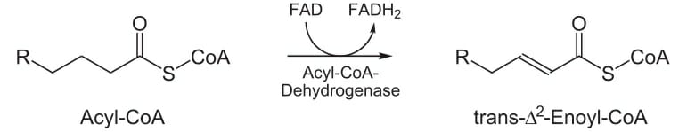
Step2; Hydration
This is catalysed by an enoyl- CoA hydratase. This step forms a beta-hydroxy fatty acyl-CoA.
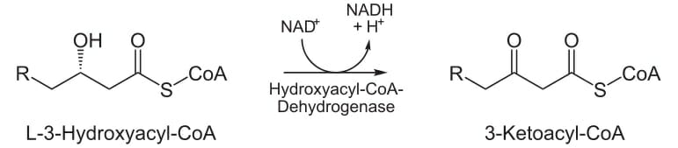
Step3; NAD⁺ Dependent Dehydrogenase
The beta-hydroxy fatty acyl-CoA is again oxidized to form beta-keto fatty acyl-CoA. The NADH when oxidized in electron transport chain will generate 2.5 ATPs.
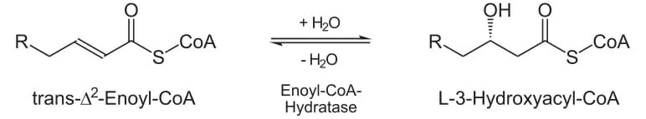
Step4; Cleavage
The beta-keto fatty acyl-CoA now undergoes thiolytic cleavage, splitting off a molecule of acetyl-CoA and leaving behind a fatty acid with 2 carbon atoms less.
The newly formed fatty acyl-CoA will sequentially undergo further cycles of step1,2,3 and 4 of beta oxidation.

