ASSIGNMENTS SOLUTION TO ENG 232
- A section view is a view used on a drawing to show an area or hidden part of an object by cutting away or removing some of that object.
- 1,.Dimension and projection lines are narrow continuous lines

2. The projection lines should not touch the drawing but a small gap should be left,

3. The projection lines should then continue for the same distance past the dimension line.

4. Arrowheads should be approximately triangular, must be of uniform size and shape and in every case touch the dimension line to which they refer.

5 Centre lines must never be used as dimension lines but must be left clear and distinct.

6 Dimensions are quoted in millimetres to the minimum number of significant figures. For example, 19 and not 19.0.

7 To enable dimensions to be read clearly, figures are placed so that they can be read from the bottom of the drawing, or by turning the drawing in a clockwise direction.

8 Leader lines are used to indicate where specific indications apply. The leader line to the hole is directed towards the centre point but terminates at the circumference in an arrow.

Full Sections : When a cutting plane line passes entirely through an object, the resulting section is called a full section
Half Sections: If the cutting plane is passed halfway through an object, and one-quarter of the object
4.. The leader line itself should be a continuous thin line. A leader line also has a terminator and some text.The four different types of terminators
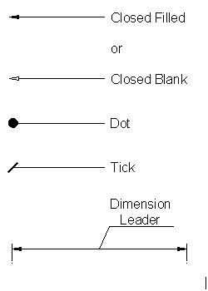

- A 50mm line is to be drawn at a scale of 5:1 (ie 5 times more than its original size) A drawing at a scale of 1:10 means that the object is 10 times smaller than in real life scale
- Diameter- ø , Radius-R SR
Spherical Radius
Square 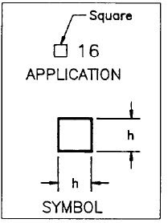

Centre line -
Cutting plane
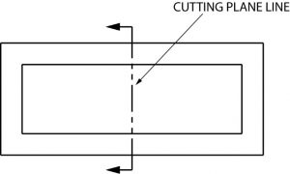

Long break line 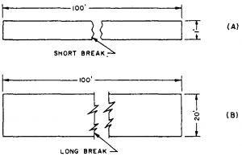

- a .The type of projection
b. The view of projection
Orthographic projection is a means of representing three-dimensional objects in two dimensions. A method of projection in which an object is depicted using parallel lines to project its outline on to a plane.
- A projection of an object is called orthographic when it is in two dimension.

First Angle Projection
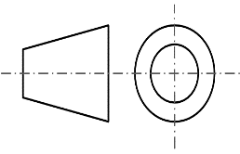
In the 1st angle projection system, objects are placed in the first quadrant. And it lies in between the observer and the plane of projection.
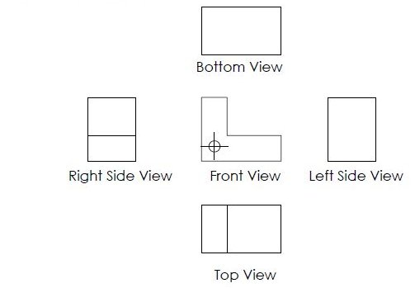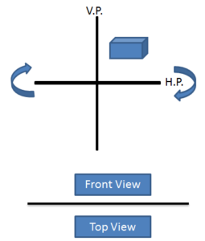

Front and Top View in First Angle Projection To draw front and top views, object front and top views are projected on vertical and horizontal planes respectively. According to the rule of projection, the horizontal plane is rotated in the clockwise direction. Horizontal plane rotation brings top view in the bottom of projected front view.

Right and Left Side View in 1st angle projection To draw Right and left side views. Object right and left side views are projected on vertical left and vertical right plane respectively. To bring the right side view on 2D plane rule of orthographic projection is Followed. Left plane is unfolded towards the left side. Therefore Right Side View is projected on the left side of the front view.
Whereas the left side view is projected on the right side of the front view.

Third Angle Projection
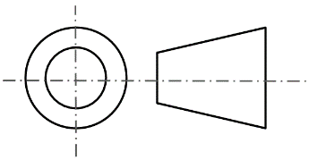
In the 3rd angle projection, objects are placed in the third quadrant and projection plane lies in between observer and the object.
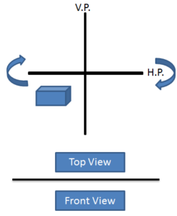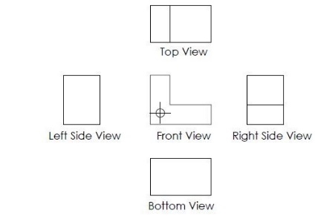

Front and Top View in 3rd Angle Projection To draw front and top views in 3rd angle projection. Object front and top views are projected on vertical and horizontal planes respectively.As per rule of projection, the horizontal plane is rotated in the clockwise direction. This rotation brings top view on top of projected front view.

Right and Left Side View in 3rd Angle ProjectionObject Right and left side views are projected on vertical right and vertical left planes respectively.To draw the right side view on a 2D plane, Right plane is unfolded towards the right side. As a result, Right side view is projected on the right side of the front view. Similarly, the left side view is projected on the left side of the front view. Bottom View is projected on the bottom plane and placed on bottom of front view
OBJECTIVES
- 12.
- 13.
- 14.
- 15.

