Name: Adeyemo Sinmiloluwa
Course: Histology
Matric no: 17/MHS01/025
Department: Medicine and Surgery

ASSIGNMENT
- ESSAY ON THE HISTOLOGICAL IMPORTANCE OF THE EYE IN RELATION TO ITS CELLULAR FUNCTION
Eyes are highly developed photosensitive organs for analyzing the form, intensity and colour of light reflected from objects and providing the sender of sight. Protected within the orbits of the skull which also contain adipose cushions, each eyeball consists externally of a tough, fibrous globe that maintains it's overall shape. Internally the eye contains transparent tissues that refract light to focus the image, a layer of photosensitive cells and a system of neurons that collect, process and transmits visual information to the brain.

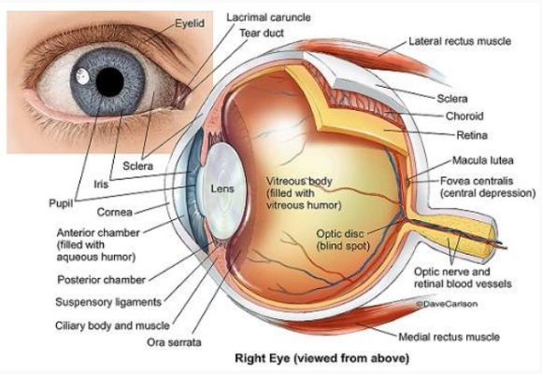
Each eye is compared if there consecutive tunics or layers
- A tough external fibrous layer consisting of the sclera and the transparent cornea
- A middle vascular layer that includes the choroid, ciliary body and iris
- An inner sensory layer, the retina, which communicates with the cerebrum through the posterior optic nerve

Below is a table showing the Histological importance of the part of the eye to it’s cellular function.
Structures | Components | Function
Fibrous Tunic(external layer)
Sclera  Cornea | Dense irregular connective tissue  Two layers of epithelium with organized connective tissue in between | Supports the eye  Protects delicate internal structures  Extrinsic eye muscle attachment site  Protects anterior surface of the eye
Vascular Tunic (middle layer)
Choroid  Ciliary body  Iris | Areolar connective tissue; highly vascularized  Ciliary smooth muscle and ciliary processes; covered with a secretory epithelium  Two layers of smooth muscle (sphincter pupillae) and connective tissue, with a central pupil | Supplies nourishment to the retina  Pigment absorbs extraneous light  Holds suspensory ligaments that attach to the lens and change lens shape for far and near vision  Epithelium secretes aqueous humor  Controls pupil diameter and thus the amount of light entering the eye
Retina (internal layer)
Pigmented layer | Pigmented epithelial cells  Photoreceptors, bipolar neurons, ganglion cells and supporting Müller cells | Absorbs extraneous light  Provides vitamin A for photoreceptor cells  Detects incoming light rays; light rays are converted to nerve signals and transmitted to the brain

- Easy on layers of the retina for information penetration
The retina is the innermost layer in the eye that is responsible for the visual processing that turns light energy from photons into three-dimensional images. Located in the posterior portion of the eyeball, the retina is the only extension of the brain that can be viewed from the outside world and gives ophthalmologists a rare window into real-time pathology affecting the retina. The retina itself consists of six different cell lines divided into ten different layers, each playing a specific role in creating and transmitting vision. The different cell types perform a particular role and form functional circuits that specialize in detecting specific variations and movements of light.

Structure and function
The retina lines the entire posterior portion of the eye, except for the area of the optic nerve and extends anteriorly to end 360 degrees circumferentially at the ora Serrata, the junction between the retina and the ciliary body.
The retina is a layered structure with ten distinct layers of neurons interconnected by synapses. The cells subdivide into three basic cell types: photoreceptor cells, neuronal cells, and glial cells. The layers from the closest to the front anterior of the head towards the posterior of the head are as follows:
- Inner limiting membrane
- Nerve fiber layer (NFL)
- Ganglion cell layer
- Inner plexiform layer
- Inner nuclear layer
- Middle limiting membrane
- Outer plexiform layer
- Outer nuclear layer
- External limiting membrane
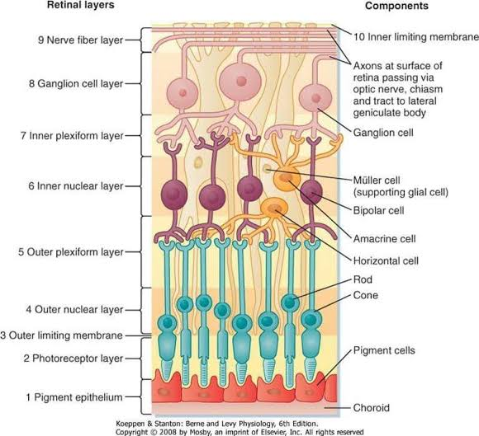
- The layer of rods and cones

Inner limiting membrane
The ILM is the retina's inner surface bordering the vitreous humor and thereby forming a diffusion barrier between the neural retina and vitreous humor. The ILM contains laterally contacting Muller cell synaptic boutons and other basement membrane parts.
Nerve fiber layer (NFL)
The nerve fiber layer is the second innermost layer of the retina from the vitreous. Patients with retinitis pigmentosa may have a measurable degree of RNFL thinning.
Ganglion cell layer
This layer contains the retinal ganglion cells (RGCs) and displaced amacrine cells. As a rule of thumb, smaller RGCs dendrites arborize in the inner plexiform layer while larger RGCs dendrites arborize in other layers.
Inner plexiform layer
The inner plexiform layer is an area comprised of a dense reticulum of fibrils formed by interlaced dendrites of RGCs and cells of the inner nuclear layer.
Inner nuclear layer
This layer of the retina contains the cell bodies of bipolar cells, horizontal cells, and amacrine cells.
Outer plexiform layer
This layer of the retina contains a neuronal synapse of between rods and cones with the footplate of horizontal cells. Capillaries are also found to be primarily running through the outer plexiform layer.
Outer nuclear layer
This layer contains the rod and cone granules that sense photon, extensions from the rod, and cone cell bodies.
External limiting membrane
This layer contains the bases of the rod and cone photoreceptors cell bodies. The ELM forms a barrier between the subretinal space, into which the inner and outer segments of rods and cones project to be in close association with the pigment epithelial layer behind the retina, and the neural retina proper.
Retinal pigment epithelium
The retina is supported by the retinal pigment epithelium (RPE), which has many functions including vitamin A metabolism, maintenance of the blood-retina barrier, phagocytosis of photoreceptor outer segments, production of mucopolysaccharide matrix surrounding the outer segments of the retina, and active transport of materials into and out of the RPE.

