A TERM PAPER
ON
USING RAMAN SPECTROSCOPY IN FORENSIC SCIENCE

BY
GROUP 4

COURSE CODE: ANA 406
COURSE TITLE: INTRODUCTION TO FORENSIC SCIENCE

LECTURER: DR. LINUS A. ENYE

GROUP MEMBERS
- Ebenezer Eno-Abasi Israel 16/MHS01/066
- Omotoso Deborah 16/MHS03/023
- Obvude Irenoise 16/MHS03/026
- Faleye Caleb Ken 16/MHS03/013
- Ogunjobi David 16/MHS01/169
- Jeje Susan 16/MHS03/015
- Adeyemi Adesola Akorede 16/MHS03/004
- Okewulonu Karen Ezichi 16/MHS06/043
- Akpan Idara Solomon 16/MHS01/032
- Osamor Michelle 16/MHS01/213

INTRODUCTION TO RAMAN SPECTROSCOPY
Raman spectroscopy named after Indian physicist C. V. Raman is a spectroscopic technique typically used to determine vibrational modes of molecules, although rotational and other low-frequency modes of systems may also be observed. Raman spectroscopy is commonly used in chemistry to provide a structural fingerprint by which molecules can be identified. Raman spectroscopy relies upon inelastic scattering of photons, known as Raman scattering. A source of monochromatic light, usually from a laser in the visible, near infrared, or near ultraviolet range is used, although X-rays can also be used. The laser light interacts with molecular vibrations, phonons or other excitations in the system, resulting in the energy of the laser photons being shifted up or down. The shift in energy gives information about the vibrational modes in the system. Infrared spectroscopy typically yields similar, complementary, information (Agrawal, 2001).
Raman spectroscopy is a molecular spectroscopic technique that utilizes the interaction of light with matter to gain insight into a material's make up or characteristics, like the Fourier-transform infrared spectroscopy (FTIR). The information provided by Raman spectroscopy results from a light scattering process, whereas IR spectroscopy relies on absorption of light. Raman spectroscopy yields information about intra- and inter molecular vibrations and can provide additional understanding about a reaction. Both Raman and FTIR spectroscopy provide a spectrum characteristic of the specific vibrations of a molecule ("molecular fingerprint') and are valuable for identifying a substance. However, Raman spectroscopy can give additional information about lower frequency modes, and vibrations that give insight into crystal lattice and molecular backbone structure.
Raman spectroscopy had always problems with the high level of elastic scattering, in particular for investigation of lines at short Raman shift. The situation has been handled by fitting the monochromator with two or three dispersion stages. The first commercially available double monochromator incorporated into a spectrophotometer was marketed by 1940 and still today double and triple monochromators are used routinely. These systems may reduce the level of Rayleigh scatter by 10 or more orders of magnitude at Raman shifts of only a few cm. The price paid for these earnings has been an increase in the size and price of the instrument and a decrease in the throughput of the optical system. The search for alternatives has resulted in the development of high efficiency holographic notch filters for rejection of Rayleigh light, which make successive dispersion stages unnecessary thus increasing significantly the luminosity of the Raman experiment. Although photoelectric devices were available in recording spectrophotometers by World War II, Raman detection for more than three decades was dominated by photography. Advantage was taken of the capability for light integration of photographic emulsions to mitigate the Raman detection problem. During the 1040s and 1950s much progress was made in electronics and reliable photomultipliers were developed. By 1970, high quality photomultiplier tubes were available and were universally used except for high resolution spectroscopy of gases in which photographic recording was still occasionally employed (Smekal, 1923)

PRINCIPLES OF RAMAN SPECTROSCOPY
When light interacts with molecules in a gas, liquid, or solid, the vast majority of the photons are dispersed or scattered at the same energy as the incident photons. This is described as elastic scattering, or Rayleigh scattering. A small number of these photons, approximately 1 photon in 10 million will scatter at a different frequency than the incident photon. This process is called inelastic scattering, or the Raman effect, named after Sir C. V. Raman, who discovered this and was awarded the 1930 Nobel Prize in Physics for his work. Since that time, Raman has been utilized for a vast array of applications from medical diagnostics to material science and reaction analysis. Raman allows the user to collect the vibrational signature of a molecule, giving insight into how it is put together, as well as how it interacts with other molecules around it (Raman & Krishnan, 1928).

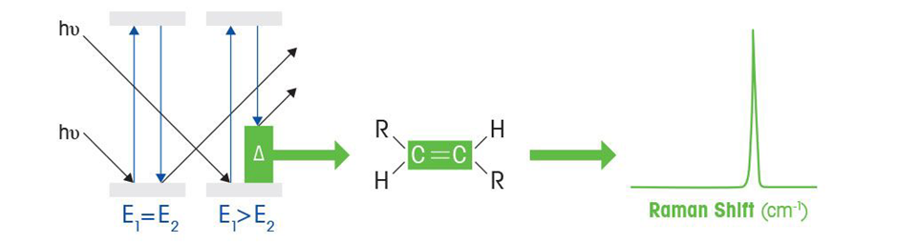

Raman Scattering Process
The Raman Scattering Process, as described by quantum mechanics, is when photons interact with a molecule, the molecule may be advanced to a higher energy, virtual state. From this higher energy state, there may be a few different outcomes. One such outcome would be that the molecule relaxes to a vibrational energy level that is different than that of its beginning state producing a photon of different energy. The difference between the energy of the incident photon and the energy of the scattered photon is the called the Raman shift (Raman & Krishnan, 1928).
How Does Raman Spectroscopy Work?
Unlike FTIR Spectroscopy that looks at changes in dipole moments, Raman looks at changes in a molecular bond polarizability. Interaction of light with a molecule can induce a deformation of its electron cloud. This deformation is known as a change in polarizability. Molecular bonds have specific energy transitions in which a change of polarizability occurs, giving rise to Raman active modes. As an example, molecules that contain bonds between homonuclear atoms such as carbon-carbon, sulfur-sulfur, and nitrogen-nitrogen bonds undergo a change in polarizability when photons interact with them. These are examples of bonds that give rise to Raman active spectral bands but would not be seen or difficult to see in FTIR (Raman & Krishnan, 1928).

HISTORY OF RAMAN SPECTROSCOPY
Although the inelastic scattering of light was predicted by Adolf Smekal in 1923 (Smekal et al., 1923), it was not observed in practice until 1928. The Raman effect underlying Raman spectroscopy is ancient and was discovered in 1928 by Dr. Chandrasekhara Venkata Raman who observed the effect in organic liquids in 1928 together with K. S. Krishnan, and independently by Grigory Landsberg and Leonid Mandelstam in inorganic crystal in India, by which he later won the Nobel Prize (Gardiner et al., 1989). However, because the intensity of the scattered light is very weak relative to the incident light (excitation light), there was no practical light source for Raman spectroscopy until the invention of the laser of the 1960s.
The first observation of Raman spectra in gases was in 1929 by Franco Rasetti. Systematic (Goodstein et al., 1982) pioneering theory of the Raman effect was developed by Czechoslovak physicist George Placzek between 1930 and 1934. The mercury arc became the principal light source, first with photographic detection and then with spectrophotometric detection (Placzek et al., 1934).
In the years following its discovery, Raman spectroscopy was used to provide the first catalog of molecular vibrational frequencies. Typically, the sample was held in a long tube and illuminated along its length with a beam of filtered monochromatic light generated by a gas discharge lamp. The photons that were scattered by the sample were collected through an optical flat at the end of the tube. To maximize the sensitivity, the sample was highly concentrated (1m or more) and relatively large volumes (5mL or more) were used (Hammes 2005).
In the late 1970’s, microscopic Raman with an optical microscope equipped with a Raman spectrometer appeared, and it was used in many fields as a local analysis tool. However, as a result of the remarkable progress of the infrared absorption method by the Fourier transform in the 80’s, the difficult-to-measure Raman spectroscopy continued to be used less often.
Later, with the advancement of CCDs used in digital cameras and video cameras, the performance of detectors improved at one time, and it became possible to obtain spectral analysis results at one time, making it possible to significantly reduce measurement time. In addition, with the development of spectrometers, the equipment has been downsized, performance has been improved, maintenance has been simplified, filters for removal of Rayleigh scattered light (stray light) have been advanced, and sensitivity has been improved. Like absorption, it has become an analytical method that researchers focus on in many areas.

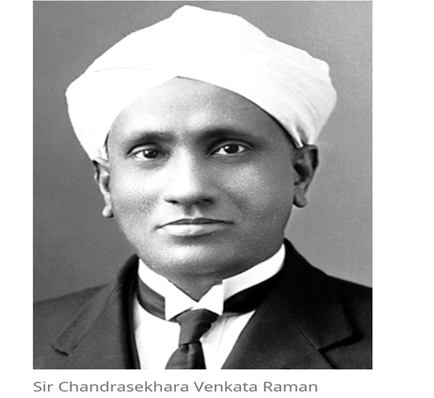
Figure 1: Sir Chandrasekhara Venkata Raman

APPLICATIONS OF RAMAN SPECTROSCOPY
Raman spectroscopy is used in many varied fields in fact, any application where non-destructive, microscopic, chemical analysis and imaging is required. Whether the goal is qualitative or quantitative data, Raman analysis can provide key information easily and quickly. It can be used to rapidly characterize the chemical composition and structure of a sample, whether solid, liquid, gas, gel, slurry or powder.
Raman spectroscopy is used in chemistry to identify molecules and study chemical bonding and intramolecular bonds. Because vibrational frequencies are specific to a molecule's chemical bonds and symmetry (the fingerprint region of organic molecules is in the wavenumber range 500–1500 cm−1), Raman provides a fingerprint to identify molecules (Clark, 2002).
Raman spectroscopy has a wide variety of applications in biology and medicine. It has helped confirm the existence of low-frequency phonons in proteins and DNA, promoting studies of low-frequency collective motion in proteins and DNA and their biological functions (Chou et al., 1977). Raman reporter molecules with olefin or alkyne moieties are being developed for tissue imaging with SERS-labeled antibodies (Schlucker et al., 2011). Raman spectroscopy has also been used as a noninvasive technique for real-time, in situ biochemical characterization of wounds. Multivariate analysis of Raman spectra has enabled development of a quantitative measure for wound healing progress (Jain et al., 2014).
Spatially offset Raman spectroscopy (SORS), which is less sensitive to surface layers than conventional Raman, can be used to discover counterfeit drugs without opening their packaging, and to non-invasively study biological tissue. A huge reason why Raman spectroscopy is so useful in biological applications is because its results often do not face interference from water molecules, due to the fact that they have permanent dipole moments, and as a result, the Raman scattering cannot be picked up on (Butler et al., 2016). This is a large advantage, specifically in biological applications. Raman spectroscopy also has a wide usage for studying biominerals. Raman gas analyzers have many practical applications, including real-time monitoring of anesthetic and respiratory gas mixtures during surgery (Taylor et al., 2010).
Raman spectroscopy can be used to investigate the chemical composition of historical documents (such as the Book of Kells), which can provide insight about the social and economic conditions when they were created. It also offers a noninvasive way to determine the best method of preservation or conservation of such materials.
Raman spectroscopy has been used in several research projects as a means to detect explosives from a safe distance using laser beams (Ben, 2008). It can be used in forensic sciences in the identification of illicit drugs, gunshot residue, accelerants in arson cases, inks used in counterfeiting, or explosives
Raman Spectroscopy is being further developed so it could be used in the clinical setting. Raman4Clinic is a European organization that is working on incorporating Raman Spectroscopy techniques in the medical field. They are currently working on different projects, one of them being monitoring cancer using bodily fluids such as urine and blood samples which are easily accessible. This technique would be less stressful on the patients than constantly having to take biopsies which are not always risk free.

TYPES OF RAMAN SPECTROSCOPY
- Resonance Raman Spectroscopy
Resonance Raman spectroscopy is a Raman enhancement technique in which the laser excitation frequency is chosen to be close to the frequency of an electronic transition of the sample. Resonance Raman can enhance the Raman scattering intensity by a factor of 102-106 and improves signal-to-noise. The enhanced Raman scattering means shorter exposure times can be used, allowing much faster spectral acquisition times. Additionally, samples at extremely low concentrations can easily be studied (Smith & Dent, 2019).
Resonance Raman spectroscopy may yield precise information on the conformation of, and on the interactions assumed by, the chromophores involved in the first steps of the photosynthetic process, whether isolated in solvents, embedded in soluble or membrane proteins, or, as shown recently, in vivo (Cecarelli et al., 2009).
By making use of this technique, it is possible, for instance, to relate the electronic properties of these molecules to their structure and/or the physical properties of their environment, or to determine subtle changes of their conformation associated with regulatory processes (Demmig-Adams et al., 2006).

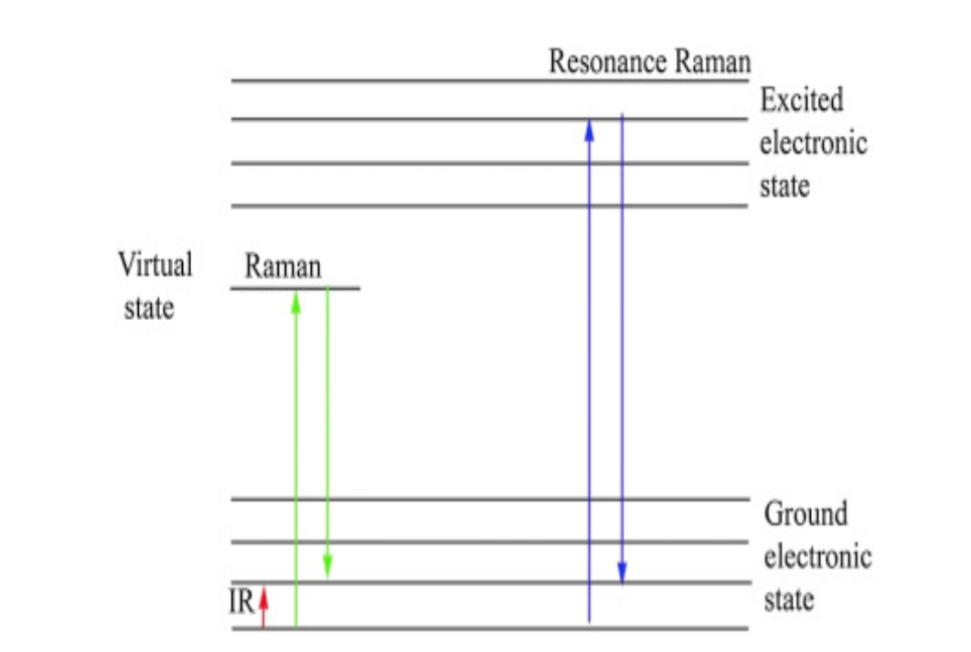

Figure 2: Schematics Representation of Raman Spectroscopy (Smith & Dent 2019)

- Surface- Enhanced Raman Spectroscopy
Surface-enhanced Raman spectroscopy (SERS) is a spectroscopic technique that simultaneously combines fingerprint recognition capabilities, typical of vibrational spectroscopies, and very high sensitivity (down to single molecule), owing to the enhancement provided by plasmonic effects (Haynes, 2005).
Raman signals are inherently weak, especially when using visible light excitation and so a low number of scattered photons are available for detection (Saviello et al., 2017). One method to amplify weak Raman signals is to employ surface-enhanced Raman scattering (SERS). SERS uses nanoscale roughened metal surfaces typically made of gold (Au) or silver (Ag). Laser excitation of these roughened metal nanostructures resonantly drives the surface charges creating a highly localized (plasmonic) light field (Alayami et al., 2018). When a molecule is absorbed or lies close to the enhanced field at the surface, a large enhancement in the Raman signal can be observed. Raman signals several orders of magnitude greater than normal Raman scattering are common, thereby making it possible to detect low concentrations (10-11) without the need for fluorescent labeling (Djozan et al., 2008). The Raman signal can be amplified further when the roughened metal surface is used in combination with laser light that is matched to the absorption maxima of the molecule. This effect is known as surface-enhanced resonance Raman scattering, (SERRS).

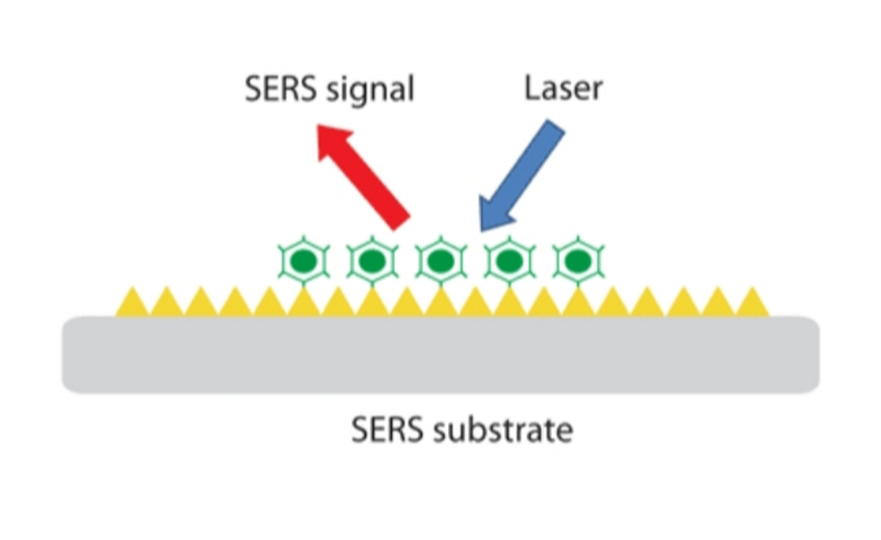Figure 3: Conceptual illustration of SERS (Semrock, 2019)

- Micro-Raman Spectroscopy
Raman micro-spectroscopy is where a Raman micro-spectrometer is used in place of a standard Raman spectrometer. A Raman micro-spectrometer consists of a specially designed Raman spectrometer integrated with an optical microscope (Alexey et al., 2015). This allows the experimenter to acquire Raman spectra of microscopic samples or microscopic areas of larger samples. The advantages are that much less samples is required and certain effects may also be enhanced over very localized regions.
Raman spectroscopy is a simple spectroscopic technique used for chemical phase identification of solid and liquid samples. Micro-Raman spectrometer is used to measure the vibrational spectra of solid samples. The phase uniformity of samples can be analyzed by performing area mapping studies (Jimenez, 2000).
In Micro-Raman, Laser light can be focused on the sample through a microscope lens that allows for the analysis of very small regions (down to 1 micrometer diameter).

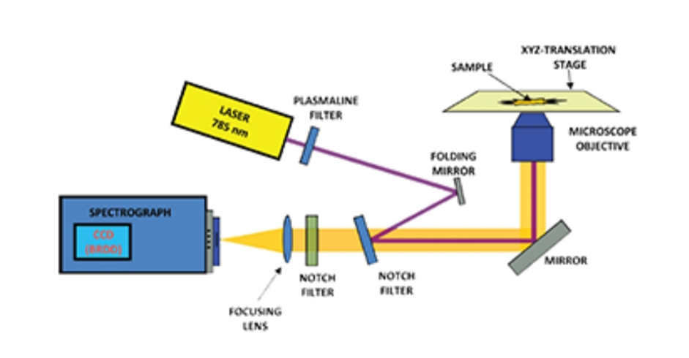
Figure 4: Schematic of the set up used for the Raman Micro-Spectroscopy measurements (Oxford, 2020).

- Non-Linear Raman Spectroscopy Techniques
Non-linear Raman spectroscopy is a spectroscopy based on nonlinear effects and involving Raman-active molecular transitions.
Linear Raman scattering can be described classically when excitation frequencies are used which are far from resonance with electronic absorption frequencies. If this is not the case, the scattering amplitude must be derived by quantum-mechanical calculation of the linear polarizability (Zheltikov, 2006).

INSTRUMENTATION OF RAMAN SPECTROSCOPY
Modern Raman spectroscopy nearly always involves the use of lasers as excitation light sources. Because lasers were not available until more than three decades after the discovery of the effect, Raman and Krishnan used a mercury lamp and photographic plates to record spectra. Early spectra took hours or even days to acquire due to weak light sources, poor sensitivity of the detectors and the weak Raman scattering cross-sections of most materials. Various colored filters and chemical solutions were used to select certain wavelength regions for excitation and detection, but the photographic spectra were still dominated by a broad center line corresponding to Rayleigh scattering of the excitation source (Long, 2002).

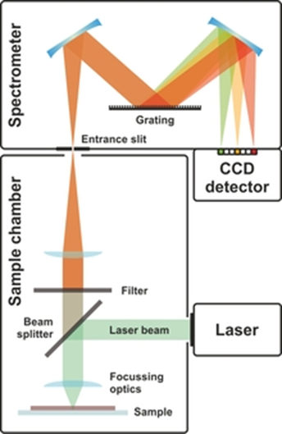
Figure 5: an image of a Raman spectroscopy set up.

Technological advances have made Raman spectroscopy much more sensitive, particularly since the 1980s. The most common modern detectors are now charge-coupled devices (CCDs). Photodiode arrays and photomultiplier tubes were common prior to the adoption of CCDs. The advent of reliable, stable, inexpensive lasers with narrow bandwidths has also had an impact (McCreery & Richard,2000).

- Lasers
Raman spectroscopy requires a light source such as a laser. The resolution of the spectrum relies on the bandwidth of the laser source used (Kukura et al., 2007). Generally shorter wavelength lasers give stronger Raman scattering due to the ν4 increase in Raman scattering cross-sections, but issues with sample degradation or fluorescence may result.
Continuous wave lasers are most common for normal Raman spectroscopy, but pulsed lasers may also be used. These often-wider bandwidths than their CW counterparts but are very useful for other forms of Raman spectroscopy such as transient, time-resolved and resonance Raman.
- Detectors
Raman scattered light is typically collected and either dispersed by a spectrograph or used with an interferometer for detection by Fourier Transform (FT) methods. In many cases commercially available FT-IR spectrometers can be modified to become FT-Raman spectrometers (Elliot et al., 2012).
- Detectors for dispersive Raman
In most cases, modern Raman spectrometers use array detectors such as CCDs. Various types of CCDs exist which are optimized for different wavelength ranges. Intensified CCDs can be used for very weak signals and/or pulsed lasers. The spectral range depends on the size of the CCD and the focal length of spectrograph used.
- Detectors for FT–Raman
FT–Raman is almost always used with NIR lasers and appropriate detectors must be use depending on the exciting wavelength. Germanium or Indium gallium arsenide (InGaAs) detectors are commonly used.
- Filters
It is usually necessary to separate the Raman scattered light from the Rayleigh signal and reflected laser signal in order to collect high quality Raman spectra using a laser rejection filter. Notch or long-pass optical filters are typically used for this purpose. Before the advent of holographic filters, it was common to use a triple-grating monochromator in subtractive mode to isolate the desired signal. This may still be used to record very small Raman shifts as holographic filters typically reflect some of the low frequency bands in addition to the unshifted laser light. However, Volume hologram filters are becoming more common which allow shifts as low as 5 cm−1 to be observed (Gordon et al., 2019).

INTRODUCTION TO FORENSIC SCIENCE
What is Forensic Science?
Forensic science is the combination of two different Latin words; forensics and science. The former, forensic, relates to a discussion or examination performed in public. Because trails in the ancient world were typically held in public, it carries a strong judicial connotation (Ali, 2006). The second, of course, is science, which is derived from the Greek for knowledge and is today closely tied to the scientific method, a systematic way of acquiring knowledge. Taken together, then, forensic science can be seen as the use of the scientific methods and processes in crime solving (Ali, 2006).
Despite its ancient etymology, forensic science is anything but old-fashioned. Branches of forensic science are rooted in almost every branch of science and many other aspects of modern society. Because of its ability to find and present objective evidence from areas as diverse as chemistry and accounting, today it is recognized as an essential part of the judicial system (Maras & Miranda, 2014).
Forensic science refers to the application of natural, physical, and social sciences to matters of the law. Most forensic scientists hold that investigation begins at the scene, regardless of their associated ﬁeld. The proper investigation, collection, and preservation of evidence are essential for fact-ﬁnding and for ensuring proper evaluation and interpretation of the evidence, whether the evidence is bloodstains, human remains, hard drives, ledgers, and ﬁles or medical records.
Scene investigations are concerned with the documentation, preservation, and evaluation of a location in which a criminal act may have occurred and any associated evidence within the location for the purpose of reconstructing events using the scientiﬁc method. The proper documentation of a scene and the subsequent collection, packaging, and storage of evidence are paramount. Evidence must be collected in such a manner to maintain its integrity and prevent loss, contamination, or deleterious change. Maintenance of the chain of custody of the evidence from the scene to the laboratory or a storage facility is critical. A chain of custody refers to the process whereby investigators preserve evidence throughout the life of a case. It includes information about who collected the evidence, the manner in which the evidence was collected, and all individuals who took possession of the evidence after its collection and the date and time which such possession took place (Maras & Miranda, 2014).

IMPORTANCE OF FORENSIC SCIENCE
- Crime-Solving Contribution: forensic science contributes to solving crimes through investigative activities like;
• Determining cause of death: forensic pathologists determine someone’s cause of death by performing autopsies. During these procedures, they examine fluids and tissues from a body to find out the cause of death and the manner of death (for example homicide or natural causes) (McEwen, 2011).
• Identifying suspects: forensic scientists can identify suspects by analyzing evidence found at the scene of a crime such as fibers, hairs, blood, and fingerprints. These methods are also used to exonerate the innocent (McEwen, 2011).
• Finding missing persons: forensic artists can help find people who have been missing for long periods of time through the process of image modification. In this technique, a photograph is aged to illustrate what someone may look like years after last being seen. This is also a tool that is used the find criminals who have eluded justice.
• Profiling criminals: forensic psychologists use profiling to help find suspects. By analyzing a crime scene, they are able to determine a criminal’s patterns and personality in an effort to narrow the suspect pool.
- Forensic Science helps Law Enforcement Officials: it solves crimes through the collection, preservation and analysis of evidence. For example, if there are no witnesses to a crime, forensic proof is often all prosecutors have to investigate. If human remains have decayed so much that they can no longer be identified, forensic expert study dental work, DNA and skeletal structure to identify a person and determine gender. In most cases, forensic investigators can ascertain the reason for death and whether crime was involved (Goymer, 2010).
- Forensic science is used most frequently with sex crimes and crimes related to drugs. Forensic toxicology establishes if an individual was intoxicated or high while driving after a deadly mishap or if somebody was poisoned to death. DNA proof retrieved from a victim’s body can also ascertain who was accountable for physical or sexual violence.
- Weapon testing is yet another essential part of forensic science. Forensic experts utilize their expertise in ammunition to analyze the impacts of a bullet, determine the number of shots fired and pinpoint the exact position of a shooter (Uzabakiriho, 2015).
- Computer forensics experts frequently help solve cybercrimes, by analyzing IP addresses and mining databases.
APPLICATION OF RAMAN SPECTROSCOPY TO FORENSIC SCIENCE
Renishaw’s inVia Raman Spectrometer is used in forensic science and it has numerous applications including the identification of illicit drugs, gunshot residue, accelerants in arson cases, inks used in counterfeiting or explosives.

Explosives and Gunshot Residue
Raman data can be obtained from almost any surface, allowing minute traces of explosives or a firearm’s discharge to be detected without attempting to lift samples from evidence. Very small discharge residues (1 micrometer in diameter) may be assessed in the laboratory.
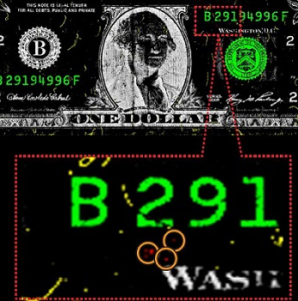
Figure 6: a dollar bill showing traces of explosives
One of the greatest benefits of using a Renishaw Raman system is gaining access to an extensive forensic database. This makes identifying compounds easier, faster, and more accurate than ever.

Fraudulent Documents
The sophistication of document fraud has risen dramatically in recent years. Documents may contain added terms and conditions after the date of signing, overlapping text, or multiple signatures that must be analyzed.
Rapid Raman imaging, such as Renishaw's StreamLine approach, is the best available method to investigate questionable documents and identify fraud. The use of a Raman microscope is non-destructive, preserving the evidence in its original form.
Raman spectroscopy is highly sensitive to minute chemical differences between inks. Images are generated in minutes, making this technique one of the fastest to characterize ink chemical structure. Furthermore, Raman imaging is significantly better at determining the order of ink deposition than competing methods.

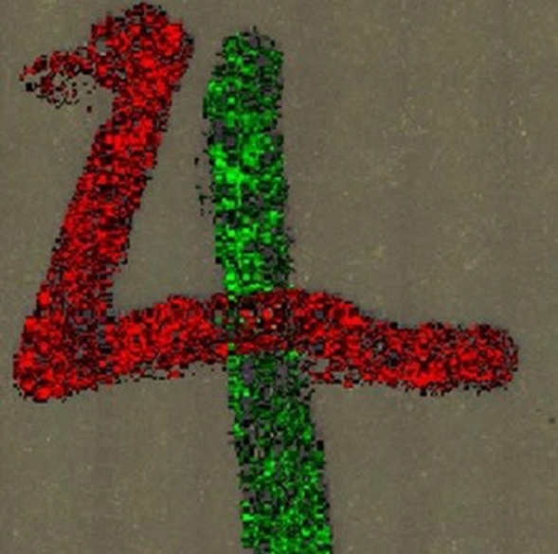

Figure 7: image taken with a Raman spectrometer of crossing inks

Illicit Drugs
Traditional methods used to identify narcotics and other illicit substances use IR spectroscopy or a gas chromatography-mass spectrometer. These approaches are destructive, requiring samples to be extensively pre-processed, and take a long time. In comparison, Raman spectroscopy represents a rapid and nondestructive method of identifying organic chemical compounds.
The Raman method is effective in analysis of tablets, powders, and liquids. Importantly, Raman data are not strongly affected by the proximity of plastics or glass, meaning that substances can be analyzed in their original packaging. This maintains evidence integrity and prevents sample contamination.
One of the challenges in identifying illicit drugs is that they often represent a mixture of compounds. For example, narcotics are typically cut with lactose or mannitol, complicating their analysis. Raman spectroscopy is capable of separating these components, therefore increasing accuracy of drug identification (Braz et al., 2013).

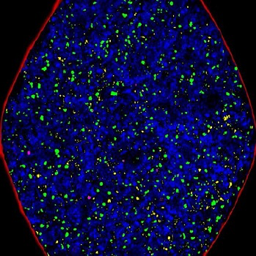
Figure 8: Raman image of a counterfeit pharmaceutical tablet

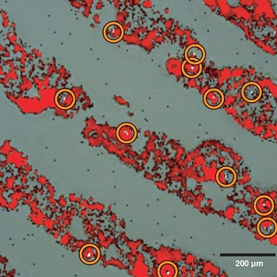
Figure 9: a fingerprint with cocaine particles

Blood Analysis
The analysis of blood has interestingly been subjected to Raman analysis, investigating the possibility of using Raman techniques to identify whether a substance is blood and even attempt to age the blood sample (Boyd et al., 2011). The research concluded that Raman spectroscopy was able to identify the presence of blood, with peaks characteristic of blood components, particularly hemoglobin, being frequently detected. This was achieved even when blood samples were significantly diluted. Furthermore, the research has investigated the possibility of using Raman spectroscopy to determine the age of blood in a rudimentary fashion, based on differences in scattering peaks between fresh and dried blood samples. With the possibility of portable Raman technology, the ability to detect blood using this technique would allow for in situ analysis at crime scenes, enabling investigators to quickly ascertain whether a substance is actually blood.
Although substances of abuse are most commonly analyzed using chromatographic techniques coupled with mass spectrometry, Raman spectroscopy has been successfully utilized in the detection of illicit substances (Moreno et al., 2014). Provided the investigator has access to an appropriate library of reference spectra for comparison purposes, it may be possible to identify drugs of abuse and their metabolites based on the characteristic spectra produced. The benefits of the application of Raman spectroscopy in this case include the possibility of in situ analysis to quickly identify potential controlled substances and the ability to analyze samples without sample preparation or destruction.
In addition, Raman spectroscopy has been successfully applied to the analysis of gunshot and explosive residues, geological samples, fibers and various bodily fluids.
Therefore, Renishaw’s Raman systems are preferred among forensic scientists because of their versatility and high performance. The inVia confocal Raman microscope has very high sensitivity and with its flexible set of imaging capabilities, users can accurately detect and analyze minute fragments of material. Forensic samples can be analyzed rapidly, maximizing efficiency without sacrificing accuracy.

ADAVANTAGES OF RAMAN SPECTROSCOPY
- Many organic and inorganic materials are suitable for Raman analysis. These can be solids, liquids, polymers or vapors.
- No sample preparation is needed.
- It is not interfered by water.
- It is non-destructive.
- It is highly specific like a chemical fingerprint of a material.
- Raman spectra are acquired quickly within seconds (Apopei et al., 2009).
- Samples can be analyzed through glass or a polymer packaging.
- Laser light and Raman scattered light can be transmitted by optical fibers over long distances for remote analysis.
- In Raman spectroscopy, the region from 4000 cm-1 to 50 cm-1 can be covered by a single recording.
- Raman spectra can be collected from a very small volume (< 1 mm in diameter).
- Inorganic materials are easily analyzable with Raman spectroscopy (Buzgar et al., 2009).

ADVANTAGES OF RAMAN SPECTROSCOPY OVER OTHER TECHNIQUES
Raman spectroscopy has a number of advantages over other analysis techniques.
Advantages of Raman spectroscopy over infrared spectroscopy (IR);
- A big advantage of using Raman over IR is that the sample preparation is much easier and less time-consuming (Louise, 2019). Speed is crucial in the analysis because runtimes need to be as short as possible so that more samples can be analyzed. The molecules analyzed do not need to possess a permanent dipole moment like molecules analyzed with IR.
- A major problem that comes up with IR analysis is interference. Water cannot be used in IR due to its intense absorption of IR, whereas it can be used as a solvent in Raman spectroscopy. The fact that water is a weak Raman scatterer means that samples can be analyzed in their aqueous form, which is highly beneficial to the pharmaceutical industry (Louise, 2019).
- Raman spectroscopy does not need a reference light path as it is a scattering technique, meaning that fiber optics and remote sampling can be used. The portability allows for remote analysis through glass containers, well plates and aqueous samples (Louise, 2019). Unlike IR, Raman can also be used to analyze gases, but this requires further specialized equipment.
Advantages of Raman Spectroscopy over other optical techniques in sampling situations
Raman spectroscopy is based on light scattering and does not rely on a specific path for the analytical light, giving it a tremendous advantage over other optical techniques when sampling solids or turbid media. Raman retains all the advantages of multiplexing and goes a step further in that the absence of a defined path length removes analytical constraints common to IR techniques (Esmonde, 2019).
Thus, multiple components can be measured at a single probe point. The spectrum is well defined on the wavelength axis with excellent peak separation, allowing the user to extract more information with less chemo-metrically intensive calibration (Esmonde, 2019). The excellent peak separation enables rapid method development and transferability across instruments and operating scales.

REFERENCES
Saul, Louise. (2019, January 09). IR Versus Raman - The Advantages and Disadvantages. Azo Optics. Retrieved on April 11, 2020 from https://www.azooptics.com/Article.aspx?ArticleID=1291.
Kaiser Optical Systems, Inc. (2019, January 23). Benefits of Raman Spectroscopy as A Real-Time Process Analytical Technology for Pharmaceutical Manufacturing and Bioprocessing. AZoM. Retrieved on April 12, 2020 from https://www.azom.com/article.aspx?ArticleID=15054.
Agrawal, G.P., 2001, Application of Nonlinear Fiber Optics. Academic Press.
Google Scholar.
Smekal A, (1923). The quantum theory of dispersion, Die Naturwissenschaften, 11(43): 873-875.
Raman C. V., and Krishnan K. S. The optical analog of the Compton effect, Nature, 121, 711 (1928).
Placzek, G (1934). "Rayleigh-Streuung und Raman-Effekt". Handbuch der Radiologie (in German). 6, 2. Leipzig: Akademische Verlagsgesellschaft. p. 209.
Gardiner, D.J. (1989). Practical Raman spectroscopy. Springer-Verlag.
Hammes, Gordon G. (2005). Spectroscopy for the biological sciences. Wiley.
Jim Clark (2000) The Fingerprint Region of An Infra-Red Spectrum.
Chou, K. C, Chen, Nian-Yi (1977). "The biological functions of low-frequency phonons". Scientia Sinica. 20(3): 447–457.
Schlücker, S.; et al. (2011). "Design and synthesis of Raman reporter molecules for tissue imaging by immuno-SERS microscopy". Journal of Bio photonics. 4(6): 453–463.
Jain, R., et al. (2014). "Raman Spectroscopy Enables Noninvasive Biochemical Characterization and Identification of the Stage of Healing of a Wound". Analytical Chemistry. 86 (8): 3764–3772.
Butler, Holly J; Ashton Lorna; Bird Benjamin; Cinque, Gianfelice; Curtis, Kelly; Dorney, Jennifer; Esmonde-White, Karen; Fullwood, Nigel J.; Gardner, Benjamin; Martin-Hirsch, Pierre L.; Walsh, Michael J.; McAinsh, Martin R.; Stone, Nicholas; Martin, Francis L. (2016). "Using Raman spectroscopy to characterize biological materials". Nature Protocols. 11 (4): 664–687.
Taylor, P. D, Vinn, O, Kudryavtsev, A, Schopf J.W. (2010). "Raman spectroscopic study of the mineral composition of cirratulid tubes (Annelida, Polychaeta)". Journal of Structural Biology. 171 (3): 402–405.
Ben Vogel (29 August 2008). "Raman spectroscopy portends well for standoff explosives detection". Jane's. Archived from the original on 2008-12-03. Retrieved 2008-08-29.
Long, Derek A. (2002). The Raman Effect. John Wiley & Sons, Ltd.
Kukura, Philipp; McCamant, David W.; Mathies, Richard A. (2007). "Femtosecond Stimulated Raman Spectroscopy". Annual Review of Physical Chemistry. 58 (1): 461–488.
Elliott, Anastasia B. S.; Horvath, Raphael; Gordon, Keith C. (2012). "Vibrational spectroscopy as a probe of molecule-based devices". Chem. Soc. Rev. 41 (5): 1929–1946.
Gordon, Geoffrey P. S. Smith Gregory S. Huff Keith C. "Investigating Crystallinity Using Low Frequency Raman Spectroscopy: Applications in Pharmaceutical Analysis" spectroscopyonline.com. Retrieved 2019-07-21.
Cecarelli M, Lutz M, Marchi M (2009) A density functional normal mode calculation of a bacteriochlorophyll a derivative. J Am Chem Soc 122:3532–3533.
Demmig-Adams B, Ebbert V, Zarter CR, Adams WWIII (2006) The relationship between photoinhibition and thermal dissipation. In: Demmig-Adams B, Adams WWIII, Mattoo AK (eds) Photoprotection, photoinhibition, gene regulation, and environment. Advances in photosynthesis and respiration, vol 21. Springer, Dordrecht, pp 39–48.
Haynes C.L. C.L., C.R. Yonzon, X. Zhang, R.P. Van Duyne, Surface-enhanced Raman sensors: Early history and the development of sensors for quantitative biowarfare agent and glucose detection. J. Raman Spectrosc. 36, 471–484 (2005).
Alyami, A., Barton, K., Lewis, L., Mirabile, A., and Iacopino, D. (2018). Identification of dye content in colored BIC ballpoint pen inks by Raman spectroscopy and Surface-Enhanced Raman Scattering. J. Raman Spectrosc. 50, 115–126.
Alyami, A., Saviello, D., Mc Auliffe, M. A. P., Mirabile, A., Lewis, L., and Iacopino, D. (2017). Metal nanoinks as chemically stable surface enhanced scattering (SERS) probes for the analysis of blue BIC ballpoint pens. Phys. Chem. Chem. Phys. 19, 14652–14658.
Djozan, D., Baheri, T., Karimian, G., and Shahidi, M. (2008). Forensic discrimination of blue ballpoint pen inks based in thin layer chromatography and image analysis. Forens. Sci Intern. 179, 199–205. doi: 10.1016/j.forsciint.2008.05.013.
Alexey Kondyurin, Marcela Bilek, in Ion Beam Treatment of Polymers (Second Edition), 2015.
Jimenez-Sandoval, Volume 31, Issue 6, 30 June 2000, Pages 419-427
A.M. Zheltikov, 2006, Introduction to Nonlinear Raman Spectrometry. Theory and Instrumentation for Raman Spectroscopy.
Ali, A. (2017). Role of forensic science in criminal justice: Bangladesh perspective. Southeast University Journal of Arts and Sciences, 2(1), 1-18.
Judge Goymer, A. (2010). The importance of forensic to the courts. Judiciary of England and Wales, 1-14.
McEwen, T. (2011). The role and impact of forensic evidence in criminal justice system, final report. 1-130.
Miranda, D. M., & Maras, M. (2014). Forensic science. Encyclopedia of Law and Economics, 11(1), 1-6.
Uzabakiriho, A. (2015). The role of forensic science in criminal investigation in Rwanda. Research Journal of Forensic Sciences, 3(5), 1-4.
Braz, A. et al. Raman spectroscopy for forensic analysis of inks in questioned documents. Forensic Sci Int, 232 (2013), pp. 206-212.
Boyd, S. et al. Raman spectroscopy of blood samples for forensic applications. Forensic Sci Int, 208 (2011), pp. 124-128.
Moreno, V. M. et al. Raman identification of drugs of abuse particles collected with colored and transparent tapes. Sci Justice, 54 (2014), pp. 164-169.

