NAME: ADENIYI-OSO OLUWAPELUMI
MATRIC NO: 17/MHS01/020
DEPARTMENT: MEDICINE AND SURGERY
COURSE: HISTOLOGY OF SPECIAL SENSES AND NEUROHISTOLOGY.

ASSIGNMENT.
- Write an essay on the histological importance of the eye in relation to their cellular function’
- Corona virus can penetrate the body through eye and implicate the immune system, briefly discuss the layers of retina for penetration.

HISTOLOGICAL IMPORTANCE OF THE EYE IN RELATION TO THEIR CELLULAR FUNCTION.

The Eye is a complex and highly developed photosensitive organ that permits an accurate analysis of the form ,light intensity, and color reflected from objects. Generally from an anatomical perspective the eye as both the External and Internal Structures.
- External Structures includes the Conjunctiva, Accessory glands,Eyelids and Muscles
II) Internal Structures includes the: a) Sclera and Cornea that form the Exterior Layer
b) Uvea the Vascular layer in the middle subdivided into the Iris, Ciliary body and Choriod
c) The retina that constitute the innermost layer made up of nervous tissue.

HISTOLOGICAL CLASSIFICATION
External Structures of the Eye.

- Conjunctiva: Lines the inner part of the eyelids, the tarsal plate lies beneath the Conjunctiva and contains meibomian glands which secrete an oily substance to decrease the evaporation of the tear film.
- Accessory glands: Apocrine glands of Moll, meibomian glands, Lacrimal glands.
- Eyelids : Mobile layer made up of skin and also muscular tissue and also covers the eyeball. It protects the eye from mechanical damage and to help adjust the amount of incoming light, blinking of the eyelid help spread a liquid film of tears over the cornea.
- Muscles: Orbicularis oculi, Levator palpebrae superioris, superior tarsal muscles of Muller

Internal Structures of the Eye

- Outermost Layer: Sclera and Cornea
The Sclera- Is a dense connective tissue made up of mainly type I collagen fibers, oriented in different directions. Lack of parallel orientation of collagen fibers gives the sclera its white appearance as opposed to the transparent nature of the cornea. The four layer of the sclera from external to internal are Episclera, Stroma ,Lamina fusca, Endothelium.
The Cornea - The transparent layer of the front Eye. Consist of type I collagen fibers oriented in a uniform parallel direction to maintain transparency. Consist of five layers
- CORNEAL EPITHELIUM: fast growing and regenerating multicellular layer which interacts directly with the tear film
- BOWMAN LAYER: this is a layer of subepithelial basement membrane protecting the underlying stroma . it is composed of type I Collagen, laminin and several other heparan sulfate proteoglycans
- STROMA: The largest layer of the cornea, the stroma has collagen fibers arranged in a regular pattern . keratocytes maintain the integrity of this layer. The function of this layer is to maintain transparency , which occurs by the regular arrangement and lattice structure of the fibrils.
- DESCEMETS MEMBRANE: an acelluar layer made of type IV collagen that serves as a modified basement membrane of the corneal endothelium.
- CORNEAL ENDOTHELIUM: one cell thick layer made of either simple squamous or cuboidal cells. Cells in this region do not regenerate and have pumps that maintain fluid balance and prevent swelling of the stroma .

- Middle layer: Uvea ( Iris, Ciliary Body, Choriod)
IRIS: Consist of I) Stromal Layer with pigmented fibro vascular tissue (II) Pigmented epithelial cells beneath the stroma. Pigmented layer of cells block rays of lights and ensures that light must move throught the pupil to reach the retina. The angle formed by the iris and cornea contains connective tissue with endothelial channels called the trabeculae meshwork which drains aqueous humour in the anterior chamber into the venous canal of schelmm.
CILIARY BODY: Divides the Posterior chamber and Vitreous body. It consist of Ciliary muscle and Ciliary epithelium.
Ciliary muscles via the lens of zonules , controls the structures of the lens which is vital for accommodation. Ciliary Epithelium produces aqueous humour which fills the anterior compartment of the eye.
CHOROID: Consist of a dense network of blood vessels supplying nourishment to structures of the eye, housed in loose connective tissue. The Choriodcapillary is located in the innermost part of the choroid and supplies the retina.

- Innermost Layer: Lens, Vitreous, Retina.
LENS: The lens separates the aqueous and vitreous chambers , consists of an outer capsule , a middle layer called cortex, and an inner layer called the nucleus. The capsule is the basement membrane of the lens epithelium which lies below, new lens cells differentiate from the lens epithelium and are incorporated peripherally pushing older lens cells towards the middle.
VITREOUS: Jelly like space made of type collagen II collagen separating the retina and the lens.
RETINA: Nervous tissue where photons of light convert to neurochemical energy via action potentials.

The layers of the eye perform distinct functions which coalesce to create a unified , perceptual experience. The essential role of the External eye structure is to protect the delicate tissue of the internal eye. The Internal part of the eye have primarily structural and visual function. The Cornea serves a protective role and is responsible for two thirds of the refractive properties of the eye, The remaining one third refraction is performed by the lens, which is functionally adjustable through the action of the Zonular fibers and Ciliary muscles. The Uvea of the eye is a crucial mediator of nutrition and gas exchange , as blood vessels course through the Ciliary body and Iris, while the Choriocapillaris in the posterior eye help support the Retina.

Corona virus can penetrate the body through eye and implicate the immune system , briefly discuss the layers of the retina.

The Corona virus can spread through Aerosol transmission in pathogenic droplets - which have been sneezed or coughed out by someone carrying the virus - in the Air, tears and other Ocular secretions. Therefore it is important to wash hands often and avoid touching your face, especially after come in contact with public or shared surface.

Possible transmission through the eye - Study indicates that coronavirus might enter through the Conjuctiva and then spread throughout the body through the vessels within the Conjuctiva. The conjuctiva is the clear , Thin membrane that covers part of the front of the eye as well as the inner part of the eyelids, However this is said to be rare(1%-3% of people with coronavirus ).
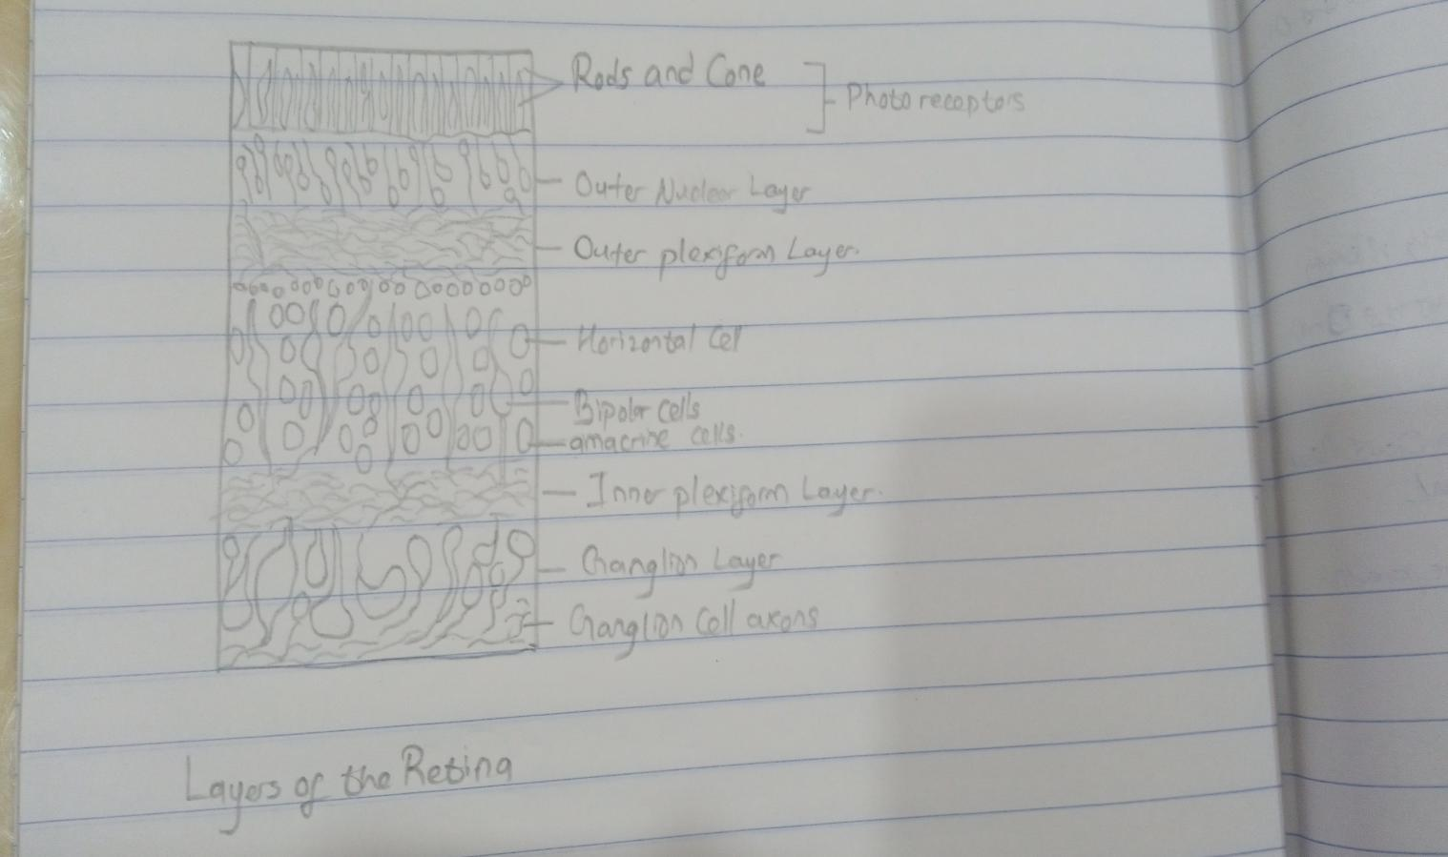

The retina is the innermost layers of the wall of the eye. It is in immediate contact with the vitreal cavity on one side with the choroid on the other side. The cellular layers of the retina
Are as follows:
- The Pigmented Epithelium which adjacent to the choriod, absorbs light to reduce back reflection of light onto the retina
- The photoreceptor layer contains photosensitive outer segments of rods and cones
- The outer nuclear layer contains cell bodies of the rods and cones
- The outer plexiform layer contains synapses between axons of photoreceptors and dendrites of intermediate neurons
- The inner nuclear layer contains cell bodies of intermediate neurons and muller cells
- The inner plexiform layer contains synapses between intermediate neurons and ganglion cells of the optic tract
- The ganglion cell layer contains cell bodies of ganglion cells
- The optic nerve fiber layer contains axons of ganglion cells tranversing the retina to leave the eyeball at the optic disk

