Name: Raji Mubarak
Dept: Industrial Chemistry.
Course: CHM 214.
Date: 11/04/2020.
Matric No: 18/ENG01/022
STRUCTURE AND BONDING ASSIGNMENT 2.

1a.) Principal Quantum Number
Electrons spin in atomic shells called orbitals. Characterized by “n,” the principal quantum number identifies the distance from the nucleus of an atom to an electron, the size of the orbital and the azimuthal angular momentum, which is the second quantum number represented by "ℓ." The principal quantum number also describes the energy of an orbital as electrons are in a constant state of motion, have opposite charges, and are attracted to the nucleus. Orbitals where n=1 are closer to the nucleus of an atom than those where n=2 or a higher number. When n=1, an electron is in a ground state. When n=2, the orbitals are in an excited state.

Angular Quantum Number
Represented by “ℓ,” the angular, or azimuthal, quantum number identifies the shape of an orbital. It also tells you which suborbital, or atomic shell layer, you can find an electron in. Purdue University says that orbitals can have spherical shapes where ℓ=0, polar shapes where ℓ=1 and cloverleaf shapes where ℓ=2. A cloverleaf shape that has an extra petal is defined by ℓ=3. Orbitals can have more complex shapes with additional petals. Angular quantum numbers can have any integer between 0 and n-1 to describe the shape of an orbital. When there are sub-orbitals, or sub-shells, a letter represents each type: “s” for ℓ=0, “p” for ℓ=1, “d” for ℓ=2 and “f” for ℓ=3. Orbitals can have more sub-shells that result in a larger angular quantum number. The greater the value of the sub-shell, the more energized it is. When ℓ=1 and n=2, the sub-shell is 2p as the number 2 represents the principal quantum number and p represents the sub-shell.

Magnetic Quantum Number
The magnetic quantum number, or "m," describes an orbital’s orientation based in its shape (ℓ) and energy (n). In equations, you'll see the magnetic quantum number characterized by the lowercase letter M with a subscript ℓ, m_{ℓ}, which tells you the orientation of the orbitals within a sub-level. Purdue University states that you need the magnetic quantum number for any shape that isn't a sphere, where ℓ=0, because spheres only have one orientation. On the other hand, the "petals" of an orbital with a cloverleaf or polar shape can face different directions, and the magnetic quantum number tells which way they face. Instead of having consecutive positive integral numbers, a magnetic quantum number can have integral values of -2, -1, 0, +1 or +2. These values split sub-shells into individual orbitals that carry the electrons. In addition, each sub-shell has 2ℓ+1 orbitals. Therefore, sub-shell s, which equals the angular quantum number 0, has one orbital: (2x0)+1=1. Sub-shell d, which equals the angular quantum number 2, would have five orbitals: (2x2)+1=5.

Spin Quantum Number
The Pauli Exclusion Principle says that no two electrons can have the same n, ℓ, m or s values. Therefore, only a maximum of two electrons can be in the same orbital. When there are two electrons in the same orbital, they must spin in opposite directions, as they create a magnetic field. The spin quantum number, or s, is the direction that an electron spins. In an equation, you may see this number represented by a lowercase m and a subscript lowercase letter s, or m_{s}. Since an electron can only spin in one of two directions -- clockwise or counterclockwise -- the numbers that represent s are +1/2 or -1/2. Scientists may refer to the spin as "up" when it's counter clockwise, which means the spin quantum number is +1/2. When the spin is "down," it has an m_{s} value of -1/2.
1b.)
n | l | m_{l} | Number of  orbitals | Orbital  Name | Number of  electrons
1 | 0 | 0 | 1 | 1s | 2
2 | 0 | 0 | 1 | 2s | 2
 | 1 | -1, 0, +1

2. VSEPR theory can be explained as follows:
- The shape of any molecule can be explained by the repulsion between all the electron pairs that are present in the valence shell.
- The repulsion between two lone pairs is greater than the repulsion between a lone pair and a bond pair. Presence of a lone pair on the central atom causes slight distortion of the bond angles from their ideal values.
- The electronegativity difference between the central atom and the other atoms determines the magnitude of repulsion between the bonding pair of electrons.
- Triple bonds cause more repulsion than the double bonds. Similarly double bond causes more repulsion than a single bond.
2b. the electron-group geometry and the molecular geometry.
Electron-group geometry is determined by the number of electron groups.
Number of electron groups | Name of electron group geometry
2 | linear
3 | trigonal-planar
4 | tetrahedral
5 | trigonal-bipyramidal
6 | octahedral

3a.)bond length or bond distance is defined as the average distance between nuclei of two bonded atoms in a molecule.

Bond angle is simply the angle between two bonds or two bonded electron pair in a compound. For example in CH4 the bond angle is 109 degrees.
Bond enthalpy (also known as bond energy) is defined as the amount of energy required to break one mole of the stated bond
Bond order is a measurement of the number of electrons involved in bonds between two atoms in a molecule
An orbital is a mathematical function that describes the wave-like behavior of an electron.
3b.)HgCl₂ is linear with bonds angles of 180 deg., HgCl₃⁻ exists in a trigonal planar arrangement with bond angles of approximately 120 deg., and HgCl₄²⁻ is tetrahedral with all bond angles approaching 109.5 deg.
4a.)
Chemical formula | Number of electron pairs | Shape | Spatial arrangement
EX₅ | - 5 | -trigonal pyramidal | -
EX₆ | - 6 | -octahedral | -
EX₇ | - 7 | -pentagonal pyramidal | -
EX₈ | - 8 | Square Antiprismatic | -
SPATIAL ARRAGMENT.
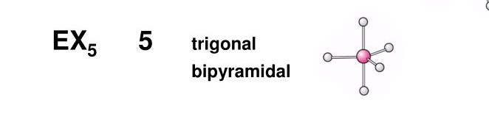
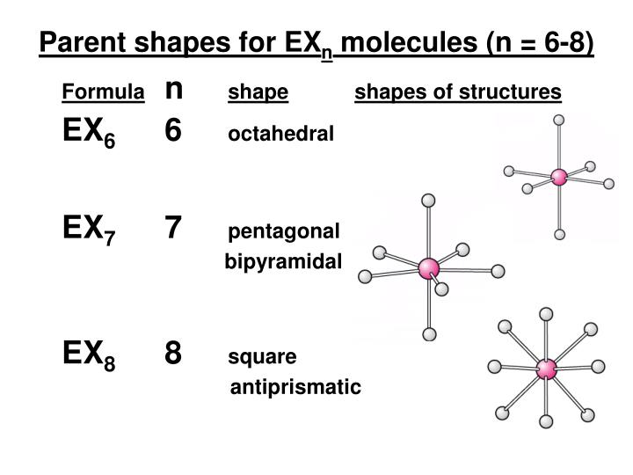
4b
i.)Phosphorus Hexafluoride
ii.)Phosphorus
iii.)Octahedral
iv.) C^N

