ADJEROH URUOMA KOSIEME
BIOMEDICAL ENGINEERING
18/ENG08/001
ENG232 ASSIGNMENT

- A sectional surface can be represented by cutting an object on an imaginary plane, removing one or more parts and thus revealing a view of the effects of sectioning.

- Rule 1: dimensions should not be duplicated nor should the same info be given in two different ways
Rule 2: dimensions should be attached to the view that best shows the contour of the feature being dimensioned.
Rule 3: avoid dimensioning hidden lines wherever possible.
Rule 4: avoid dimensioning over or through the object.
Rule 5: holes should be located by their center lines.
Rule 6: avoid crossing extension lines when possible.

- - A half section is a view of an object showing one half of the view in section.
- A full section is a view of an object showing the two halves of the view in section with the interior of the object revealed.

- Leader lines are thin solid lines that terminate in an arrow head or dot.

- - Scale = 5:1 This means that the drawing was scaled up to five times its original size.

- Scale=1:10 This means that the drawing was scaled down to ten times its original size.

- - diameter = Ø
- Radius = R e.g. radius = R50mm
- Square
- Spherical radius = SR
- Cutting plane line = 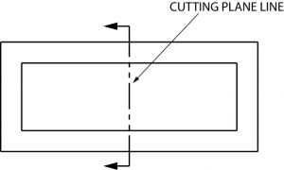
- Center line =
- Long break =

- The elements to be considered when obtaining a projection include; dimensions, hidden details/features, center lines and angle of the projection. An orthographic projection is a method of projection in which an object is depicted using parallel lines to project its outline onto a plane.

- The projection of an object is called an orthographic projection if the object (formerly in three dimension) is represented in two dimensions. It is a form of parallel projection in which all the projection lines are orthogonal to the projection plane, resulting in every plane of the scene appearing in affine transformation on the viewing surface.

- - First angle projection: this is a method of creating two dimensional drawing of a three dimensional object. It is mainly used in Europe and Asia. Its symbol is

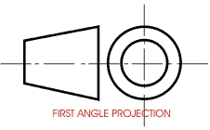

The object is placed in between the plane of projection and the observer (i.e. the first quadrant)
- Third angle projection: this is a method of creating a two dimensional drawing of a three dimensional object. Here the object is placed below and behind the viewing of planes meaning the plane of projection is between the observer and the object. Its symbol is

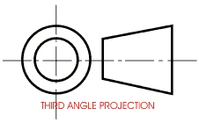
OBJECTIVES
- A
- B
- C
- B
- A
- B
- C
- B
- A
- A

