NAME: MGBEMENA IFUNANYA PRECIOUS.
COURSE TITLE: SOCIOLOGY 102
COURSE CODE; SOC 102

ASSIGNMENT: WHAT IS FAMILY.
DISCUSS THE FUNCTION OF THE FAMILY.
DISCUSS THE AFRICAN TRADITIONAL FAMILY.
DISCUSS YOUR NUCLEAR FAMILY.
DRAW YOUR FAMILY TREE.

ANSWERS
A family is a group consisting of two parents and their children living together as a unit. It can also be defined as a specific group of people that may be made up of parents, children, aunts, uncles, cousins and grandparents.
It is also a group of people that share common ancestors.

DISCUSS THE FUNCTION OF THE FAMILY.
Family is the most universal and fundamental social institution which performs a variety of functions in human society.
There are six types of functions of family namely:
Affectional, Economic functions, Recreational functions, Protective functions, Religious functions, educational functions.
These two functions of are also widely known as primary and secondary family.

ESSESNTIAL OR PRIMARY FAMILY.
MacIver has divided functions of family into essential and non-essential. Malcverian functions of family, family may also perform some other essential functions.
- STABLE SATISFACTION OF SEXUAL NEEDS.
This is the most essential function of family, family has been performing the functions since the inceptions of human civilization. It is a well-known fact that sex urge is the most important and powerful instinct and natural urge of human being .it is the primary duty of family to satisfy the sexual urge of its members in a stable and desirable way

- PROCREATION AND REARING OF CHILDREN.
It is another important sectional function of the family. Necessary and arrangement of stable satisfaction of sexual urges resulted in procreation .family provides the legitimate basis in the production of children. It institutionalizes the process of procreation. By preforming this function of procreation family contributes to the continuity of family and ultimately human race. Hence perpetuation of human race is the most important function of the family. Not only is the production of children but also child rearing another important of the function of the family. Family is the only place where the function of child rearing is better performed. It provides food, shelter, affection, protection, and security to all its members. It plays a vital role in the socialization of child. Family takes care of the child at the need of time. Hence it is rightly remarked that family is an institution par excellence for the procreation and rearing of children.

- PROVISION OF HOME.
Family perform another important function of providing a home for common living to all its members. It is not only a home that children are born and brought up. Even if children are born in hospital in modern times still they are taken care of and properly nourished in a home only. Because family and home has no substitute. In a home of all the members of the family living together and a child is brought up under the strict vigilance of all its members. All the members need a home to live happily in peace and comfort and protection. A home provides emotional and psychological support to all its members . in a home family perform the role of a modern club. Man got peace by living in a home.

- SOCIALIZATION
It is another important essential function of the family. It is said that man is not born human but made human. New born human baby become human being after they are socialized. Family plays an important role in the socialization process. It is one of the primary agent of socialization .living in a family human baby learns norms, values, morals and ideals of society. He learns culture and acquire character through the process of socialization. His personality develops in the course of his living in family. From family he learns what’s right and wrong. through socialization he becomes a social man and acquire good character.

NON ESSENTIAL OR SECONDARY FUNCTION OF THE FAMILY.
Famous sociologist MacIver has divided functions into essential and non essential functions. Under the secondary functions includes economic, religious, educational, health and recreational functions .these functions are as follows;

- ECONOMIC FUNCTIONS
Since ancient times family has been performing several economic functions. It is an important economic unit. In ancient time family was both a production and consumption unit. It is used to fulfil almost all the economic needs of its members such as food, clothing, housing etc. in the then days family was self-sufficient. But nowadays almost all the economic functions of family is performed by other agencies and family only remain in the consumption unit.

- EDUCATIONAL FUNCTIONS
Family performs many educational functions for its members. As a primary educational institution family used to teach letters, knowledge, skills and trade secret to all its members. It looks after the primary education of its members and moulds their character mother act as the first and best teacher of a child. Besides he learns all sorts of informal education like discipline, obedience, manners from family. At present many of educational function of the family are taken over by schools, universities.

- RELIGIOUS FUNCTION
Family is the centre of all religious activities. All the family members offer their prayers together and observe different traditional rituals and rites. All the members believe in a particular religion and observe religious ceremonies at home. Children learn different religious value from their parents, living in spiritual atmosphere develops among the children. Common family worship become very rare and absolute.

- RECREATIONAL FUNCTION
Family performs several recreational functions for its members by entertaining them in various ways .in ancient period family was the only centre for recreation. All the members together organise feasts, visits, the family, relations organise family picnics. Of course modern club replaces many recreational functions of the family . but at the same time it is said that present family acts as a modern club without its evil effects.

- CULTURAL FUNCTIONS
Family also performs several cultural functions as well. It preserves different cultural traits. Man learns and acquires culture from family and transmits it to succeeding generations. That is why family is considered as centre of culture.

DISCUSS THE AFRICAN TRADITIONAL FAMILY

Traditional African family patterns are slowly but progressively being altered as a result of the process of modernization which is exhibited through trends like urbanization. Family patterns that were the norm in traditional rural African societies are gradually being altered and substituted by modern values. Sub Saharan Africa has one of the fastest annual population growth rate (Merrick 202:41). It has the fastest rate of urbanization presently taking place in the world. The transformation of societies in the sub-continent from rural to urban settings has immensely contributed in triggering changes in family structure. This has triggered the distortion of cultural /traditional norms and values that characterized rural communities in the region. African families are increasingly faced with the challenge and pressure emanating from the competition prevailing between traditional and modern family values. Hence, Contemporary family patterns in the region are increasingly subjected to transform and adapt to changing times. Discussions of family patterns in contemporary Sub Saharan Africa are usually made in reference to the process of acculturation, urbanization (the movement from rural to urban areas), which have helped to shape modern family structures, as well as fostered the prevalence of demographic changes (Kalu 1981:353). Family in sub Saharan Africa is experiencing changes which are felt in fertility rates that is the number of children women give birth to, and age at marriage to name a few. 1.2 Overview of family patterns in sub Saharan Africa Despite the changes taking place in sub Saharan African societies due to the modernization process, the family still remains a prominent nexus in the social life of Africans. In Africa, there is considerable importance attached to the respect for elders and ancestors. African communities are characterized by the prevalence of collectivism as opposed to individuality. Paulina Makinwa-Adebusoye (2001:5) outlined the major characteristic features of African household to be that they are mostly rural, patriarchal and hierarchical, polygamous and open 2 to kinship networks, and finally they attached substantial importance to lineage continuation. These features in all play a pivotal role in influencing the number of children women give birth to. The social organization of most African families is embedded in a patriarchal and hierarchical system that precludes the possibility of women, who generally have lower status than men in the society to make deliberate choice on the number of children they want to have (Makinwaadebusoye2001:5). At marriage women tend to have lower status than all the members of their husband’s family (Makinwa-adebusoye (20016). In traditional rural societies in most sub Saharan societies, women were voiceless and powerless. According to Göran Therborn (2006) African societies have experienced slight distortion in the patriarchal tradition, following the advent of urbanization, as well as due to the drop in the importance attached to land and cattle in the economy.

1.3 Marriage Marriage can be perceived from different facets, as an institution, a partnership, a lifecycle phase and as a role. Marriage as an institution is confronted with the process of adapting to the process of modernization which inherently helps to mold modern marriage structure. Wilhelma Kalu (1981) stated that the institution of marriage is considerably subjected to the trend of accommodation to the process of industrialization/modernization. Socioeconomic circumstances are encountering changes which forge alteration of the fundamental values of culture. Marriage constitutes a vital variable that is pivotal for procreation. The distortion of its structure tends to serve as a medium where socioeconomic changes associated with the main values of culture can be measured. Traditional tenets of African marriages are increasingly 3 subjected to stabilize amidst sporadic societal changes emanating from modernization and globalization. This, Wilhelmina Kalu (1981:350) emphasized inherently brings in to perspective the need for the redefinition of the role and features of marriage unavoidable.

1.4 Family Size The advent of modernity has inherently fostered a progressive transformation of African family organization marked by the drift from larger family size to small size households. Demographers often identify the changes taking place in family patterns such as changes in family size to be a characteristic of the second demographic transition process (Perelli-Harris 2005:57). It is marked by the reorientation of family values from extended families to smaller family sizes. According to Briennna Perelli-Harris (2005) the shift in society is inevitable and is 5 part of the process of modernization. One major area that has encountered or is experiencing alteration is the size of family that is the number of children that married women give birth to. Discussion of family size here is made in reference to the number of children that are born in a family. It is imperative to highlight that family size discussions in the region is renown to be dominated by the extended family settings whereby a family is not made up only of a married couple and their children but also include uncles, aunties, grandparents to name a few. Extended families still has quite a strong hold in Africa despite the advent of modernization. The main reason for this has been linked to the role that extended family plays as social security in the society.

DISCUSS YOUR NUCLEAR FAMILY.

Nuclear family, is also called elementary family in sociology is a group of people who are united by ties of partnership and parenthood and consisting of a pair of adults and their socially recognized children. Typically, but not always, the adults in a nuclear family are married. Although such couples are most often a man and woman, the definition of the nuclear family has expanded with the advent of same sex marriage. Children in a nuclear may be the couple’s biological or adopted offspring.
Thus defined, the nuclear family was once widely held to be the most basic and universal form of social organization. Anthropological research, however has illuminated so much variability of this form that is safer to assume that what is universal as a NUCLEAR FAMILY. In the roles of husband, wife, father, mother, daughter, son brother, sisters are embodied by people who biological relationships are often necessarily confirm to the western definitions of these terms.

DRAW YOUR FAMILY TREE

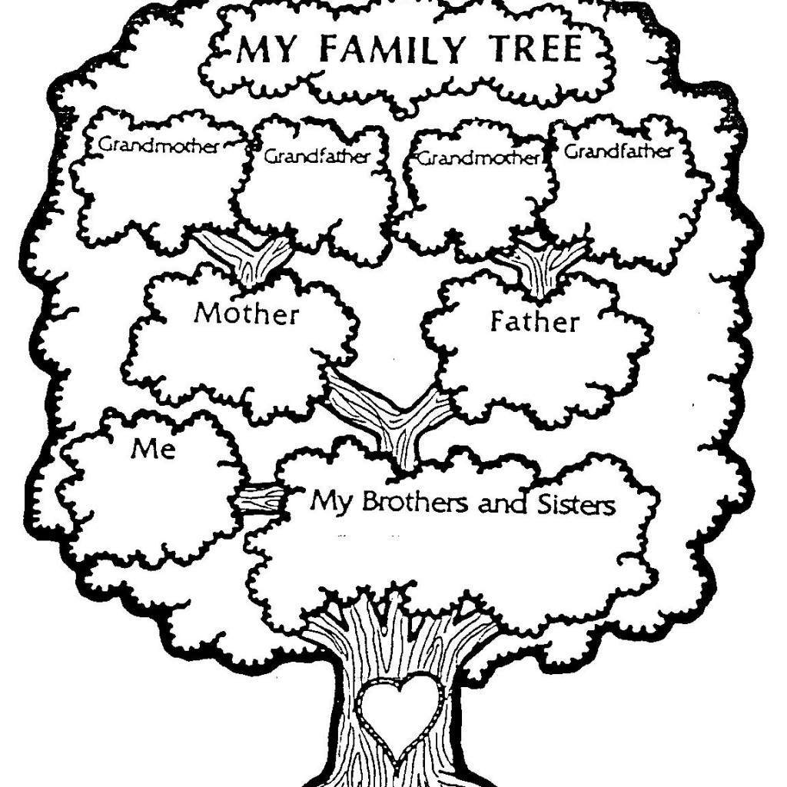

MY FAMILY TREE.

