NAME: FOLASHADE JEGEDE

MATRIC NO.:17/MHS01/168

LEVEL: 300

COURSE: HISTOLOGY

Assignment
1) Write an essay on the histological importance of eye in relation to cellular function
2) Corona virus can penetrate the body through eye and implicate the immune system, briefly discuss the layers of retina for information penetration.

Answers
1)The eye is an organ specialized for sight. It has many parts which work together to accomplish vision and to keep the structures required for vision safe from infection and injury. These parts are arranged in three layers of tissue concentrically and include;
(A) The outermost layer of eye: This part consists of the sclera and the cornea.
(i) SCLERA: It is the tough opaque layer of the eye that provides protection and structural integrity. It is also known as ‘the white of the eye’.
Histology: The sclera consists of thin non-keratinized stratified squamous epithelium, tough dense connective tissue made up of flat collagen bundles, a moderate amount of ground substance and few fibroblasts. It is relatively avascular. It has four layers, which are the episclera, stroma, lamina fusca and endothelium arranged from external to internal.
The external surface of the sclera, the episclera is connected by loose system of thin collagen fibers to a dense layer of connective tissue called Tenon’s capsule. Tenon’s capsule comes in contact with the loose conjunctival stroma at the junction of cornea with sclera.
Cellular Function 1) The fibrous nature of the sclera maintains the structural integrity of the eyeball. 2) The tough dense connective tissue of the sclera maintains ocular shape of the eyeball. 3) The rough fibrous nature protects the eye from serious damage.
Clinical Significance 1) Scleritis: It is a serious inflammatory disease that affects the white outer coating of the eye, the sclera. 2) Buphthalmos: The corneoscleral envelope of children with the congenital glaucoma responds to raised intraocular pressure by irreversibly stretching.
(ii) CORNEA: It is the transparent layer forming the front of the eye.
Histology: The cornea consists of five layers, which are the epithelium, the Bowman’s membrane, stroma, Descemet’s membrane and endothelium. The endothelium is made up of non-keratinized stratified squamous epithelium. In the basal part of the epithelium are numerous mitotic figures that are responsible for the cornea’s remarkable regenerative capacity.
The Bowman’s membrane consists of collagen fibers crossing at random, a condensation of the intercellular substance and no cells. Bowman’s membrane contributes greatly to stability and strength of cornea.
The stroma is formed by many layers of parallel collagen bundles that cross approximately right angles to each other and run full width of cornea. It maintains transparency which occurs by regular arrangement and lattice structures.
Descemet’s membrane is a thick homogenous structure composed of fine collagenous filaments organized in a three-dimensional network.
The endothelium of the cornea is a simple squamous epithelium. These cells possess organelles for secretion of cells engaged in active transport and protein synthesis and may be related to the synthesis and maintenance of Descemet’s membrane.
Cellular Function 1) The cornea shields the rest of the eye from germs, dust and harmful materials. 2) The primary role of the cornea is refraction of light to help along with the lens to focus light on the retina. 3) It allows for light to enter the eye for vision.
Clinical Significance 1) Keratoconus: This is the weakening and thinning of the central cornea. 2) Fuchs’ endothelial dystrophy: It is a hereditary abnormality of the inner cell layer of the eye, endothelium.
(B) The middle layer of the eye: This part of the eye contains the uvea, which includes the choroid, ciliary body and iris.
(i) IRIS: This is the colored portion of the eye. It is a muscle that controls the size of the pupil and the amount of light reaching the retina.
Histology: The iris is made up of 5 layers, which the anterior border layer, stroma, muscular layer, anterior pigmented epithelium and posterior pigmented epithelium. The anterior border is not a separate layer within the stroma but is a condensation of iris stroma. Iris stroma contains vasculature, nerves, melanocytes, macrophages and fibrocytes. The sphincture pupillae and dilator pupillae muscles connect to the stroma. The pupillary border of the iris is often in contact with the anterior lens capsule, however aqueous humor is still able to flow in the potential space.
The muscular layer includes a circular sphincter muscle near the pupil margin that can constrict and thereby limit the amount of light allowed through the pupil. It also contains radial dilator muscles that expand the pupillary aperture. Immediately posterior to the thin layer of dilator muscles are the anterior and posterior pigmented epithelial layers arranged in apex-to-apex configuration. The epithelium is lines by simple cuboidal pigmented epithelial cells. At the center of iris there is a hole called pupil that allows light enter the eye.
Cellular Function 1) The pigmented layer of the cells blocks rays of light and ensures that light must move through the pupil to reach the retina. 2) The muscular layer of the iris regulates the amount of light entering the pupil by constriction and expansion.
Clinical Significance 1) Iris cyst: This is an epithelial-lined space that involves a layer of the iris. 2) Iris melanoma: This is the presence of mass/tumor in the iris.
(ii) CILIARY BODY: It is the tissue that divides the posterior chamber and vitreous body.
Histology: It consists of ciliary muscle and ciliary epithelium. The ciliary muscle is composed of smooth muscles arranged as three muscle fibers, longitudinal, circular and oblique. The ciliary muscle via the lens zonules controls the structure of the lens, which is vital for accommodation. Zonules or suspensory ligaments are connective tissue fibers that connect ciliary muscle and lens.
The ciliary epithelium which is composed of low cuboidal cells is continuous with retinal pigmented epithelium. It produces aqueous humor which fills anterior compartment of the eye.
Cellular Function 1) The contraction and relaxation of ciliary muscles change the tension of suspensory ligament of the lens which allows the lens to change shape for accommodation. 2) Epithelial cells aid in blood-aqueous barrier.
Clinical Significance 1) Ciliary body melanoma: It is a type of cancer that affects the ciliary body.
(iii) CHOROID: It is a thin, variably vascular tissue forming the posterior uvea.
Histology: It consists of a dense network of blood vessels supplying nourishment to structures of the eye. It is three layers, the choriocapillaris, stroma and lamina fusca arranged from internal to external. The choriocapillaris (choriocapillary layer) is located in the innermost layer of the choroid and supplies the retina. The stroma typically contains numerous melanocytes which form a dark optical background to the retina. The lamina fusca serves as a thin web like attachment between the choroid and sclera.
Cellular Function 1) The choroid supplies oxygen and nutrients to the outer retina. 2) It regulates retinal heat. 3) It provides pigment absorption of excess light, so avoiding reflection.
Clinical Significance 1) Choroidal rupture: This occurs when there is a tear in the choroid, Bruch’s membrane and retinal pigment epithelium. 2) Choroidal dystrophy: It is an eye disorder that affects a layer of blood vessels called choroid.
(C) The innermost layer: This layer consists of the lens, vitreous humor and retina.
(i) LENS: It is a transparent biconvex structure in the eye that, along with the cornea helps to refract light to be focused on the retina.
Histology: The lens has 3 main parts, which are; the lens capsule, the lens epithelium and lens fiber from outermost to innermost respectively. The lens capsule is located at the outermost layer of the lens. It is a smooth, transparent basement membrane that completely surrounds the lens. It is elastic and composed of type IV collagen and sulfated glycosaminoglycans (GAGs). It is synthesized by lens epithelium.
The lens epithelium is located on the anterior portion of the lens between the lens capsule and lens fibers. It is lined by simple cuboidal epithelium. It serves as progenitors for new lens fibers and also regulates most of the homeostatic function of cell.
Lens fibers form the bulk of the lens. They are long, thin, transparent cells that are firmly packed. The lens split into regions depending on the age of the lens fiber of a particular layer. The mature lens fibers have no organelles or nuclei.
Cellular Function 1) The elastic nature of the lens capsule allows the lens to assume a more globular shape when not under tension of the suspensory ligaments. 2) The lens epithelium regulates most of the homeostatic function of the lens. 3) The lens is flexible and allows for accommodation.
Clinical Significance 1) Cataracts: They are opacities of the eye. 2) Aphasia: This is the absence of lens from the eye. 3) Presbyopia: This is the age-related loss of accommodation which is marked by inability of the eye to focus on nearby objects.
(ii) VITREOUS HUMOR: It is a transparent, colorless, gelatinous mass that fills the space between the lens and retina of the eyeball
Histology: The vitreous chamber appears empty as a result of its high-water content. The vitreous chamber’s exterior surface, known as the anterior hyaloid face, is behind the lens, whereas the posterior hyaloid face lies just anterior to the retina. The vitreous is firmly attached at the vitreous base located at the ora serrata. Additional firm attachments exist at the optic nerve head, overlying retinal vessels, and near the human fovea.
The lens epithelium is a monolayer of cuboidal cells located just below the anterior and equatorial lens capsule where the cells are columnar. The lens epithelial cells located at the lens equator continue to divide and produce lens fibers throughout life, with mitotic figures sometimes present. Epithelial cells are not present posterior to the lens equator under normal conditions. The central lens fibers, which are the oldest lens fibers, lack nuclei and have few intracellular organelles.
Cellular Function 1) The vitreous humor maintains the shape of the eye. 2) It helps absorb shock to the eye. 3) It keeps the retina properly connected to the back wall of the eye.
Clinical Significance 1) Vitreous detachment: This is a condition in which a part of the eye called vitreous humor shrinks and separates from the retina. 2) Vitreous hemorrhage: It is the extraversion of blood into the vitreous humor and its adjacent structures.
(iii) RETINA: It is the nervous tissue of the eye where photons of light convert to neurochemical energy via action potentials.
Histology: The retina is divided into various layers, they are; 1)Retinal pigment epithelium: It is made of cuboidal cells containing melanin which absorbs light. These cells also establish a blood-retina barrier through tight junctions. 2) Rod and cone cells: This is the layer of cells with photoreceptors and glial cells. Rods are located peripherally and are more sensitive to light and motion than cones. Cones have higher visual acuity and specificity for color vision. 3) Outer limiting membrane: a layer of Muller cells and rod/cone junctions which serves to separate the photosensitive regions of the retina from the areas that transmit the electrical signals. 4) Outer nuclear layer: This layer consists of nuclei of rod and cone cells. 5) Outer plexiform layer: This layer contains synaptic processes of rod and cone cells. 6) Inner nuclear layer: This layer contains the cell body of glial, amacrine, bipolar, and horizontal cells. 7) Inner plexiform layer: This layer relays information from cells of the inner nuclear layer. Thus, this layer has axons of amacrine, bipolar, and glial cells and dendrites of retinal ganglion cells. 8) Ganglion cell layer: This layer contains nuclei of retinal ganglion cells. 9) Nerve fiber layer: This layer contains axons of retinal ganglion cells and the astroglia which support them. Collectively, these axons constitute the optic nerve. 10) Internal limiting membrane: A thin layer of Muller glial cells and basement membrane which demarcates the vitreous anteriorly from the retina posteriorly.
Cellular Function 1) The photoreceptor cell layer of the retina enables it to process light. 2) The retina processes the information and sends it to the brain via optic nerve.
Clinical Significance 1) Retinal detachment: It occurs when the outer pigment epithelial layer separates from the inner neurosensory layer consisting of rods and cones.

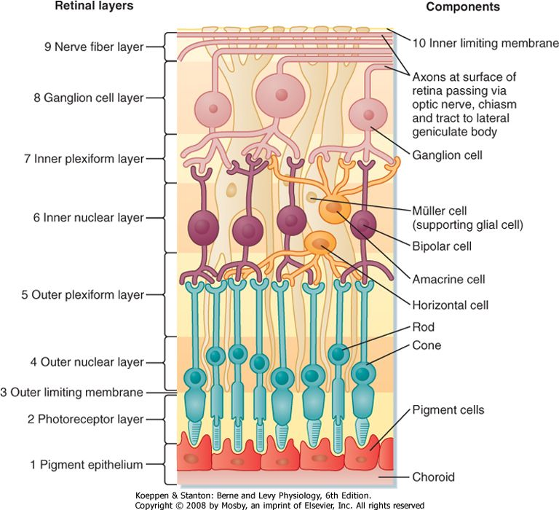

2) The innermost layer of the eye which is the retina develops with two fundamental sublayers from the external and internal layers of embryonic optic cup. They are:
(A) The outer retinal pigmented layer (PL): This layer consists of cuboidal or low columnar cells with basal nuclei and surrounds the neural layer of the retina. It provides essential nutrition and waste removal for the photoreceptor cells. Accumulation of waste can lead to macular degeneration (AMD) and Stargardt disease.
(B) The inner retinal region: This is the neural layer. It is thick and stratified with various neurons and photoreceptors. It is made up of at least 15 types of neurons which have distinct synapses with one another. Nine distinct layers make up the neural retina, which are: i) Internal Limiting Layer (ILL): It consists of terminal expansions of other Muller cell processes that cover the collagenous membrane of vitreous body. ii) Nerve Fiber Layer (NFL): It contains the ganglionic cell axons that converge at the optic disc and form optic nerve. iii) Ganglionic Layer (GL): It contains cell bodies of the ganglionic cells and are thicker near the retina’s center than its periphery. iv) Inner Plexiform Layer (IPL): It contains fiber and synapses of the ganglion cells and bipolar neurons of the next layer. v) Inner Nuclear Layer (INL): It contains cell bodies of several types of bipolar neurons which begins to integrate signals from the rod and cone cells. vi) Outer Plexiform Layer (OPL): It contains fibers and synapses of the bipolar neurons and rod and cone cells. vii) Outer Nuclear Layer (ONL): It contains the cell bodies and nuclei of photosensitive rod and cone cells. viii) Outer Limiting Layer (OLL): It is a layer formed by junctional complexes holding the rod and cone cells to the intervening Muller cells. ix) Rod and Cone Layer (RCL): It contains the outer segments of rods and cone cells where the photoreceptors are located.
In total, the retina has 10 layers for information penetration.

