NANCY NNANNA CHINEMEREM
17/mhs01/203
ANA 305 ASSIGNMENT
MEDICINE & SURGERY
300 LEVEL.

- The eye is a complex and highly developed photosensitive
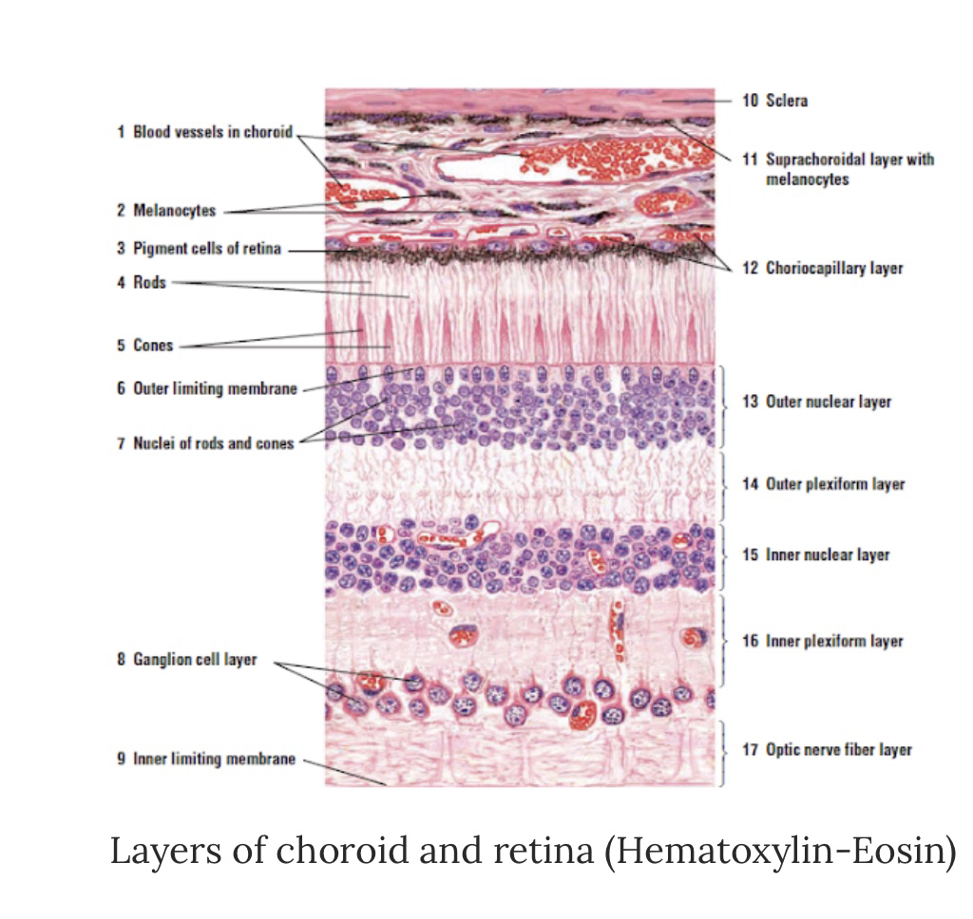
Organ that permits an accurate analysis of the form, light intensity and colour reflected from objects.
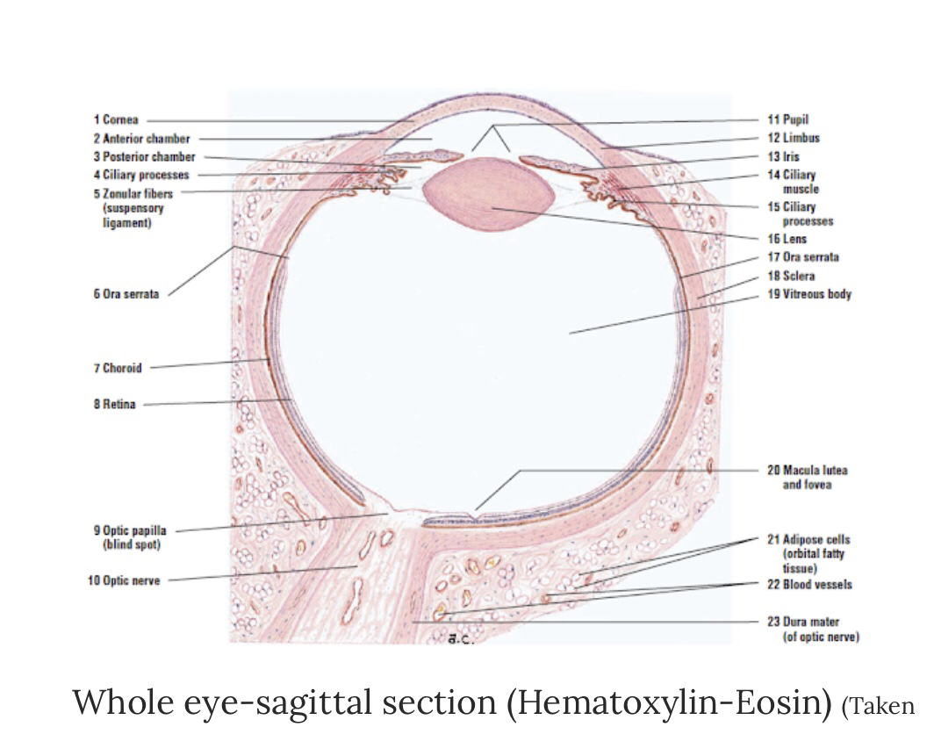

Each eye is composed of 3 concentric layers :
The external layer:
SCLERA: A dense irregular connective tissue made of mainly flat collagen bundles intersecting in various directions while remaining parrallel to the surface of the organ a moderate amount of ground substance and few fibroblasts . In relation to its cellular functions thick collageneous capsule structure provides support for the eye and Is the point of attachment for extra occular muscles and is in continuity with the conjuctiva.

CORNEA : This is the transparent front layer of the eye , consists of 2 layers of epithelium with organized connective tissue in between . Consists of type 1 collagen fibers oriented in a uniform parallel direction to maintain transparency. Consists of 5 layers :
- Epithelium ( nonkeratinized , stratisfied Squamous)
- Bowmans layer
- Stroma ( also called Substantia Propria)
- Descements membrane
- Corneal Epithelium. The cornea is transparent and Avascular. Directs lights to the lens - refractive power twice that of the lens.
Corneal Epithelium- Stratified squamous ( non keratinizing). Has high rate of turnover for repair damage and Abrasion . Sterm cells in basal layer near the limbus under go differentiation , epithelium migrates.

Stroma of the cornea : corneal fibroblasts are called keratinocytes. Stroma is multilayered with alternating layers of Keratocytes and Ecm fibrils and proteoglycans. The orientation of collagen fibrils changes layer.

Corneal endothelium- simple cuboidal epithelium mediated hydration and nutrition of the Stroma and corneal epithelium.

MIDDLE LAYER - ( vasucular trunk )
Choroid - consists of dense network of blood vessels supplying nourishment to structures of the eye , housed in loose connective tissue . Areolar connective tissue- highly vascularized pigment absorbs extraneous light. The choriocapillary layer is located in the inner most part of the choroid and supplies to the retina.

Ciliary body - Tissue that divides the posterior chamber and vitreous body . Consists of the ciliary muscle and the ciliary epithelium. The ciliary muscle via the lens , which is vital for accommodation, zonules are connective tissue fibers that connects the ciliary muscles and lens . This holds sensory ligaments that attach to cells and change lens shape for far and near vision.
The ciliary epithelium produces aqueous hun our which fills the anterior compartment Of the eye.

Iris : consists of 2 layers of smooth muscles ( sphincter, pupillae and dilator pupillae) and connective tissue with a central pupil. The iris controls pupil diameter and thus the amount of light entering the eye.

INTERNAL LAYER ( Retina)

Lens: separates the aqueous and vitreous chambers
Pigmented layer- pigmented epithelial cells it’s provides vitamin A for photo receptor cells. Absorbs extraneous light .

Neural layer : photoreceptors, bipolar neurons , ganglion cells and supporting muller cells
Functions: detects incoming light rays. Light rays are conceded to nerve signals and transmission to brain.
- Conjunctiva: The conjunctiva lines the inner part of the eyelids. The tarsal plate lies beneath the conjunctiva and contains meibomian glands, which secrete an oily substance to decrease the evaporation of the tear film.
- Tear film: The tear film consists of aqueous, mucus, and oily secretions.
- Accessory glands: Apocrine glands of Moll, meibomian glands, lacrimal glands.
- Muscles: Orbicularis oculi, levator palpebrae superioris, superior tarsal muscle.
- Eyelid: The eyelid, likewise known as the cover of the eye, a mobile layer made up of skin and also muscular tissue and also covers the eyeball.

2). Corona virus can penetrate the body through the eye and implicate the immune system , the layers of the retina for the information penetration are :

Coronaviruses are a broad family of viruses that normally affect only animals, although some of them can spread from animals to humans. They can produce anything from a common cold to more serious diseases. the virus seems to spread through small respiratory droplets produced when an infected person coughs or sneezes, although it could also spread if people touch an object contaminated with the virus and then touch their mouth, nose or eyes. Therefore. Corona virus can implicate the immune system and layers of the retina for information penetration.

The retina can be divided into 10 layers including:
1.) The inner limiting membrane (ILM);
2.) The nerve fiber layer (NFL);
3.) The ganglion cell layer (GCL);
4.) The inner plexiform layer (IPL);
5.) The inner nuclear layer (INL);
6.) The outer plexiform layer (OPL);
7.) The outer nuclear layer (ONL);
8.)The outer limiting membrane (OLM);
9.) The photoreceptor layer (PL), and
10.) The retinal pigmented epithelium (RPE) monolayer.

Retina: nervous tissue of the eye where photons of light convert to neurochemical energy via action potentials
Moreover, the retina itself is divided into various layers as follows:
Retinal pigment epithelium: made of cuboidal cells containing melanin which absorbs light. These cells also establish a blood-retina barrier through tight junctions.
"Rod and cone cells": the layer of cells with photoreceptors and glial cells. Rods are located peripherally and are more sensitive to light and motion than cones. Cones have higher visual acuity and specificity for color vision.
"Outer limiting membrane": a layer of Muller cells and rod/cone junctions which serves to separate the photosensitive regions of the retina from the areas that transmit the electrical signals.
"Outer nuclear layer": This layer consists of nuclei of rod and cone cells.
"Outer plexiform layer": This layer contains synaptic processes of rod and cone cells.
"Inner nuclear layer”: This layer contains the cell body of glial, amacrine, bipolar, and horizontal cells
"Inner plexiform layer": This layer relays information from cells of the inner nuclear layer. Thus, this layer has axons of amacrine, bipolar, and glial cells and dendrites of retinal ganglion cells.
"Ganglion cell layer": This layer contains nuclei of retinal ganglion cells.
"Nerve fiber layer": This layer contains axons of retinal ganglion cells and the astroglia which support them. Collectively, these axons constitute the optic nerve.
"Internal limiting membrane": A thin layer of Muller glial cells and basement membrane which demarcates the vitreous anteriorly from the retina posteriorly.

Six major cell types form the various layers within the human retina :

1. Photoreceptors (rods and cones) - form the outer nuclear layer
* Synapse with bipolar cells at the outer plexiform layer
* Rods deal predominantly with peripheral and night vision
* Cones deal mainly with central vision

2. Bipolar cells - make up the inner nuclear layer
* Synapse with amacrine cells and ganglion cells at the inner plexiform layer
3. Amacrine cells
* Inhibitory cells which interact with bipolar cells and retinal ganglion cells

4. Retinal ganglion cells - form the ganglion cell layer (innermost layer, furthest from the photoreceptors)
* Axons tract towards the back of the eye and form the optic nerve

5. Horizontal cells
* Assist in operations such as contrast enhancement and preservation of spatial information.[2]
6. Muller cells
* glial cells which support metabolism and homeostasis of the retina.

Functions:
The retina transmits light signals into chemical signals that are sent to the brain. This process requires the ability to sense the stimulus of light and transmit that signal from cell to cell.[.
- Photoreceptors (rods and cones): The detection of light begins at the deepest cell layer in the retina, the photoreceptors, located in the outer nuclear layer. Rods are very light sensitive and are responsible for dim-light vision. Cones, on the other hand, are not very light sensitive but are specific for a particular wavelength of light. Thus, cones are responsible for high acuity color vision.
- Bipolar cells: Photoreceptors use the neurotransmitter, glutamate, to communicate at the synapse with bipolar cells within the outer plexiform layer.[4] Bipolar cell bodies are just shallow to this layer at the inner nuclear layer. At the inner plexiform layer, bipolar cells are responsible for transmitting an impulse to retinal ganglion cells.
- Retinal ganglion cells: These are the final receivers and transmitters of the initial stimulus. They send the information they receive down their axons, which eventually form the optic nerve and project to higher brain centers.
- Amacrine cells: Amacrine cells modulate the excitation of the retinal ganglion cells through contact with ganglion cell dendrites or bipolar cell axon terminal bulbs, using the neurotransmitters GABA and glycine.
- Horizontal cells: These cells function to modulate the communication between photoreceptors and bipolar cells. Bipolar cells contact ganglion and amacrine cells at the inner plexiform layer.
- Müller cells: These are cells are of glial origin and are essential for proper retinal function. They contact almost every cell type in the retina, spanning the entire width from the photoreceptors to the inner retina. They serve to recycle neurotransmitters, prevent glutamate toxicity, and regulate nutrient homeostasis in the retina.

